ZooKeeper for Application Health Management

1. Why ZooKeeper?
Distributed systems face a deceptively hard problem: how does one process know whether another process is still alive?
At first glance this seems simple — just ping it. But in practice, network-based health checks (keep-alives, heartbeats, HTTP health endpoints) are fragile:
- False positives: A process might respond to a ping while being deadlocked, stuck in a GC pause, or functionally broken.
- False negatives: A healthy process might miss a heartbeat deadline due to a momentary network partition, causing the monitor to wrongly declare it dead.
- Who watches the watcher? If the monitoring process itself crashes, there is no one left to notice that workers are dying. You end up building a monitoring system for your monitoring system.
- Consensus is hard: When multiple monitors disagree about whether a process is alive, you need a protocol to resolve the conflict — and getting that right is notoriously difficult (see: the Paxos and Raft papers).
ZooKeeper solves all of this. It is a distributed coordination service — a small cluster of servers (typically 3 or 5) that collectively maintain a consistent, ordered, hierarchical data store. Because ZooKeeper itself is replicated and fault-tolerant, it can serve as the single source of truth for “who is alive right now.”
Rather than building bespoke health-checking into every application, you connect to ZooKeeper once and let it handle the hard parts: failure detection, notification delivery, and consistency guarantees.

2. Leader Election in Distributed Systems

The Fundamental Problem: Who Is in Charge?
In any distributed system where multiple nodes work together, a core question arises: who coordinates the work? A master (or leader) node must be elected to distribute workload to the other nodes, make global decisions, and serve as the serialization point for ordering events. Without a single agreed-upon leader, the system faces several dangers:
- Split-brain: Two or more nodes believe they are the leader simultaneously, issuing conflicting commands and corrupting shared state. In a replicated database, two nodes accepting writes as “primary” leads to divergent data that is expensive or impossible to reconcile.
- Duplicate work: Without a coordinator to assign tasks, workers may redundantly process the same jobs, wasting compute resources.
- No ordering guarantees: Operations that require a total order (log replication, transaction commits, configuration changes) need a single decision-maker to serialize them.
- Deadlock and livelock: Peer-to-peer consensus without a leader is expensive — requiring quorum protocols for every single decision — and can stall under contention.
Leader election is therefore a foundational primitive in distributed systems. Once a leader is elected, it can distribute work to other nodes, aggregate results, rebalance partitions, and make global decisions that would otherwise require expensive all-to-all coordination.

Classic Leader Election Algorithms

Bully Algorithm (Garcia-Molina, 1982)
Each process has a unique numeric ID. When a process detects the leader has failed, it initiates an election by sending an “Election” message to all processes with higher IDs. If no higher-ID process responds within a timeout, the initiator declares itself leader by broadcasting a “Coordinator” message. If a higher-ID process responds, it “bullies” the initiator and takes over the election. The highest-ID surviving process always wins.
Node 3 detects leader failure
→ sends Election to Node 4, Node 5
→ Node 5 responds "OK" (I'll take over)
→ Node 5 sends Election to no one (no higher IDs)
→ Node 5 broadcasts "Coordinator: I am the leader"
Aspect | Detail
Best case messages | O(1) — the highest-ID process initiates and sends one Coordinator message
Worst case messages | O(n²) — the lowest-ID process triggers a cascade
Assumptions | Synchronous network, reliable failure detection, crash-stop failures only
Weakness | Not partition-tolerant; favors highest ID regardless of suitability

Ring Algorithm (Chang-Roberts, 1979)
Processes are arranged in a logical ring. When a process detects the leader has failed, it creates an Election message containing its own ID and sends it clockwise. Each recipient compares the candidate ID with its own: if the incoming ID is higher, it forwards the message; if its own ID is higher, it substitutes its ID and forwards. When the message completes the ring and returns to the originator, that process is the leader.
Ring: [N1] → [N2] → [N3] → [N4] → [N1]
N2 detects leader failure, sends Election(2)
N3 receives Election(2), has higher ID → sends Election(3)
N4 receives Election(3), has higher ID → sends Election(4)
N1 receives Election(4), has lower ID → forwards Election(4)
N2 receives Election(4), has lower ID → forwards Election(4)
...
N4 receives its own Election(4) → N4 is the leader
N4 sends Coordinator(4) around the ring
Aspect | Detail
Best case messages | 2(n-1)
Worst case messages | O(n²) — IDs arranged in decreasing order around ring
Assumptions | Ring topology, synchronous network, crash-stop failures
Weakness | Latency proportional to ring size

Paxos-Based Election (Lamport, 1998)
Paxos is a family of consensus protocols that can elect a leader in an asynchronous network. A proposer sends a Prepare request with a unique proposal number to all acceptors. If a majority (quorum) of acceptors respond with promises not to accept lower-numbered proposals, the proposer sends an Accept request. If a quorum accepts, the proposer becomes leader.
Aspect | Detail
Messages per round | O(n) to/from the quorum
Fault tolerance | Tolerates f crash failures with 2f+1 nodes
Safety | Guaranteed under full asynchrony — no timing assumptions
Weakness | Notoriously complex to implement; “dueling proposers” can prevent progress

Raft Leader Election (Ongaro & Ousterhout, 2014)
Raft was designed explicitly for understandability. Time is divided into terms (monotonically increasing logical clocks). All nodes start as followers. If a follower receives no heartbeat from a leader within a randomized election timeout, it becomes a candidate, increments its term, votes for itself, and sends RequestVote RPCs to all other nodes. A candidate receiving votes from a majority becomes leader and immediately begins sending heartbeat AppendEntries RPCs to assert authority.
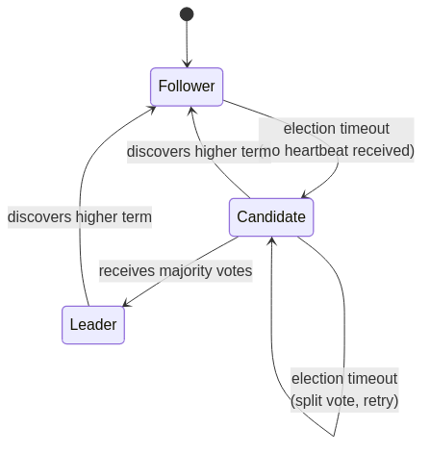
Diagram 1
Aspect | Detail
Messages per election | O(n) — one RequestVote to each peer
Fault tolerance | Tolerates f crash failures with 2f+1 nodes
Split vote resolution | Randomized election timeouts break symmetry
Fencing mechanism | The term number is a natural fencing token — stale leaders are rejected
Strength | Understandable, practical, widely adopted

Comparison of Classic Algorithms
Algorithm | Model | Fault Tolerance | Worst Case Messages | Key Strength | Key Weakness
Bully | Synchronous | Crash-stop | O(n²) | Simple | Not partition-safe
Chang-Roberts Ring | Synchronous | Crash-stop | O(n²) | Lower avg messages | Requires ring topology
Paxos | Async (safety) | Crash (2f+1) | O(n) per round | Proven correct | Complex implementation
Raft | Async safety, partial sync liveness | Crash (2f+1) | O(n) per election | Understandable | Brief availability gap during elections

Modern Production Implementations
Modern distributed systems use leader election as a core building block. Each delegates the hard parts to a well-tested consensus protocol:
System | Protocol | Election Primitive | Fencing Mechanism
Apache ZooKeeper | ZAB (ZooKeeper Atomic Broadcast) | Ephemeral sequential znodes — smallest sequence wins | zxid / znode version
etcd | Raft | Raft term-based election among peers | Raft term number
HashiCorp Consul | Raft | Raft election among server nodes (3 or 5) | Raft term number
Kubernetes | Lease API (backed by etcd) | Lease object with holderIdentity and duration | Lease resourceVersion
ZooKeeper (ZAB) uses a two-phase protocol: a leader is elected via a quorum vote, then the leader broadcasts state changes to followers in strict order. Applications build on top of this using the ephemeral sequential znode recipe described in this project.
etcd is the backbone of Kubernetes — every cluster stores all its state (pods, services, configurations) in etcd. The etcd Raft leader serializes all writes. A 5-node etcd cluster tolerates 2 node failures.
Consul deploys agents on every node with a separate set of 3–5 servers participating in Raft consensus. The elected leader processes all queries and replicates state for service discovery, health checking, and KV operations.
Kubernetes provides a higher-level Lease API. A process acquires a Lease by writing its identity to a Lease object. The Lease has a duration and must be periodically renewed. If the leader fails to renew, Kubernetes’ optimistic concurrency control ensures only one standby can acquire the Lease next.

Key Challenges

Network Partitions and Split-Brain
A network partition isolates subsets of nodes into independent groups. Each group may attempt to elect its own leader — the dreaded split-brain scenario. Quorum-based algorithms (Raft, Paxos, ZAB) prevent this: only the partition containing a majority of nodes can elect a leader. The minority partition becomes unavailable for writes.
Cluster: [N1, N2, N3, N4, N5]
Partition: [N1, N2, N3] | [N4, N5]
Left partition (3 nodes): has quorum → can elect a leader
Right partition (2 nodes): no quorum → read-only or unavailable
Additional defenses include: - Fencing (STONITH — “Shoot The Other Node In The Head”): forcefully power off a node suspected of being a stale leader before allowing a new leader to operate. - Fencing tokens: every lease acquisition increments a monotonic token; storage servers reject requests bearing old tokens (see Martin Kleppmann’s analysis of distributed locking). - Leader leases with bounded duration: authority expires after a fixed time unless renewed, preventing indefinite stale leadership.

CAP Theorem Implications
The CAP theorem (Brewer, 2000; proved by Gilbert & Lynch, 2002) states that during a network partition, a system must choose between Consistency and Availability:
- CP systems (ZooKeeper, etcd, Consul): prioritize consistency. During a partition, the minority side becomes unavailable. No quorum means no leader means no writes.
- AP systems (Cassandra, DynamoDB): prioritize availability. May allow conflicting writes during partitions, resolving conflicts later. These systems typically do not use single-leader election.
Leader election is inherently a CP operation — you cannot guarantee a single leader while remaining fully available during partitions.

Byzantine Failures
The algorithms above assume crash-stop failures — nodes either work correctly or halt entirely. Byzantine failures, where nodes send arbitrary or malicious messages, require specialized protocols like PBFT (Practical Byzantine Fault Tolerance, Castro & Liskov, 1999), which needs 3f+1 nodes to tolerate f failures (vs. 2f+1 for crash failures). Most production systems (ZooKeeper, etcd, Consul) do not handle Byzantine failures, assuming a trusted internal network.

Best Practices for Leader Election
- Use lease-based leadership, not indefinite locks. A leader holds a lease for a fixed duration and must periodically renew it. If the leader crashes, the lease expires, and a new leader can be elected. This avoids permanent lockout. ZooKeeper ephemeral nodes with session timeouts and Kubernetes Leases both implement this pattern.
- Use fencing tokens for correctness. Every lease acquisition should produce a monotonically increasing fencing token. All downstream resources (databases, storage) must reject requests bearing a token older than the last seen token. This is the only truly safe way to prevent a stale leader (one that hasn’t yet realized it lost leadership) from corrupting data. In ZooKeeper, the zxid or znode version number serves this purpose. In Raft, the term number is a natural fencing token.
- Heartbeats must be frequent relative to election timeouts. Raft recommends: heartbeat interval ≪ election timeout ≪ MTBF (mean time between failures). Too-frequent elections waste resources; too-infrequent elections leave the system leaderless for too long.
- Support graceful leadership transfer. Rather than waiting for a timeout when shutting down a leader for maintenance, the leader can explicitly hand off to a follower. In Raft, the leader sends a TimeoutNow RPC to a chosen follower, causing it to immediately start an election. This avoids the availability gap of waiting for election timeouts.
- Minimize leader responsibilities. Design the system so that brief dual-leadership during failover causes at worst duplicate work, not data corruption. If you cannot support fencing tokens end-to-end, accept that two leaders may occasionally overlap and ensure the system handles this gracefully.

Failure Detection: A Prerequisite for Election
Before a new leader can be elected, the system must detect that the current leader has failed. This is surprisingly difficult in an asynchronous network.
Mechanism | How It Works | Used By
Heartbeat + timeout | Leader sends periodic heartbeats; followers trigger election if no heartbeat within timeout. Simple but tuning the timeout is a fundamental tension — too short causes false positives, too long delays detection. | Raft, ZAB, most production systems
Phi accrual failure detector | Outputs a continuous suspicion level (φ) based on statistical distribution of heartbeat inter-arrival times. Adapts dynamically to network conditions. | Akka, Apache Cassandra
SWIM protocol | Each node periodically pings a random peer; on failure, asks k others to probe indirectly. Membership changes propagated via gossip in O(log n) time with only O(n) messages per detection period. | HashiCorp Serf, Consul (gossip layer)
The FLP impossibility result (Fischer, Lynch, Paterson, 1985) proves that no deterministic algorithm can guarantee consensus in a fully asynchronous system where even one process may fail. All practical failure detectors therefore make timing assumptions — they trade theoretical impossibility for practical reliability.

How This Project Implements Leader Election
This project uses ZooKeeper’s ephemeral sequential znode recipe, sometimes called the “small-node-wins” algorithm:
- Each node creates an ephemeral sequential znode under /election (e.g., /election/c_0000000000).
- The node with the smallest sequence number becomes the leader.
- Each non-leader watches its immediate predecessor (not the leader), forming a chain that limits notifications to O(1) per failure — avoiding the thundering herd problem.
- When a predecessor’s ephemeral znode is deleted (the node crashed or disconnected), the watcher fires and the next node re-evaluates whether it is now the leader.
- The OnElectionCallback interface decouples election from behavior — the same binary acts as leader or worker depending on election outcome.
This approach leverages ZooKeeper’s built-in session management and ephemeral node lifecycle, giving the application leader election with automatic failover and no custom heartbeat code — the coordination service handles the hard parts.

3. How ZooKeeper Replaces Keep-Alives
Traditional keep-alive systems work like this:
Worker → periodic heartbeat → Monitor
"I'm still alive"
The monitor sets a deadline. If the heartbeat doesn’t arrive in time, it assumes the worker is dead. This approach has two fundamental weaknesses:
- Tuning the timeout is a losing game. Too short and you get false alarms from GC pauses or network blips. Too long and dead workers go unnoticed for minutes.
- The monitor must poll or maintain timers for every worker. This scales poorly and is itself a single point of failure.
ZooKeeper replaces this entire mechanism with ephemeral nodes and sessions.

Sessions
When an application connects to ZooKeeper, it establishes a session. ZooKeeper and the client maintain this session with automatic, built-in heartbeats — you don’t write any keep-alive code. If the client crashes, hangs, or loses network connectivity for longer than the session timeout (e.g. 3 seconds), ZooKeeper declares the session dead.

Ephemeral Nodes
An ephemeral node (znode) is a piece of data in ZooKeeper’s tree that is tied to the session that created it. When the session dies, ZooKeeper automatically deletes the ephemeral node. No application code runs. No heartbeat handler fires. The ZooKeeper cluster itself handles the cleanup.
This means the presence of an ephemeral node is a reliable proxy for “the application that created it is alive.” Its absence means the application is gone.
Traditional: Worker --heartbeat--> Monitor --timeout--> "worker is dead"
(app code) (app code) (app code)
ZooKeeper: Worker creates Worker crashes ZooKeeper deletes
ephemeral node (or disconnects) the node automatically
(one line of code) (no code needed) (no code needed)
The application does not need to implement any heartbeat loop. It creates one ephemeral node at startup, and ZooKeeper does the rest.

4. What a Watcher Is
Knowing that an ephemeral node disappears when its creator dies is only half the story. The other half is: how does anyone find out?
This is where Watchers come in. A Watcher is a one-time callback that ZooKeeper triggers when something changes on a node you’re interested in. You register a watcher by passing it to a read operation:
// "this" is the Watcher — ZooKeeper will call this.process() when
// the children of WORKERS_PATH change (a child added or removed)
List<String> children = zooKeeper.getChildren(WORKERS_PATH, this);
When a change occurs — a child node is created, deleted, or modified — ZooKeeper delivers a WatchedEvent to the watcher’s process() method:
@Override
public void process(WatchedEvent event) {
switch (event.getType()) {
case NodeChildrenChanged:
// A worker was added or removed — react accordingly
reconcileWorkers();
break;
}
}

Key properties of watchers
Property | What it means
One-time | A watcher fires exactly once. You must re-register it in the callback to keep getting notifications. This is by design — it prevents event storms.
Ordered | Events are delivered in the order they happened. You will never see a “node deleted” event before the “node created” event.
No missed events | If a node changes between the time you set the watcher and receive the response, you still get the event.
Push, not poll | You don’t loop checking for changes. ZooKeeper pushes the event to you.
Because watchers are one-time, a common pattern is to re-register the watcher inside the callback itself. In our project, getChildren(WORKERS_PATH, this) both reads the current children and sets a new watcher for the next change — creating a self-sustaining notification loop with no polling.

5. Embedding ZooKeeper in Any Application
Any application — regardless of language, framework, or purpose — can become “ZooKeeper-managed” by doing two things at startup:
- Connect to ZooKeeper (establishing a session)
- Create an ephemeral node (registering its presence)
That’s it. There is nothing else the application needs to do for health management. No heartbeat thread, no health endpoint, no keep-alive timer.
Here is the entire integration from this project’s FlakyWorker:
// Step 1: Connect
this.zooKeeper = new ZooKeeper("localhost:2181", 3000, this);
// Step 2: Create an ephemeral node
zooKeeper.create(
"/managed_workers/w_", // path prefix
workerId.getBytes(), // optional metadata (worker ID, address, etc.)
ZooDefs.Ids.OPEN_ACL_UNSAFE, // ACL
CreateMode.EPHEMERAL_SEQUENTIAL); // ephemeral + auto-incrementing suffix
From this point forward:
- If the application crashes — the JVM exits, the TCP connection drops, ZooKeeper’s session timer expires, and the ephemeral node is deleted. Any watcher on the parent node is notified.
- If the application hangs — the ZooKeeper client library can no longer send session heartbeats. After the session timeout, the same cleanup happens.
- If the network partitions — same outcome. The session expires, the node is deleted, watchers fire.
The application doesn’t need to know about any of this. It just creates one node and goes about its business.

What the monitoring side looks like
A separate process (the WorkerManager in our project) watches the parent node:
// Read current children AND set a watcher for changes
List<String> children = zooKeeper.getChildren("/managed_workers", this);
if (children.size() < targetWorkerCount) {
spawnWorker(); // launch a replacement
}
When any child ephemeral node disappears (a worker died), ZooKeeper fires the NodeChildrenChanged event, and the manager reacts — in our case, by spawning a replacement process.
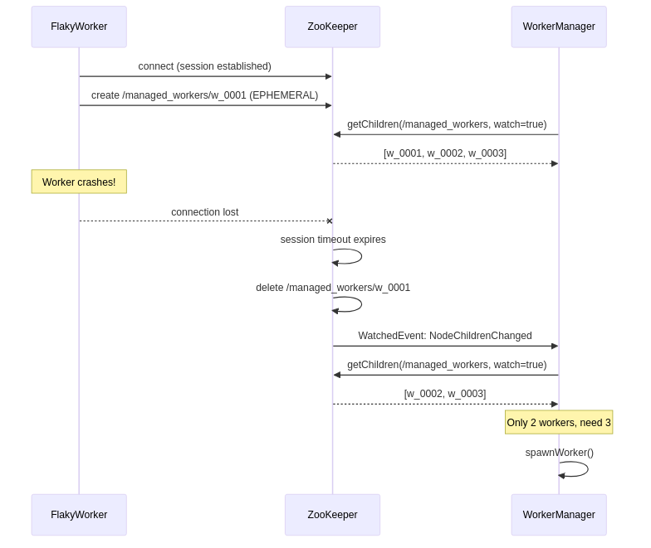
Diagram 2
This pattern works for any type of application — web servers, batch jobs, microservices, database proxies — because the ZooKeeper integration is completely decoupled from the application’s actual work. The worker doesn’t know or care that it’s being watched.

6. Running the Demo

Prerequisites
- Docker and Docker Compose
- Java 21
- Maven 3.9+

Start ZooKeeper
docker compose up -d zookeeper
Verify it’s healthy:
docker exec zookeeper bash -c 'echo ruok | nc localhost 2181'
You should see imok.

Option A: Run locally (outside Docker)
Build the project from the root:
mvn clean package -DskipTests
Start the manager, which will spawn 3 worker processes automatically:
java -jar example/target/example-1.0-SNAPSHOT-jar-with-dependencies.jar 3 localhost:2181
You’ll see output like:
[manager] Starting — target workers: 3, ZooKeeper: localhost:2181
[manager] Connected to ZooKeeper at localhost:2181
[manager] Created /managed_workers
[manager] Current workers: 0, target: 3
[manager] Spawning new worker process...
[manager] Spawning new worker process...
[manager] Spawning new worker process...
[manager] Pool OK — 3 workers running
[worker-12345] Registered at /managed_workers/w_0000000000
[worker-12345] Working... iteration 1
[worker-12346] Registered at /managed_workers/w_0000000001
[worker-12347] Registered at /managed_workers/w_0000000002
After ~10 iterations (roughly 10 seconds), a worker will randomly crash:
[worker-12345] CRASH at iteration 8!
[manager] Detected worker pool change!
[manager] Current workers: 2, target: 3
[manager] Spawning new worker process...
[manager] Pool OK — 3 workers running
The manager detects the death via ZooKeeper’s watcher and immediately spawns a replacement. The pool is maintained at 3 indefinitely.

Option B: Run in Docker
Build and start both ZooKeeper and the manager container:
docker compose up -d worker-manager
This builds the example module in a multi-stage Docker build and starts the manager, which spawns workers as child JVM processes inside the container. View the logs:
docker compose logs -f worker-manager

Inspecting ZooKeeper state
While the demo is running, you can inspect the live znodes using ZooKeeper’s CLI:
docker exec -it zookeeper bin/zkCli.sh
Then inside the CLI:
ls /managed_workers
# [w_0000000000, w_0000000001, w_0000000002]
get /managed_workers/w_0000000000
# worker-12345
Watch as workers crash and get replaced — the node names will increment as new ephemeral-sequential nodes are created, and old ones disappear.

Cleanup
docker compose down

