**Figure 1a.** Partial correlation network of BYSAS and DASS-21 for heterosexual males



**Figure 1b.** Partial correlation network of BYSAS and DASS-21 for heterosexual females



**Figure 1c.** Partial correlation network of BYSAS and DASS-21 for LGBTQ+ subgroup



**Figure 2a.** Comparison of centrality indices. Nodes represent items of BYSAS and DASS-21 for subgroups

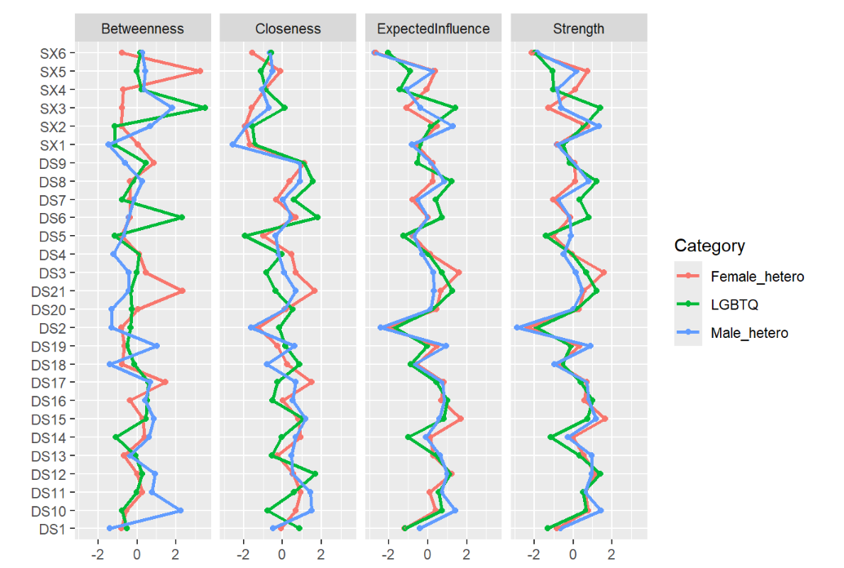

**Figure 2b**. Comparison of bridge centrality. Nodes represent items of BYSAS and DASS-21 for subgroups

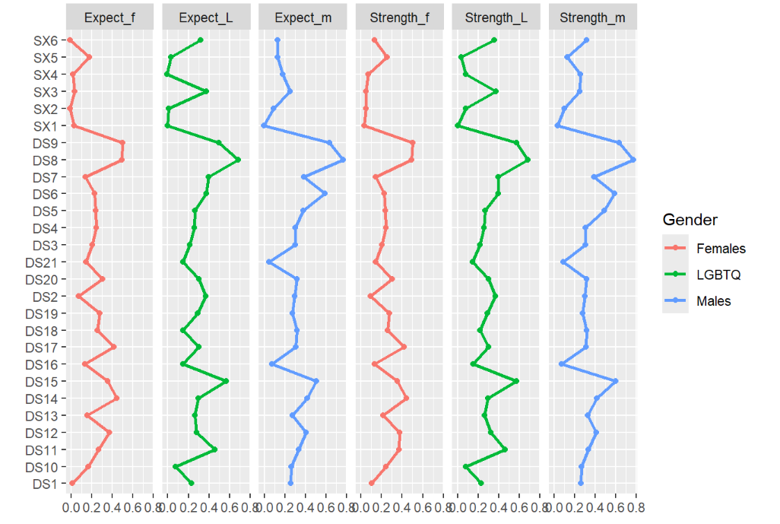

**Figure 3a.** DAG depicting directed relationships between DASS-21 and BYSAS for heterosexual male subgroup

**Figure 3b.** DAG depicting directed relationships between DASS-21 and BYSAS for heterosexual female subgroup

**Figure 3c.** DAG depicting directed relationships between DASS-21 and BYSAS for LGBTQ+ subgroup

