**Bi188 Midterm Examination**

**Spring 2015**

Due **Monday, May 4rd, 12:00pm**

(as a PDF emailed to sgoh@caltech.edu, phe@caltech.edu and woldb@caltech.edu).

The exam is closed-book and closed-notes, ***though you will need internet access to use the genome browser for one question.***

You are asked to identify some specific features on a figure as well. This can be done onto a printout or you can drop the png into powerpoint or other favored program and make your annotations that way. Also, uou can draw while taking the exam and convert to electronic after time is up…..or even hand in paper.

You have 3 hours to complete the exam, though we expect that the exam can be completed well within 2 hours.

There are 3 parts to this exam that adds up to a total of 35 points.

Express your answers concisely. Most questions need only one or a few sentences.

Please read no further until you are ready to take the exam.

1. Genome structure and Copy Number Variation (total of 12 points)

1. Where are Copy Number Variations (CNVs) more likely to occur in the human genome?(1 point)
2. Give a major difference between CNV in the human genome versus the mouse genome (1 point) and comment on how this has changed during evolution of the primate lineage (2 points).

1. Identify a class of human diseases that is prominently affected by CNV. (2 points)

Below in figure 1-1 autosomal-dominant brachydactyly type A2 (BDA2) is a limb malformation featured by hypoplastic middle phalanges of the second and fifth fingers.  Mutations in genes such as Bone morphogenetic protein receptor 1B (BMPR1B) or Growth and differentiation factor 5 (GDF5) are causes known thus far. These known genes behave according to a simple Mendelian recessive model. However, in another study, duplication of a ~5.5kb region (shown below) was found to be associated with a BDA2 phenotype, demonstrating that Copy Number Variations of non-coding regions can contribute to pathogenesis of human disease.

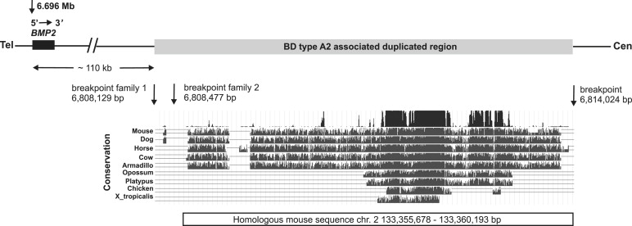

D. Where is the cis-regulatory module for the above case most likely localized? (use words or draw)(2 points)

E. In the same study, the authors proposed that the duplication of the cis-regulatory module results in too much *Bmp2* expression, thus deregulating the fine-tuned BMP pathway by competing with another ligand GDF5 and disturbing BMPR1B (one of its receptors) signaling. Propose an alternate mechanism to explain how this mutation could act in a dominant negative manner. (2 points)

F. A study of global CNVs in human genome has shown that deletions are less likely to associate with RefSeq genes among healthy individuals than duplications. Postulate why. (2 points)

2. Cancer genomics 12 points

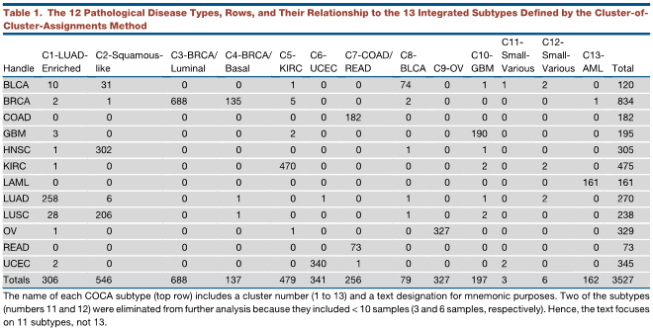

Fig 2-1: Classification of cancer samples of different origin histopathologically classified groups (Y-axis) into subgroups (x-axis) according to Cluster of Cluster Assignments (COCA) from multiple genomic measures.

a) What are the top two conclusions YOU draw from the analysis in Fig 2-1, which is taken from the Pan-Cancer study group. Highlight specific relationships/observations to support your point. (4 points)

b) Examine the CNV data in fig 2-2 below, which shows somatic copy-number alterations – red for amplification, blue for deletion – in different chromosomes (Y-axis) across different subgroups of samples (X-axis). Now, comment on the COCA classifications with respect to overall CNV patterns: In doing this, compare in particular C2, C10 and C13 with each other and relative to the entire set. (3 points)

c) What is chromothrypsis and is there a cluster that you think is most likely to have this behavior based on what you see here? Which cluster/tumor type is it and what’s your reason? (2.5 points)

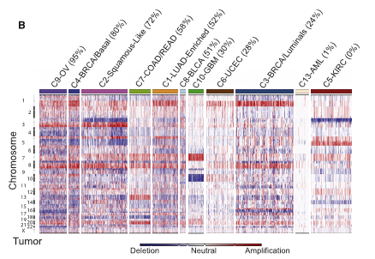

Figure 2-2. Somatic copy-number alterations in clustered tumors (X-axis) on different chromosomes (Y-axis). Red shows amplification, blue shows deletion.

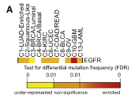

Figure 2-3. Mutation rate of EGFR, a gene associated with cell proliferation, across different COCA subtypes.

d) You have learned that EGFR is normally associated with signaling cell proliferation in many cell types, so it is not surprising that it can operate as an oncogene. In data of Fig 2-3 shown immediately above, it is altered at a significantly elevated frequency relative to other tumor types in glioblastoma multiforme, (GBM). Based on the data in fig 3-2, what mutational mechanism would you suggest is a major contributor for EGFR in GBM? Explain your answer. If relevant, consult the human genome browser to support your explanation. (2.5 points)

Part 3 Gene structure and expression 11 points

Below is a Genome Browser graphic describing the differential regulation of two genes in two different cell types. Cell type 1 is pre-B cell lymphoblastoid (or just B-cells for our purpose), and cell type 2 is HepG2 (or liver for our purpose).

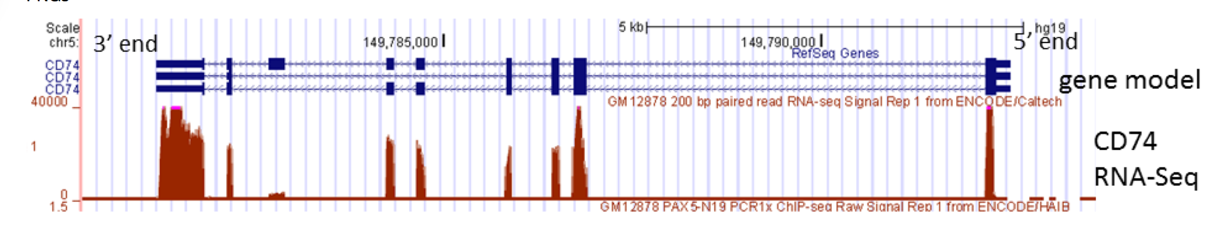

3a. What do the expression data shown above tell you about splice isoform use for CD74? Be specific about what evidence you are using to make your conclusion.(2 points) Specify the informative kind of read that you would look for in the primary RNA-Seq data to definitively prove the isoform map you deduced based on read density (1 point).

3b. RNA-seq is usually quantified in RPKM (or the conceptually equivalent FPKM) units. What is the definition of RPKM?(1 point) If you calculated expression values in RPM instead, how would that distort your comparisons of RNA abundance and what group of genes would be most affected? (1 point)

3c In the figure below a locus containing two genes is shown together with RNA-Seq data and ChIP-seq data. All measurements were done from the same cell preparation, for three pertinent transcription factors and the p300 histone acetyltransferase enhancer protein. Information on sequence conservation appears in the summary track and is shown in further detail in the alignment plots from species as distant as fish. Annotate the figure as you wish to aid in answering the questions (you can drop the png into ppt and do it that way; use any other program you like; or go old school and print it to draw on). It is OK to draw first and then transfer after exam in over to some electronic form to send – but the answer itself cannot be changed when you do that).

Of the two genes shown, which one is the likely target of the transcriptional regulators shown? (1 point)

3d Of the candidate regulatory elements suggested by the data, identify the three you think are most likely to be active transcriptional enhancers in these cells. Briefly, why? (1 point)

3e It is sometimes said that “sequence conservation is king” for highlighting cis-acting regulatory modules (CRM). What do the data at this locus suggest to you about this generality? (you can/should be brief in answering this). (1 point)

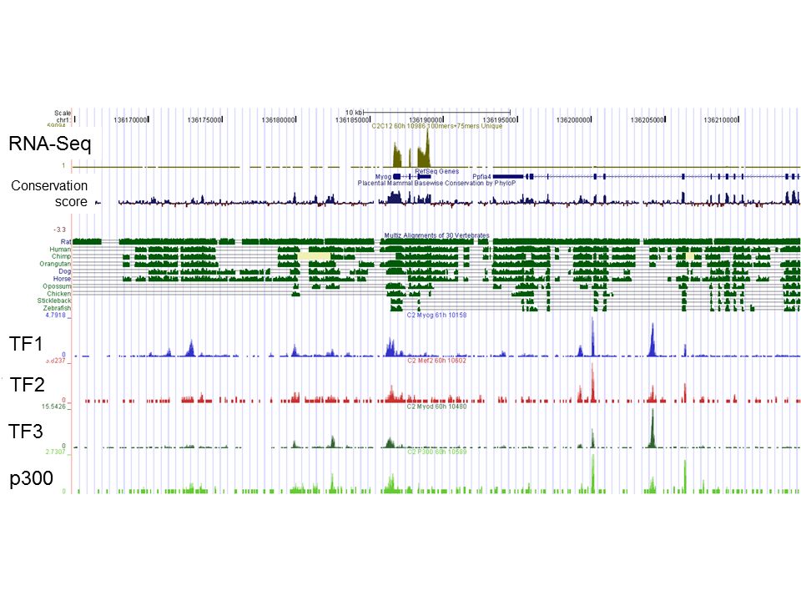

Below, you see transcriptomes clustered from a collection of 96 tissues that were assayed for RNA using a microarray platform. 14,000 genes were quantified. A 2-way hierarchical clustering was used to group the genes by similarity of expression profile across the tissues, and to group the tissues by similarity of genes expressed in them.

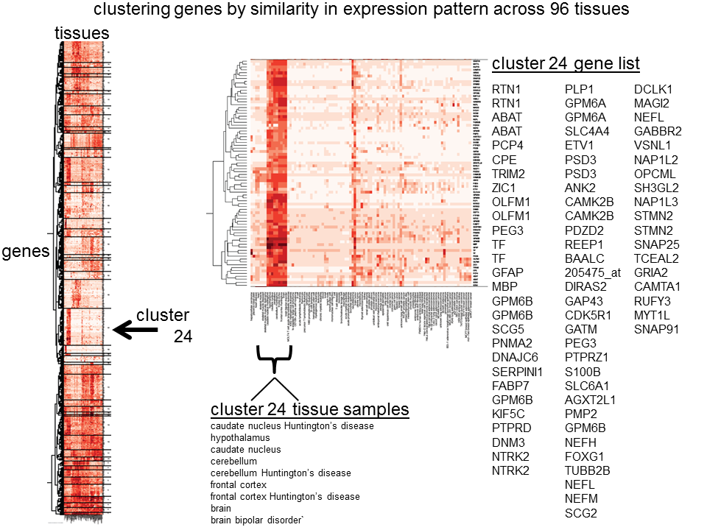

Focus on cluster 24 (arrow on left side). You can see that this cluster of 9 samples (see middle callout box) is very well defined from the other tissues in the study. The gene expression pattern (red is high, white is low) is very distinct in this cluster. The genes in this cluster are called out on the right side of the panel.

Follow these instructions to answer the question at step (6):

1)Go to this website: (you are allowed to use it for the rest of this question)

<http://llama.mshri.on.ca/funcassociate/>

2) in the dialog box for species (upper left), select Homo sapiens

3) in the “choose a namespace” dialog box, select “hgnc_symbol”

4) “Provide a list of genes as a query”, copy and paste the list of gene names below:

|  |
| --- |
| RTN1 |
| RTN1 |
| ABAT |
| ABAT |
| PCP4 |
| CPE |
| TRIM2 |
| ZIC1 |
| OLFM1 |
| OLFM1 |
| PEG3 |
| TF |
| TF |
| GFAP |
| MBP |
| GPM6B |
| GPM6B |
| SCG5 |
| PNMA2 |
| DNAJC6 |
| SERPINI1 |
| FABP7 |
| GPM6B |
| KIF5C |
| PTPRD |
| DNM3 |
| NTRK2 |
| NTRK2 |
| PLP1 |
| GPM6A |
| GPM6A |
| SLC4A4 |
| ETV1 |
| PSD3 |
| PSD3 |
| ANK2 |
| CAMK2B |
| CAMK2B |
| PDZD2 |
| REEP1 |
| BAALC |
| 205475_at |
| DIRAS2 |
| GAP43 |
| CDK5R1 |
| GATM |
| PEG3 |
| PTPRZ1 |
| S100B |
| SLC6A1 |
| AGXT2L1 |
| PMP2 |
| GPM6B |
| NEFH |
| FOXG1 |
| TUBB2B |
| NEFL |
| NEFM |
| SCG2 |
| DCLK1 |
| MAGI2 |
| NEFL |
| GABBR2 |
| VSNL1 |
| NAP1L2 |
| OPCML |
| SH3GL2 |
| NAP1L3 |
| STMN2 |
| STMN2 |
| SNAP25 |
| TCEAL2 |
| GRIA2 |
| CAMTA1 |
| RUFY3 |
| MYT1L |
| SNAP91 |

5) click the “Functionate” button.

3F. Now Inspect the list that results and describe which categories are present. Does this make biological sense, considering the tissue samples it is from? Why? (3 points)

END