**Business Requirement for ThinkFood**

Contents

1. System Overview 2

2. Requirements Scope 2

2.1 In Scope 2

2.2 Out of Scope 3

3. Functional Requirements 3

3.1 UML Use Case Diagram 4

3.2 UML Use Case Specifications 5

4. Non-Functional Requirements 15

1. Data Model 15

2. UI Screen Mock-ups 16

**Table of Figures**

Figure 1-Register page 16

Figure 2-Checkout page 16

Figure 3-View products through main page 17

Figure 4-Login page 22

Figure 5-Add restaurant page 22

Figure 6-Remove restaurant page 23

Figure 7-Recrive order page 23

Figure 8-Remove order page 24

## System Overview

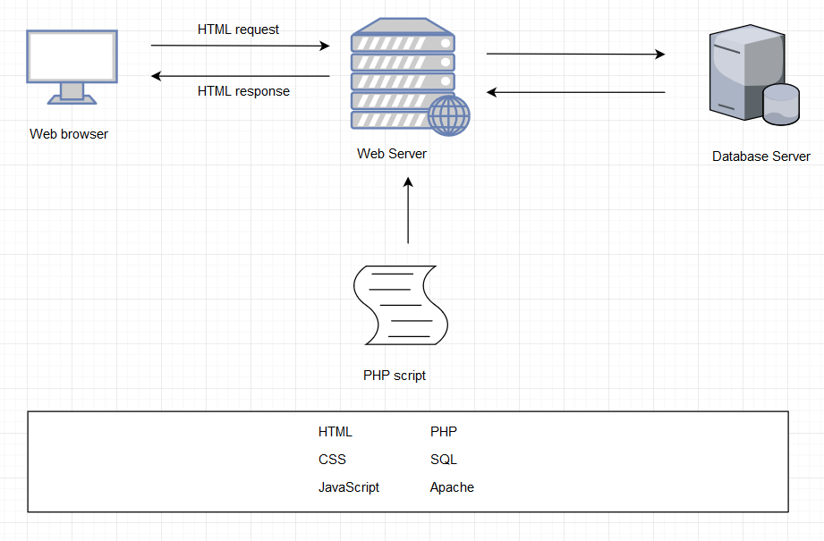

MY SQL

Figure 1 – System Architecture

## Requirements Scope

### In Scope

|  |  |
| --- | --- |
| **Requirement No** | **Description** |
| R01 | The client must be able to log into an admin account |
| R02 | The client must be able add products the web site |
| R03 | Must be able display products by categories |
| R04 | Customers must register place orders |
| R05 | display the current items in the cart |
| R06 | add selected products the cart |
| R07 | delete products (individually or all) from their cart |
| R08 | adjust the quantity of a selected product currently in the cart |
| R09 | preserve the contents of the cart if the user’s session is disconnected |
| R10 | have the cart accessible regardless from any machine the customer is logging in |
| R11 | Create a unique file for each order that contains the order confirmation information |
| R12 | include a secure, online payment process |
| R13 | Allow customers view their order history |
| R14 | Provide an intuitive, consistent look and feel the user interface |
| R15 | Use free open source software |
| R16 | Have the system fully tested and up and running in 8 weeks |
| R20 | Allow customers provide reviews for any of the products they have purchased |
| R21 | Must be able display the evaluation reviews for any products |
| R22 | Provide customers with appropriate product recommendations when they log in |
| R23 | Provide customers with any product recommendations when they look at a particular product |
| R24 | Ask customers to agree with the term condition on their first log in |

### 2.2 Out of Scope

|  |  |
| --- | --- |
| **No** | **Requirement** |
| 1 | preserve the contents of the cart if the user’s session is disconnected accidentally |
| 2 | allow the order to be shipped ta different address and person other than the user |
| 3 | Allow customers change their order after they have created it |
| 4 | Allow customers change their registration information |

## Functional Requirements

* R01 – The client must be able to log in to an admin account
* R02 – The client must be able to add products to the web site
* R03 – Must be able to display products by categories
* R04 - Customers must register to place orders
* Must provide a fully functioning shopping cart utility where a customer can:
  + R05 – display the current items in the cart
  + R06 - add selected products to the cart
  + R07 - delete products (individually or all) from their cart
  + R08 - adjust the quantity of a selected product currently in the cart
  + R09 - preserve the contents of the cart if the user’s session is disconnected
  + R10 - have the cart accessible regardless from any machine the customer is logging in
  + R11 - Create a unique file for each order that contains the order confirmation information
  + R12 - include a secure, online payment process
* R13 - Allow customers to view their order history

Extra:

* R20 – Allow customers to provide reviews for any of the products they have purchased
* R21 – Must be able to display the evaluation reviews for any products
* R22 – Provide customers with appropriate product recommendations when they log in
* R23 – Provide customers with any product recommendations when they look at a particular product
* R24 – Ask customers to agree with the term condition on their first log in

### 3.1 UML Use Case Diagram

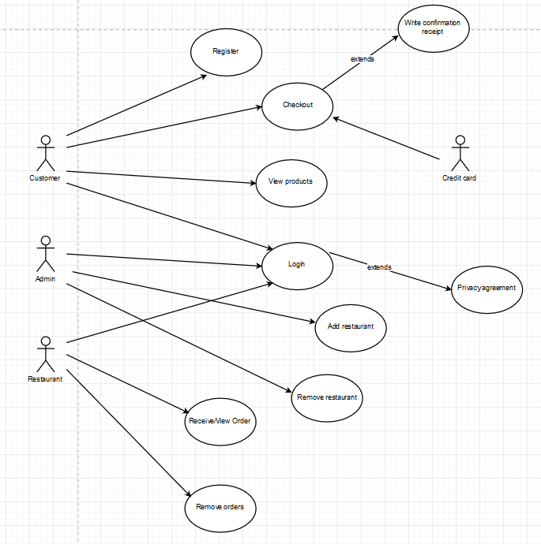

Figure 2 - Login Screen

### 3.2 UML Use Case Specifications

**Registration**

|  |  |  |  |
| --- | --- | --- | --- |
| **Use Case Name:** | Register | **Use Case ID:** | UC001 |
| **Primary Actor:** | Customer | | |
| **Description:** | Customers fill out the mandatory items to register their accounts. | | |
| **Triggering Event:** | Log-in is necessary for making a purchase. Customer information is needed for delivery and payment. | | |
| **Steps Performed (Main Path)** | | | |
| 1. Click the register button on the website | | | |
| 1. Fill the personal information given | | | |
| 1. Customers are checking the information correctly typed by validation function | | | |
| 1. The information will be saved on the database | | | |
| 1. Let the user know that the registration has been approved | | | |
| **Extensions or Alternate Scenarios** | | | |
| 2a. Users can cancel the registration | | | |
| 2b. Users do not fill the personal information properly, warning pops | | | |
| **Pre-Conditions:** | The database server must connect to the registration session in the website. | | |
| **Post-Conditions:** | The customer can log in and view the products | | |
| **Assumptions:** | Customer is good standing within general registration | | |
| **Success Guarantee:** | 1.The customer can log in successfully with the account they just have created  2. The information is stored in the database without any violation | | |
| **Outstanding Issues:** | The connection could be lost during registration. | | |
| **Priority:** | HIGH | | |

**Check-Out**

|  |  |  |  |
| --- | --- | --- | --- |
| **Use Case Name:** | Check-Out | **Use Case ID:** | UC002 |
| **Primary Actor:** | Customer, Credit Card | | |
| **Description:** | The customer can check out the amount of products using payment system | | |
| **Triggering Event:** | The customer selects the products and click the check-out button | | |
| **Steps Performed (Main Path)** | | | |
| 1. View the cart after shopping | | | |
| 2. The customers select the products and click the check-out button | | | |
| 3.The customers type the credit card number and extra information | | | |
| 4. Create a Unique file in server to store order’s confirmation | | | |
| **Extensions or Alternate Scenarios** | | | |
| 3a. The customer put the wrong format of credit card | | | |
| 3b. Customer try to exit check-out session | | | |
| **Pre-Conditions:** | 1. The customers must be logged in 2. The customers must have a valid credit card | | |
| **Post-Conditions:** | A confirmation message shows up on the website to inform customer about their order | | |
| **Assumptions:** | Customer is in good standing within the system. | | |
| **Success Guarantee:** | 1. After payment, customers and restaurants can receive the information | | |
| **Outstanding Issues:** | Customer’s order cannot proceed  The restaurant cannot receive orders | | |
| **Priority:** | HIGH | | |

**Write Confirmation Receipt**

|  |  |  |  |
| --- | --- | --- | --- |
| **Use Case Name:** | Write Confirmation Receipt | **Use Case ID:** | UC002 |
| **Primary Actor:** | Customer | | |
| **Description:** | Customer order receipt will be stored in the server | | |
| **Triggering Event:** | When the customer checked out the order | | |
| **Steps Performed (Main Path)** | | | |
| 1. The Customer checked out the order | | | |
| 2. The system will receive the order | | | |
| 3. After the confirmation the system will write the order receipt in new created file | | | |
|  | | | |
| **Extensions or Alternate Scenarios** | | | |
| 2.a When the System is unable to confirm the order, the system will print an error and display it to the customer page. | | | |
|  | | | |
| **Pre-Conditions:** | When the payment is successfully completed | | |
| **Post-Conditions:** | After confirmation the system will create a unique file in the server and stored the receipt | | |
| **Assumptions:** | The server has enough storage | | |
| **Success Guarantee:** | 1. The system will save the receipt into the server | | |
| **Outstanding Issues:** | 1. Does the system check if the server has enough storage? 2. Does the system has a proper permission to store a file? | | |
| **Priority:** | HIGH | | |

**View Products**

|  |  |  |  |
| --- | --- | --- | --- |
| **Use Case Name:** | View Products | **Use Case ID:** | UC003 |
| **Primary Actor:** | Customer | | |
| **Description:** | Customer can check products menu which includes product picture, price , review and rating | | |
| **Triggering Event:** | Customer selects the products | | |
| **Steps Performed (Main Path)** | | | |
| 1. After logging in, the customer can select the different category of food to make sure which restaurant they prefer. | | | |
| 1. The customer views menu from selected restaurants. | | | |
| 1. The customer can check the picture, price and rating for each product. | | | |
| 1. The customer can add selected products in their cart. | | | |
| 1. The customer can view, add or delete current order in cart | | | |
| **Extensions or Alternate Scenarios** | | | |
| 3a. When the customer select a product, there will be recommendation at the | | | |
|  | | | |
| **Pre-Conditions:** | 1. The customer must be connected to the system 2. The restaurant has already registered into the system | | |
| **Post-Conditions:** | The customer can view the product | | |
| **Assumptions:** | Customer is in good standing within the system. | | |
| **Success Guarantee:** | 1. The customer can check product picture, product price and product rating clearly after selected a restaurant. 2. The customer can check current recommendation for restaurant and dishes in main page 3. The customer can view/change the current order in their cart | | |
| **Outstanding Issues:** |  | | |
| **Priority:** | High | | |

**Log In**

|  |  |  |  |
| --- | --- | --- | --- |
| **Use Case Name:** | Log in | **Use Case ID:** | UC004 |
| **Primary Actor:** | Customer, Admin, Restaurant | | |
| **Description:** | Customer, admin and restaurant can log in the system with different authorities | | |
| **Triggering Event:** | Customer, admin and restaurant can log in the system after they registered. | | |
| **Steps Performed (Main Path)** | | | |
| 1. Customer or Admin or restaurant owner open the system. | | | |
| 1. After they registered, they can access the system through log in page | | | |
| 1. After logged in, customer or admin or restaurant owner can enter different main page | | | |
| **Extensions or Alternate Scenarios** | | | |
| * 1. After customer log in, the website should base on the current main page with the recommendations | | | |
| * 1. After admin log in, they can manage restaurants and products | | | |
| * 1. After restaurant log in, they can manage the orders | | | |
| **Pre-Conditions:** | 1. All types of users log in with valid passwords | | |
| **Post-Conditions:** | 1. All users can be logged in with different authorities | | |
| **Assumptions:** | Customer /restaurant is a current user/business in good standing within the system. | | |
| **Success Guarantee:** | 1. The customer can log in and active successfully. 2. The admin can log in and active successfully. 3. The restaurant can log in and active successfully. | | |
| **Outstanding Issues:** | 1. User forgot the account information | | |
| **Priority:** | HIGH | | |

**Add Restaurant**

|  |  |  |  |
| --- | --- | --- | --- |
| **Use Case Name:** | Add restaurant | **Use Case ID:** | UC05 |
| **Primary Actor:** | Admin | | |
| **Description:** | Admin can add more restaurant to the website | | |
| **Triggering Event:** | Add restaurant button | | |
| **Steps Performed (Main Path)** | | | |
| 1. Admin login to the site | | | |
| 1. Admin choose add restaurant button | | | |
|  | | | |
|  | | | |
| **Extensions or Alternate Scenarios** | | | |
| 2a. Admin can cancel adding process. Go back to home screen | | | |
| 2b. Admin can add menus | | | |
| 2c. Admin will add restaurant’s information, contact, location, menu, price, etc… | | | |
|  | | | |
| **Pre-Conditions:** | 1. Admin must be connected to the website 2. Admin must chose add restaurant option | | |
| **Post-Conditions:** | Admin must fill all information for that restaurant and their products or added at least one restaurant | | |
| **Assumptions:** | Admin knows how to use and manage the site | | |
| **Success Guarantee:** | Admin added a restaurant successfully and the information is saved on the database | | |
| **Outstanding Issues:** | 1. Admin cannot add restaurant 2. Admin add a restaurant without important information | | |
| **Priority:** | High | | |

**Remove Restaurant**

|  |  |  |  |
| --- | --- | --- | --- |
| **Use Case Name:** | Remove restaurant | **Use Case ID:** | UC06 |
| **Primary Actor:** | Admin | | |
| **Description:** | Admin can remove restaurant on the website | | |
| **Triggering Event:** | Remove restaurant button | | |
| **Steps Performed (Main Path)** | | | |
| 1. Admin login to the site | | | |
| 1. Admin choose remove restaurant button | | | |
| **Extensions or Alternate Scenarios** | | | |
| 2a. Admin can cancel removing process. Go back to home screen | | | |
| 2b. Admin will choose which restaurant he/she wants to be removed then click delete button. | | | |
| 2c. Alert a confirmation message when delete button is clicked | | | |
| 2d. Admin can remove the products on each restaurant | | | |
| **Pre-Conditions:** | 1. Admin must be connected to the website 2. Admin must chose remove restaurant option | | |
| **Post-Conditions:** | Admin must choose at least one restaurant to be removed | | |
| **Assumptions:** | Admin knows how to use and manage the site | | |
| **Success Guarantee:** | Admin removed a restaurant successfully on the database | | |
| **Outstanding Issues:** | 1. Admin cannot remove restaurant 2. The restaurant’s information not deleted properly | | |
| **Priority:** | High | | |

**Receive and View Orders**

|  |  |  |  |
| --- | --- | --- | --- |
| **Use Case Name:** | Receive and View Orders | **Use Case ID:** | UC007 |
| **Primary Actor:** | Restaurant | | |
| **Description:** | The customer’s orders are sent to the restaurant view. The restaurant can view the orders they receive and cook it | | |
| **Triggering Event:** | When the customer made purchases | | |
| **Steps Performed (Main Path)** | | | |
| 1. The restaurant is logged in | | | |
| 1. Someone makes an order at their own category menu in the website | | | |
| 1. The confirmation of the order is completed | | | |
| 1. The system will be sent the order information to the restaurant view | | | |
| **Extensions or Alternate Scenarios** | | | |
| 2.a The customers canceled their order after payment | | | |
|  | | | |
|  | | | |
|  | | | |
| **Pre-Conditions:** | The restaurant must be register in the database, after that they just need to log in. They mush have the authority as a restaurant | | |
| **Post-Conditions:** | The restaurant has cooked the order they receive | | |
| **Assumptions:** | The restaurant is always logged in | | |
| **Success Guarantee:** | The restaurant will cook as the order they received | | |
| **Outstanding Issues:** | Does the system know if the restaurant’s menu is out of stock? | | |
| **Priority:** | High | | |

**Remove orders**

|  |  |  |  |
| --- | --- | --- | --- |
| **Use Case Name:** | Remove orders | **Use Case ID:** | UC008 |
| **Primary Actor:** | Restaurant | | |
| **Description:** | The restaurant can remove the orders they received | | |
| **Triggering Event:** | When the restaurant wants to remove the order | | |
| **Steps Performed (Main Path)** | | | |
| 1. The restaurant must be log in | | | |
| 1. The restaurant must have received the orders | | | |
| 1. The restaurant selects what orders they want to remove | | | |
| 1. The order selected is removed | | | |
| **Extensions or Alternate Scenarios** | | | |
| 3a. more than 1 orders could be removed at once | | | |
|  | | | |
|  | | | |
|  | | | |
| **Pre-Conditions:** | The restaurant must be logged in to the database, they also must have received the orders | | |
| **Post-Conditions:** | The restaurant erased the orders | | |
| **Assumptions:** | Restaurant can’t provide the product for some reason | | |
| **Success Guarantee:** | The restaurant has deleted the orders they received | | |
| **Outstanding Issues:** | 1. Does the system will recommend the other menu equivalent to the food they order? 2. The canceled order should be refunded to the customer | | |
| **Priority:** | Medium | | |

|  |  |  |  |
| --- | --- | --- | --- |
| **Use Case Name:** | Ask customers to agree with the term condition | **Use Case ID:** | UC009 |
| **Primary Actor:** | Customer | | |
| **Description:** | Customers being asked to agree with the term condition to continue using web service | | |
| **Triggering Event:** | On customers first time log in | | |
| **Steps Performed (Main Path)** | | | |
| 1. Customers choose log in option | | | |
| 2. Customers log in successfully | | | |
| 3. Term condition show up | | | |
| **Extensions or Alternate Scenarios** | | | |
| 3a. Customers might not agree with the term condition | | | |
| **Pre-Conditions:** | Customers must choose log in option | | |
| **Post-Conditions:** | Customers agree with the term condition | | |
| **Assumptions:** | Customers will agree with the term condition | | |
| **Success Guarantee:** | Customers agree with the term condition | | |
| **Outstanding Issues:** | 1. The website cannot load 2. Customers do not know how to use web service | | |
| **Priority:** | Medium | | |

**Ask customers to agree with the term condition**

## Non-Functional Requirements

|  |  |
| --- | --- |
| No | Description |
| R14 | Provide an intuitive, consistent look and feel the user interface |
| R15 | Use free open source software |
| R16 | Have the system fully tested and up and running in 8 weeks |

## Data Model

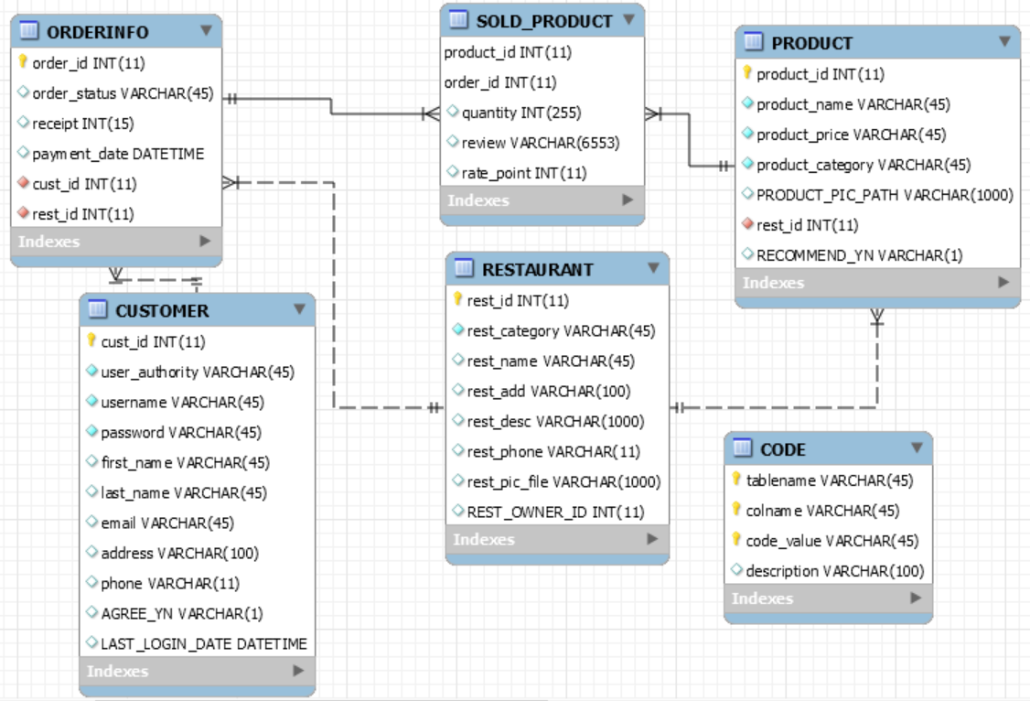

## UI Screen Mock-ups

6.1 The following screen is for UC001 and shows the current contents of the customer register page.

Figure 3-Register page

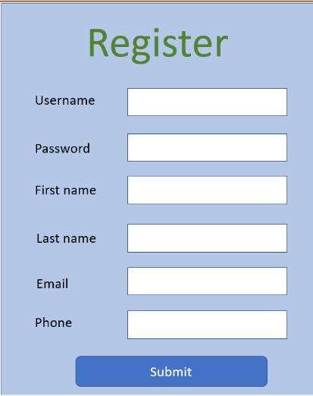

6.2 The following screen is for UC002 and shows the current contents of the customer checkout page.

Figure 4-Checkout page

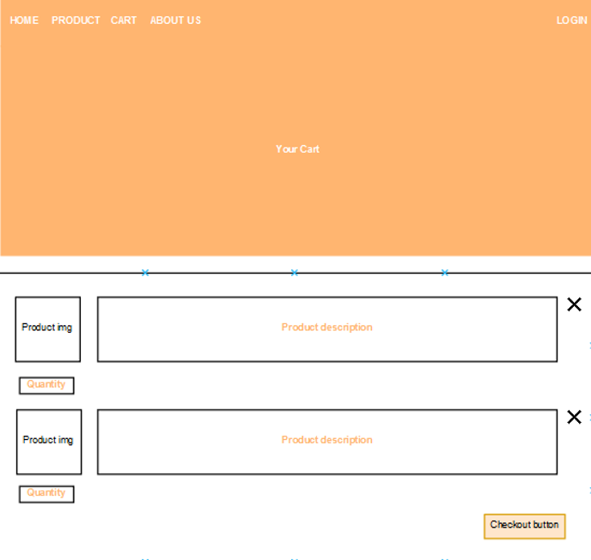

6.3 The following screen is for UC003 and shows the current contents of the customer view products page.

Figure 5-View products through main page

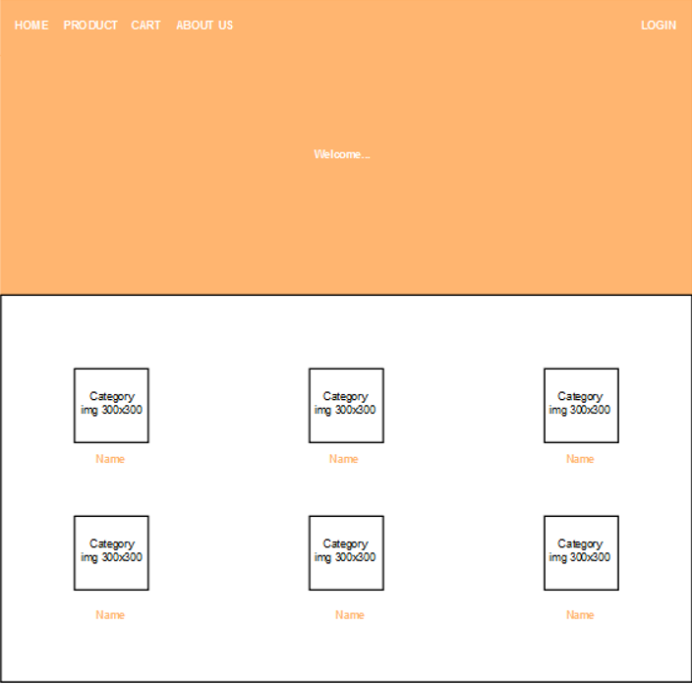

View products from main page

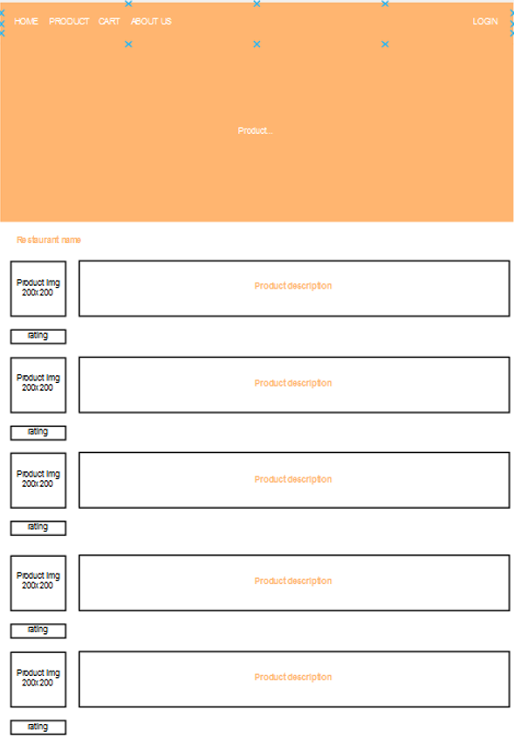

View products from restaurant page

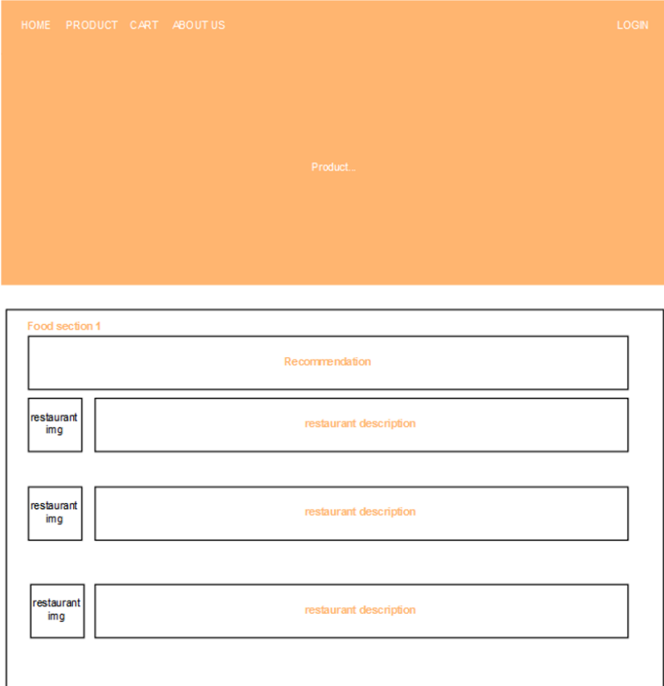

View products from recommendation page

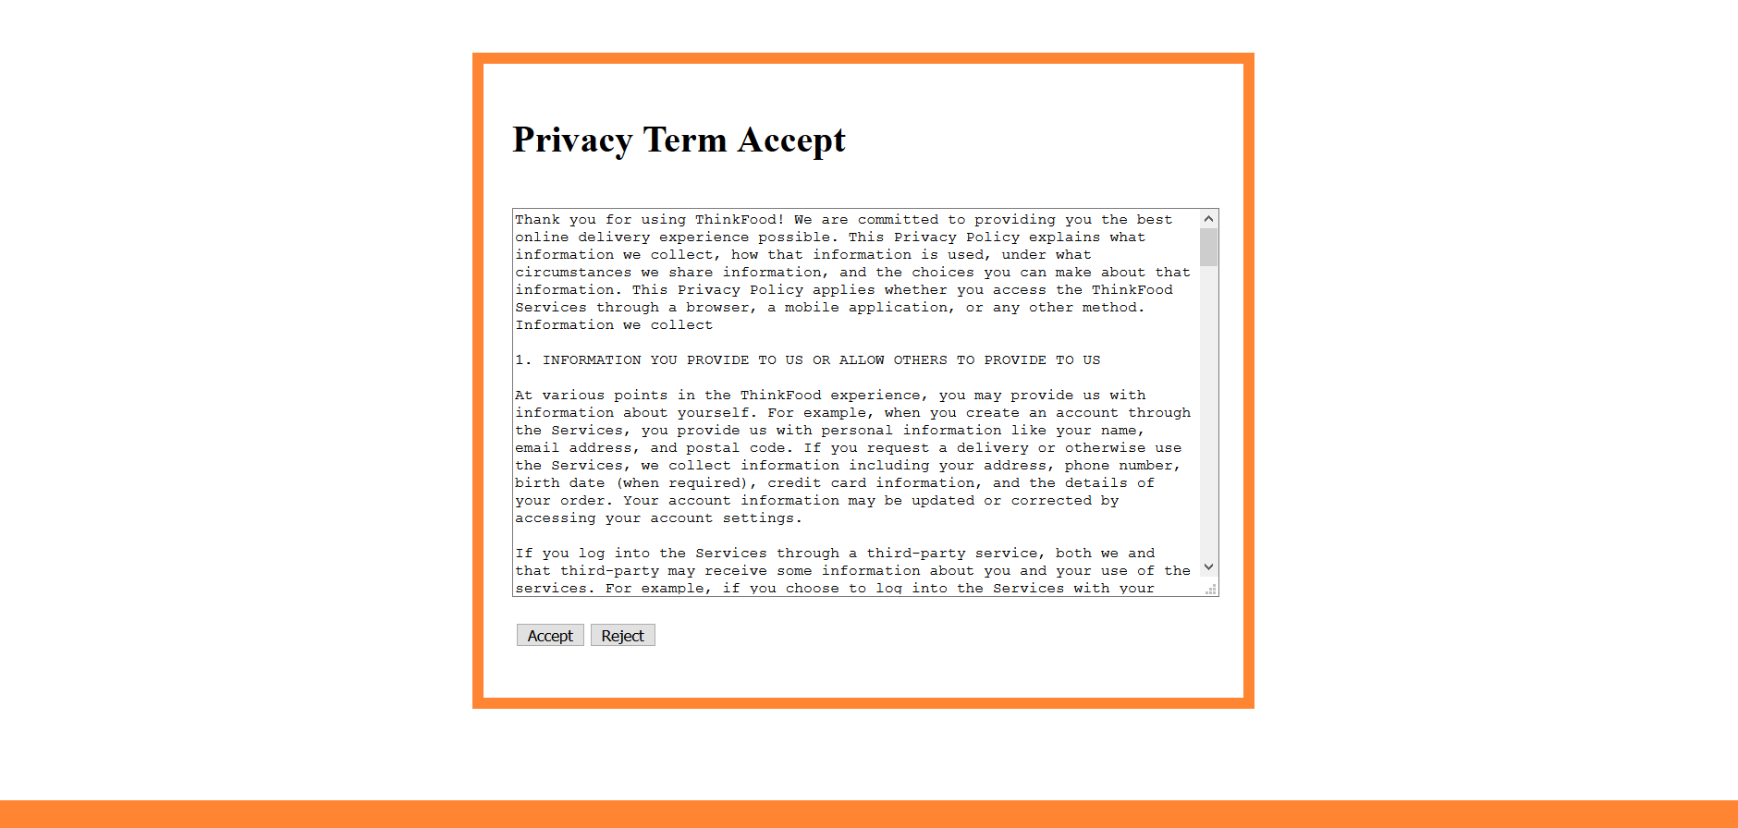

Privacy agreement page

6.4 The following screen is for UC004 and shows the current contents of the customer/Admin/Restaurant login page.

Figure 6-Login page

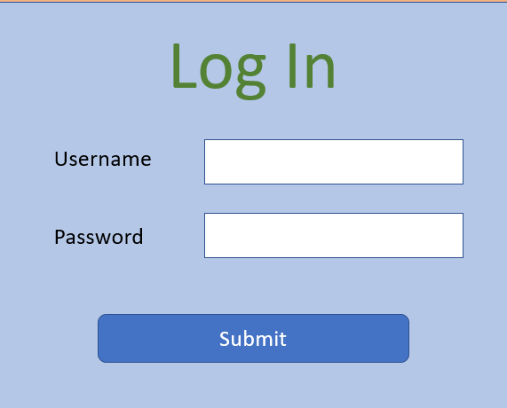

6.5 The following screen is for UC005 and shows the current contents of the Admin add restaurant page.

Figure 7-Add restaurant page

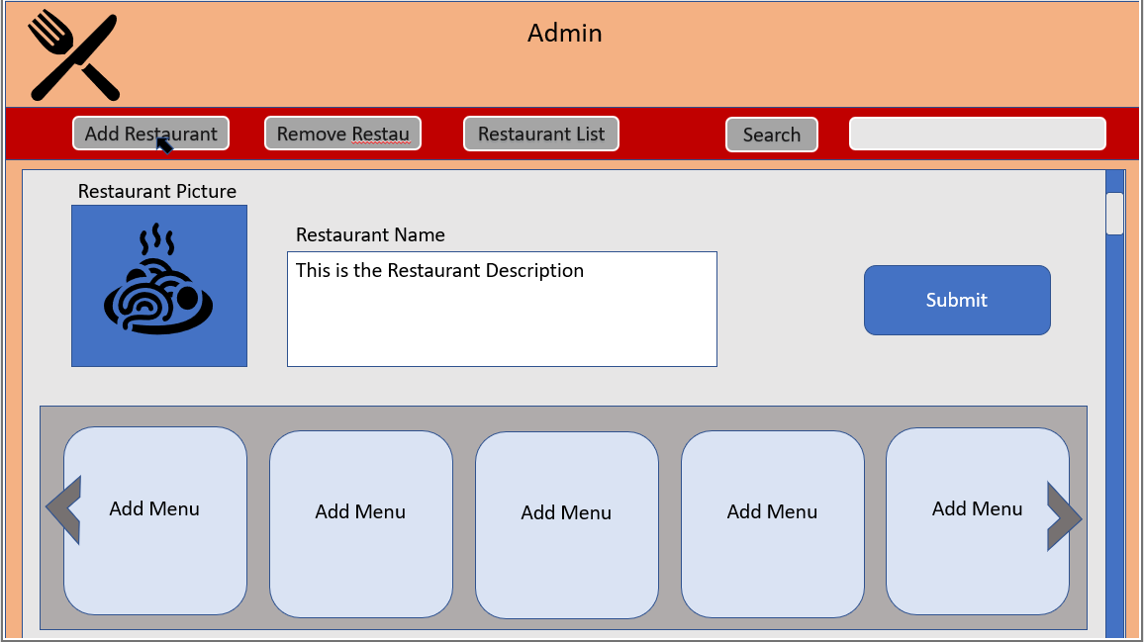

6.6 The following screen is for UC006 and shows the current contents of the Admin remove restaurant page.

Figure 8-Remove restaurant page

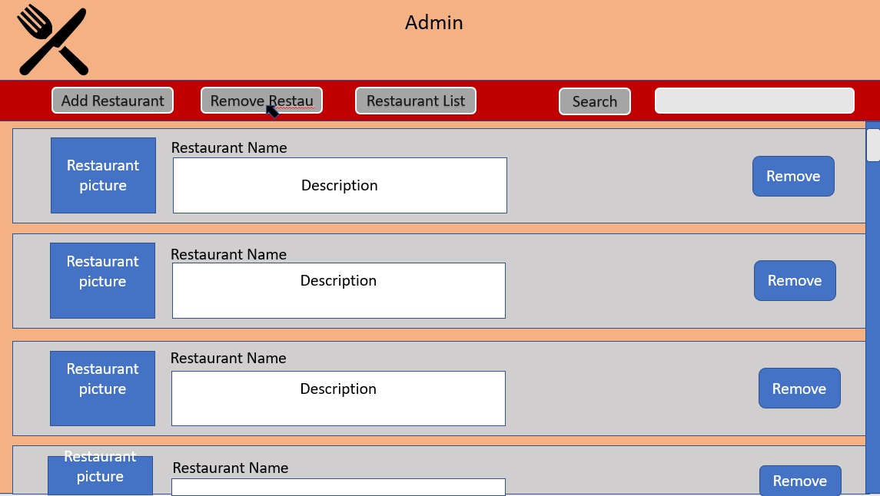

6.7 The following screen is for UC007 and shows the current contents of the restaurant receive/view orders page.

Figure 9-Recrive order page

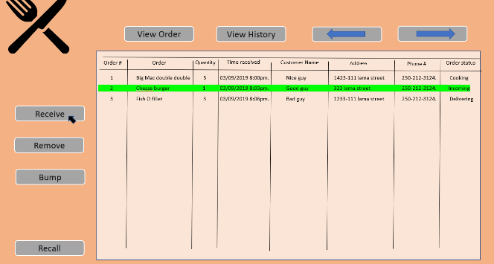

6.8 The following screen is for UC008 and shows the current contents of the restaurant remove orders page.

Figure 10-Remove order page

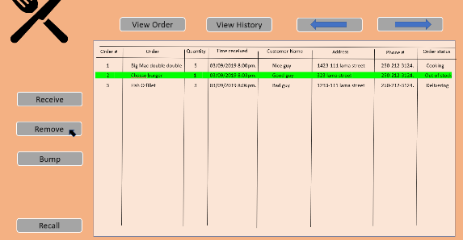

## Change Log

|  |  |  |
| --- | --- | --- |
| **Change Request Id** | **Issue Date** | **Description** |
| CR01 | 2019-Mar-14 | *R11 requirements is changed to Create a unique file for each order that contains the order confirmation information* |
| CR02 | 2019-Mar-28 | *R24 Ask customers to agree with the term condition* |
|  |  |  |