Class: CGS2823 Advanced Website Development

Professor: Miller

Student: Brian Johnston

Flow Chart

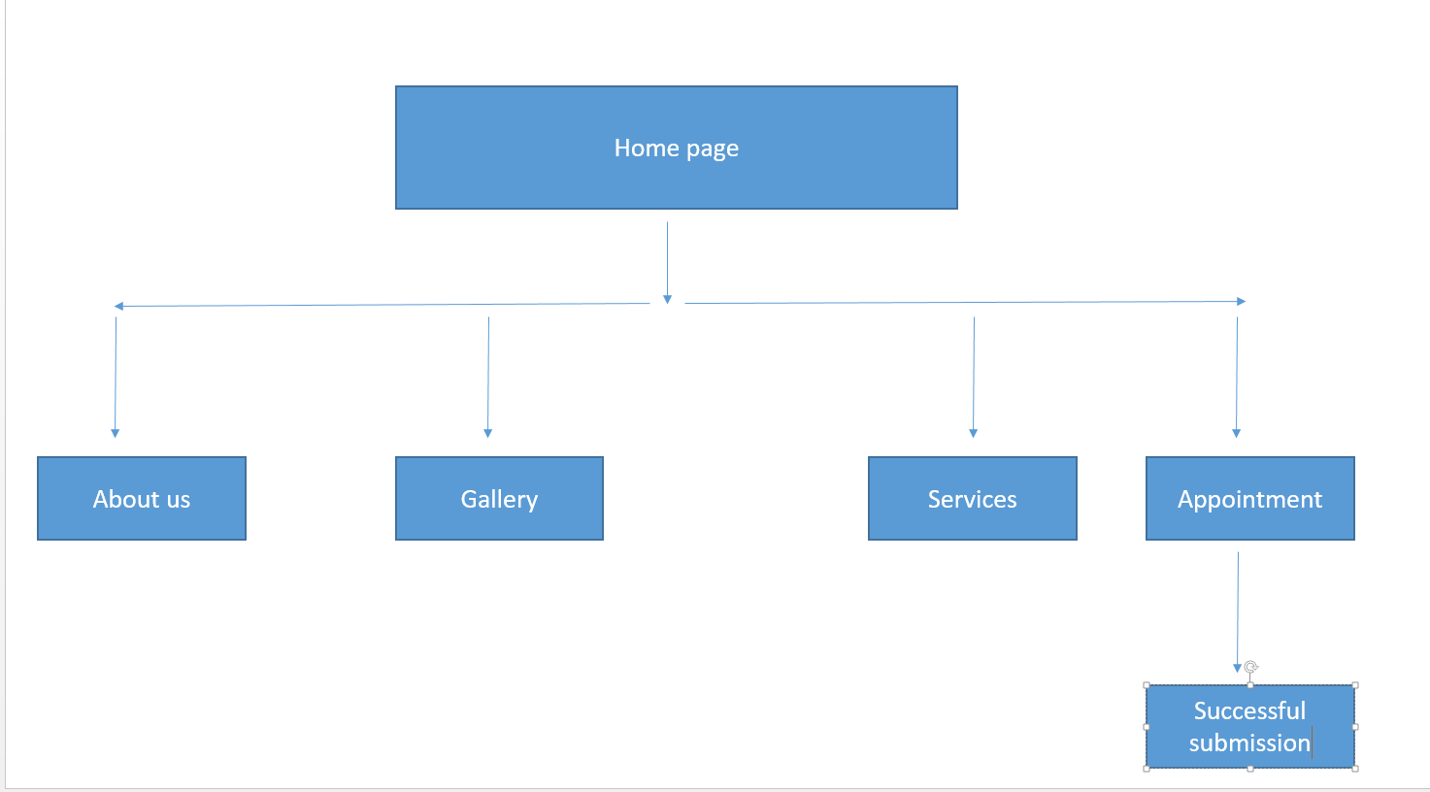

Wireframes:

\*future layout changes may occur due to client requests or unforeseen website demands

Layout 1 will be used for about us, Services, and appointment

Layout 2 will be used for Gallery

Mobile Layout:

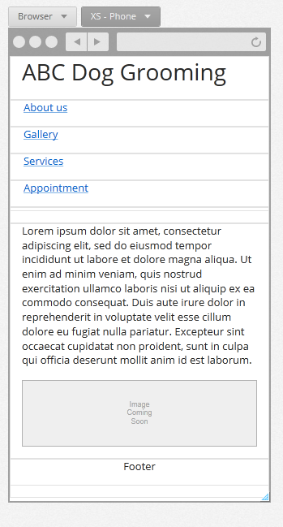

Tablet Layout:

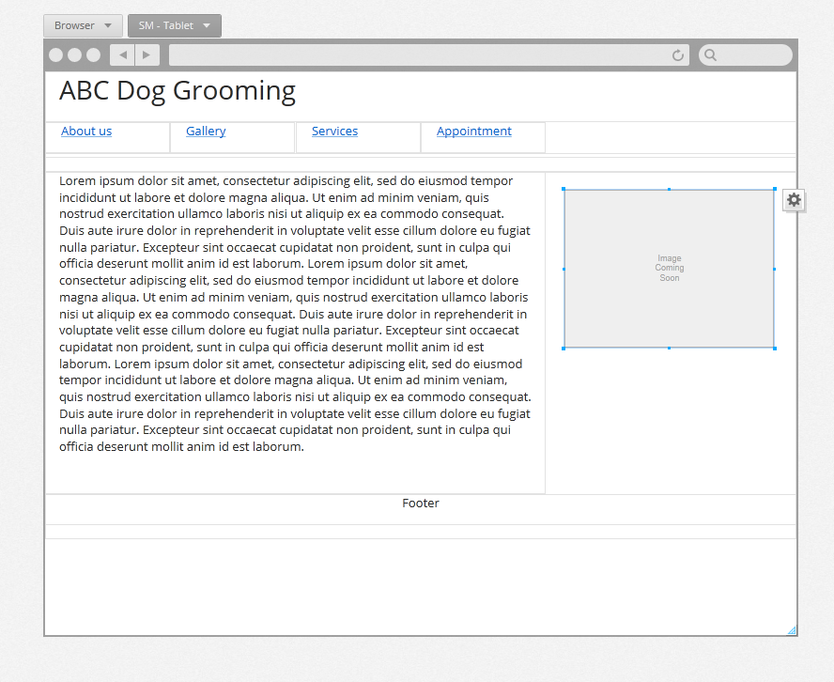

Desktop Layout

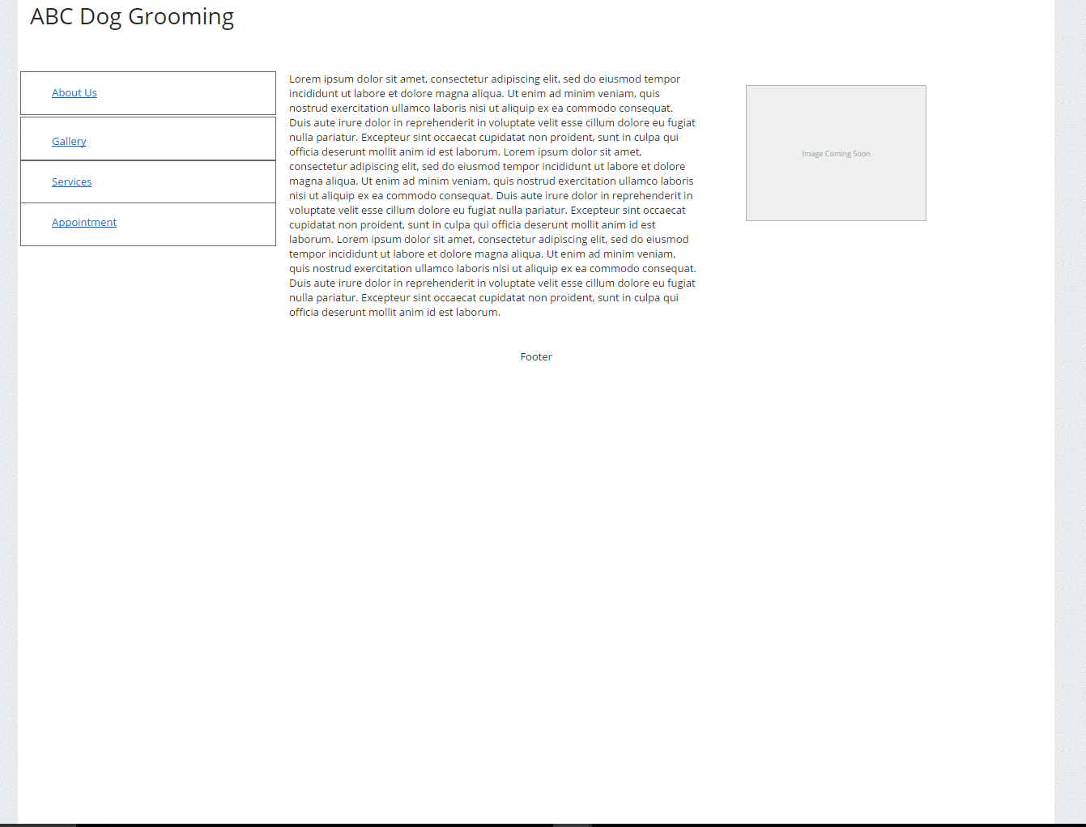

Gallery Example – Layout 2

Mobile –

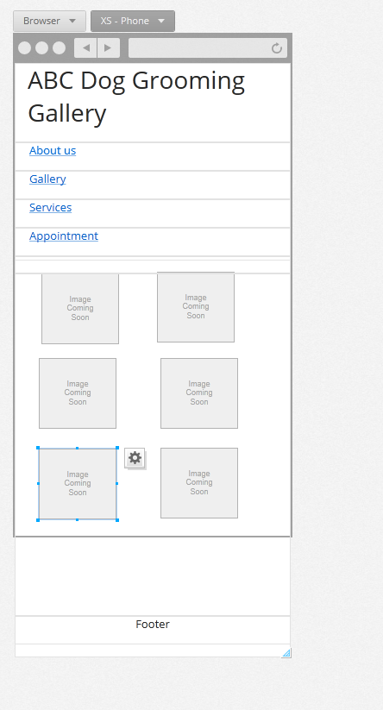

Tablet –

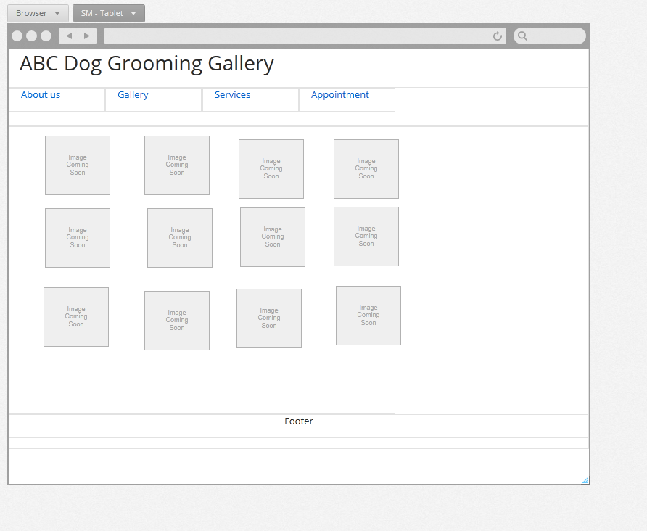

Desktop –

