I worked alone

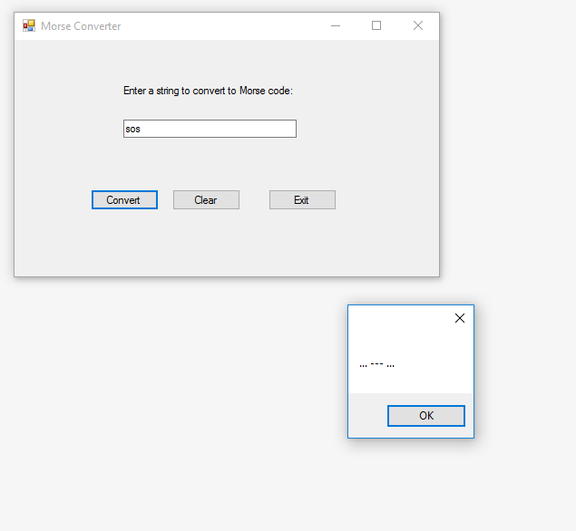

using System;

using System.Collections.Generic;

using System.ComponentModel;

using System.Data;

using System.Drawing;

using System.Linq;

using System.Text;

using System.Threading.Tasks;

using System.Windows.Forms;

namespace MorseCode

{

public partial class Form1 : Form

{

public Form1()

{

InitializeComponent();

}

private void convertButton_Click(object sender, EventArgs e)

{

//Array to hold characters

char[] Letters = new char[] { ' ', ',', '.', '?', '0', '1', '2', '3', '4', '5', '6', '7', '8', '9',

'a', 'b', 'c', 'd', 'e', 'f', 'g', 'h', 'i', 'j', 'k', 'l', 'm', 'n',

'o', 'p', 'q', 'r', 's', 't', 'u', 'v', 'w', 'x', 'y', 'z' };

//Array to hold Morse code

string[] MorseCode = new string[] { " ", "--..--", ".-.-.-", "..--..", "-----", ".----", "..---",

"...--", "....-", ".....", "-....", "--...", "---..", "----.",

".-", "-...", "-.-.", "-..", ".", "..-.", "--.", "....", "..",

".---", "-.-", ".-..", "--", "-.", "---", ".--.", "--.-", ".-.",

"...", "-", "..-", "...-", ".--", "-..-", "-.--", "--.." };

//Declare variables

string input = inputTextBox.Text.ToLower();

string result = "";

int index = -1;

//Step through input and convert

for (int i = 0; i <= input.Length - 1; i++)

{

index = Array.IndexOf(Letters, input[i]);

if (index != -1)

result += MorseCode[index] + " ";

}

//Show result in dialog

MessageBox.Show(result);

}

private void button2_Click(object sender, EventArgs e)

{

//Clear fields

inputTextBox.Clear();

inputTextBox.Focus();

}

private void exitButton_Click(object sender, EventArgs e)

{

this.Close();

}

}

}