I worked alone

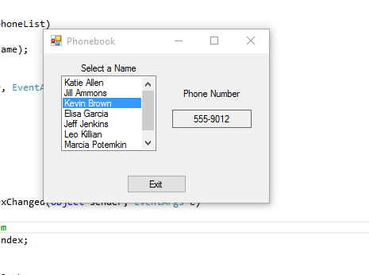

using System;

using System.Collections.Generic;

using System.ComponentModel;

using System.Data;

using System.Drawing;

using System.Linq;

using System.Text;

using System.Windows.Forms;

using System.IO;

namespace Phonebook

{

struct PhoneBookEntry

{

public string name;

public string phone;

}

public partial class Form1 : Form

{

//Field to hold a list of the phonebook entry objects

private List<PhoneBookEntry> phoneList = new List<PhoneBookEntry>();

public Form1()

{

InitializeComponent();

}

//The ReadFile method reads the contests of the phonelist.txt file and stores it as PhoneBookEntry objects in the phone list

private void ReadFile()

{

try

{

StreamReader inputFile; //read the file

string line; //to hold line from the file

//create and instance of the phonebookentry struct

PhoneBookEntry entry = new PhoneBookEntry();

//create delm array

char[] delim = { ',' };

//open file

inputFile = File.OpenText("PhoneList.txt");

//open phonelist file

while(!inputFile.EndOfStream)

{

//read aline from the file

line = inputFile.ReadLine();

//tokenize the line

string[] tokens = line.Split(delim);

//store the tokens in the entry obj

entry.name = tokens[0];

entry.phone = tokens[1];

//add entry to the list

phoneList.Add(entry);

}

}

catch (Exception ex)

{

MessageBox.Show(ex.Message);

}

}

private void DisplayNames()

{

foreach(PhoneBookEntry entry in phoneList)

{

nameListBox.Items.Add(entry.name);

}

}

private void Form1_Load(object sender, EventArgs e)

{

//read the phonelist txt file

ReadFile();

//display names

DisplayNames();

}

private void nameListBox_SelectedIndexChanged(object sender, EventArgs e)

{

//get index of the seletected item

int index = nameListBox.SelectedIndex;

//display text

phoneLabel.Text = phoneList[index].phone;

}

private void exitButton_Click(object sender, EventArgs e)

{

this.Close();

}

}

}