I worked on this alone

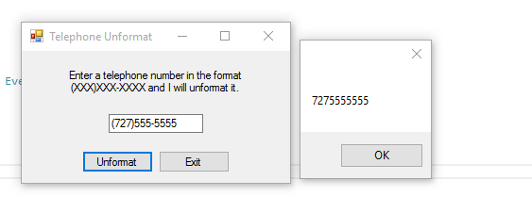

using System;

using System.Collections.Generic;

using System.ComponentModel;

using System.Data;

using System.Drawing;

using System.Linq;

using System.Text;

using System.Windows.Forms;

namespace Telephone_Unformat

{

public partial class Form1 : Form

{

public Form1()

{

InitializeComponent();

}

//The IsValidFormat accets string arguement and determines if its properly formated (xxx)XXX-XXXX

//if the argument is properly formatted, the method returns true otherwise false

private bool IsValidFormat(string str)

{

const int VALID_LENGTH = 13; // Length of a valid string

bool valid; // Flag to indicate validity

//determin whether str is properly formatted.

if (str.Length == VALID_LENGTH && str[0] == '(' && str[4] == ')' && str[8] == '-')

{

valid = true;

}

else

{

valid = false;

}

//return the value of valid.

return valid;

}

//the unformat method accepts a string in the (xxx)xxx-xxxx and removes the paren and hyphen

private void Unformat(ref string str)

{

//first delete the left paren at positions 0

str = str.Remove(0, 1);

//next delete right paren b/c of previous deletion it is now at position 3

str = str.Remove(3, 1);

// next delete hyphon. Becaus of deletions now at position 6

str = str.Remove(6, 1);

}

private void unformatButton_Click(object sender, EventArgs e)

{

//get trimmed copy of users input

string input = numberTextBox.Text.Trim();

//if input is properly formatted, un format it and displau

if (IsValidFormat(input))

{

Unformat(ref input);

MessageBox.Show(input);

}

else

{

//displau an error

MessageBox.Show("Invalid input");

}

}

private void exitButton_Click(object sender, EventArgs e)

{

//close the form

this.Close();

}

}

}