I worked alone

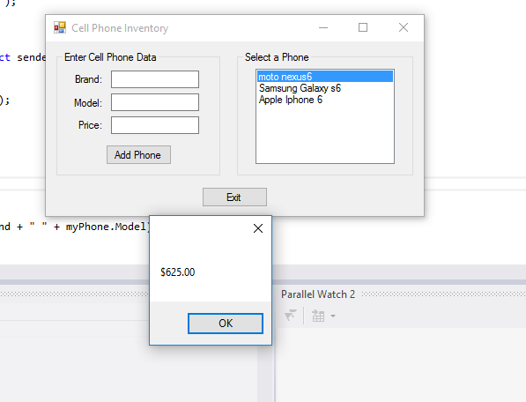

using System;

using System.Collections.Generic;

using System.ComponentModel;

using System.Data;

using System.Drawing;

using System.Linq;

using System.Text;

using System.Windows.Forms;

namespace Cell_Phone_Inventory

{

public partial class Form1 : Form

{

// List to hold CellPhone objects

List<CellPhone> phoneList = new List<CellPhone>();

public Form1()

{

InitializeComponent();

}

//The GetPhoneData method accepts a CellPhone object as an argument. It assigns the data entered by the user to the object's properties.

private void GetPhoneData(CellPhone phone)

{

// Temporary variable to hold the price.

decimal price;

// Get the phone's brand.

phone.Brand = brandTextBox.Text;

// Get the phone's model.

phone.Model = modelTextBox.Text;

// Get the phone's price.

if (decimal.TryParse(priceTextBox.Text, out price))

{

phone.Price = price;

}

else

{

//displau error message

MessageBox.Show("invalid price");

}

}

private void addPhoneButton_Click(object sender, EventArgs e)

{

//create a cell phone object

CellPhone myPhone = new CellPhone();

//Get the phone data.

GetPhoneData(myPhone);

//add the celphone obj to the list

phoneList.Add(myPhone);

//add an entry to the list box

phoneListBox.Items.Add(myPhone.Brand + " " + myPhone.Model);

//clear texboxes

brandTextBox.Clear();

modelTextBox.Clear();

priceTextBox.Clear();

//reset the focus

brandTextBox.Focus();

}

private void phoneListBox_SelectedIndexChanged(object sender, EventArgs e)

{

//get the index of the selected item

int index = phoneListBox.SelectedIndex;

//display the price

MessageBox.Show(phoneList[index].Price.ToString("c"));

}

private void exitButton_Click(object sender, EventArgs e)

{

//close the form

this.Close();

}

}

}