I worked alone.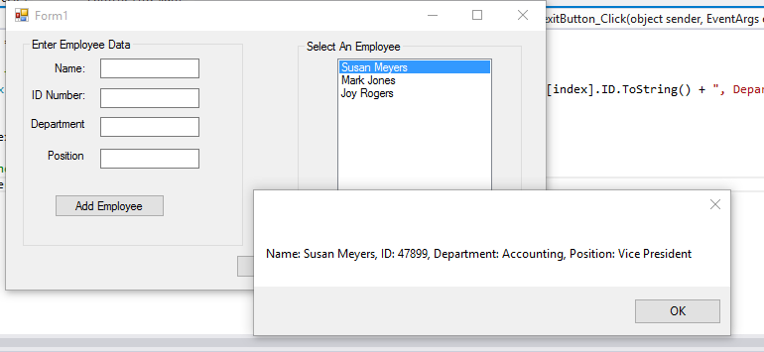

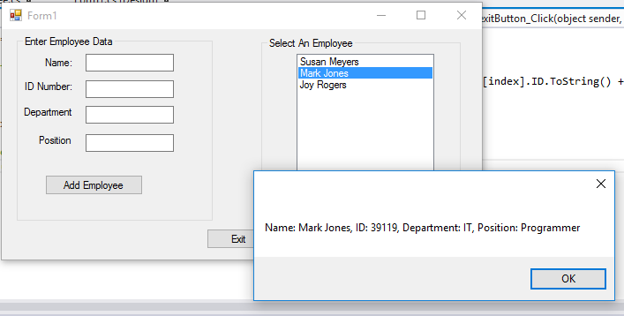

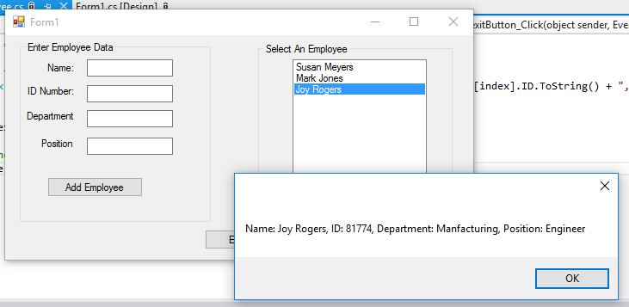

**Employee.cs**

using System;

using System.Collections.Generic;

using System.Linq;

using System.Text;

using System.Threading.Tasks;

namespace EmployeeClass

{

class Employee

{

//Fields

private string _name; //Employee Name

private int _id; //Employee ID

private string _department; //Employee Department

private string _position; //Employee Position

//Parameterless Constructor

public Employee()

{

_name = "";

_id = 0;

_department = "";

_position = "";

}

//Name Property

public string Name

{

get { return _name; }

set { _name = value; }

}

//ID property

public int ID

{

get { return _id; }

set { _id = value; }

}

//Department property

public string Department

{

get { return _department; }

set { _department = value; }

}

//Position property

public string Position

{

get { return _position; }

set { _position = value; }

}

}

}

**Form1.cs**

using System;

using System.Collections.Generic;

using System.ComponentModel;

using System.Data;

using System.Drawing;

using System.Linq;

using System.Text;

using System.Threading.Tasks;

using System.Windows.Forms;

namespace EmployeeClass

{

public partial class Form1 : Form

{

List<Employee> employeeData = new List<Employee>();

public Form1()

{

InitializeComponent();

}

private void GetEmployeeData(Employee data)

{

//Variable to hold ID

int id;

//Get the Employee's name

data.Name = nameTextBox.Text;

//Get the Employee's ID

if (int.TryParse(idTextBox.Text, out id))

{

data.ID = id;

}

else

{

MessageBox.Show("Enter a Validate ID Number");

}

//Get the Employee's Department

data.Department = departmentTxtBox.Text;

//Get the Employee's Position

data.Position = positionTextBox.Text;

}

private void addButton_Click(object sender, EventArgs e)

{

{

//Create Employee object

Employee newEmployee = new Employee();

//Get the Employee data

GetEmployeeData(newEmployee);

//Add employee to the list

employeeData.Add(newEmployee);

//Add an entry to the list box

employeeListbox.Items.Add(newEmployee.Name);

//Clear the text boxes

nameTextBox.Clear();

idTextBox.Clear();

departmentTxtBox.Clear();

positionTextBox.Clear();

nameTextBox.Focus();

}

}

private void employeeListbox_SelectedIndexChanged(object sender, EventArgs e)

{

//Get the index of the selected item

int index = employeeListbox.SelectedIndex;

//Display the employee's data

MessageBox.Show("Name: " + employeeData[index].Name.ToString() + ", ID: " + employeeData[index].ID.ToString() + ", Department: " + employeeData[index].Department.ToString() + ", Position: " + employeeData[index].Position.ToString());

}

private void exitButton_Click(object sender, EventArgs e)

{

//close the form

this.Close();

}

}

}