I worked alone

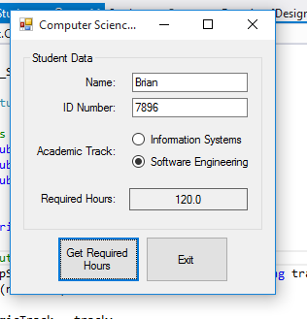

Form1cs:

using System;

using System.Collections.Generic;

using System.ComponentModel;

using System.Data;

using System.Drawing;

using System.Linq;

using System.Text;

using System.Windows.Forms;

namespace Computer_Science_Student

{

public partial class Form1 : Form

{

public Form1()

{

InitializeComponent();

}

private void getHoursButton_Click(object sender, EventArgs e)

{

//variables to hold input

string name, id, track;

//get the student's name and id

name = nameTextBox.Text;

id = idTextBox.Text;

//get the students academic track

if (infoSystemsRadioButton.Checked)

{

track = "Information Systems";

}

else

{

track = "Software Engineering";

}

//create a compscistudnet object

CompSciStudent csStudent = new CompSciStudent(name, id, track);

//display students required hours

requiredHoursLabel.Text = csStudent.RequiredHours.ToString("n1");

}

}

}

Compscistudent.cs

using System;

using System.Collections.Generic;

using System.Linq;

using System.Text;

namespace Computer_Science_Student

{

class CompSciStudent :Student

{

//constants

private double MATH_HOURS = 20;

private double CS_Hours = 40;

private double GEN_Hours = 60;

//fields

private string _academicTrack;

//constrocutor

public CompSciStudent(string name, string id, string track)

: base(name, id)

{

_academicTrack = track;

}

//academic track property

public string AcademicTrack

{

get { return _academicTrack; }

set { _academicTrack = value; }

}

//required hours property

public override double RequiredHours

{

get { return MATH_HOURS + CS_Hours + GEN_Hours; }

}

}

}

Student.cs

using System;

using System.Collections.Generic;

using System.Linq;

using System.Text;

namespace Computer_Science_Student

{

abstract class Student

{

//fields

private string _name;

private string _id;

//constructors

public Student(string name, string id)

{

_name = name;

_id = id;

}

//name property

public string Name

{

get { return _name; }

set { _name = value; }

}

//id property

public string ID

{

get { return _id; }

set { _id = value; }

}

//requiiredhour propery(abstract)

public abstract double RequiredHours

{

get;

}

}

}