I worked alone

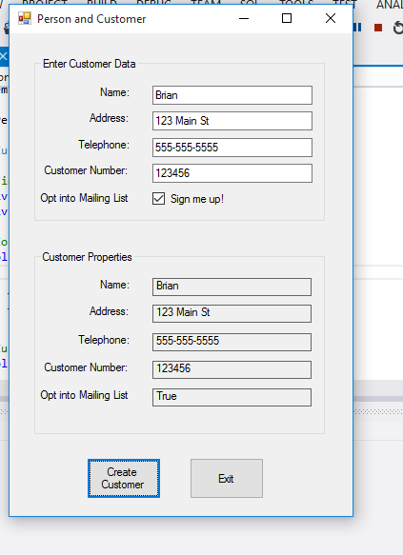

FORM1.cs

using System;

using System.Collections.Generic;

using System.ComponentModel;

using System.Data;

using System.Drawing;

using System.Linq;

using System.Text;

using System.Threading.Tasks;

using System.Windows.Forms;

namespace Person_and_Customer_Classes

{

public partial class Form1 : Form

{

public Form1()

{

InitializeComponent();

}

/*

* The GetCustData method accepts customer as an arguement. It assigns the data entered by

* the user to the objects properties.

*/

private void GetCustData(Customer customer)

{

//Temp variables

int custNumber;

//Get the customer data

if (nameTextBox.Text != "")

{

customer.Name = nameTextBox.Text;

if (addressTextBox.Text != "")

{

customer.Address = addressTextBox.Text;

if (telephoneTextBox.Text != "")

{

customer.Telephone = telephoneTextBox.Text;

if (int.TryParse(customerNumberTextBox.Text, out custNumber))

{

customer.CustomerNumber = custNumber;

}

else

{

//Error message

MessageBox.Show("Please enter a valid customer number.");

}

}

else

{

MessageBox.Show("Please enter a valid telephone number.");

}

}

else

{

MessageBox.Show("Please enter a valid address.");

}

}

else

{

MessageBox.Show("Please enter a valid name.");

}

}

private void button1_Click(object sender, EventArgs e)

{

//Create Customer object

Customer newCustomer = new Customer();

//Get the customer data.

GetCustData(newCustomer);

//Display customer data.

nameLabel.Text = newCustomer.Name;

addressLabel.Text = newCustomer.Address;

telephoneLabel.Text = newCustomer.Telephone;

custNumberLabel.Text = newCustomer.CustomerNumber.ToString();

if (mailListCheckBox.Checked)

{

mailListLabel.Text = "True";

}

else

{

mailListLabel.Text = "False";

}

}

private void button2_Click(object sender, EventArgs e)

{

//Close the form

this.Close();

}

private void Form1_Load(object sender, EventArgs e)

{

}

}

}

Customer.cs

using System;

using System.Collections.Generic;

using System.Linq;

using System.Text;

using System.Threading.Tasks;

namespace Person_and_Customer_Classes

{

class Customer : Person

{

//Fields

private int _custNumber;

private bool _mailList;

//Constructor

public Customer()

{

_custNumber = 0;

_mailList = false;

}

//Customer Number property

public int CustomerNumber

{

get { return _custNumber; }

set { _custNumber = value; }

}

//Mailing List property

public bool MailList

{

get { return _mailList; }

set { _mailList = value; }

}

}

}

Person.cs

using System;

using System.Collections.Generic;

using System.Linq;

using System.Text;

using System.Threading.Tasks;

namespace Person_and_Customer_Classes

{

class Person

{

//Fields

private string _name;

private string _address;

private string _telephone;

//Constructor

public Person()

{

_name = "";

_address = "";

_telephone = "";

}

//Name property

public string Name

{

get { return _name; }

set { _name = value; }

}

//Address property

public string Address

{

get { return _address; }

set { _address = value; }

}

//Telephone property

public string Telephone

{

get { return _telephone; }

set { _telephone = value; }

}

}

}