I worked alone

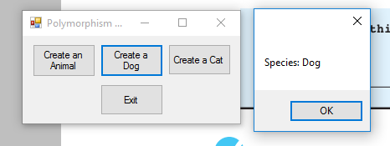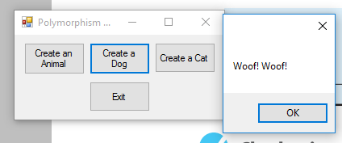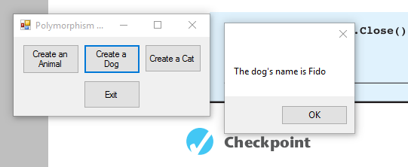

**Form1.cs**

using System;

using System.Collections.Generic;

using System.ComponentModel;

using System.Data;

using System.Drawing;

using System.Linq;

using System.Text;

using System.Windows.Forms;

namespace Polymorphism

{

public partial class Form1 : Form

{

public Form1()

{

InitializeComponent();

}

//show animal info method accepts an animal object as an argument. It displays the objects species and calls the makesound method

private void ShowAnimalInfo(Animal animal)

{

MessageBox.Show("Species: " + animal.Species);

animal.MakeSound();

}

private void createAnimalButton_Click(object sender, EventArgs e)

{

Animal myAnimal = new Animal("Regular animal");

ShowAnimalInfo(myAnimal);

}

private void createDogButton_Click(object sender, EventArgs e)

{

Dog myDog = new Dog("Fido");

MessageBox.Show("The dog's name is " + myDog.Name);

ShowAnimalInfo(myDog);

}

private void createCatButton_Click(object sender, EventArgs e)

{

Cat myCat = new Cat("Kitty");

MessageBox.Show("The Cat's name is " + myCat.Name);

ShowAnimalInfo(myCat);

}

private void exitButton_Click(object sender, EventArgs e)

{

//close the form

this.Close();

}

}

}

**Animal.cs**

using System;

using System.Collections.Generic;

using System.Linq;

using System.Text;

using System.Windows.Forms; ///NEEDED FOR MESSAGEBOX

namespace Polymorphism

{

class Animal

{

//field

private string _species;

//constructor

public Animal(string species)

{

_species = species;

}

//species propery

public string Species

{

get { return _species; }

set { _species = value; }

}

//makesound method

public virtual void MakeSound()

{

MessageBox.Show("Grrrrrr");

}

}

}

**DOG.cs**

using System;

using System.Collections.Generic;

using System.Linq;

using System.Text;

using System.Windows.Forms; ///NEEDED FOR MESSAGEBOX

///

namespace Polymorphism

{

class Dog :Animal

{

//field

private string _name;

//constructor

public Dog(string name)

: base("Dog")

{

_name = name;

}

//name property

public string Name

{

get { return _name; }

set { _name = value; }

}

//make sound method

public override void MakeSound()

{

MessageBox.Show("Woof! Woof!");

}

}

}

**Cat.cs**

using System;

using System.Collections.Generic;

using System.Linq;

using System.Text;

using System.Windows.Forms; ///NEEDED FOR MESSAGEBOX

namespace Polymorphism

{

class Cat : Animal

{

//field

private string _name;

//constoctur

public Cat(string name)

: base("Cat")

{

_name = name;

}

//name property

public string Name

{

get { return _name; }

set { _name = value; }

}

//make sound method

public override void MakeSound()

{

MessageBox.Show("Meow");

}

}

}