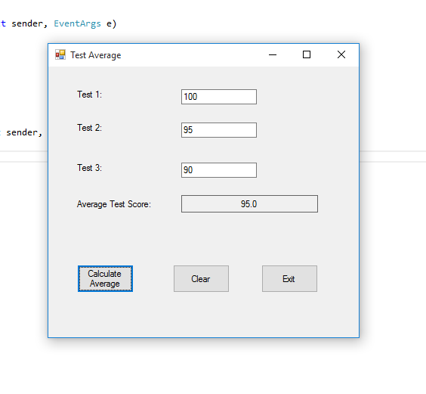

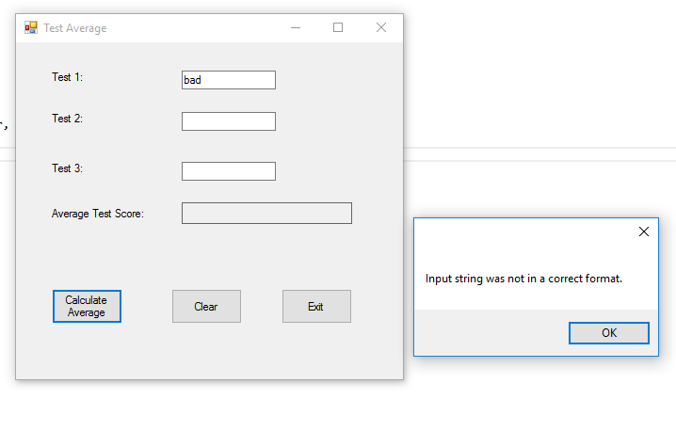

Code:

using System;

using System.Collections.Generic;

using System.ComponentModel;

using System.Data;

using System.Drawing;

using System.Linq;

using System.Text;

using System.Threading.Tasks;

using System.Windows.Forms;

namespace Test_Average

{

public partial class Form1 : Form

{

public Form1()

{

InitializeComponent();

}

private void calculateButton_Click(object sender, EventArgs e)

{

try

{

double test1; //To hold test1 score

double test2; //to hold test2 score

double test3; //to hold test 3 score

double average; //to hold average

//get three test schores

test1 = double.Parse(test1TextBox.Text);

test2 = double.Parse(test2TextBox.Text);

test3 = double.Parse(test3TextBox.Text);

//calculate average

average = (test1 + test2 + test3) / 3;

//display average rounded to 1 decimal point

averageLabel.Text = average.ToString("n1");

}

catch (Exception ex)

{

//display default error message

MessageBox.Show(ex.Message);

}

}

private void clearButton_Click(object sender, EventArgs e)

{

//clear values

test1TextBox.Text = "";

test2TextBox.Text = "";

test3TextBox.Text = "";

averageLabel.Text = "";

}

private void exitButton_Click(object sender, EventArgs e)

{

this.Close();

}

}

}