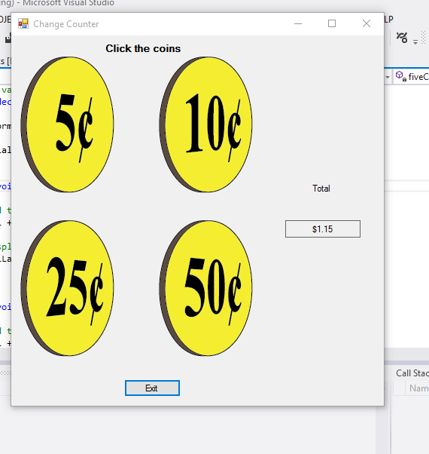

using System;

using System.Collections.Generic;

using System.ComponentModel;

using System.Data;

using System.Drawing;

using System.Linq;

using System.Text;

using System.Threading.Tasks;

using System.Windows.Forms;

namespace changecounter

{

public partial class Form1 : Form

{

//contstant fields

const decimal FIVE_CENTS_VALUE = 0.05m;

const decimal TEN_CENTS_VALUE = 0.10m;

const decimal TWENTY_FIVE_CENTS_VALUE = 0.25m;

const decimal FIFTY_CENTS_VALUE = .50m;

// total variaiable starts with 0

private decimal total = 0m;

public Form1()

{

InitializeComponent();

}

private void fiveCentsPictureBox_Click(object sender, EventArgs e)

{

//add to total

total += FIVE_CENTS_VALUE;

//display new total

totalLabel.Text = total.ToString("c");

}

private void tenCentsPictureBox_Click(object sender, EventArgs e)

{

//add to total

total += TEN_CENTS_VALUE;

//display new total

totalLabel.Text= total.ToString("c");

}

private void twentyFiveCentsPictureBox_Click(object sender, EventArgs e)

{

//add to total

total += TWENTY_FIVE_CENTS_VALUE;

//display new total

totalLabel.Text =total.ToString("c");

}

private void fiftyCentsPictureBox_Click(object sender, EventArgs e)

{

//add to total

total += FIFTY_CENTS_VALUE;

//display new total

totalLabel.Text = total.ToString("c");

}

private void exitButton_Click(object sender, EventArgs e)

{

this.Close();

}

}

}