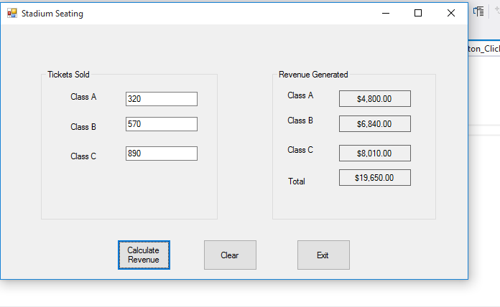

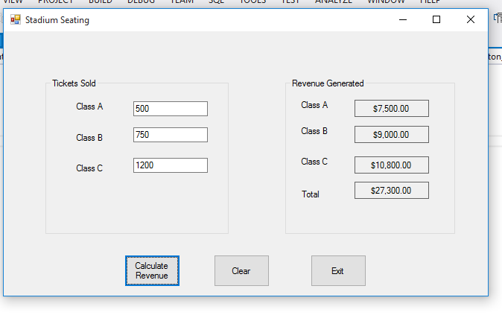

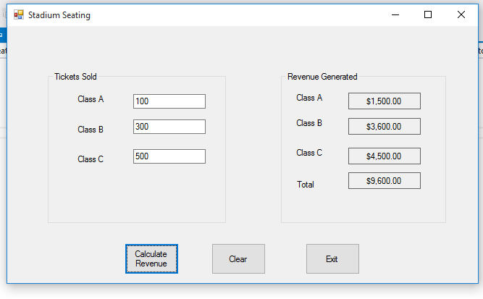

using System;

using System.Collections.Generic;

using System.ComponentModel;

using System.Data;

using System.Drawing;

using System.Linq;

using System.Text;

using System.Threading.Tasks;

using System.Windows.Forms;

namespace Stadium_Seating

{

public partial class Form1 : Form

{

//declaring seat value

const int CLASS_A_COST = 15;

const int CLASS_B_COST = 12;

const int CLASS_C_COST = 9;

public Form1()

{

InitializeComponent();

}

private void calculateButton_Click(object sender, EventArgs e)

{

try

{

//to catch number of tickets

int classa;

int classb;

int classc;

int classARev;

int classBRev;

int classCRev;

int totalRev;

//getting values

classa = int.Parse(inputClassATextBox.Text);

classb = int.Parse(inputClassBTextBox.Text);

classc = int.Parse(inputClassCTextBox.Text);

//getting revenues

classARev = classa * CLASS_A_COST;

classBRev = classb * CLASS_B_COST;

classCRev = classc * CLASS_C_COST;

totalRev = classARev + classBRev + classCRev;

//displaying revenue totals

classAOutputLabel.Text = classARev.ToString("c");

classBOutputLabel.Text = classBRev.ToString("c");

classCOutputLabel.Text = classCRev.ToString("c");

totalOutputLabel.Text = totalRev.ToString("c");

}

catch (Exception ex)

{

//display default exception

MessageBox.Show(ex.Message);

}

}

private void clearButton_Click(object sender, EventArgs e)

{

//clearing textboxes

inputClassATextBox.Text = "";

inputClassBTextBox.Text = "";

inputClassCTextBox.Text = "";

//clearing labels

classAOutputLabel.Text = "";

classBOutputLabel.Text = "";

classCOutputLabel.Text = "";

totalOutputLabel.Text = "";

//Setting focus class a input

inputClassATextBox.Focus();

}

private void exitButton_Click(object sender, EventArgs e)

{

this.Close();

}

}

}