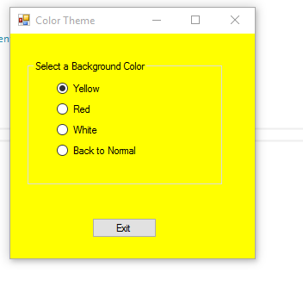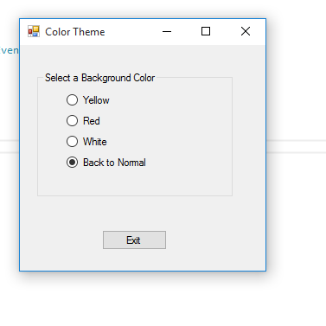

using System;

using System.Collections.Generic;

using System.ComponentModel;

using System.Data;

using System.Drawing;

using System.Linq;

using System.Text;

using System.Threading.Tasks;

using System.Windows.Forms;

namespace Color_Theme

{

public partial class Form1 : Form

{

public Form1()

{

InitializeComponent();

}

private void yellowRadioButton_CheckedChanged(object sender, EventArgs e)

{

if (yellowRadioButton.Checked)

{

this.BackColor = Color.Yellow;

}

}

private void redRadioButton_CheckedChanged(object sender, EventArgs e)

{

if (redRadioButton.Checked)

{

this.BackColor = Color.Red;

}

}

private void whiteRadioButton_CheckedChanged(object sender, EventArgs e)

{

if (whiteRadioButton.Checked)

{

this.BackColor = Color.White;

}

}

private void normalRadioButton_CheckedChanged(object sender, EventArgs e)

{

if (normalRadioButton.Checked)

{

this.BackColor = SystemColors.Control;

}

}

private void exitButton_Click(object sender, EventArgs e)

{

//close form

this.Close();

}

}

}