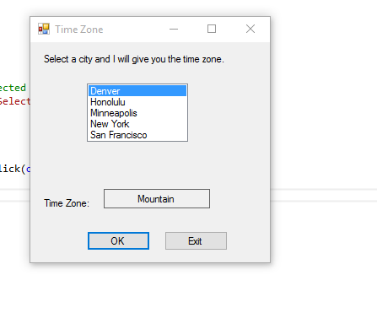

I Worked Alone

using System;

using System.Collections.Generic;

using System.ComponentModel;

using System.Data;

using System.Drawing;

using System.Linq;

using System.Text;

using System.Threading.Tasks;

using System.Windows.Forms;

namespace Time_Zone

{

public partial class Form1 : Form

{

public Form1()

{

InitializeComponent();

}

private void okButton_Click(object sender, EventArgs e)

{

string city; //holds name of city

if (cityListBox.SelectedIndex != -1)

{

//get selected item

city = cityListBox.SelectedItem.ToString();

//determine the timezone

switch (city)

{

case "Honolulu":

timeZoneLabel.Text = "Hawaii-Aluetian";

break;

case "San Francisco":

timeZoneLabel.Text = "Pacific";

break;

case "Denver":

timeZoneLabel.Text = "Mountain";

break;

case "Minneapolis":

timeZoneLabel.Text = "Central";

break;

case "New York":

timeZoneLabel.Text = "Eastern";

break;

}

}

else

{

//no city was selected

MessageBox.Show("Select a city.");

}

}

private void exitButton_Click(object sender, EventArgs e)

{

this.Close();

}

}

}