I worked alone

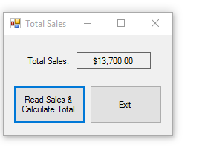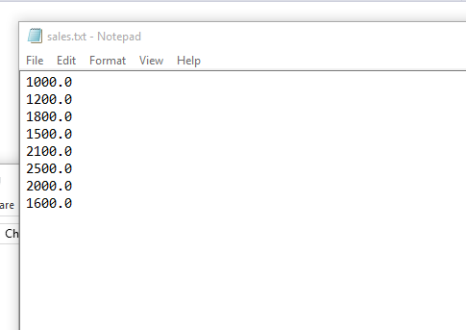

using System;

using System.Collections.Generic;

using System.ComponentModel;

using System.Data;

using System.Drawing;

using System.Linq;

using System.Text;

using System.Windows.Forms;

using System.IO;

namespace Total_Sales

{

public partial class Form1 : Form

{

public Form1()

{

InitializeComponent();

}

private void calculateButton_Click(object sender, EventArgs e)

{

try

{

//variables

decimal sales; //to hold sales amount

decimal total = 0m; //accumulator set to 0

//declare stream reader

StreamReader inputfile;

//open input file and get a streamreader object

inputfile = File.OpenText("Sales.txt");

//read file contents

while (!inputfile.EndOfStream)

{

sales = decimal.Parse(inputfile.ReadLine());

//add sales to total

total += sales;

}

//Close file

inputfile.Close();

//display total

totalLabel.Text = total.ToString("c");

}

catch (Exception ex)

{

//display error

MessageBox.Show(ex.Message);

}

}

private void exitButton_Click(object sender, EventArgs e)

{

this.Close();

}

}

}