I worked alone

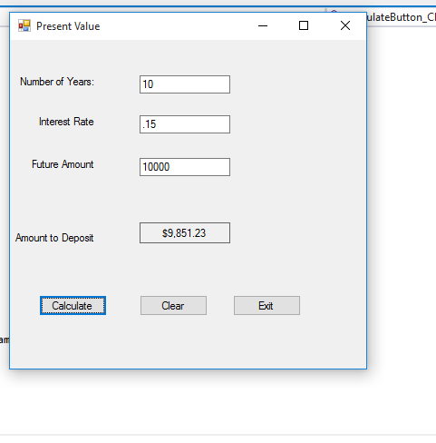

using System;

using System.Collections.Generic;

using System.ComponentModel;

using System.Data;

using System.Drawing;

using System.Linq;

using System.Text;

using System.Threading.Tasks;

using System.Windows.Forms;

namespace PresentValue

{

public partial class Form1 : Form

{

public Form1()

{

InitializeComponent();

}

//method to calculte present value

private double PresentValue(double future, double interest, double years)

{

return future / (Math.Pow(1 + interest/100, years));

}

private void CalculateButton_Click(object sender, EventArgs e)

{

//declare variables

double futureValue, interestrate, presentValue, amountyears;

//getting future value

if(double.TryParse(desiredTextBox.Text, out futureValue))

{

//get interest rate

if(double.TryParse(rateTextBox.Text, out interestrate))

{

//get years

if(double.TryParse(yearsTextBox.Text, out amountyears))

{

//calculating present value

presentValue = PresentValue(futureValue, interestrate, amountyears);

//posting to output label

outputLabel.Text = presentValue.ToString("c");

}

else

{

//show error message for years

MessageBox.Show("Please enter a valid amount of years.");

}

}

else

{

//show error message for interest

MessageBox.Show("Please enter a valid interest rate.");

}

}

else

{

//show error message for future value

MessageBox.Show("Please enter a valid future amount.");

}

}

private void clearButton_Click(object sender, EventArgs e)

{

//clear textboxes

yearsTextBox.Text = "";

rateTextBox.Text = "";

desiredTextBox.Text = "";

//clear outputlabel

outputLabel.Text = "";

//change focus to years textbox

yearsTextBox.Focus();

}

private void exitButton_Click(object sender, EventArgs e)

{

//close form

this.Close();

}

}

}