I worked alone

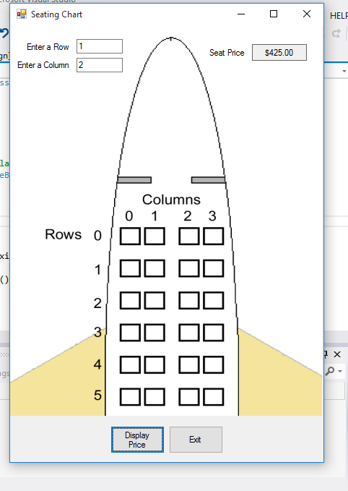

using System;

using System.Collections.Generic;

using System.ComponentModel;

using System.Data;

using System.Drawing;

using System.Linq;

using System.Text;

using System.Windows.Forms;

namespace Seating_Chart

{

public partial class Form1 : Form

{

public Form1()

{

InitializeComponent();

}

private void displayPriceButton_Click(object sender, EventArgs e)

{

//varialbles for selected row and column

int row, col;

//const for max row and column subscirpts

const int MAX_ROW = 5;

const int MAX_COL = 3;

//create array with seat proces

decimal[,] prices ={ {450m, 450m, 450m, 450m},

{425m, 425m, 425m, 425m},

{400m, 400m, 400m, 400m},

{375m, 375m, 375m, 375m},

{375m, 375m, 375m, 375m},

{350m, 350m, 350m, 350m}

};

//get select row num

if (int.TryParse(txtRow.Text, out row))

{

//get col num

if (int.TryParse(txtCol.Text, out col))

{

//check if row is in range

if (row >= 0 && row <= MAX_ROW)

{

//check if col is in range

if (col >= 0 && col <= MAX_COL)

{

//display the selected price seat

priceLabel.Text =

prices[row, col].ToString("c");

}

else

{

//error messae invalid column

MessageBox.Show("Column must be 0 and through " + MAX_COL);

}

}

else

{

// error msge invalid row

MessageBox.Show("Row must be 0 through " + MAX_ROW);

}

}

else

{

//display error non int column

MessageBox.Show("Enter an integer for the column.");

}

}

else

{

//display error for non int row

MessageBox.Show("Enter an integer for the row.");

}

}

private void exitButton_Click(object sender, EventArgs e)

{

this.Close();

}

}

}