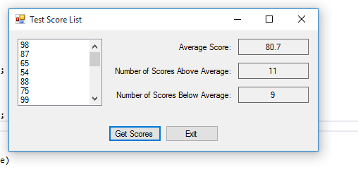

I worked alone

using System;

using System.Collections.Generic;

using System.ComponentModel;

using System.Data;

using System.Drawing;

using System.Linq;

using System.Text;

using System.Windows.Forms;

using System.IO;

namespace Test_Score_List

{

public partial class Form1 : Form

{

public Form1()

{

InitializeComponent();

}

private void ReadScores(List<int> scoresList)

{

try

{

//open the test scores file

StreamReader inputFile=File.OpenText("TestScores.txt");

//read scores into the list

while(!inputFile.EndOfStream)

{

scoresList.Add(int.Parse(inputFile.ReadLine()));

}

//c;pse file

inputFile.Close();

}

catch (Exception ex)

{

//diplay error

MessageBox.Show(ex.Message);

}

}

//diplsays contents of scorelist paramater in list bontro

private void DisplayScores(List<int> scoresList)

{

foreach (int score in scoresList)

{

testScoresListBox.Items.Add(score);

}

}

//avg method returns avf og the values in the scoresList Paramater

private double Average(List<int> scoresLIst)

{

int total = 0; //acumulator

double average; //to hold average

//calc total of scores

foreach (int score in scoresLIst)

{

total += score;

}

//calc average

average = (double)total/scoresLIst.Count;

//return average

return average;

}

//above average method returns the number of above avg scores in the scorelist

private int AboveAverage(List<int> scoresList)

{

int numAbove = 0; //acumulator

//get average score

double avg = Average(scoresList);

//count num of above average scores

foreach (int score in scoresList)

{

if (score > avg)

{

numAbove++;

}

}

//return number of above average scores

return numAbove;

}

//below average scores in score list

private int BelowAverage(List<int> scoresList)

{

int numBelow = 0; //acumulator

double avg = Average(scoresList);

//count num of below avg

foreach (int score in scoresList)

{

if (score < avg)

{

numBelow++;

}

}

return numBelow;

}

private void getScoresButton_Click(object sender, EventArgs e)

{

double averageScore; //holds avg score

int numAboveAverage; //num of above avg scores

int numBelowAverage; //num of below scores

//create list to hold scores

List<int> scoresList = new List<int>();

//read the scores from the file into the list

ReadScores(scoresList);

//display scores

DisplayScores(scoresList);

//display avg score

averageScore = Average(scoresList);

AverageLabel.Text = averageScore.ToString("n1");

//display above avg

numAboveAverage = AboveAverage(scoresList);

aboveAverageLabel.Text = numAboveAverage.ToString();

//display eblow avg

numBelowAverage = BelowAverage(scoresList);

belowAverageLabel.Text = numBelowAverage.ToString();

}

private void exitButton_Click(object sender, EventArgs e)

{

//close form

this.Close();

}

}

}