Student: Brian Johnston

Class: COP2362

Assignment: Square Roots

Note: Your email said it was okay for me to use the method I sent you.

I worked alone.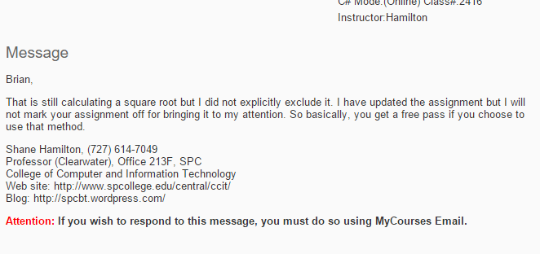

Screenshots:

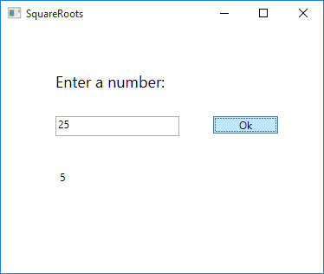

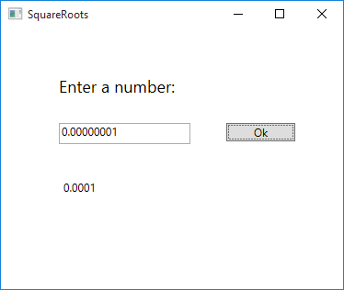

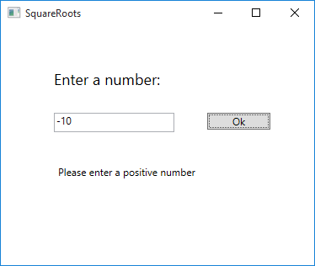

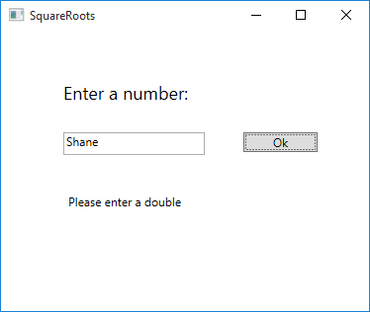

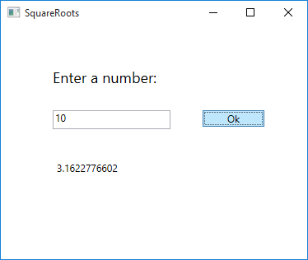

Code:

Mainwindow.XAMl.cs

using System;

using System.Collections.Generic;

using System.Linq;

using System.Text;

using System.Threading.Tasks;

using System.Windows;

using System.Windows.Controls;

using System.Windows.Data;

using System.Windows.Documents;

using System.Windows.Input;

using System.Windows.Media;

using System.Windows.Media.Imaging;

using System.Windows.Navigation;

using System.Windows.Shapes;

namespace SQRT

{

/// <summary>

/// Interaction logic for MainWindow.xaml

/// </summary>

public partial class MainWindow : Window

{

public MainWindow()

{

InitializeComponent();

}

private void calc()

{

double origNum = double.Parse(num.Text);

if (origNum > 0) //determine if number is whole

{

double circleRadi = ((origNum + 1) / 2); //intresecting circle radius

double square = Math.Cos(Math.Asin((circleRadi - 1) / circleRadi)) * circleRadi; //square root https://en.wikipedia.org/wiki/Square_root_of_3#Geometry_and_trigonometry

square = Math.Round(square, 10, MidpointRounding.AwayFromZero);

outputLabel.Content = square.ToString(); //convert to string to populate label

}

else //if number is negative

{

outputLabel.Content = "Please enter a positive number";

}

}

private void Button_Click_1(object sender, RoutedEventArgs e)

{

try

{

calc(); //calls calc method to determine sqrt

}

catch (FormatException) //format execption

{

outputLabel.Content = "Please enter a double";

}

}

}

}

Mainwindow.XAML:

<Window x:Class="SQRT.MainWindow"

xmlns="http://schemas.microsoft.com/winfx/2006/xaml/presentation"

xmlns:x="http://schemas.microsoft.com/winfx/2006/xaml"

Title="SquareRoots" Height="322.727" Width="387.5">

<Grid Margin="0,0,0,82">

<TextBox x:Name="num" HorizontalAlignment="Left" Height="23" Margin="63,103,0,0" TextWrapping="Wrap" VerticalAlignment="Top" Width="143"/>

<TextBlock HorizontalAlignment="Left" Margin="63,51,0,0" TextWrapping="Wrap" Text="Enter a number:" VerticalAlignment="Top" FontSize="18" Width="143"/>

<Button x:Name="okButton" Content="Ok" HorizontalAlignment="Left" Margin="245,103,0,0" VerticalAlignment="Top" Width="75" Click="Button_Click_1"/>

<Label x:Name="outputLabel" Content="" HorizontalAlignment="Left" Margin="63,173,0,0" VerticalAlignment="Top" Height="27" Width="257"/>

</Grid>

</Window>