Student: Brian Johnston

ID:2019405

Class:COP2362

Instructer: Hamilton, Shane

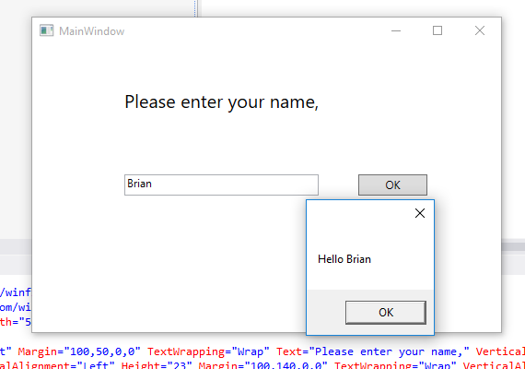

XAML:

<Window x:Class="WPFHello.MainWindow"

xmlns="http://schemas.microsoft.com/winfx/2006/xaml/presentation"

xmlns:x="http://schemas.microsoft.com/winfx/2006/xaml"

Title="MainWindow" Height="350" Width="525">

<Grid>

<Grid.ColumnDefinitions>

<ColumnDefinition Width="56\*"/>

<ColumnDefinition Width="461\*"/>

</Grid.ColumnDefinitions>

<TextBlock HorizontalAlignment="Left" Margin="44,50,0,0" TextWrapping="Wrap" Text="Please enter your name," VerticalAlignment="Top" FontSize="20" FontFamily="Global User Interface" Grid.Column="1"/>

<TextBox x:Name="userName" HorizontalAlignment="Left" Height="23" Margin="44,140,0,0" TextWrapping="Wrap" VerticalAlignment="Top" Width="211" Grid.Column="1"/>

<Button x:Name="ok" Content="OK" HorizontalAlignment="Left" Margin="298,140,0,0" VerticalAlignment="Top" Width="75" Height="23" Click="okClick" Grid.Column="1"/>

</Grid>

</Window>

MainWindo.Xaml.cs

using System;

using System.Collections.Generic;

using System.Linq;

using System.Text;

using System.Threading.Tasks;

using System.Windows;

using System.Windows.Controls;

using System.Windows.Data;

using System.Windows.Documents;

using System.Windows.Input;

using System.Windows.Media;

using System.Windows.Media.Imaging;

using System.Windows.Navigation;

using System.Windows.Shapes;

namespace WPFHello

{

/// <summary>

/// Interaction logic for MainWindow.xaml

/// </summary>

public partial class MainWindow : Window

{

public MainWindow()

{

InitializeComponent();

}

private void okClick(object sender, RoutedEventArgs e)

{

MessageBox.Show("Hello " + userName.Text);

}

}

}