Student: Brian Johnston

Class:COP2362

Assignment Tutorial 2-1

I worked alone

Screen capture step 9 pg 180

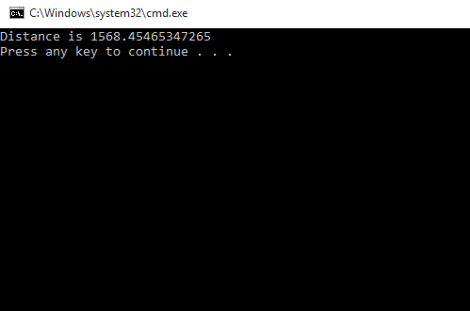

Screen capture pg 184 step 6

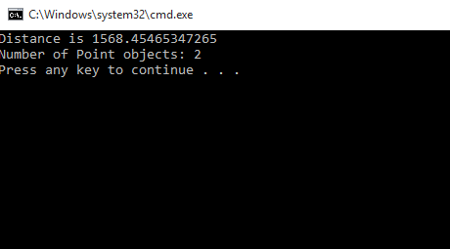

Code – Program.cs

namespace Classes

{

class Program

{

static void doWork()

{

Point origin = new Point();

Point bottomRight = new Point(1366, 768);

double distance = origin.DistanceTo(bottomRight);

Console.WriteLine("Distance is {0}", distance);

Console.WriteLine("Number of Point objects: {0}", Point.ObjectCount());

}

static void Main(string[] args)

{

try

{

doWork();

}

catch (Exception ex)

{

Console.WriteLine(ex.Message);

}

}

}

}

Point.cs:

#region Using directives

using System;

using System.Collections.Generic;

using System.Text;

#endregion

namespace Classes

{

class Point

{

private int x, y;

private static int objectCount = 0;

public Point()

{

this.x = -1;

this.y = -1;

objectCount++;

}

public Point(int x, int y)

{

this.x = x;

this.y = y;

objectCount++;

}

public double DistanceTo(Point other)

{

int xDiff = this.x - other.x;

int yDiff = this.y - other.y;

double distance = Math.Sqrt((xDiff \* xDiff) + (yDiff \* yDiff));

return distance;

}

public static int ObjectCount()

{

return objectCount;

}

}

}