Student: Brian Johnston

Class:COP2362

Assignment Tutorial 2-2

I worked alone

Screenshot:

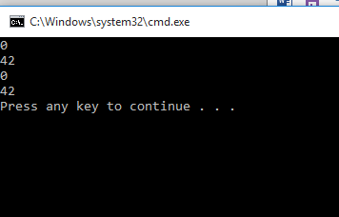

Code

Program.cs

#region Using directives

using System;

using System.Collections.Generic;

using System.Text;

#endregion

namespace Parameters

{

class Program

{

static void doWork()

{

int i = 0;

Console.WriteLine(i);

Pass.Value(ref i);

Console.WriteLine(i);

WrappedInt wi = new WrappedInt();

Console.WriteLine(wi.Number);

Pass.Reference(wi);

Console.WriteLine(wi.Number);

}

static void Main(string[] args)

{

try

{

doWork();

}

catch (Exception ex)

{

Console.WriteLine(ex.Message);

}

}

}

}

WrappedInt.cs

namespace Parameters

{

class WrappedInt

{

public int Number;

}

}

Pass.cs

using System;

namespace Parameters

{

class Pass

{

public static void Value(ref int param)

{

param = 42;

}

public static void Reference(WrappedInt param)

{

param.Number = 42;

}

}

}