
Finding, Nurturing, and Keeping Clients
A practical guide for new real estate agents
Contents
Introduction 1
Who this is for 1
How to use this handbook 1
Watch the overview 2
Reading plan 3
Quick start 3
What the boxes mean 4
1. Mindset and business foundations 5
You own a business now 5
The work is the win 5
Leading and lagging indicators 6
Working backward from an income goal 6
Your CRM is your headquarters 8
2. Finding clients 10
Sphere of influence and referrals 10
Online leads 11
Open houses 12
Geographic farming 13
Expired listings and for-sale-by-owners 13
Referral partners 14
Track every source 15
3. Marketing and brand presence 17
Your home base 17
What people should say about you 18
A content calendar you can keep 18
Market every listing thoroughly 19
Paid advertising 20
4. Your CRM and daily operating system 22
The one-time setup 22
The daily rhythm 23
Speed-to-lead 24
Optional tools 26
5. Nurturing leads 27
Why one call is never enough 27
Designing a nurture plan 28
The follow-up plan starter library 29
Qualify early 30
The weekly pipeline review 31
6. Scripts: conversations that convert 33
How to use a script 33
Three rules to read every script by 33
7. Common errors and pitfalls of new agents 38
The six errors 38
How the errors feed each other 39
The one correction 39
Try it on Sam 40
8. Staying organized and motivated 42
One source of truth 42
A sample day 42
Time-blocking the week 42
Weekly activity targets 43
Motivation that lasts 44
When it is quiet 45
9. Working with clients and dealing with objections 47
The consultation sequence 47
Objections are questions in disguise 48
Objection quick reference 49
Document everything 51
Between yes and closing 51
After the transaction 52
10. Keeping clients: long-term relationships 53
The post-close plan 53
Adding value without selling 54
Reactivating a quiet database 55
Asking for referrals 55
11. Legal protection and professional standards 57
Agency disclosure 58
Buyer agreements and compensation 58
Fair Housing 58
Texts and calls 59
What to document 59
Professional standards 60
12. Your first 90 days: daily, weekly and monthly plans 62
Days 1 to 30: install the system 63
Days 31 to 60: build the rhythm 63
Days 61 to 90: grow the pipeline 64
Measure every week 64
Review every month 64
Assemble your 90-Day Business Plan 65
13. Resources and next steps 67
Do these this week 67
Where to get help 67
The two habits that matter most 67
Plan the next 90 days 68
Appendix A: Weekly activity scorecard 70
Appendix B: Follow-up plan starter kit 71
B.1 New online lead (90 days) 71
B.2 New sphere contact: 8x8 (8 weeks) 71
B.3 Quarterly database plan (ongoing) 72
B.4 Post-close plan (first year) 72
B.5 Monthly Neighborhood Nurture (ongoing) 72
B.6 Buyer Long-Term Nurture (90 to 180 days) 73
B.7 Seller Long-Term Nurture (6 to 12 months) 73
Appendix C: CRM setup checklist 74
Appendix D: Glossary 76
Appendix E: Interactive tools 78
Also interactive 79
Appendix F: Essential links 80

Introduction

Who this is for
This handbook is for the agent in their first year: licensed, affiliated with a brokerage, and unsure what to do on a Tuesday morning when no one is calling. It does not teach you to write a contract or run a closing. Your broker and your state course do that. It teaches the other half of the job: how to find people who might buy or sell, stay in touch until they are ready, and earn the next introduction when they close. It is written for agents in any state, and the rules differ from state to state, so check your own state's rules with your broker before you rely on any rule in this book.
BY DAY 90 YOU WILL HAVE
- A written income goal, turned into the number of conversations you hold each day.
- A CRM that tells you every morning who to call.
- Three follow-up plans running, so no lead goes quiet unnoticed.
- Your first consultations behind you, and a pipeline you review every Friday.
- A post-close plan ready to assign the day your first client goes under contract.

How to use this handbook
Most new agents do not fail for lack of effort. They fail because effort is scattered across activities that do not compound. This handbook gives you one system with three outcomes, and every chapter serves one of them:
- Find. Generate a steady flow of conversations with people who may buy or sell.
- Nurture. Follow up often enough, and helpfully enough, that you are the agent they call when they are ready.
- Keep. Stay useful after closing so past clients send you the next ones.

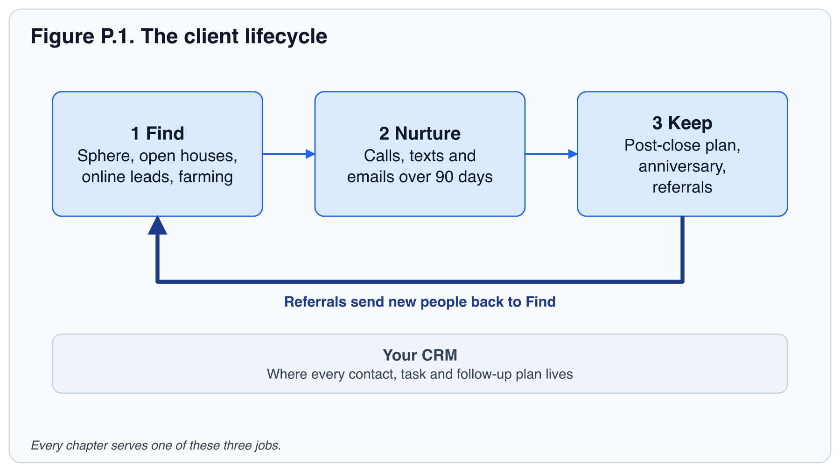
The book is written to be worked, not just read. Each chapter opens with what you will be able to do by the end, teaches the idea, shows the words to say, and closes with an exercise, the key takeaways and a quiz. Read a chapter, do the exercise the same day, and move on. Do not try to install everything in one weekend.

Watch the overview
Video. The Blueprint for New Real Estate Agents
[Video: The Blueprint for New Real Estate Agents. Available in the online handbook.]
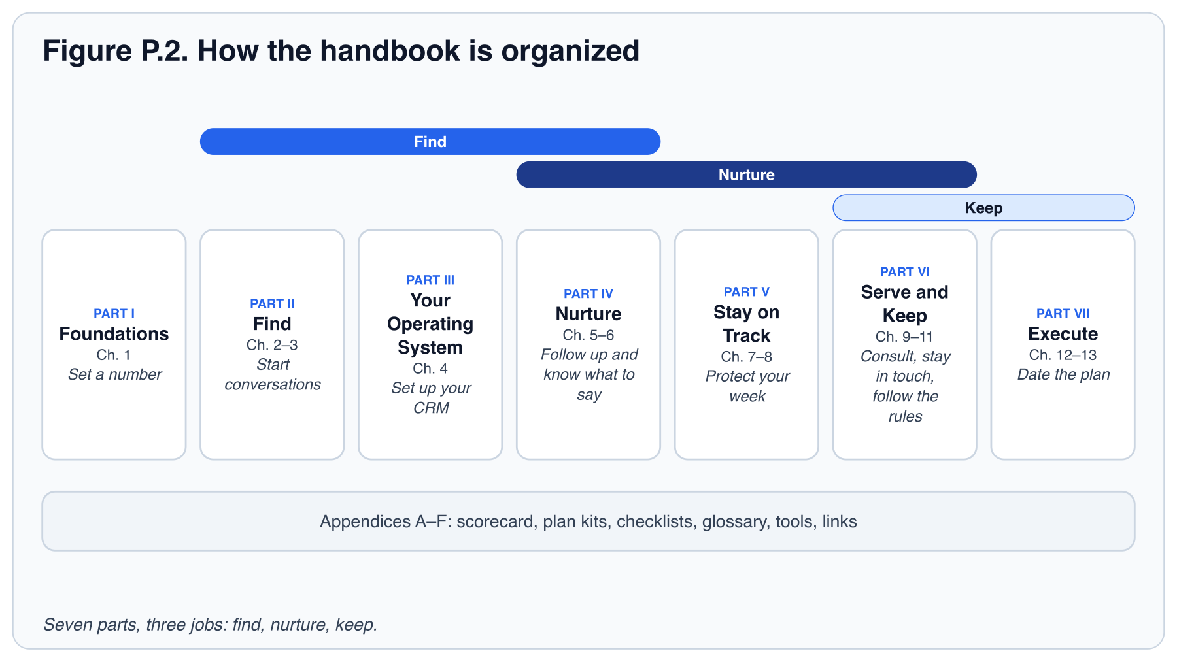

Reading plan
- Week 1: Chapters 1, 2 and 3. Set your daily number, build your sphere list, and set up the home base people will find you through.
- Week 2: Chapters 4, 5 and 6. Set up your CRM, put every lead on a plan, and learn the words to say.
- Week 3: Chapters 7, 8 and 9. Audit your habits, protect your calendar, and practice consultations.
- Week 4: Chapters 10, 11, 12 and 13. Add post-close plans and professional safeguards, then put dates on your first 90 days.

The plan follows the book, so each chapter builds on the ones before it. Two things cannot wait for week 4. The safeguards you need before you contact anyone are in the quick start below. And read Chapter 10 before your first client goes under contract, whatever week you are in. The post-close plan is built once, assigned on the day the client goes under contract, and activated on closing day; it runs seven dated touches in the first year, starting with the closing-day note.

Quick start
If you want to start before you have read anything else, do these three things this week. None of them needs another chapter.
- Turn your income goal into a daily number of conversations with the calculator in Chapter 1, and write the number on a card where you work.
- Block 9:30 to 11:00 every weekday morning in your calendar and label it "Lead generation". Do not move it.
- Open your CRM first thing every morning and update it before you stop working.

Before your first outreach
Check these four things before you call, text or post for business. Chapter 11 covers each one in full, and your broker has your state's version.
- Consent before automated texts. Send automated texts or calls only to people whose consent you have recorded in the CRM, and stop at the first opt-out.
- Describe the property, not the people. In posts, listings and conversation, talk about the home and its location, never about who should live there or who lives there now. "Four bedrooms, fenced yard, two blocks from the park" is fine. "Great for families" is not.
- Agency disclosure at first substantive contact. When a conversation moves from casual to real help with buying or selling, give your state's agency disclosure in plain language, and keep the signed copy.
- Do-not-call. Do not call or text numbers on a do-not-call list, or outside the hours your state allows. Ask your broker which lists to check against.

What the boxes mean
FIELD NOTE
A practical tip from agents who do this every day.

PITFALL
A trap new agents fall into, and how to avoid it.

TRY IT TODAY
An exercise for the same day. Most take under an hour; setting up your CRM and building your sphere list take longer.

CHECKPOINT
Questions to confirm you can apply the chapter. Checkpoints appear in the online handbook only.

LEGAL
A rule set by law, your state or your broker, titled for when it applies (for example, "Before you call"). It tells you what to check and whom to ask. It is not legal advice.

IN THIS CHAPTER YOU WILL LEARN TO
What you will be able to do by the end. It opens every chapter.

KEY TAKEAWAYS
The few points to remember. They close every chapter, just before its quiz.

INTERACTIVE
A calculator, planner or practice tool that works in the online handbook. Appendix E lists every one.

PART I: FOUNDATIONS

1. Mindset and business foundations
Before tactics, the one decision that shapes everything else: you are running a business, and businesses run on systems and leading indicators.
Nobody hired you to be here. No one sets your Monday schedule, no manager notices when a week goes by without a single real conversation, and no paycheck arrives for effort alone. That freedom is the reason many people come into this business, and the reason many leave it.
This chapter turns the freedom into a plan. You will do one piece of arithmetic that tells you how many conversations a day your income goal requires, and you will learn why that number, not your closings, is the thing to watch. Everything else in the book (finding people, following up, staying in touch after the sale) serves that number.
IN THIS CHAPTER YOU WILL LEARN TO
- Sort a list of activities into leading and lagging indicators, and choose three leading indicators to track weekly.
- Convert an annual income goal into the number of conversations you need each day.
- Estimate the runway your first months need, and decide what share of each commission check is set aside before you spend it.
- Open your CRM first each morning and name the first three things you check there.

You own a business now
When you were an employee, somebody else found the customers, set the schedule and decided what mattered. All three jobs are now yours.
It also comes with costs that arrive before income does. In your first month you will likely pay license and association fees, MLS access, a CRM and some marketing, and a commission business pays only at closing. Ask your broker for a realistic list of month-one costs, and plan for several months of expenses before your first check.
The agents who last think of themselves as owners of a small company with one product: trusted guidance through a large financial decision. A company needs a way to find customers, a way to stay in touch with them, and a way to keep them. That is the whole structure of this book.

The work is the win
The hardest part of the first months is not the arithmetic. It is making the call when you expect to hear "no", and staying steady through 60 to 120 days with no closings. You cannot control who says yes. You can control how many real conversations you have today, and a "no" still counts toward that number.
Think in ratios. If it takes about 20 conversations to book one appointment, each "no" is one-twentieth of an appointment, not a rejection. Hit the daily number, and the results follow on their own schedule. Chapter 8 returns to staying motivated when results are slow.

Leading and lagging indicators
A lagging indicator tells you what already happened. Closings, commission income and the number of listings you hold are all lagging. By the time they move, the work that moved them is weeks or months old.
A leading indicator is an activity you control today that predicts the lagging number later. Conversations held, appointments set, follow-up tasks completed and contacts added to your database are leading. You can do all of them tomorrow morning regardless of the market. Your three weekly numbers to start: conversations, appointments set and follow-ups completed.
New agents who set goals only on closings get discouraged, because closings do not respond for 60 to 120 days. Set your goals on activity, review them weekly, and let the closings arrive on their own schedule.

Working backward from an income goal
Here is the arithmetic every agent should do once a year. Use your own local numbers; the ones below are an example. A conversation means a real two-way exchange about real estate with a person who could buy, sell or refer, not a voicemail. A side is one end of a transaction, buyer or seller.
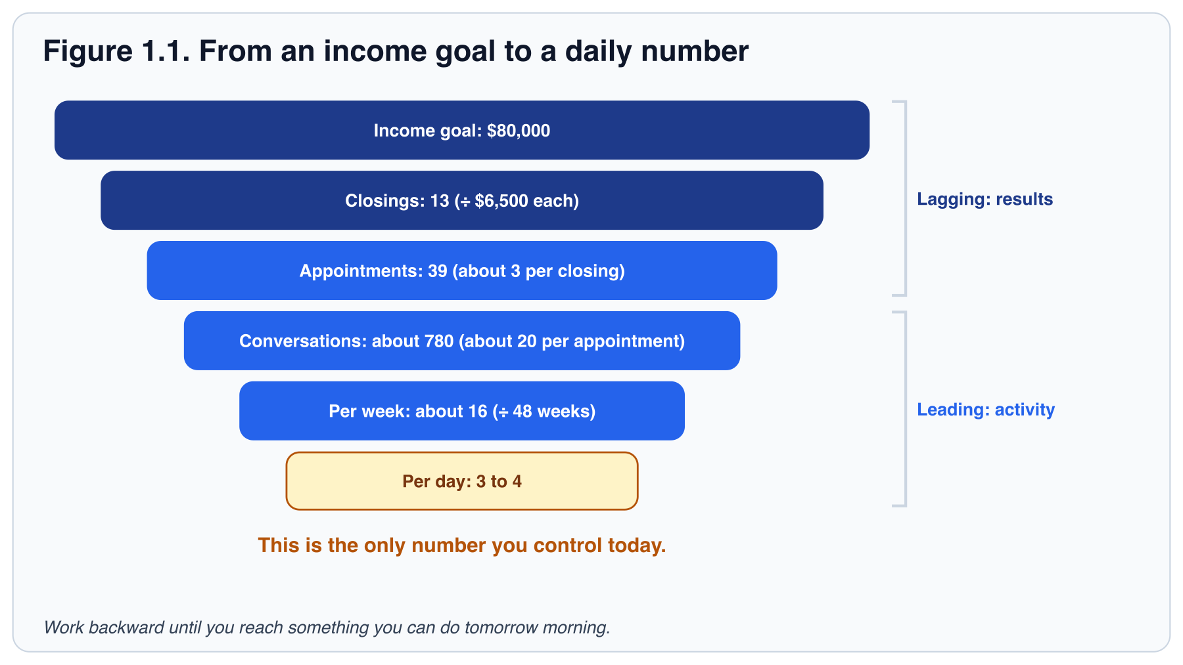
Table 1.1. From an income goal to a daily number. The example column matches Figure 1.1. Fill in the last column with your own numbers.
LINE | HOW TO WORK IT OUT | EXAMPLE | YOUR NUMBER
Income goal | The commission income you want to earn this year. | $80,000
Average commission per closing | Ask your broker for the figure for an agent in their first year. | $6,500
Closings needed | Income goal ÷ average commission per closing, rounded up. | 13
Appointments needed | Closings × appointments per closing (about 3). | 39
Conversations needed | Appointments × conversations per appointment (about 20). | About 780
Conversations per week | Conversations ÷ working weeks in the year (48). | About 16
Conversations per day | Weekly number ÷ 5 working days. | 3 to 4

INTERACTIVE · INCOME GOAL CALCULATOR
Turn an income goal into closings, conversations a week and a daily number, then stress-test it.
Use this tool in the online handbook.

Three or four real conversations a day feels small. That is the point. A daily target you can hit on a bad day is worth more than a heroic target you hit twice and abandon.
FIELD NOTE
Your ratios will be worse than the example in your first six months and better after a year. Track your own. For example, if your own ratio turns out to be eight conversations to book one appointment, your daily plan writes itself from that number. Table 1.1's example uses about 20. Table 8.2 is the weekly scorecard.

The ladder tells you how much activity the goal needs. One more piece of arithmetic tells you how long you can afford to wait for it.
Table 1.2. Runway and commission worksheet. Fill it in once with your broker's month-one list, then revisit it after your first closing.
LINE | HOW TO FILL IT IN | EXAMPLE | YOUR NUMBER
Monthly business costs | Association and MLS dues, CRM, errors-and-omissions insurance, phone, mileage, marketing, continuing education. Ask your broker for the month-one list. | $600
Monthly living costs | Rent or mortgage, food, insurance, debt payments. The business has to cover these too, eventually. | $3,400
Months to first check | Closings lag activity by 60 to 120 days, and a contract takes another 30 to 45 days to close. Plan on four to six. | 5
Runway needed | (Business costs + living costs) × months to first check. Savings, a working partner or part-time income has to cover it. | $20,000
From every commission check | Set aside a share for taxes first (you are self-employed; a tax professional sets the share, and many new agents start at a quarter to a third), then a tenth for the business, then pay yourself. | 30% taxes, 10% business, 60% pay

Ask whether your brokerage has a cap or a split for first-year agents, and put the quarterly estimated-tax dates in your calendar today (Appendix F links the IRS page). An agent who runs out of runway in month four was often one month from a closing.

Your CRM is your headquarters
Your CRM is where your contacts, tasks, follow-up plans, Opportunities (your active deals, shown as a pipeline; Opportunities is the Keller Williams Command name) and marketing live. The habit that matters most in your first 90 days is simple: open your CRM first thing every morning and update it before you stop working. The first three things to check are the new leads that arrived overnight, the tasks due today, and the Opportunities that moved; Chapter 4 builds the full daily rhythm around them. Contacts that live in your phone, sticky notes and inbox are contacts you will forget. If you treat your CRM as non-negotiable, you stay organized. If you do not, you will fall behind within a quarter, and the leads you lose in that stretch are hard to win back.
TRY IT TODAY
- Fill in the "Your number" column of Table 1.1 with your own income goal and your office's average commission. If you do not yet know the commission, ask your broker for the figure for an agent in their first year, not a top producer's.
- Write your daily conversation target on a card and put it where you work. Keep this number. You will split it across lead sources in Chapter 2 and use it in the Chapter 8 scorecard.
- List the last five things you did for your business this week. Mark each L (leading) or G (lagging). What share were leading?
- Fill in Table 1.2 with your broker's month-one cost list. If the runway line is larger than what you have, decide today what covers the gap, and put the quarterly estimated-tax dates in your calendar.
- Block 9:30 to 11:00 tomorrow morning in your calendar and label it "Lead generation". This is the same 90-minute block Chapters 4 and 8 use. Do not move it.

KEY TAKEAWAYS
- Closings lag activity by 60 to 120 days. Measure the activity that produces them.
- Work backward from income to a daily conversation target you can hit on your worst day.
- Your CRM is the single source of truth. Open it first, update it last.

INTERACTIVE · TEST YOUR KNOWLEDGE
Three multiple-choice questions and a fill-in-the-blank, with the right answer and the reason shown on click.
Use this tool in the online handbook.

PART II: FIND

2. Finding clients
Where clients come from, what each source costs, and how to make your name mean "local expert" before anyone needs you.
In Chapter 1 you worked out that your income goal needs roughly 16 conversations a week. That is a number. It is not yet a plan, because the next question is the practical one: with whom?
Every lead source trades time for money or money for time. Some cost nothing but nerve; some cost a monthly bill. This chapter shows you the six sources new agents use, what each demands of you, and how to start with the one that is cheapest and works best: the people who already know your name. You are not finding clients yet. You are finding conversations that become clients.
IN THIS CHAPTER YOU WILL LEARN TO
- List at least 150 people in your sphere and contact them in the order announce, give, ask, repeat.
- Choose the first two lead sources to work, based on what each costs in time and money and what you can follow up on today.
- Run an open house in three phases (before, during, after) so that every visitor enters a follow-up plan.
- Calculate cost per appointment and cost per closed deal for one source from four monthly counts.

Sphere of influence and referrals
Your sphere of influence is everyone who already knows you and would take your call: family, friends, former colleagues, neighbors, your dentist, the parents at your kid's school, the people in your gym class. For most agents this is the highest-return source they will ever have, because trust is already built and the cost is only time.
Build the list first. Go through your phone contacts, social media connections, email history and holiday card list. Most people find 150 to 300 names. Import every one into your CRM and tag them by relationship so you can sort later. If your CRM is not set up yet (Chapter 4 covers it), build the list in a spreadsheet and import it later.
Then work the list with value first. The order matters:
- Announce. Tell everyone you are in real estate and with whom. One message, personal, not a mass blast. Send it as a personal call or text, not through an automated tool, and check your broker's outreach rules first (Chapter 11).
- Give. Send something useful: a neighborhood market update, a home maintenance checklist, an introduction to a good contractor.
- Ask. After two or three helpful touches, ask for introductions. Chapter 6 has the words, including the announcement.
- Repeat. Put the whole sphere on a touch plan so no one hears from you only when you want something.

PITFALL
New agents often skip the sphere because calling friends feels awkward, then spend money on portal leads to avoid the discomfort. Your sphere often converts far better than a portal lead. The awkwardness fades after the tenth call. The ad bill does not.

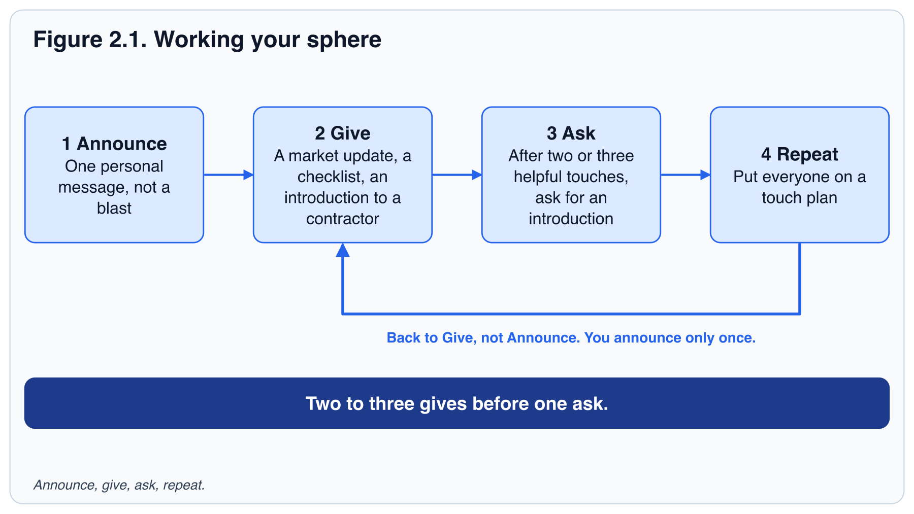

Online leads
Portal leads (Zillow Premier Agent and similar), your own ads, and inquiries through your Agent Site or IDX website provide volume. They also convert at a far lower rate, because the person has no relationship with you and has often inquired with several agents at once. Two things decide whether online leads pay off:
- Speed. The first agent to make real contact usually wins the conversation. Chapter 4 covers the five-minute response window (for now, reply as fast as you can).
- Persistence. Most online leads are 6 to 18 months from a transaction. Without a long nurture plan you are paying to warm up a lead for someone else.

Do not rely on online leads exclusively, and do not buy them until you pass the 9 p.m. test in Chapter 3: an immediate automated reply, a call by the next morning, and a 90-day plan, all running without you having to remember. You build that system in Chapters 4 and 5; test it on your sphere first.

Open houses
An open house is a lead-generation event with a listing as the excuse. Treat it that way and it will produce buyers who are active now and neighbors who may sell next year. Treat it as sitting in a house for three hours and it will produce nothing.
The sequence matters. Before is about being able to answer a price question on the spot. During is about capturing people, not selling to them. After is where the leads are made.

Before
- Preview the home and the five nearest comparable sales so you can answer price questions on the spot.
- Invite the 20 nearest neighbors in person or with a door-knock the day before. "Would you like to see what your neighbor's home is listed for?" is an easy opener.
- Set up digital sign-in on a tablet that feeds your CRM. Paper sign-in sheets get lost.

During
- Greet every visitor, ask one open question about their search, and capture name, phone and email.
- Ask the qualifying questions in conversation (Chapter 5 teaches the four; for now, ask when they hope to move and whether they are working with an agent).
- Offer a concrete next step: a list of similar homes, a buyer consultation, or a neighbor's home value report.

After
- Follow up with every visitor within 24 hours. A text the same evening and a call the next morning is the standard.
- Put every visitor on a follow-up plan. The visitor who was "just looking" today is often the buyer in four months.
- Log the open house and its visitors as a lead source so you can measure it.

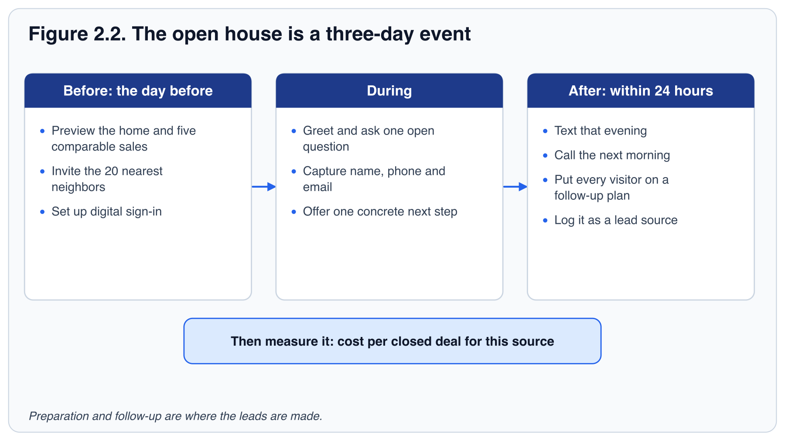

Geographic farming
Farming means choosing one neighborhood of 300 to 500 homes and becoming the agent everyone there recognizes. It works through consistency: monthly mailers, door-knocking, a neighborhood market report, sponsoring the block party. Expect six to twelve months before listings appear, so farm only if you can afford the wait. As a rule of thumb many agents use, pick a farm with a turnover rate of at least 6 percent a year, few dominant agents, and homes at a price point that pays you fairly for the effort.

Expired listings and for-sale-by-owners
Owners whose listing expired, or who are trying to sell alone, have already raised their hand. Many agents will call them, so the approach has to be respectful and persistent. Lead with curiosity about what they want to do next, not with criticism of their last agent or their price. This source rewards skilled, consistent prospectors and frustrates everyone else. A simple opener is: "I saw your home came off the market. What would you like to happen next?" Treat it as an advanced source and postpone it until your sphere and follow-up are working.
BEFORE YOU CALL
Cold calls and texts to these owners can fall under Do Not Call and consent rules, and the rules differ by state. Ask your broker which lists you may use, what to scrub against, and when you may call or text. This is a pointer, not legal advice. Chapter 11 covers the habits.

Referral partners
Lenders, attorneys, other agents and relocation contacts meet people before they pick an agent. For a new agent with no past clients, they are the next-best source after your sphere. Introduce yourself (Chapter 6 has the script), ask how they like to work, and refer to them when it helps your client. Ask your broker about any rules on referral fees before money or favors change hands.
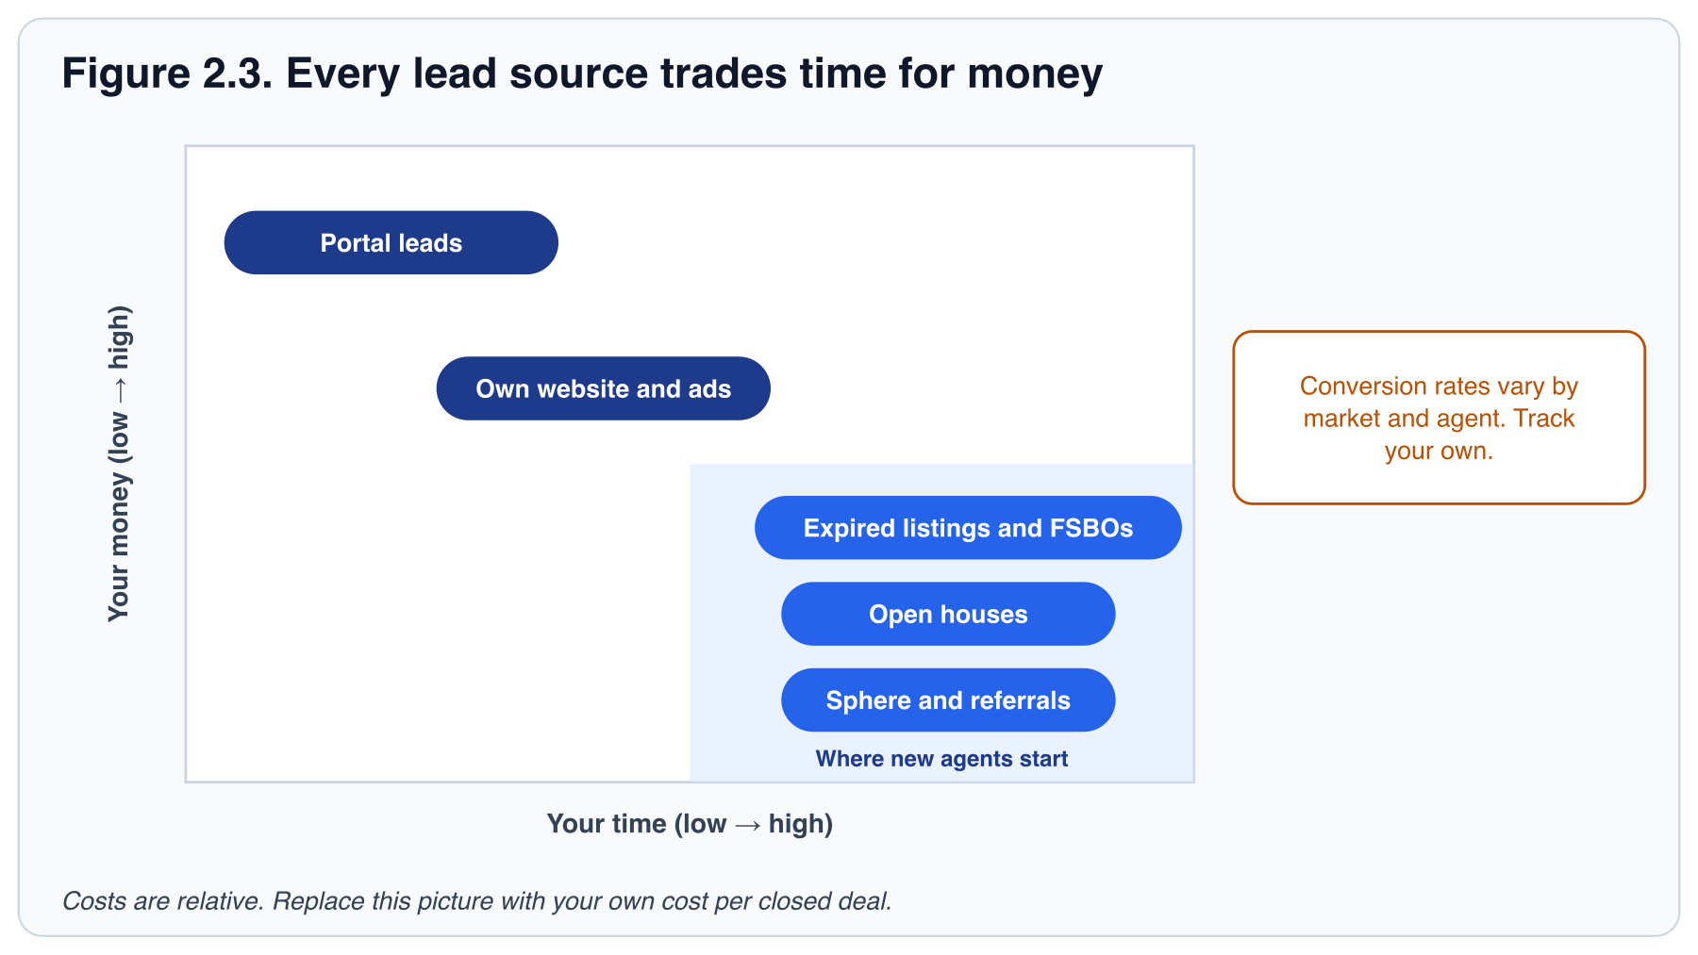
Table 2.1. Lead source comparison. These ranges are illustrative. They are not the same unit, and they are not comparable across sources. Use them only as a rough picture of where to start, then replace them with your own cost per closed deal.
LEAD SOURCE | ILLUSTRATIVE RANGE (NOT A MEASURED RATE) | COST PROFILE | EXCLUSIVITY | BEST FOR
Sphere of Influence & Referrals | 15–30%+ | Low (Time & relationship) | High (Usually exclusive) | Experienced & new agents building long-term business
Zillow Premier Agent | 1–5% | High (Significant monthly spend) | Moderate (Shared leads possible) | Agents with strong follow-up systems & budget
Own IDX Website & Ads (PPC, Social) | 2–6% | Moderate (Ad spend & maintenance) | High (Directly generated) | Agents willing to manage marketing & long nurture
Open Houses | 5–15% | Low (Time-intensive) | High (Direct personal interaction) | Identifying active local buyers
Expired Listings & FSBOs | 3–8% | Low (Time & prospecting tools) | Low (Competitive) | Persistent, skilled prospectors seeking quick inventory

INTERACTIVE · LEAD SOURCE COMPARISON
Compare typical conversion ranges, then work out your own cost per appointment and cost per closed deal, with your time priced in.
Use this tool in the online handbook.

Track every source
In your CRM, every contact carries a lead source. Fill it in every time. At the end of each month, count by source: contacts added, appointments held, closings, and dollars spent. Two numbers come out of those counts. Cost per appointment is (dollars spent + your hours at a rate you choose) ÷ appointments held, and you can calculate it in month one. Cost per closed deal is the same spend ÷ closings. It is the number that decides where your budget goes, but a new source often has no closing for months, so compare sources on cost per appointment first and confirm the choice on cost per closed deal once the closings arrive.
Worked example, open houses, month one. Four houses, 38 visitors captured, 6 appointments, and one closing in month five. Cost: $120 in materials plus 24 hours at $25 an hour, or $720. Cost per appointment: $720 ÷ 6 = $120, known at the end of month one. Cost per closed deal: $720 ÷ 1 = $720, known only in month five. After six months you will know which sources deserve more of your week and which to stop. Chapter 3 picks up with how people will see you once those conversations start.
TRY IT TODAY
- Take your weekly conversation number from Chapter 1 and split it across your sources. A new agent might start with: sphere 10, open house follow-ups 3, other 3. Write the split on your card from Chapter 1.
- Build your sphere list. Aim for 150 names. Import them into your CRM with a "Sphere" tag, or keep them in a spreadsheet until your CRM is ready.
- Send the announcement message (Chapter 6 has the script) to the first 20 people. Personal, two sentences, no sales pitch.
- Ask a colleague whether you can host their next open house. Ask what you are allowed to say about the listing and how leads are shared. Schedule it.

KEY TAKEAWAYS
- Your sphere is the best-converting, cheapest source you will ever have. Work it first.
- Online leads need speed and a long nurture. Without both, you are paying to warm leads for other agents.
- Open houses are events: invite neighbors, capture digitally, follow up within 24 hours.
- Tag every contact with a source. Measure cost per appointment first, then cost per closed deal.

INTERACTIVE · TEST YOUR KNOWLEDGE
Three multiple-choice questions and a fill-in-the-blank, with the right answer and the reason shown on click.
Use this tool in the online handbook.

PART II: FIND

3. Marketing and brand presence
In Chapter 2 you chose where your first conversations will come from. Chapter 3 is about what people see once you have started them. A friend you called last week will look you up. A neighbor who picks up your mailer will search your name. Before they decide whether to call you, they will decide who you are.
Marketing should make them feel two things: you are the local expert, and you are the person who will take care of them. Consistency beats perfection. This chapter shows you how to be easy to find, easy to remember and easy to trust, without spending money you do not yet need to spend. Your first marketing budget is your calendar.
IN THIS CHAPTER YOU WILL LEARN TO
- Write one sentence that says who you help and where, and use it in your profile, bio and first post.
- Plan a four-week content calendar you can keep on your busiest week.
- List the five posts every listing should produce, and explain how each leads back to you.
- Apply the 9 p.m. test to decide whether you are ready to pay for leads.

Your home base
Your Agent Site (your public website profile, listings and home search) and your Client App (a branded search app for your clients that keeps you attached to every home they save) are the places you send everyone. Both names are the Keller Williams Command examples; if your brokerage calls them something else, or does not provide them, use your public profile page and a link to your home search. Set them up in your first week, with a professional photo, a short bio written in plain language, and your real contact details. Check that every link on your social profiles and email signature points to your Agent Site.
Your reviews live here too. Turn on reviews on your Agent Site and claim your profile on Google and on the portals your market uses, so the 30-day review request in Chapter 10 has somewhere to land. Reviews are marketing you do not write: an online lead reads them before deciding whether to answer your call, and three honest reviews make a new agent look established. Ask only people you have actually served, never write or trade reviews, and reply to every one.
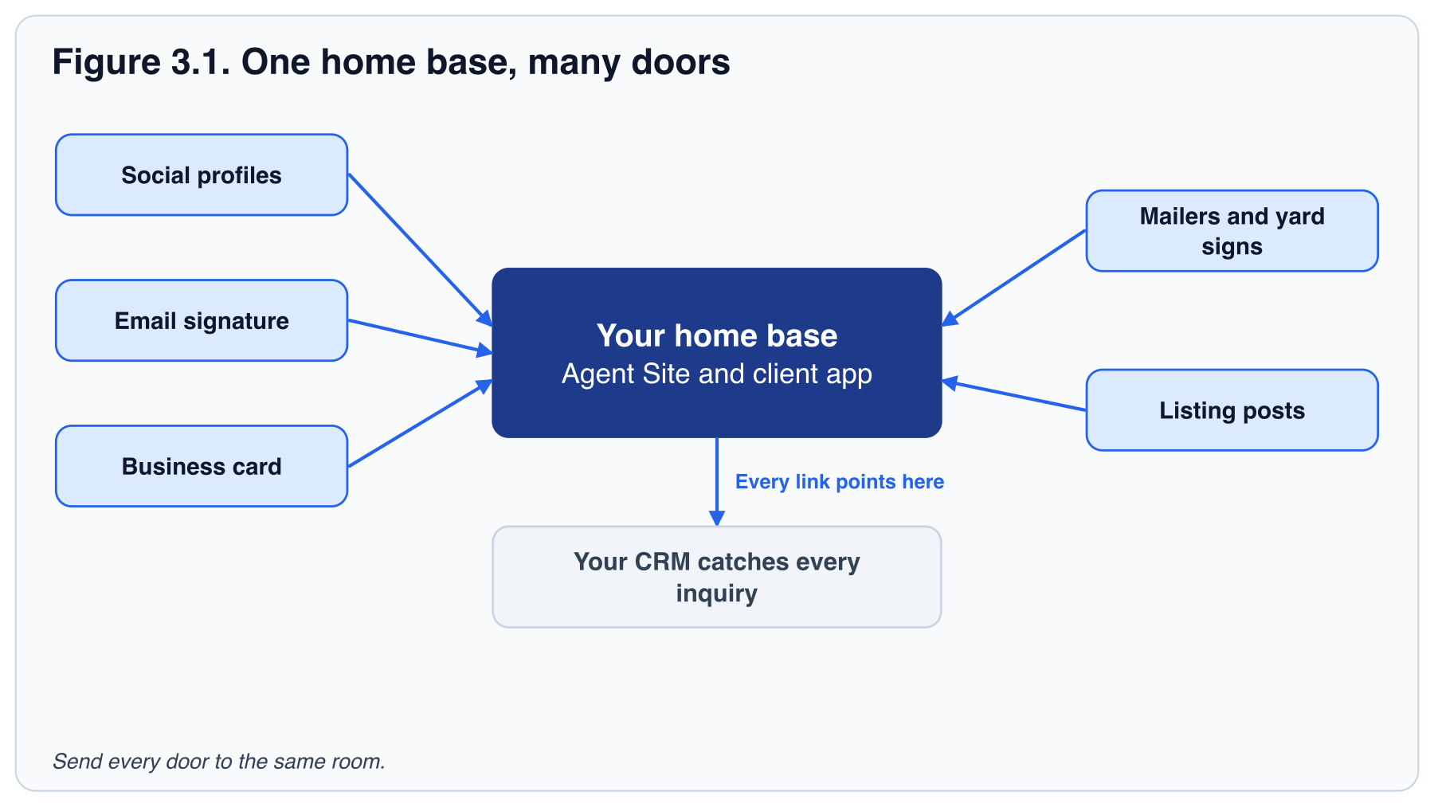

What people should say about you
For a new agent, a brand is a promise stated in one sentence, plus proof. Fill in the blanks: "I help [who] [do what] in [where]." For example: "I help first-time buyers in Eastside feel confident about their first offer." Use that sentence in your bio, your profile and your first post. Every post after that is proof of the sentence.
Proof is the problem when you have no sold homes. Until you have your own, borrow a colleague's with their permission, or profile a local business, a school or a park. Credibility starts with knowing the place.

A content calendar you can keep
People hire the agent they remember. Showing up regularly with useful information is how they remember you. Pick a schedule that you can keep on a busy week, then keep it. A workable minimum for a new agent:
Table 3.1. A minimum sustainable content calendar. Batch-create a month of posts in one sitting.
CADENCE | CONTENT | WHERE
Weekly | One neighborhood or market observation: what sold, what is new, what surprised you. | Social post, email to sphere segment
Weekly | One educational tip: inspection, financing, timing, preparing a home. | Short video or image post
Monthly | Market update with three numbers: median price, days on market, months of inventory. | Email newsletter via your CRM, mailer to farm
Quarterly | A local guide: schools, parks, restaurants, events. | Blog post on Agent Site, shareable PDF
Per listing | Coming soon, just listed, open house, under contract, just sold. | Social, email, mailers to the neighborhood

FIELD NOTE
You do not need to be a video personality. A 45-second phone video of you standing in front of a home you toured or a place you know well, explaining one useful thing, tends to outperform a polished stock graphic. Once you have a sold home of your own, stand in front of that. People hire people.

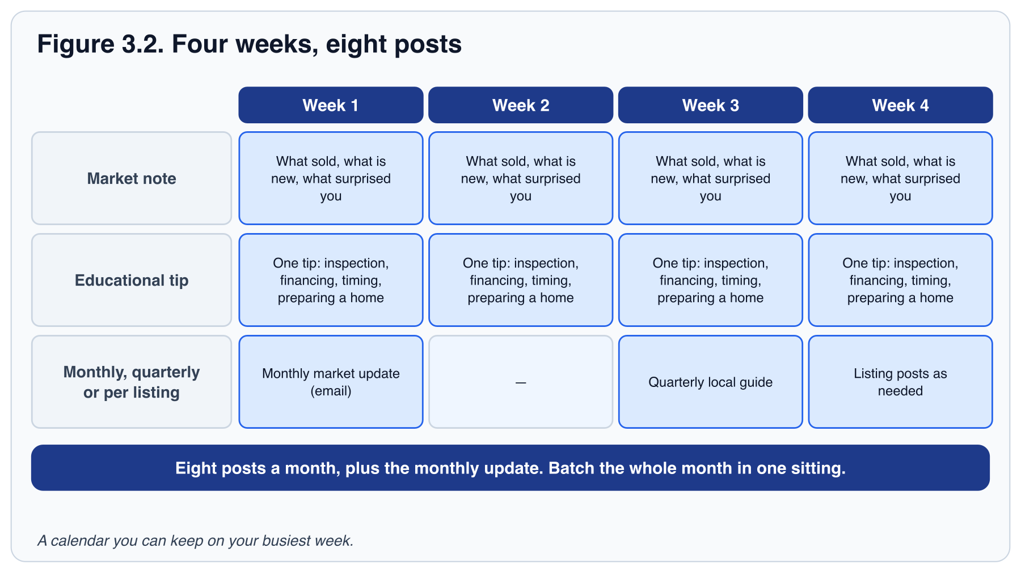

Market every listing thoroughly
A listing is the most powerful marketing asset you will hold. Good listing marketing sells the house and also generates buyers (who call about it) and sellers (neighbors who see you working). For every listing, at minimum:
- Professional photography and a floor plan. Phone photos cost sellers money and cost you credibility.
- A "coming soon" post and a "just listed" post, each with a call to action that leads to you.
- Mailers or door-knocks to the 50 nearest homes before the open house.
- A "just sold" update with a line about how many showings or offers it received. This is the single best seller-lead post you can make.

Your broker has rules for what must appear on every ad, such as the brokerage name and your license number, and for how listing photos and Fair Housing language may be used. Ask before you post. Chapter 11 covers the standards.
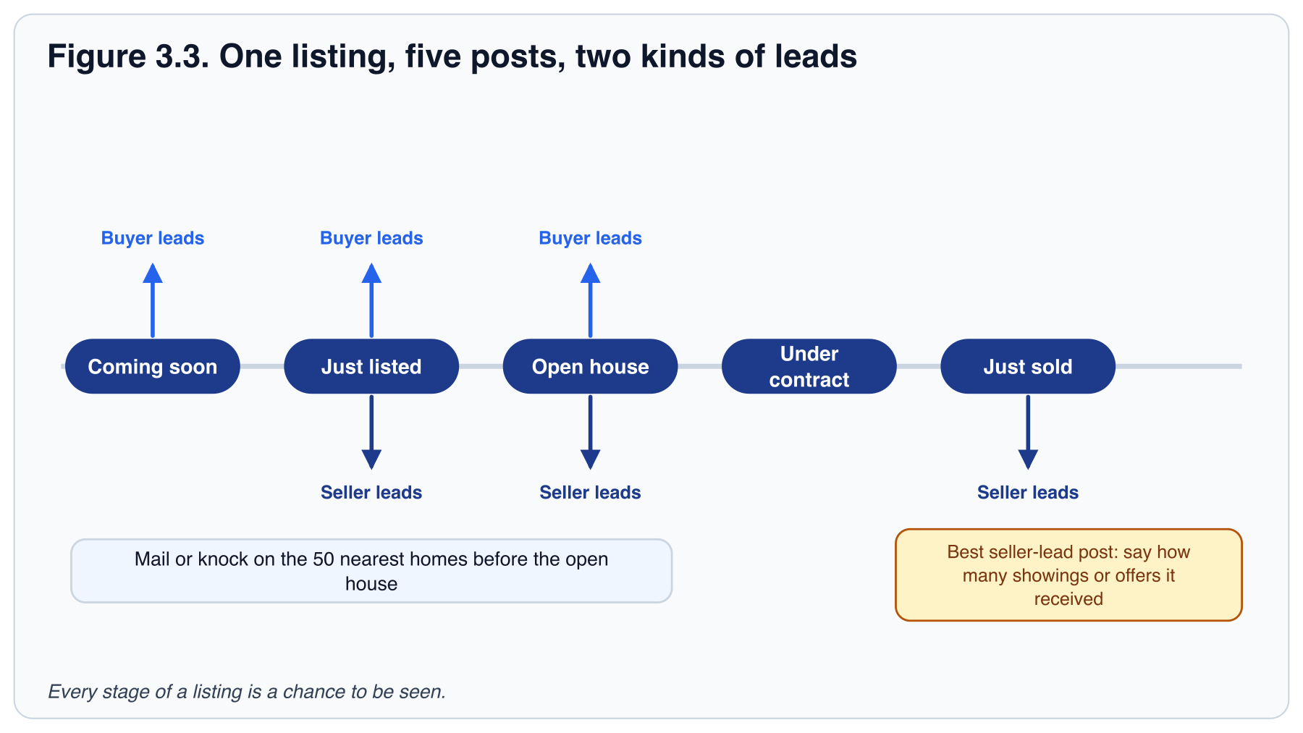

Paid advertising
Facebook and Instagram ads, Google ads and portal placements can all accelerate volume. They are worth it only when your follow-up system is already catching and nurturing leads reliably. The test is simple. Before you pay for leads, pass the 9 p.m. test: a lead arriving at 9 p.m. tonight gets an immediate automated reply, a call by the next morning and a 90-day plan, all without you having to remember. You will build all three in Chapters 4 and 5. Until you have, hold off: buying leads before then is buying a leak.
When you do start, start small, run one source at a time for 90 days, and track cost per appointment and cost per closed deal before scaling.
PITFALL
Spending on branding before spending time on conversations. Logos, car magnets and a custom website produce nothing on their own. Your first marketing budget is your calendar.

TRY IT TODAY
- Write your one-sentence promise. Complete your public profile and send yourself the client app invitation, if your brokerage provides one, to see what a client sees.
- Pick the question for your video from your sphere conversations in Chapter 2. Record one 45-second video answering it and post it to your sphere list.
- Write next month's eight posts (two a week for four weeks) in one sitting, make every post answer your promise, and schedule them.
- Rehearse a listing: choose any currently listed home near you. List the five posts you would make, from "coming soon" to "just sold", and write the first line of each.

KEY TAKEAWAYS
- A one-sentence promise plus proof is your brand. Your website and client search app (the Agent Site and Client App, in Keller Williams Command) are the home base. Send everyone there.
- A modest, consistent content schedule beats bursts of brilliance.
- Every listing should produce buyers and future sellers, not only a closing.
- Paid ads amplify a system. They cannot replace one.

INTERACTIVE · TEST YOUR KNOWLEDGE
Three multiple-choice questions and a fill-in-the-blank, with the right answer and the reason shown on click.
Use this tool in the online handbook.

PART III: YOUR OPERATING SYSTEM

4. Your CRM and daily operating system
One tool, set up once, used every day. Your CRM is where the system lives, and speed-to-lead is its first rule.
By now you know where leads come from and how people will find you. What you do not yet have is a place to put them. A name in your phone, a number on a sticky note and an email you meant to answer are three different places a lead can disappear.
This chapter gives you one place. You will set up your CRM in your first week, build a daily rhythm around it, and learn the rule that decides whether online leads are worth paying for: answer within minutes. Chapters 2 and 3 told you to build this before you spend. Here is how. Your CRM is your core tool: set it up properly once so it works for you every day, then let it enforce the habits you have not built yet. Where a screen has a brand name, this chapter uses the Keller Williams Command name and labels it as an example; in another CRM, use its equivalent.
IN THIS CHAPTER YOU WILL LEARN TO
- Complete the six-part CRM setup, in order, in your first week.
- Run your day in five blocks (start of day, follow-up tasks, prospecting, appointments, end of day) with a time budget for each, and protect the first three.
- Set up a two-layer response to every online inquiry, and test it with a friend.
- Decide whether a new tool is worth adding by applying two conditions.

The one-time setup
Your CRM rewards agents who set it up completely and punishes those who set it up halfway. Do these six things in order during your first week. Appendix C turns them into a checklist.
- Complete your profile and Marketing Profile (the Keller Williams Command example; in another CRM, its branding settings). Photo, bio, phone, email, license number, social links, brand colors. Everything your CRM generates for you pulls from here.
- Import contacts. Phone, email, social and any spreadsheet you have. Deduplicate, then tag each contact by relationship (sphere, past client, lead) and by source.
- Create or download follow-up plans. Start with an 8x8 (an eight-week plan for new sphere contacts; Chapter 5 explains it), a quarterly call plan for the whole database, a new-lead plan with fast early touches, and a post-close plan. The post-close plan is built once, assigned on the day the client goes under contract, and activated on closing day; it runs seven dated touches in the first year, starting with the closing-day note. Build it now, so it is ready before your first contract. Table 5.1 lists the starter library and Appendix B has day-by-day versions.
- Set lead routing rules if you are on a team, so inquiries reach the right person instantly.
- Customize your Opportunities pipeline (the Keller Williams Command example; in another CRM, its pipeline or deal stages). Rename stages to match how you actually work (for example: New, Contacted, Appointment set, Active, Under contract, Closed) so your pipeline view is honest.
- Install the CRM mobile app and turn on notifications for new leads and due tasks.

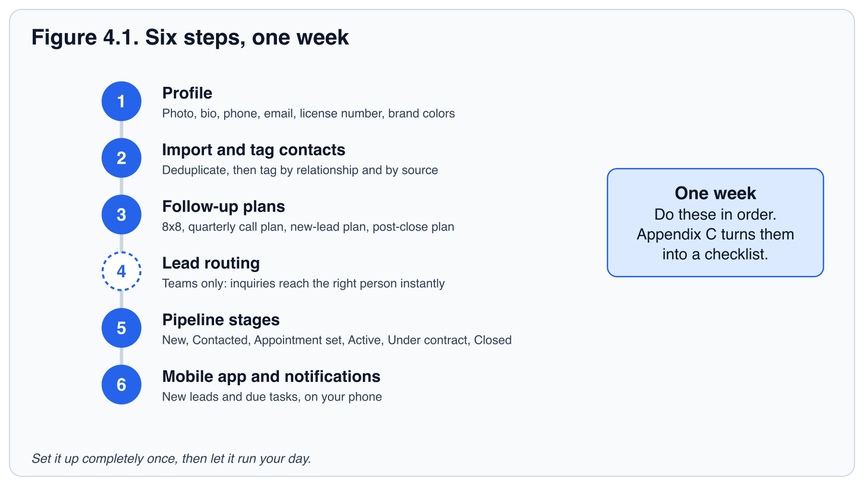

The daily rhythm
Once your CRM is set up, your day has a shape. Start in your CRM, work the follow-ups it hands you, prospect, hold appointments, and end in your CRM. The order matters: follow-ups come before prospecting because a lead you already have is worth more than one you have not met yet.
Figure 4.2. The CRM-centered daily operating rhythm. The day opens and closes in your CRM, and follow-ups come before new prospecting.
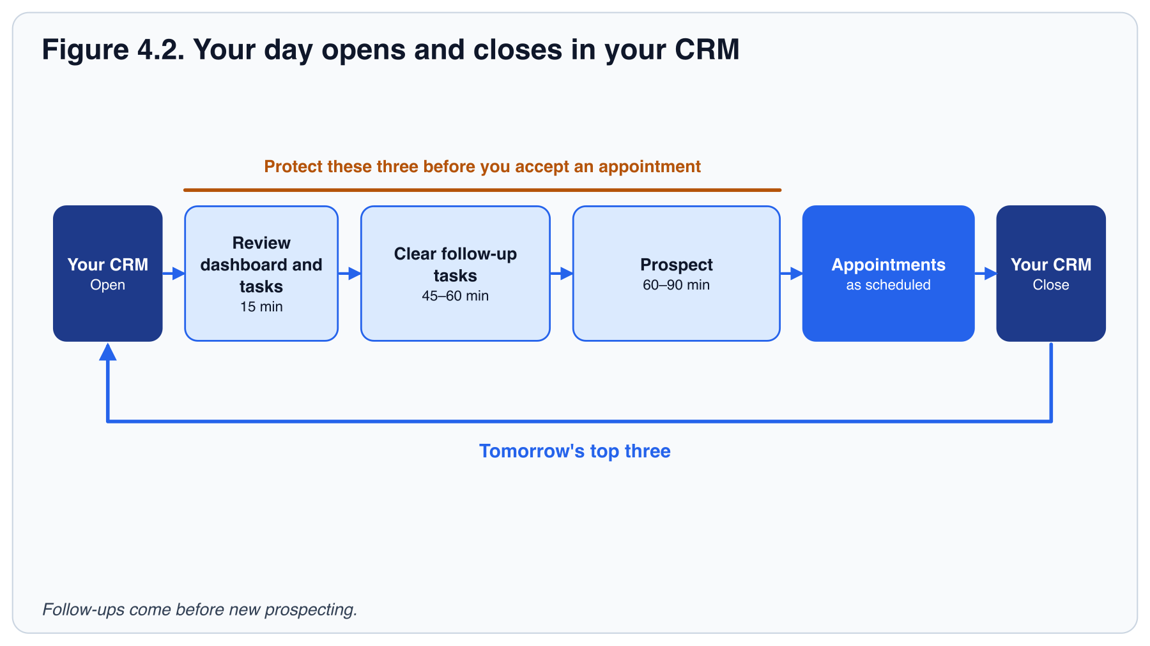
Table 4.1. Time budget for the daily rhythm. Protect the first three blocks before you accept any appointment. This is the same 90-minute prospecting block as the Chapter 1 and Chapter 8 schedule (9:30 to 11:00).
BLOCK | WHAT HAPPENS | TIME
Start of day | Review the dashboard: new leads overnight, tasks due today, Opportunities that moved. | 15 min
Follow-up plan tasks | Clear every due task: calls, texts, emails. Log the outcome on each contact. | 45 to 60 min
Prospecting block | New conversations: sphere calls, open house follow-ups, farm, expireds. Hit your daily number. | 60 to 90 min
Client appointments | Consultations, showings, listing presentations, inspections. | As scheduled
End of day | Log every conversation, move Opportunities to the right stage, set tomorrow's top three. | 15 min

Speed-to-lead
When someone inquires online, they are usually sitting in front of a screen at that moment, and they have probably sent the same inquiry to two or three other agents. The agent who responds first with a real, human message is the one who gets the conversation. Response time is among the biggest factors you control in online-lead conversion.
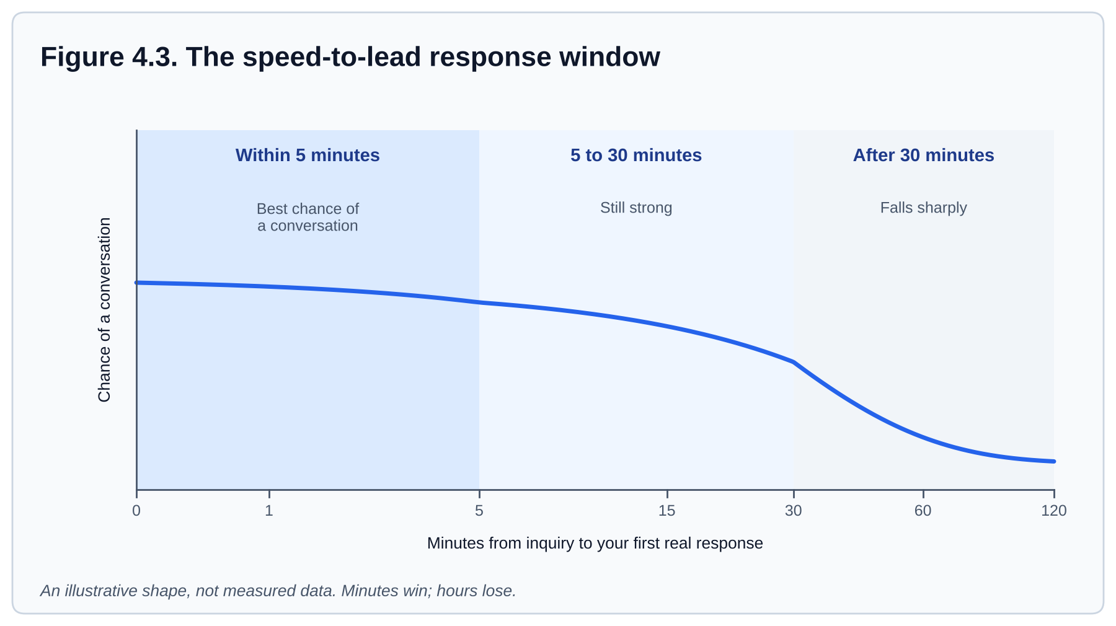
Figure 4.3. The speed-to-lead response window. This is an illustrative shape, not measured data: the chance of a conversation is highest inside five minutes, still strong within about half an hour, and falls sharply after that. Most agents respond in hours. Top producers respond in minutes.
The standard is two layers:
- Automated first touch, within one minute. A new-lead follow-up plan sends an email the moment the lead lands, and a text only with recorded consent. It should sound like you and ask one easy question. Send automated texts or calls only to people whose consent you have recorded in the CRM, and stop at the first opt-out. Honor quiet hours. An inquiry is not, by itself, consent for an automated text sequence.
- Live call. Answer every new lead with a live call within five minutes when you can, and always the same day. Turn on mobile notifications for new leads and step out of whatever you are doing, unless you are with a client. If you are with a client, let the automated first touch buy you time and call at the first break.

If you cannot make a live call within the hour, send a personal voice note or, if you have permission to text them, a short text that names the property or area they asked about. Specificity proves a human read the inquiry.
FIELD NOTE
Test your own speed-to-lead. Have a friend submit an inquiry on your website (your Agent Site, in the Keller Williams Command example) at 9 p.m. on a weekday. Time how long until they get a text, an email and a call. Fix whatever is slower than you expected before you spend a dollar on ads.

INTERACTIVE · RESPONSE-TIME STOPWATCH
Time a real test inquiry against the one-minute and five-minute standards.
Use this tool in the online handbook.

Optional tools
Branded client apps, AI texting assistants and dialers can all add value later. Add them only when two things are true: your basic CRM system is running cleanly, and you have enough lead volume that the tool pays for itself. A new agent with a working CRM setup and 30 leads a month does not need a second CRM. A tool you have not mastered is one more place for a lead to get lost.
TRY IT TODAY
- Work through Appendix C and finish the CRM setup checklist. Start by importing the sphere list you built in Chapter 2. Plan on a full day for the whole checklist, not an hour; do the profile and import first, and the rest as you can.
- Set up a minimal new-lead plan: an acknowledgment on day 0 and one question (email, plus a text if you have permission). Chapter 5 builds the full plan. Then run the speed-to-lead test above.
- Put the daily rhythm from Table 4.1 into your calendar as recurring blocks.

KEY TAKEAWAYS
- Set your CRM up completely in week one: profile, contacts, follow-up plans, routing, pipeline, mobile app.
- Open and close every day in your CRM. Follow-ups before prospecting.
- Speed-to-lead means an automated reply in a minute and a live call in minutes, not hours.
- Add optional tools only when the basics are working and the volume justifies the cost.

INTERACTIVE · TEST YOUR KNOWLEDGE
Three multiple-choice questions and a fill-in-the-blank, with the right answer and the reason shown on click.
Use this tool in the online handbook.

PART IV: NURTURE

5. Nurturing leads
Most leads convert between the fifth and twelfth touch. Most agents quit after the second. The gap between those two facts is where your business is.
The first minute is the easy part. Your CRM sends a text, you pick up the phone, and, if you are quick, you reach someone. Then what? Most leads are not ready to decide on the first call. They are curious, early, unsure of financing, or waiting on a life event.
Follow-up that is frequent, varied and genuinely useful is what turns an inquiry into a client. This chapter shows you how to cross the gap: a 90-day plan that rotates calls, texts and emails; four questions that tell you how to help; and one Friday habit that keeps anyone from slipping away. Four ideas: why you follow up, what a good plan looks like, how to qualify, and how to check you are doing it.
IN THIS CHAPTER YOU WILL LEARN TO
- Explain in two sentences why most leads convert after several touches, not one.
- Plan a 13-touch, 90-day sequence that mixes channels and gives value every third touch.
- Qualify a lead early with four questions, and stage them as active or nurture.
- Run a weekly pipeline review so nobody falls through the cracks.

Why one call is never enough
A person who inquires about a home online is usually months from a decision. One call cannot carry them through all of that. Many agents and industry trainers report that most conversions happen between the fifth and twelfth contact, spread across weeks or months; treat that as a working assumption and track your own. Most new agents stop after one or two attempts. The leads they abandon are the ones that would have closed for the agent who kept going.
PITFALL
Treating "no answer" as "not interested". Unanswered calls are normal. A lead who has not replied to three touches is still a lead. The plan continues until they say stop or until they buy.

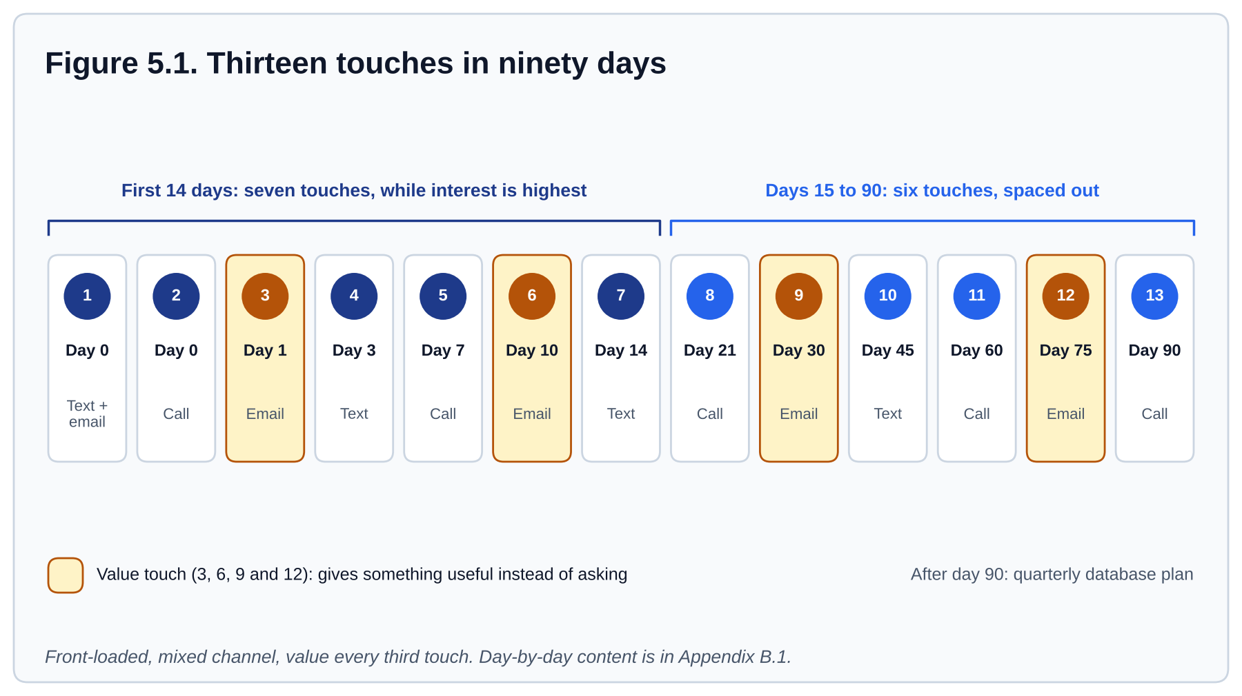
Figure 5.1. The 13-touch, 90-day nurture timeline from Appendix B.1. Touches are front-loaded in the first 14 days, then spaced out. Every third touch (3, 6, 9 and 12) gives something of value instead of asking for something.

Designing a nurture plan
A good plan has four properties. Build every follow-up plan against them.
- Front-loaded. Seven touches in the first 14 days, while interest is highest.
- Mixed channel. Calls, texts and emails in rotation. Some people only answer texts. Some only read email. No single channel reaches everyone.
- Value every third touch. A neighborhood report, a buyer guide, a "homes like the one you asked about" list, a short video. Give before you ask.
- Long. At least 90 days of scheduled touches, then roll into the quarterly database plan.

Launch the right plan on every new lead the day it arrives, and launch the quarterly plan on your existing database this week. Table 5.1 shows which plan fits which contact, and Appendix B has day-by-day versions you can build into your CRM in an afternoon. One rule applies to every automated plan. Send automated texts or calls only to people whose consent you have recorded in the CRM, and stop at the first opt-out. Honor quiet hours too; Chapter 11 has the detail.
FIELD NOTE
Write your automated texts the way you would type them to a friend. "Hi Jordan, it's Sam with [Brokerage]. Still thinking about the Maple Street area?" outperforms anything that sounds like a newsletter.

The follow-up plan starter library
Appendix B has a ready sequence for six of these, and B.4 shows where the post-close and home anniversary touches fit. Start with three: the 8x8 for new sphere contacts, the Quarterly Call Plan, and the 90-day new-lead plan (the 13 touches in Figure 5.1). Between them they cover the highest-impact activities. Add the neighborhood and long-term nurture plans once the first three are running consistently.
Table 5.1. Follow-up plan starter library. Touch counts are approximate. For a new online lead, use one plan: the 13 touches in Figure 5.1 and Appendix B.1. Its first minute is the instant response from Chapter 4 and its first week is the early sprint. 8x8 means only the eight-week sphere plan in Appendix B.2.
PLAN | PURPOSE | TOUCHES | BEST USE CASE | TIMING
New online lead (90 days) | Fast early engagement, then steady follow-up | 13 | Portal, website and ad inquiries | First minute, first 8 days, then 90 days
8x8 | Establish a new sphere relationship | 8 | Fresh sphere contacts | 8 weeks
Quarterly Call Plan (QCP) | Stay top of mind with the database | 4 per year | Sphere, past clients and long-term nurture | Every 90 days
Monthly Neighborhood Nurture | Local market value and visibility | 12 per year | Geographic farm and neighborhood presence | Monthly
Buyer Long-Term Nurture | Educate and stay in touch | 10 to 14 | Buyers not ready to move soon | Over 90 to 180 days
Seller Long-Term Nurture | Build the listing pipeline | 8 to 12 | Potential sellers and home valuation leads | Over 6 to 12 months
Home Anniversary | Post-close relationship maintenance | 1 to 2 per year | Past clients, every year after the first (the first anniversary is in the post-close plan) | On the purchase anniversary
Post-Close Plan | Reinforce the relationship | 7 in year one | Recently closed clients | First 12 months after close (Table 10.1)

- Customize the language so it sounds like you. Appendix B plans are starting points, not final scripts.
- Launch a plan on the contact in your CRM the day the contact arrives, then review and clear the resulting tasks daily.
- Chain plans: the new-lead plan rolls into a long-term nurture, which rolls into the Quarterly Call Plan. Nobody leaves the database unless they ask to.
- Time the post-close plan by the contract, not the calendar. The post-close plan is built once, assigned on the day the client goes under contract, and activated on closing day; it runs seven dated touches in the first year, starting with the closing-day note.

Qualify early
Qualifying is not interrogating. It is asking the four questions that tell you how to help and how to prioritize your time. Work them naturally into your first real conversation.
Table 5.2. The four qualifying questions. The middle columns are written for a buyer; the last column is the seller version of each. Record the answers in your CRM on the contact the same day.
QUESTION | WHAT YOU ARE LEARNING | NATURAL PHRASING | IF THEY ARE SELLING
Timeline | When they want to move, and what is driving the date. | "When are you hoping to be settled in?" | "When would you like to be moved out, and what's driving that date?"
Motivation | Why now, and how committed they are. | "What's prompting the move?" | Same question. Listen for where they are going next; a seller is usually also a buyer.
Financing | Whether they are pre-approved, cash, or need a lender introduction. For a seller: what they owe, what they think the home is worth, and whether the next purchase depends on this sale. | "Have you had a chance to talk with a lender yet?" | "Do you have a rough idea of what you owe on the home, and does your next move depend on this one selling first?"
Representation | Whether another agent is already helping them. | "Are you working with anyone on this yet?" | "Have you talked with any other agents about selling?"

Example. Jordan inquired about 14 Maple Street on Tuesday. On the day-7 call you learn: wants to move by next summer (timeline), a new job in the area (motivation), has not spoken to a lender (financing), not working with an agent (representation). Stage: nurture, with a lender introduction as your next step.
A seller gets the same four questions with the wording in the last column. Table 9.1 step 2 adds the two you ask at the consultation itself: what they believe the home is worth, and their past experience with agents.
Use the answers to place every lead in an Opportunity stage. A pre-approved buyer moving in 60 days is an active opportunity and gets calls. A "maybe next year" lead is a nurture and gets the follow-up plan. Both are valuable. They just need different attention this week.
INTERACTIVE · QUALIFY AND STAGE A LEAD
Spot which of the four qualifying questions are answered and decide active versus nurture.
Use this tool in the online handbook.

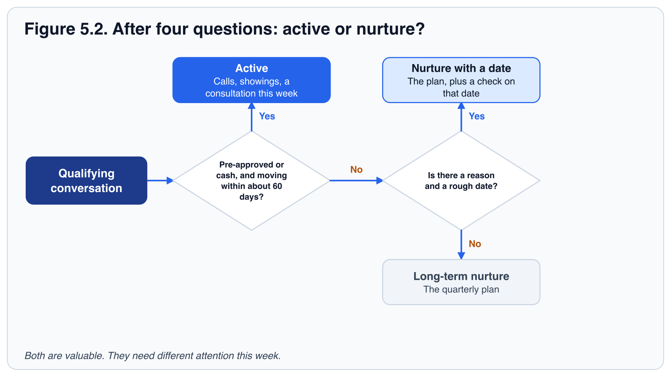

The weekly pipeline review
Every Friday, open your Opportunities pipeline and your follow-up plan task list and ask three questions about every active contact:
- When did I last have a real two-way conversation with this person?
- What is the next step, and is it scheduled?
- Is this person in the right stage?

Anyone with no conversation in 14 days and no scheduled next step gets a call on Monday. This 30-minute habit is the difference between a pipeline and a list of names. Chapter 8 puts this review and the scorecard in the same Friday half-hour.
TRY IT TODAY
- Build the new-lead follow-up plan from Appendix B in your CRM and apply it to the next lead you receive. If you have none yet, use a friend as a test lead. Do not apply a text plan to old leads unless their consent to texts is recorded in your CRM.
- Call five people from your sphere list and ask the four qualifying questions in conversation (Table 5.2). Rehearse the day-7 call out loud first, using the Chapter 6 rules.
- Put a recurring 30-minute "Pipeline review" block on Friday, right after your prospecting block (the Chapter 8 schedule). After your first review, tag each active contact with its source from Chapter 2.

KEY TAKEAWAYS
- Most conversions happen between touch 5 and touch 12. Plan for at least 90 days.
- Front-load touches, mix channels, give value every third touch.
- Qualify early on timeline, motivation, financing and representation, and record it.
- Review the pipeline every Friday. Fourteen quiet days triggers a call.

INTERACTIVE · TEST YOUR KNOWLEDGE
Three multiple-choice questions and a fill-in-the-blank, with the right answer and the reason shown on click.
Use this tool in the online handbook.

PART IV: NURTURE

6. Scripts: conversations that convert
Your follow-up plan now says "Day 7: call." That is a task, not a conversation. Many new agents see the task, feel the pause before the call, and push it to tomorrow.
A script gets you past the pause. It is not something to read; it is a way to know the first sentence, the one question, and what "done" looks like. This chapter gives you the scripts that your follow-up plans, your sphere, your referral partners, your first consultations and your past clients will call for, and a method to make them sound like you. The goal is a natural conversation that moves the relationship one step forward.
IN THIS CHAPTER YOU WILL LEARN TO
- Open a conversation with a new lead by phone, text and voicemail, naming what they asked about.
- Announce your new career to your sphere, and ask for introductions in a way that gives before it asks.
- Apply three rules (be specific, ask one question, stop talking) to any message you write.
- Keep a relationship going after the first contact: the quarterly call, the three post-close touches, and the introduction to a lender or attorney.
- Rehearse a script out loud until you can say it in your own words.

How to use a script
Read it, rewrite it in your own words, then say it out loud until you do not need the paper. Record yourself on your phone and listen back; you will hear every place where you rush or apologize. Each script below has a purpose and a next step. If you reach the next step, the script worked, even if you said none of the exact words. Practice loop: read, rewrite, say aloud, record, listen, repeat.

Three rules to read every script by
- Say their name and the specific thing they asked about. Specificity proves you read the inquiry.
- Ask one question at the end. A message with no question rarely gets a reply.
- Stop talking. After the question, wait. Silence is where the other person decides to engage.

Every script below follows them: name, specific detail, one question, then silence.
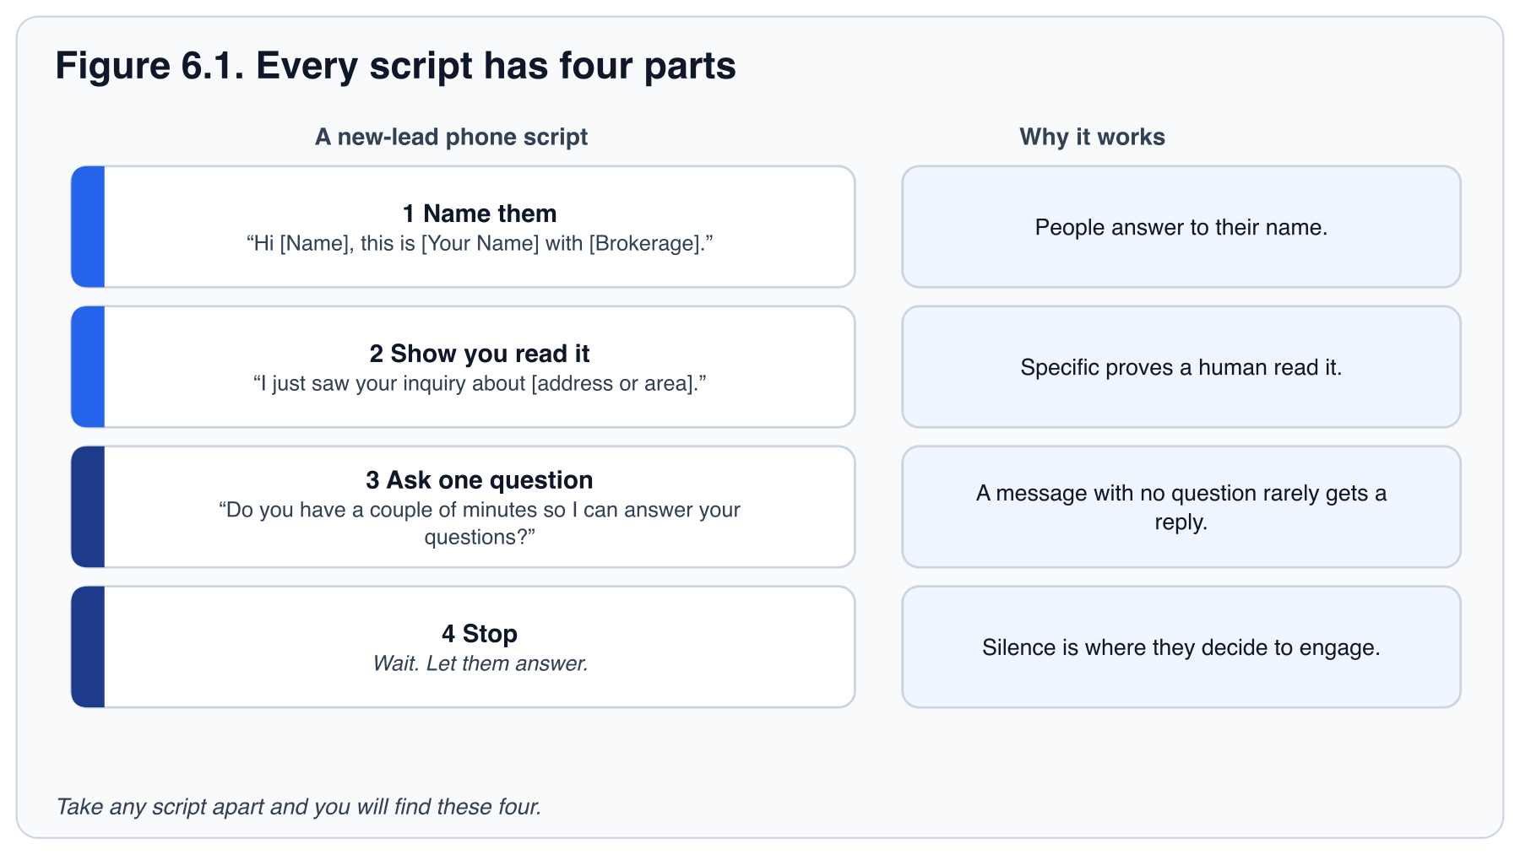
SCRIPT · NEW LEAD: PHONE CALL
"Hi [Name], this is [Your Name] with [Brokerage]. I just saw your inquiry about [address or area]. Do you have a couple of minutes so I can answer your questions?"
Purpose: make human contact fast. Next step: a 10-minute conversation now, or a scheduled call today. If you are calling later than the same day, say "following up on your inquiry" instead of "I just saw".

SCRIPT · NEW LEAD: VOICEMAIL
[Script wording is not in this print edition. Paste it here from Script practice in the online handbook.]
Purpose: be specific and easy to answer. Next step: a callback, or your next scheduled touch. Keep it under 20 seconds.

SCRIPT · NEW LEAD: TEXT
[Script wording is not in this print edition. Paste it here from Script practice in the online handbook.]
Purpose: get a reply. Next step: a time for a call. If they answer with a question, answer it and ask one back. Send this as a personal, non-automated text unless their consent to texts is recorded in your CRM (the consent rule in Chapter 11).

SCRIPT · SPHERE: ANNOUNCEMENT
[Script wording is not in this print edition. Paste it here from Script practice in the online handbook.]
Purpose: tell people, warmly, without asking for business. Next step: a real conversation. Log it as a conversation, not a pitch.

SCRIPT · SPHERE: REFERRAL ASK
[Script wording is not in this print edition. Paste it here from Script practice in the online handbook.]
Purpose: an introduction. Use it after you have given two or three helpful touches (Chapter 2). Next step: a name and permission to reach out, or "I'll keep you in mind." Either is a win. Thank them and keep in touch.

SCRIPT · REFERRAL PARTNER: INTRODUCTION
[Script wording is not in this print edition. Paste it here from Script practice in the online handbook.]
Purpose: open a two-way relationship by giving first. Chapter 2 ranks referral partners second only to your sphere. Next step: a meeting on the calendar, or their preferred way to receive a client. Meet three and pick one (Chapter 13). Ask your broker about referral-fee rules before any money or favors change hands.

SCRIPT · OPEN HOUSE: GREETING
[Script wording is not in this print edition. Paste it here from Script practice in the online handbook.]
Purpose: greet and ask one open question. Next step: their name, phone and email, and one concrete follow-up offer.

SCRIPT · EXPIRED LISTING OR FSBO: OPENER
"I saw your home came off the market. What would you like to happen next?"
Purpose: lead with curiosity, not criticism. Next step: listen, then offer a short conversation. Postpone this source until your sphere and follow-up are working.

SCRIPT · BUYER CONSULTATION: OPENING
[Script wording is not in this print edition. Paste it here from Script practice in the online handbook.]
Chapter 9 teaches the full consultation. Purpose: set the frame. Next step: their agreement, then your questions. Cover timeline, motivation, financing and must-haves before you talk about homes.

SCRIPT · SELLER CONSULTATION: OPENING
[Script wording is not in this print edition. Paste it here from Script practice in the online handbook.]
Chapter 9 teaches the full consultation. Purpose: earn the right to present. Next step: their goals, then your comparables, then your marketing plan, then the listing agreement.

SCRIPT · OBJECTION: "I'M JUST LOOKING"
"That's completely fine. Most people start that way. Would it help if I sent you a few homes that match what you described, so you can see what's out there?"
Table 9.2 in Chapter 9 lists this objection with the others. Purpose: keep the door open and earn permission to stay in touch. Next step: their email and a follow-up plan.

SCRIPT · PAST CLIENT: REFERRAL ASK
[Script wording is not in this print edition. Paste it here from Script practice in the online handbook.]
Purpose: turn a happy client into a source. Next step: a name, or a review on your Agent Site. Ask at the closing table and again at the 30-day check-in.

SCRIPT · POST-CLOSE: ONE-WEEK CALL
"How's the move going? Anything you need?"
Table 10.1, week one. Purpose: catch problems while you can still help. Next step: an introduction from your vendor list, or "all good" and the 30-day call stays on the calendar. Ask for nothing on this call.

SCRIPT · POST-CLOSE: 30-DAY REVIEW REQUEST
[Script wording is not in this print edition. Paste it here from Script practice in the online handbook.]
Table 10.1, day 30. Purpose: turn a happy client into public proof (Chapter 3 says where your reviews live). Next step: a review posted within a week, or a named reason why not. Ask only clients you served, and never write or trade reviews. The second referral ask (the box above) follows in the same call.

SCRIPT · POST-CLOSE: HOME-ANNIVERSARY CARD
[Script wording is not in this print edition. Paste it here from Script practice in the online handbook.]
Table 10.1, month 12. Purpose: the most natural seller conversation you will ever have. Next step: a reply, or your call a week after the card lands. Mail it; a call or text follows the card, not instead of it.

SCRIPT · QUARTERLY CALL
[Script wording is not in this print edition. Paste it here from Script practice in the online handbook.]
Appendix B.3 and the quarterly row of Table 10.1. Purpose: stay useful to the whole database four times a year, with a reason each time. Next step: a life change you log in your CRM, or nothing new and next quarter's call stays scheduled. One reason, one fact, one question.

TRY IT TODAY
- Rewrite the new-lead phone script in your own words. Use the lead from your Chapter 5 speed-to-lead test as the person you are calling. Record yourself three times, and score each recording: did I (1) use their name and the thing they asked about, (2) end on one question, (3) stop talking after it? Aim for three yes.
- Role-play the buyer consultation opening with a colleague. Swap roles. Give your partner the same three-item checklist so feedback is specific.
- Use the sphere referral ask on three people from your Chapter 2 list who have already received a "give" touch. Log the outcomes in your CRM.

KEY TAKEAWAYS
- A script succeeds when it reaches its next step, not when you say it word for word.
- Be specific, ask one question, then be quiet.
- Practice out loud and on recording. Reading is not rehearsal.

INTERACTIVE · TEST YOUR KNOWLEDGE
Three multiple-choice questions and a fill-in-the-blank, with the right answer and the reason shown on click.
Use this tool in the online handbook.

PART V: STAY ON TRACK

7. Common errors and pitfalls of new agents
The traps are predictable, which means they are avoidable. A simple system and a protected calendar remove most of them.
You have now met the core of the system: find people, follow up, say the right words. Before the book turns to routines and conversations with clients, take a day to look at where this fails in real life.
New agents fall into the same six traps. They reinforce one another, which is why a bad month can become a bad year. The good news is that the correction is the same for all six, and you already have most of it. It works not because you become a different person, but because the system does the remembering. This chapter helps you see which trap is yours.
IN THIS CHAPTER YOU WILL LEARN TO
- Score your own week against the six errors and name the one that costs you most.
- Trace how one error leads to the next until the cycle closes.
- Choose the single fix, from the chapter named in the Fix column, that you will make this week.

The six errors
Table 7.1. The six new-agent errors, their cost, and where this handbook fixes each. Some fixes are in chapters ahead of this one. If yours is, do its Try It now and return to the chapter later.
ERROR | WHAT IT LOOKS LIKE | WHAT IT COSTS | FIX
Slow or inconsistent follow-up | Leads answered next day; plans never launched; "I'll call them later." | The leads that would have converted go to the agent who called first. | Speed-to-lead automation and a daily follow-up block (Ch. 4).
Paying for leads before the system is ready, or relying only on portals | All money and hope on Zillow; sphere never called. | Low conversion, high cost, no referral engine. | Work the sphere first; buy leads only with a system in place (Ch. 2).
No system or database hygiene | Contacts in the phone, notes in email, tasks in memory. | Lost leads, missed anniversaries, no way to measure. | Everything in your CRM, every day (Ch. 4).
Unstructured days | Busy all day with errands, social media and email; zero conversations. | Activity without leading indicators; nothing compounds. | Time-blocked daily rhythm (Ch. 8).
Under-documenting | Verbal agreements, no notes on offers or disclosures. | Risk, disputes, and forgotten details that lose trust. A client says "you told me the fee was negotiable," and you have nothing in writing. | Notes in your CRM after every conversation (Ch. 11).
Expecting results too fast | Discouraged after 30 days with no closing; activity drops. | Quitting at the exact point the pipeline would have paid. | Track leading indicators; review weekly; 90-day horizon (Ch. 12).

Five of the six are habits, and a system fixes habits. "Expecting results too fast" is different: it is a belief, and what fixes it is information, namely the 90-day timeline in Chapter 12.

How the errors feed each other
These are not six separate problems. Slow follow-up loses leads. Lost leads mean an empty pipeline. An empty pipeline is discouraging. Discouragement makes the day unstructured, and an unstructured day produces slow follow-up. The loop runs on its own once it starts.
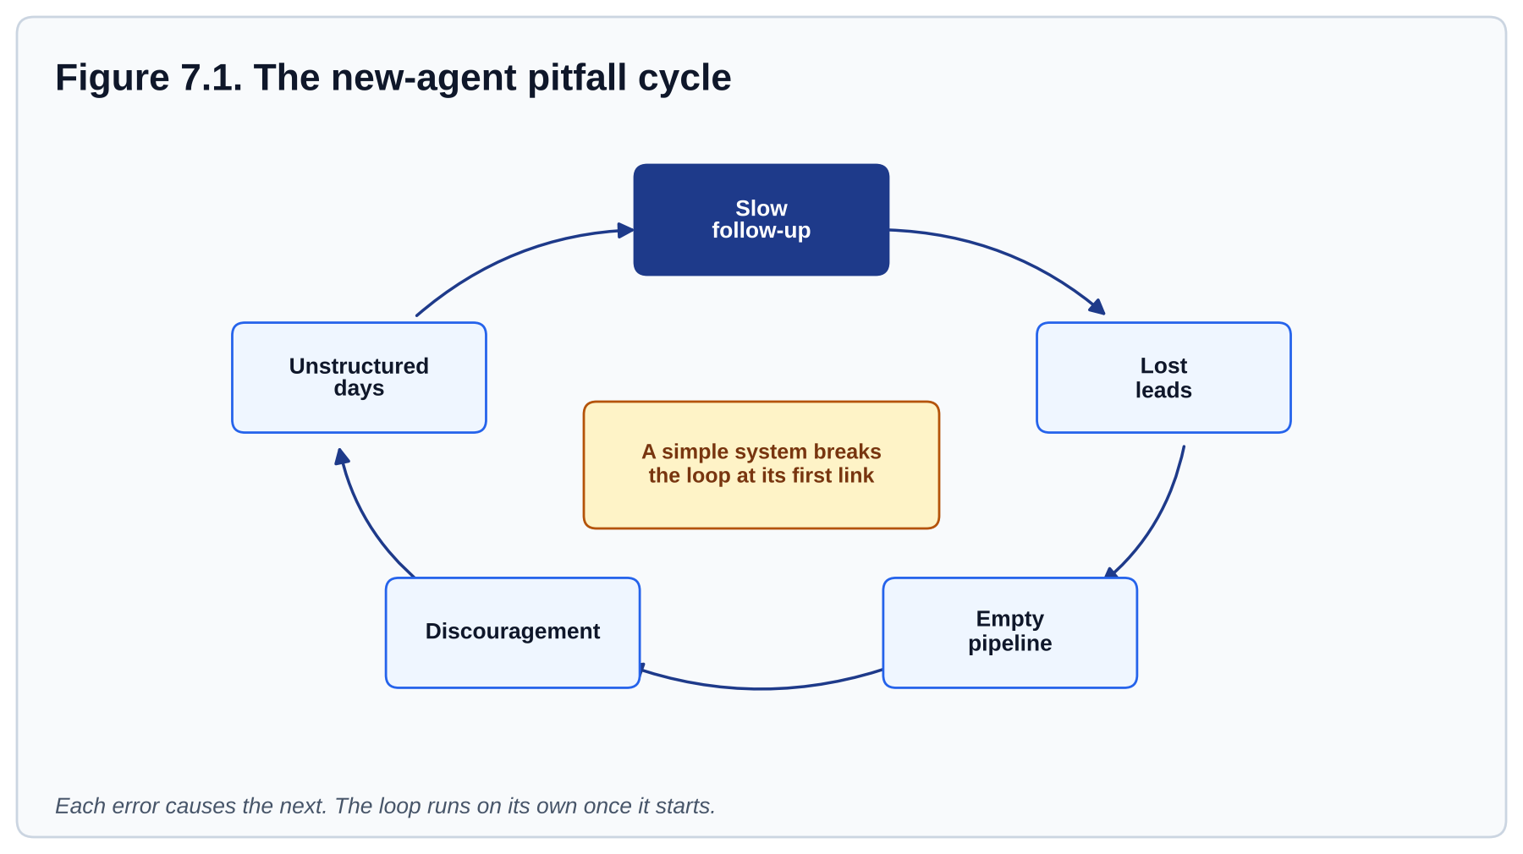
Figure 7.1. The new-agent pitfall cycle. Each error causes the next. Installing a simple system breaks the loop at its first link.

The one correction
You do not need six fixes. You need one system that makes the six errors hard to commit:
- Install your CRM and follow-up plans. Follow-up becomes automatic and documentation becomes the default.
- Protect a daily prospecting and follow-up block. Structure replaces willpower.
- Track activity, not closings. You can see progress every week, so the 90-day wait is bearable.
- Review every Friday. Small drifts get corrected before they become habits.

Most of these pitfalls shrink quickly once the system is in place. Expect to catch yourself in them, not to never fall into them.

Try it on Sam
Sam closed no deals in the first 30 days. This week: Monday a lead came in at 4 p.m. and Sam called at 6 p.m., two hours late. Tuesday Sam spent the morning on a logo. Wednesday's follow-up tasks went undone because "nothing is due." Thursday Sam had no appointment and felt low. Friday Sam did no pipeline review. Which of the six errors can you find? In what order did they occur? Which one single change on Monday would have broken the chain?
TRY IT TODAY
- Score yourself honestly on each of the six errors from 1 (never) to 5 (every day), using the last two weeks. Write one example beside each score.
- For your highest score, read the chapter named in the Fix column and do its exercise this week. If it points ahead in the book, do the Try It now and return to the chapter later.
- Ask your broker, a mentor or an accountability partner to score you too. Compare.

INTERACTIVE · SIX-ERRORS SELF-SCORE
Rate yourself on each error and get pointed to the chapter that fixes the biggest one.
Use this tool in the online handbook.

KEY TAKEAWAYS
- The six errors are predictable and linked. One starts the loop; the loop runs on its own.
- You do not need willpower. You need a system that makes the errors hard to commit.
- Your CRM, a protected block, activity tracking and a Friday review break the cycle.

INTERACTIVE · TEST YOUR KNOWLEDGE
Three multiple-choice questions and a fill-in-the-blank, with the right answer and the reason shown on click.
Use this tool in the online handbook.

PART V: STAY ON TRACK

8. Staying organized and motivated
Chapter 7 ended on a claim: you do not need willpower, you need a system. This chapter is the system's shape across a week.
There are two parts. The first is a calendar that is already decided, so that on Tuesday morning you are not choosing what to do; you are doing what Monday's version of you scheduled. The second is a scoreboard that moves every day you work, so that a long wait for your first closing does not feel like standing still. Organization reduces stress, and lower stress protects motivation.
IN THIS CHAPTER YOU WILL LEARN TO
- Build a weekly calendar where lead generation comes first, and hold it for four weeks.
- Score your week on five core numbers, and name the one thing you will do differently.
- Respond to a slow week with a defined first action instead of waiting.

One source of truth
Every contact, note, task and opportunity lives in your CRM. Not some of them. Not the important ones. All of them. The moment you keep a second list, you have two places to check and one of them will be wrong. If a conversation happened and it is not in your CRM, treat it as not having happened: log it now.

A sample day
Table 4.1 in Chapter 4 sets the blocks of the day, and Table 8.1 below puts them on the clock. End the morning prospecting block at your daily conversation number or at 90 minutes, whichever comes first, and log what happened.
The morning block is sacred because it is the only block nobody else will schedule for you. Clients, lenders and inspectors will all ask for afternoons. Give them afternoons.

Time-blocking the week
Table 8.1. A sample weekly time block. Lead generation sits in the same place every day so it never depends on how you feel.
TIME | MON | TUE | WED | THU | FRI
8:00 | CRM dashboard, plan the day
8:30 | Follow-up plan tasks
9:30 | Prospecting, 90 minutes (sphere, open-house follow-ups, farm) |  |  |  | Prospecting, then pipeline review
11:00 | Lunch, errands, email
13:00 | Appointments | Appointments | Content batch, marketing | Appointments | Appointments
16:00 | Client work, transaction tasks
17:30 | End-of-day CRM update, top three for tomorrow

INTERACTIVE · WEEKLY TIME-BLOCK PLANNER
Build your morning blocks, check that lead generation lands before noon, export to your calendar.
Use this tool in the online handbook.

FIELD NOTE
Protect the block by telling people about it. "I'm with clients until 11:00, can we talk at 1?" is true, and it trains your sphere, your lender and your family to expect it.

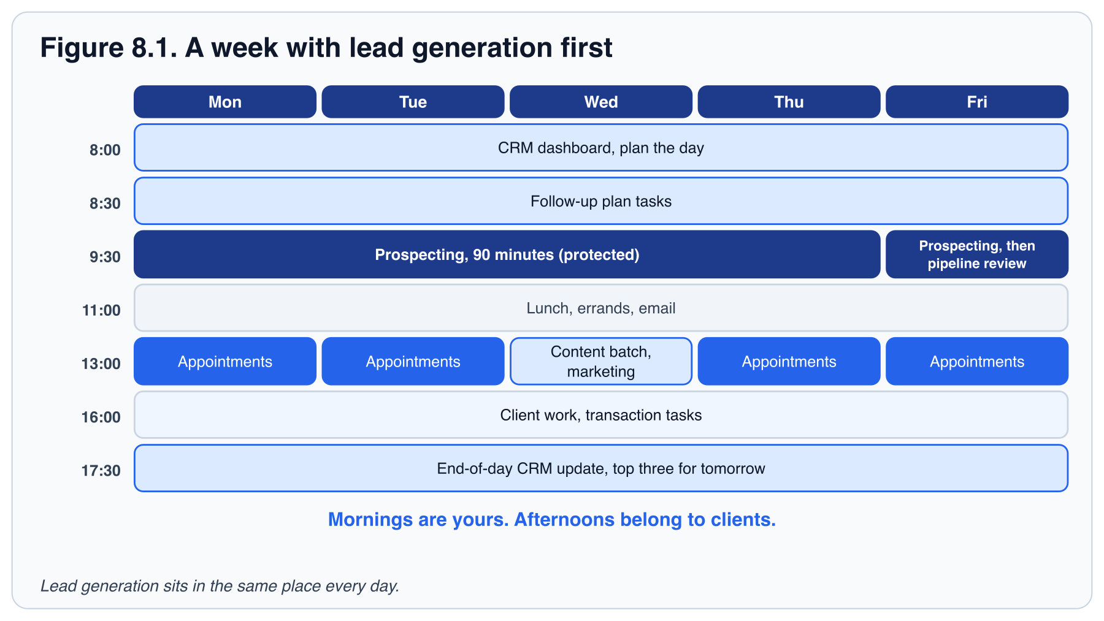

Weekly activity targets
These are the numbers a full-time new agent should aim for each week while also handling client work and learning. Start at the lower end of each range in your first 30 days while the habit and the system settle in, then raise them as your confidence grows.
Thirteen rows is a lot to track. If you want a shorter list, track five core numbers: conversations, appointments set, follow-ups completed, new contacts added and morning blocks held. The other rows are on the Appendix A scorecard for when the habit is steady.
Table 8.2. Weekly activity targets for a new agent. These are the same rows as Appendix A, which is the fill-in scorecard. Review the numbers every Friday and set next week's plan from them.
ACTIVITY | WEEKLY TARGET | NOTES AND PURPOSE
Outbound calls | 40 to 60 | Mix of sphere, database and new leads. Focus on conversations, not just dials.
Conversations | 15 to 25 | Actual two-way talks, by phone or in person.
Follow-ups completed | 30 to 50 | Follow-up plan tasks, nurture touches and overdue contacts cleared.
Appointments set | 1 to 2 | Consultations and listing appointments. Follows from your Chapter 1 ratio (see below).
Appointments held | 1+ | The appointments you actually sat.
Open houses or events | 1 | Frequency builds local presence once you have one to host; Chapter 12 asks for the first inside your first 30 days.
Database updated (days out of 5) | 5 | Log notes and clear tasks before the end of the day.
New contacts added | 15 | Each one tagged with a source.
Content posted | 2 | Per the calendar in Table 3.1.
Morning blocks held (out of 5) | 4+ | The 90-minute prospecting block, before 11:00.
Active opportunities | Growing | Count them every Friday.
Pipeline value | Growing | Likely commission across active opportunities.
Referrals received | Track | Write the number down even when it is zero.

The appointment target comes from the same method as Chapter 1. At about 20 conversations per appointment, 15 to 25 conversations a week produce roughly one appointment a week, so a new agent should aim for one or two, not a handful. If your own ratio is better, say one appointment for every five or eight conversations in a warm sphere, replace the 20 with your number and raise the target to match.

Motivation that lasts
Motivation fails when you measure the wrong thing. If the only scoreboard is closings, you will go 60 to 120 days with a score of zero, and nobody stays motivated through that. Keep a scoreboard of leading indicators instead: calls, conversations, follow-ups completed, appointments set. Those numbers move every day you do the work. Table 8.2 sets the targets and Appendix A is the scorecard.
Three habits protect motivation:
- Celebrate small wins. A booked appointment is a win. Ten conversations before noon is a win. Say it out loud or write it down.
- Review every Friday. After Friday's prospecting block (Table 8.1), spend 30 minutes running the Chapter 5 pipeline review and filling in the Appendix A scorecard. Compare this week's numbers to last week's. Decide one thing to do differently. Then stop working on it until Monday.
- Stay close to the office. Training, accountability partners, team meetings. Real estate is a solo business that is easier with company.

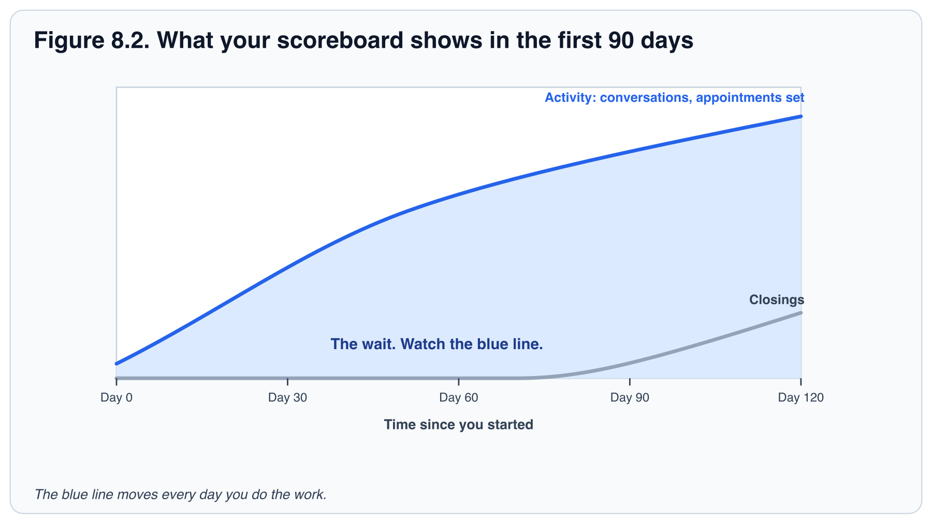

When it is quiet
The hard part of this business is rarely the calendar. It is the day when nobody picks up, the week with no appointments, or the Friday you hear that a colleague closed first. Decide in advance what you do on those days, because on the day you will not feel like deciding.
- On a day with no conversations, start with the lowest-barrier task: a text, not a call. One reply is enough to restart the day.
- After a hard call, record yourself retelling it and listen back, the way you practiced in Chapter 6. Find the one sentence you would change, and change only that.
- When a colleague closes first, compare their result to your leading indicators, not to your closings. Their closing is the product of work they did months ago. Yours is on the way.
- When it all feels like too much, use the rule from the Friday review: decide one thing to do differently, then stop working on it until Monday.

PITFALL
Letting a slow week become a slow month by "waiting for things to pick up". Nothing picks up on its own. Go back to the morning block and the daily number; the market usually responds to activity.

TRY IT TODAY
- Build Table 8.1 into your calendar as recurring events for the next 12 weeks.
- Print Appendix A and fill in this week's numbers, even if they are small. Compare the conversations row to the daily number you set in Chapter 1.
- Find an accountability partner at your office and agree to share the same five numbers every Friday.
- Look at your highest-scoring error from Chapter 7. Mark on your Table 8.1 where in the week that error is most likely to happen, and add a buffer.

KEY TAKEAWAYS
- Your CRM is the only list. A conversation not logged did not happen.
- Lead generation goes first in the day, in the same place every day.
- Measure leading indicators, celebrate small wins, review on Fridays, stay connected.

INTERACTIVE · TEST YOUR KNOWLEDGE
Three multiple-choice questions and a fill-in-the-blank, with the right answer and the reason shown on click.
Use this tool in the online handbook.

PART VI: SERVE AND KEEP

9. Working with clients and dealing with objections
A consultation is a conversation. An objection is a request for information. A closed client is the beginning of the relationship, not the end.
Everything so far has been about getting a person to the table: finding them, following up, staying organized enough to show up. This chapter is about the meeting itself.
A good consultation is a conversation, not a pitch. You ask, you listen, and only then do you show how you work. When the client pushes back, that is rarely a refusal. It is usually a question they have not yet put into words. You will learn a five-step shape for the meeting, a four-step pattern for the pushback, and the two-minute habit that protects both of you afterward.
IN THIS CHAPTER YOU WILL LEARN TO
- Lead a buyer or seller consultation through five steps, spending at least half the meeting asking and listening.
- Answer an objection using four steps (acknowledge, clarify, respond, check), and identify which step each line of a sample answer performs.
- Write a two-minute CRM note after a client conversation: date, who, what was discussed, what was decided, what happens next.

The consultation sequence
Both buyer and seller consultations follow the same shape. Set the frame, ask, listen, present, agree on next steps. Agents who skip the asking and go straight to presenting lose the client's trust before they have earned it.
Table 9.1. The five-step consultation. Steps 2 and 3 should take at least half the meeting.
STEP | BUYER CONSULTATION | SELLER CONSULTATION
1. Frame | The opening script from Chapter 6. Agree on the agenda. | The opening script from Chapter 6. Agree on the agenda.
2. Ask | Timeline, motivation, financing, must-haves, deal-breakers, who else is involved in the decision. | Goals, timeline, why they are moving, what they believe the home is worth, past experience with agents.
3. Listen | Repeat back what you heard. "So the priority is the school district, and a yard matters more than square footage." | Repeat back. "You need to be in the new city by August, and net proceeds matter more than top-line price."
4. Present | How the process works step by step, how you search, how offers work in this market, what representation means. | Comparable sales, your pricing recommendation and the reasoning, your marketing plan (Chapter 3), what happens week by week.
5. Agree | Buyer representation agreement, lender introduction, first showing date. | Listing agreement, price, photography date, go-live date.

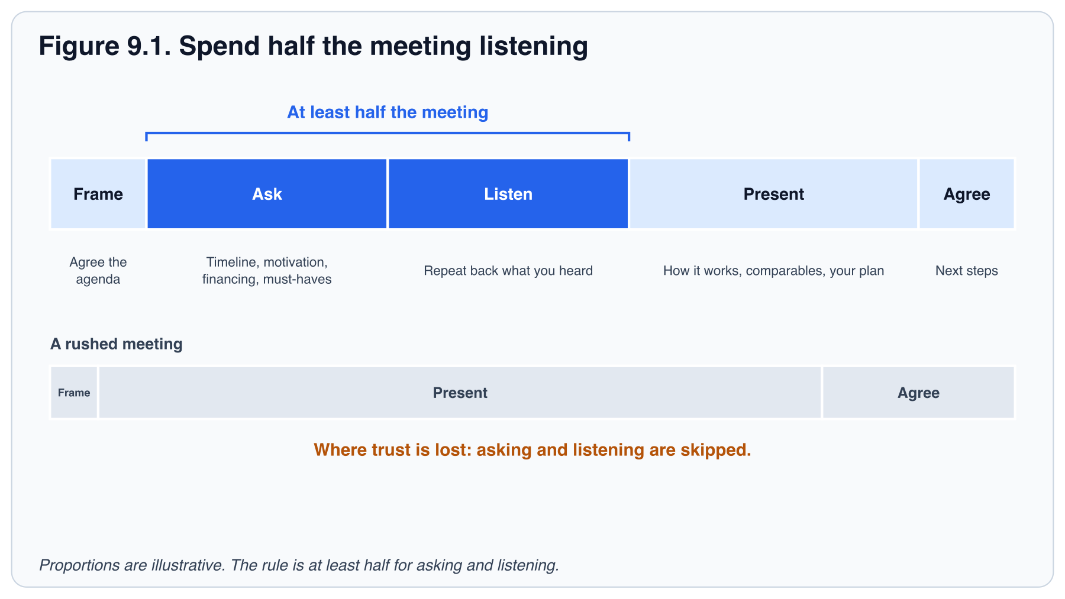
INTERACTIVE · CONSULTATION LAB
Rebalance a meeting so asking and listening take half, then spot the missed step in sample consultations.
Use this tool in the online handbook.

Objections are questions in disguise
Most objections are requests for more information or reassurance. "Your fee is too high" usually means "show me what I get for it." Compensation is something you agree in writing before you start. Chapter 11 covers the rules, and your broker confirms the wording. "We want to wait" usually means "we are nervous about the market." Respond with curiosity, not defense. The four-step pattern below works for nearly every objection, and Table 9.2 applies it to the ones you will hear most.
- Acknowledge. "That makes sense." You are not agreeing; you are showing you heard.
- Clarify. "Can I ask what's behind that?" Find the real concern.
- Respond. Answer the real concern with facts, a story, or a demonstration.
- Check. "Does that address it?" Then stop talking.

Here is the pattern on the most common objection, with each step marked:
- Acknowledge. "I understand. It's a big number." (They know you heard.)
- Clarify. "Can I ask what you're comparing it to?" (Find the real concern: another agent's quote, a net figure, or a general worry.)
- Respond. Walk through what they would net and what the work involves. (Answer the real concern, not the one you assumed.)
- Check. "Does that make sense?" Then stop.

SCRIPT · OBJECTION: "WE WANT TO INTERVIEW OTHER AGENTS"
[Script wording is not in this print edition. Paste it here from Script practice in the online handbook.]
Purpose: stay in the running and set the follow-up. Next step: a scheduled call after the other interviews.

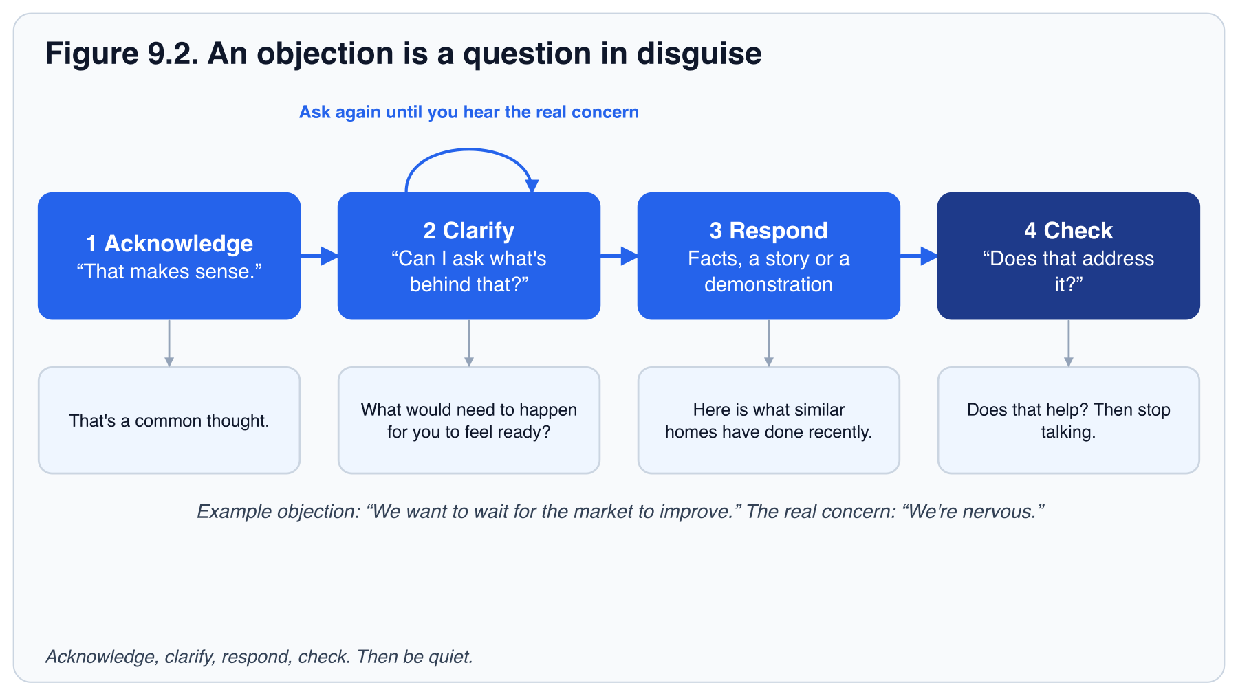

Objection quick reference
Treat each response as a starting framework, not a line to memorize. After you respond, ask a question that moves the conversation forward. Log the objection and your response in your CRM so the next follow-up is specific. Practice the three or four you hear most until they feel natural.
Table 9.2. Objection handling quick reference. These are common objections. "I already have an agent" includes someone working with another agent on a specific home. The interview-other-agents script is the box above this table, not a second row.
OBJECTION | RESPONSE FRAMEWORK | GOAL OF THE RESPONSE
"I'm just looking." | Acknowledge and offer value. The Chapter 6 script: "That's completely fine. Most people start that way. Would it help if I sent you a few homes that match what you described, so you can see what's out there?" | Keep the conversation open and useful.
"We're not ready yet." | Explore timeline and stay in touch. "No problem. When do you think you might be ready? I can send occasional updates so you're informed when the time comes." | Qualify timing and earn permission to nurture.
"I already have an agent." | Respect and leave the door open. "Great, I'm glad you have help." "If anything changes or you'd like a second opinion, feel free to reach out." | Stay professional and memorable.
"Your fee is too high." | Focus on value and net proceeds. "I understand. Compensation is something we agree in writing before we start. Let me show you how I work and what you'd net, and I'll confirm the structure with my broker." Chapter 11 has the short version of that rule. | Shift from fee to outcome, and do not quote an old listing form.
"Why do I have to sign an agreement before you show me homes?" | Explain the rule and what they get. "Fair question. Before we tour, I work under a written agreement. It spells out exactly what I'll do for you and how I'm paid, so there are no surprises later. Can I walk you through it now, before we pick a day to see homes?" Chapter 11 has the rule; your broker has the form and the timing. | Turn a requirement into a clear expectation, and sign before the first showing.
"I want to wait for the market to improve." | Provide data and options. "That's a common thought. Here's what similar homes have done recently. We can also look at what waiting might cost versus moving now." | Educate without pressure.
"I need to think about it." | Clarify the real concern. "Of course. What specifically would you like to think through? I'm happy to answer any questions that would help." | Uncover the real objection.
"Can you just send me listings?" | Agree and add a next step. "Absolutely. I'll send a few. What's the best way for me to follow up after you've had a chance to look?" | Move from passive to engaged.
"You're new, aren't you?" | Be honest and specific. "I am, and that means you get my full attention. My office and broker are behind every file I touch. What matters most to you in an agent?" | Replace worry with evidence.

Document everything
After every consultation, offer discussion, price change or disclosure conversation, write a short note in your CRM: date, who, what was discussed, what was decided, what happens next. Two minutes of typing protects you from "but you said" months later and makes your follow-up specific. Chapter 11 covers what to document for legal protection.
A good note is five lines or fewer. For example: 14 Oct, Priya & Dev Shah, buyer consult, 55 min. Goals: move by August for school; budget $520k; pre-approved. Concern: "we may wait for rates." Discussed: cost of waiting vs. buying now. Decided: agreement to be signed Thursday; send three homes by Wednesday. Next: call Thursday 5 p.m.

Between yes and closing
A client who is well informed becomes a past client who refers. Between the signed agreement and the closing table, give every client one named point of contact (you), a short update every week even when nothing has changed, and a call before every deadline. Log each of those in your CRM.
Use this checklist on every file that goes under contract:
- The day you go under contract, confirm that you are their point of contact and how to reach you, and assign the post-close plan in your CRM (Chapter 10).
- Send a short update every week, even when nothing has changed. Pick a day and keep it.
- Call before each deadline in the contract, for example inspection, appraisal, loan approval, final walk-through and closing. Your contract sets the dates; your broker or transaction coordinator confirms them.
- Log every update and call in your CRM the same day.

SCRIPT · UNDER CONTRACT: WEEKLY UPDATE
[Script wording is not in this print edition. Paste it here from Script practice in the online handbook.]
Purpose: keep the client informed, even in a quiet week. Next step: their questions answered now, and your call before the next deadline. Log the update in your CRM. If you send it as an automated text, their consent to texts must be recorded in your CRM first (the consent rule in Chapter 11).

After the transaction
Stay in touch. The clients who feel cared for after closing become your best source of future business. Chapter 10 shows the post-close plan. The habit starts at the closing table: thank them, ask for the introduction, and tell them to expect to hear from you.
TRY IT TODAY
- Write your own version of the buyer consultation, step by step, on one page. Use your opening from Chapter 6 and the four questions from Chapter 5.
- Pick the two objections you fear most in Table 9.2 and practice the four-step response out loud. Use the Chapter 6 rubric: name, one question, stop. Make the buyer-agreement question one of them if you have not yet signed one.
- Go back through the last week and add a note in your CRM for every conversation that is missing one.

KEY TAKEAWAYS
- Frame, ask, listen, present, agree. Asking and listening come before presenting.
- Objections are requests for information. Acknowledge, clarify, respond, check.
- Document every conversation in your CRM the same day.

INTERACTIVE · TEST YOUR KNOWLEDGE
Three multiple-choice questions and a fill-in-the-blank, with the right answer and the reason shown on click.
Use this tool in the online handbook.

PART VI: SERVE AND KEEP

10. Keeping clients: long-term relationships
A closing feels like the end. For the client it is the day the move is real; for you it should be the day the relationship properly begins.
The people you serve today are the ones most likely to call you, and to send you their friends, in the years ahead. They will not do that because you were pleasant at the closing table. They will do it because you were still there in month three, on their first anniversary, and when a pipe burst in the second winter. A database of past clients and sphere contacts who hear from you regularly is the most valuable asset you will build, and the cheapest one to maintain. This chapter makes "still being there" a schedule instead of a hope.
IN THIS CHAPTER YOU WILL LEARN TO
- Schedule the six-step post-close plan from the day of closing (seven dated touches in the first year), and explain the purpose of each step.
- Apply one test to any message to decide whether it adds value or only markets.
- Reactivate a quiet part of your database in batches, starting with one useful message.

The post-close plan
Most homeowners move again within a decade or two, and know several people who will move before then. The agent they remember gets those transactions. Being remembered is a schedule, not an accident. The post-close plan is built once, assigned on the day the client goes under contract, and activated on closing day; it runs seven dated touches in the first year, starting with the closing-day note. This chapter gives you the schedule; Chapter 6 gives you the words for the one-week call, the 30-day review request, the anniversary card and the quarterly call.
Table 10.1. The post-close plan: the first year of the relationship. Build it once as a follow-up plan and apply it at every closing. It has six steps. "Quarterly" repeats at months 3, 6 and 9, and the home anniversary at month 12 takes the place of a fourth quarter, so a client gets seven dated touches in the first year. The annual appreciation event or gift is yours to schedule once a year, not a separate dated touch per client. After the first year, the client stays on the Quarterly Call Plan (Appendix B.3).
WHEN | TOUCH | PURPOSE
Closing day | Handwritten note and a small closing gift. Check your brokerage's policy on gifts and keep within it. | End on a high note. Ask for the introduction.
1 week | Call: "How's the move going? Anything you need?" | Catch problems early. Offer vendor introductions.
30 days | Call or visit. Ask for a review on your Agent Site. | Reviews drive online leads. Second referral ask.
Quarterly | Call with a reason: market update, tax season, seasonal maintenance. | Stay useful. Hear about life changes early.
Home anniversary | Card or call with an updated home value. An automated estimate is not a market analysis; say so. | The most natural seller conversation you will ever have.
Annually | Client appreciation event or a personal gift. | Make the relationship social, not transactional.

INTERACTIVE · POST-CLOSE SCHEDULER
Turn a closing date into every first-year touch with its date, and export them.
Use this tool in the online handbook.

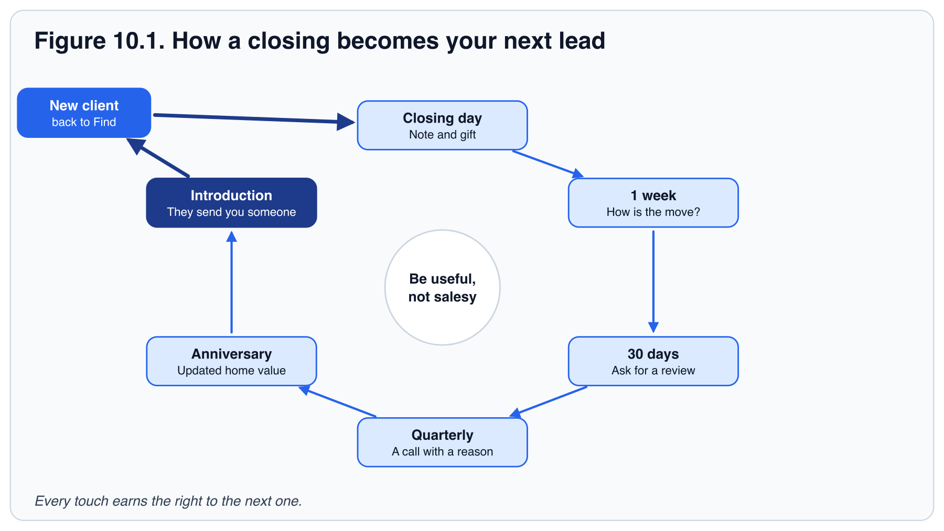

Adding value without selling
The test for every touch: would the person be glad to receive it if they were never going to move again? Local insights, a reminder to change furnace filters, a list of trusted contractors, a note on a property tax deadline, an invitation to a neighborhood event. These pass the test. "Thinking of selling?" every month does not.
- Vendor list. Keep a short list of a plumber, electrician, handyman, painter and cleaner you trust. Introducing them is a gift that costs you nothing, as long as you accept nothing of value for it and tell the client they are free to choose anyone (Chapter 11).
- Home value updates. Once a year, unprompted. Homeowners love knowing. Sellers come from this.
- Life events. A new baby, a promotion, a graduation. A card beats a market update.

Reactivating a quiet database
If you have let your database go cold, do not apologize for it. Send one useful piece of market information to everyone, then start calling in small batches with a simple "thinking of you" and one question about how things are. Most people will be glad to hear from you. Put everyone you reach back on the quarterly plan so it does not go cold again. A workable pace is a batch of 10 a day, starting with the people who liked your last message.

Asking for referrals
Ask at three moments: at closing, at the 30-day call, and any time a client thanks you unprompted. Ask plainly, using the script from Chapter 6, and then stop. Thank every referral within a day, by phone or a handwritten note, whether or not it becomes a transaction. Track each one in your CRM with a "Referred by" field, so you can see how many of your leads come from past clients.
FIELD NOTE
Track one more number: referrals received per month. When this number grows, your business becomes less dependent on paid leads every year. Many experienced agents report that most of their business now comes from past clients and referrals.

TRY IT TODAY
- Build the post-close follow-up plan from Table 10.1 in your CRM.
- List five vendors you would recommend without hesitation. Add them to your CRM with a "Vendor" tag. If you have fewer, ask three colleagues for their top picks and note who recommended each.
- Find the next three home anniversaries in your database and schedule the calls. No past clients yet? Choose three friends or family members who bought a home, note their purchase date, and put the anniversary in your CRM.
- Rewrite the one-week call, the 30-day review request and the home-anniversary card from Chapter 6 in your own words for an imaginary client, keeping the Chapter 6 rules (name, one question, stop). Role-play the first with a colleague.

KEY TAKEAWAYS
- Every client is assigned the post-close plan when the client goes under contract, and it starts on closing day.
- Give value they would want even if they never moved again.
- Home anniversaries and value updates are where seller conversations begin.

INTERACTIVE · TEST YOUR KNOWLEDGE
Three multiple-choice questions and a fill-in-the-blank, with the right answer and the reason shown on click.
Use this tool in the online handbook.

PART VI: SERVE AND KEEP

11. Legal protection and professional standards
Every touch you have learned so far, the text, the call, the post, the open house, sits inside a set of rules. Most of them protect the person on the other end. A few protect you. Learn them once, early, and they become habits you do not notice.
This chapter is not legal advice. Your state and your broker set the rules, and they change. What it gives you is the shape of them: what to disclose and when, how to talk about a neighborhood so that everyone is treated the same, and what to write down so that you and your clients are protected if memory fails. When in doubt, ask your broker or office leadership before you act.
IN THIS CHAPTER YOU WILL LEARN TO
- Explain agency in two sentences and deliver your state's disclosure at the first substantive contact.
- Rewrite a listing description or social post so it describes the property, not the people.
- Send automated texts only with consent, and stop at the first opt-out.
- Record the seven items on the documentation list the day they happen.

READ THIS FIRST
This chapter describes professional habits, not legal advice. Agency, disclosure, compensation and advertising rules differ by state and change over time. Your broker, your office leadership and your state association are the authorities. When any situation feels unusual, stop and ask before you act.

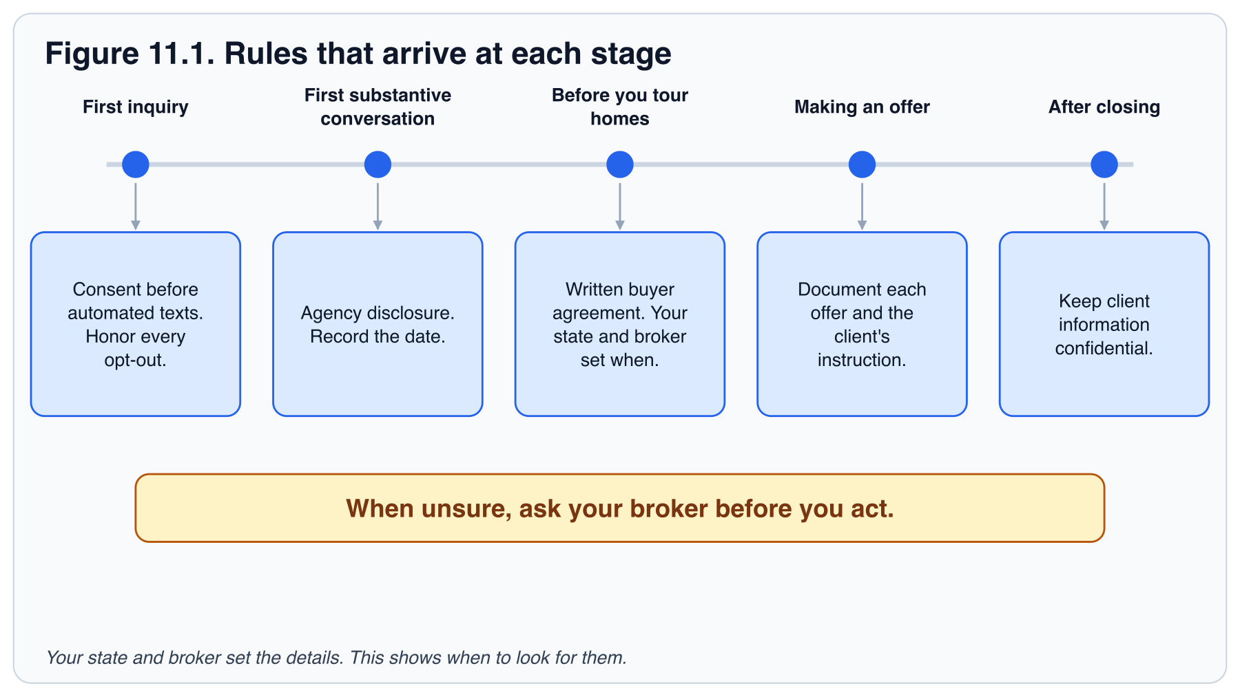

Agency disclosure
Before you provide services to a buyer or seller, they must understand whom you represent and what that means. Your state has a required disclosure form and a required timing, usually at first substantive contact. Learn both in your first week. Present the form in plain language, answer questions, and keep the signed copy in your transaction system. If a conversation moves from casual to substantive, that is the moment to disclose.

Buyer agreements and compensation
Two rules a new agent in 2026 will be corrected on in week one. Confirm both with your broker before you use them:
- Get a written buyer representation agreement before you tour homes. Your state and your broker set when it has to be signed.
- Compensation is negotiable. An offer of compensation to the buyer's agent is no longer a field in the MLS. Who pays, and how much, is a conversation with your client. Do not quote a number from an old listing form.

This is a pointer, not legal advice. Your broker has the current form and the words to use.

Fair Housing
Federal law prohibits discrimination in housing on the basis of race, color, religion, national origin, sex, familial status and disability. Many states and cities add further protected classes. Ask your broker for yours. The rules apply to how you advertise, whom you serve, what you say about neighborhoods and how you treat every inquiry.
- In marketing. Describe the property, not the ideal buyer. "Great for families" and "perfect for young professionals" are both problems. "Four bedrooms, fenced yard, two blocks from the park" is fine.
- In conversation. Do not characterize neighborhoods by who lives there. When a client asks "is this a good area?", give every client the same third-party sources on schools, crime statistics and amenities. Do not editorialize, and do not describe who lives there. Some brokerages have their own guidance on crime statistics, so confirm the wording with your broker before you share any source.
- In service. Give every inquiry the same response time, the same information and the same options. Your speed-to-lead automation helps here because it treats everyone identically.

INTERACTIVE · FAIR HOUSING DRILL
Judge real phrases as problem or fine, with the reason for each.
Use this tool in the online handbook.

Texts and calls
The follow-up plans in Chapters 4 and 5 send automated texts. The rule behind them is simple. Send automated texts or calls only to people whose consent you have recorded in the CRM, and stop at the first opt-out.
- Do: record where and when each person agreed to receive texts, in the contact's CRM record.
- Do: stop all texts and automated plans the moment someone opts out, and log it.
- Do not: add a contact to an automated text plan because you have their number.
- Do not: call or text numbers on a do-not-call list, or outside permitted hours. Federal rules bar telemarketing calls before 8 a.m. or after 9 p.m. in the recipient's time zone, and some states are stricter. Ask your broker for the current rules.

What to document
Keep notes in your CRM or your transaction system for every item below. Date, parties, what was said or delivered, and what was decided.
- Agency disclosure given and signed, with the date.
- Every offer, counteroffer and the client's instruction on each.
- Pricing conversations and the client's decision.
- Disclosures delivered (property condition, lead paint, HOA documents) and when.
- Inspection findings discussed and the client's choices.
- Any advice you gave that the client declined to follow.
- Referrals to lenders, inspectors or attorneys, with a note that the client chose freely.

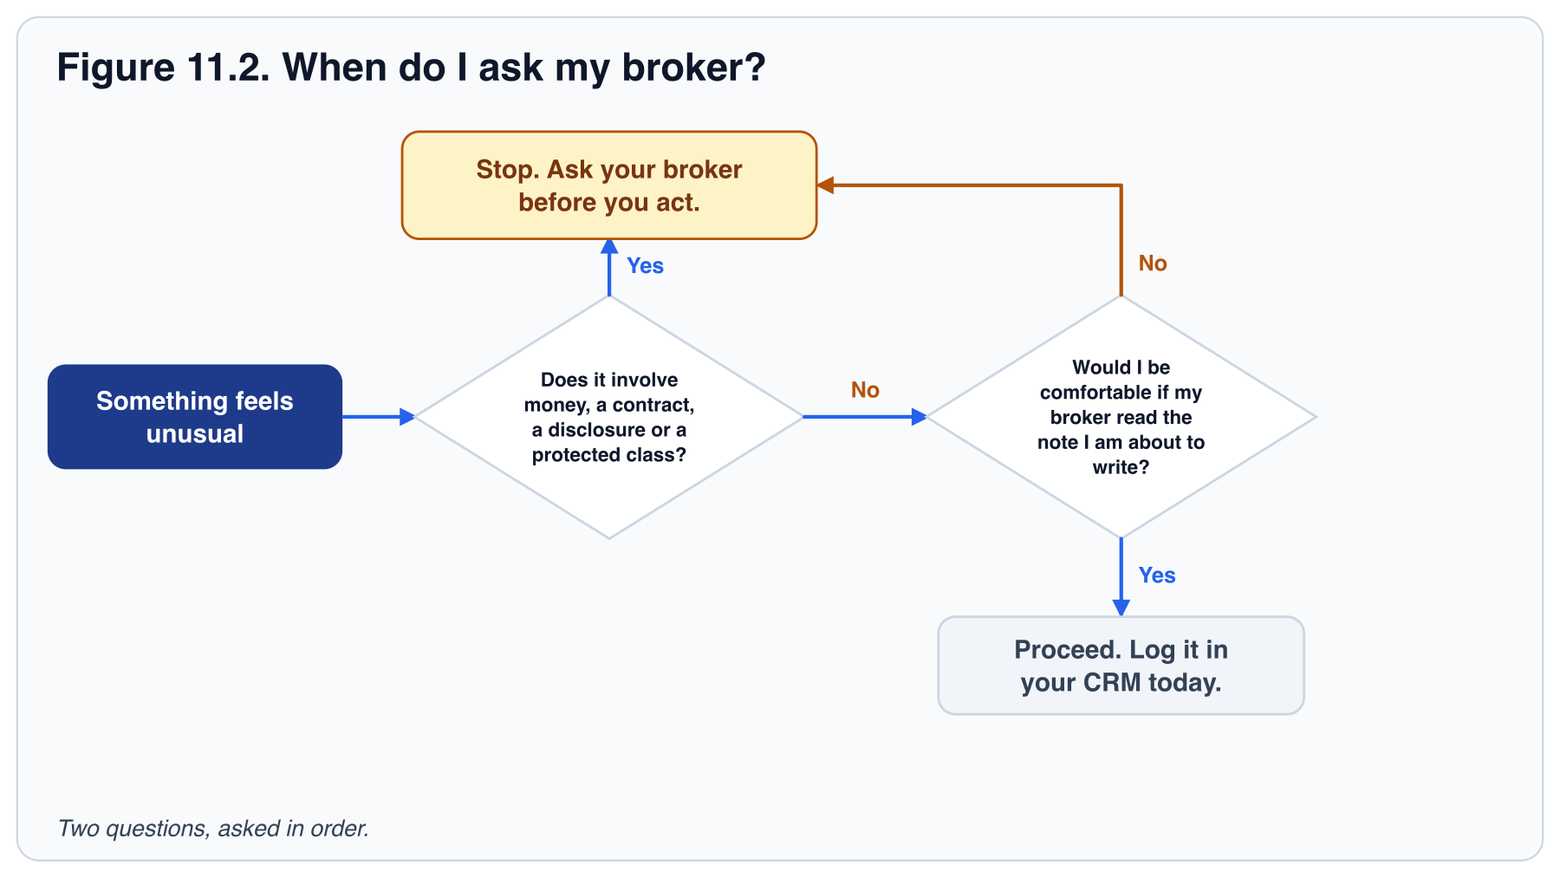

Professional standards
- Follow your local MLS rules, and the National Association of REALTORS® Code of Ethics if you are a REALTOR® member.
- Never give legal, tax or structural advice. Refer to the professional. Say: "That's a question for your attorney. I can introduce you to two."
- Keep client information confidential, including after the transaction.
- Respect do-not-call and anti-spam rules (see Texts and calls above). Honor every opt-out immediately in your CRM.
- Know the advertising rules for your state. Marketing usually has to show your brokerage name and your license number. Ask your broker for the exact wording.
- Do not pay or accept anything of value for referring a client to a lender, vendor or another agent until your broker has told you what is allowed.
- Know your office policy on wire fraud warnings, and repeat the warning to every client before closing.

SCRIPT · WIRE FRAUD WARNING
[Script wording is not in this print edition. Paste it here from Script practice in the online handbook.]
Purpose: protect the client from the most common closing-day fraud. Next step: log in the CRM that you gave the warning, with the date. Use the wording your broker or title company prefers.

TRY IT TODAY
- Ask your broker for your state's agency disclosure form and read it aloud until you can explain it in two sentences.
- Review your last ten social posts and listing descriptions for language that describes people instead of property.
- Ask your broker what three situations they most want to hear about before you act.
- Open your Chapter 4 new-lead plan. Highlight every automated text. For each, write where consent was recorded.
- Practice the agency disclosure with a colleague as if they were a first-time buyer. They should ask two questions you must answer in plain words.
- Take one conversation from this week that touched price, an offer or a disclosure and write its note against the seven-item list: date, parties, what was said or delivered, what was decided.

KEY TAKEAWAYS
- Disclose agency at first substantive contact and keep the signed copy.
- Describe property, never people. Treat every inquiry identically.
- Document decisions the same day. Ask your broker before anything unusual.

INTERACTIVE · TEST YOUR KNOWLEDGE
Three multiple-choice questions and a fill-in-the-blank, with the right answer and the reason shown on click.
Use this tool in the online handbook.

PART VII: EXECUTE

12. Your first 90 days: daily, weekly and monthly plans
The first 90 days, measured weekly. Everything in this book reduces to a few numbers you can check every Friday.
You have now met every part of the system. You know where your first conversations come from, where they are recorded, how you follow up, what you say, how you spend your mornings, how you run a consultation, and how you stay in touch after a closing. What remains is to put dates on it.
Ninety days is long enough to build the system and start a pipeline, and short enough to hold yourself to. This chapter turns the book into a calendar: three phases of thirty days, one scorecard every Friday, and one hour each month to decide where your time goes next. Closings usually follow in the second 90 days. When you finish this chapter, you will have a plan with your name on it.
IN THIS CHAPTER YOU WILL LEARN TO
- Date a 90-day roadmap with checkpoints at days 30, 60 and 90.
- Fill in the weekly scorecard each Friday and decide the one thing to do differently next week.
- Run a one-hour monthly review that changes where your time goes.
- Assemble your 90-Day Business Plan from the work you did in Chapters 1 to 11.

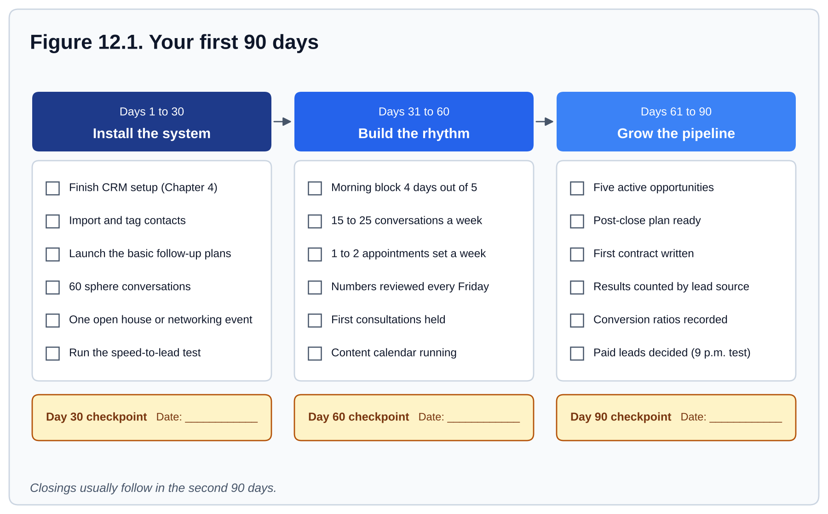
Figure 12.1. The first 90 days milestone roadmap. Install the system, build the rhythm, then grow the pipeline. Closings usually follow in the second 90 days.
Your day, in one line: open the CRM, clear follow-ups, prospect to your number, hold appointments, close the CRM.

Days 1 to 30: install the system
Finish CRM setup (Chapter 4), import and tag contacts, launch the basic follow-up plans, and have at least 60 real conversations with your sphere (about 15 a week, the lower end of the Chapter 8 range). Hold one open house or one networking event. Run the speed-to-lead test. Do not worry about closings; worry about whether the system is on.
The steps for this phase are on the roadmap above.

Days 31 to 60: build the rhythm
Hold the morning block at least four days out of five. Hit the Table 8.2 targets, including 15 to 25 conversations a week and 1 to 2 appointments set. Review your numbers every Friday. By day 60 you should have held your first consultations and signed a written buyer representation agreement before touring any homes. Chapter 11 covers buyer agreements. The content calendar from Chapter 3 should be running on its own.
The steps for this phase are on the roadmap above.

Days 61 to 90: grow the pipeline
Your pipeline review should show at least five active opportunities. Have the post-close plan ready, then write your first contract. The post-close plan is built once, assigned on the day the client goes under contract, and activated on closing day; it runs seven dated touches in the first year, starting with the closing-day note. Count the results by lead source. By day 90 most sources will not have produced a closing yet, so compare them on cost per appointment (Chapter 2) and treat cost per closed deal as the number you confirm in the second 90 days. Decide, with that data and the 9 p.m. test from Chapter 3, whether paid leads make sense next quarter. Record your conversion ratios so the next 90 days can be planned from real numbers.
The steps for this phase are on the roadmap above.

Measure every week
Every Friday, fill in Appendix A. Table 8.2 is the same list of targets. Do not keep a second, shorter scorecard. If the full list is too much at first, start with the five core numbers from Chapter 8: conversations, appointments set, follow-ups completed, new contacts added and morning blocks held. Then decide one thing to do differently next week, as in the Chapter 8 Friday review.
INTERACTIVE · PIPELINE VALUE CALCULATOR
Total your pipeline value and see who needs a Monday call.
Use this tool in the online handbook.

Review every month
On the first working day of the month, spend one hour on four questions: Which source produced the most appointments per hour spent? Which follow-up plan got the most replies? Where did leads stall in the pipeline? What one change will I make this month? Write the answers in your CRM as a note titled "Monthly note" so next month's review can find and check them.
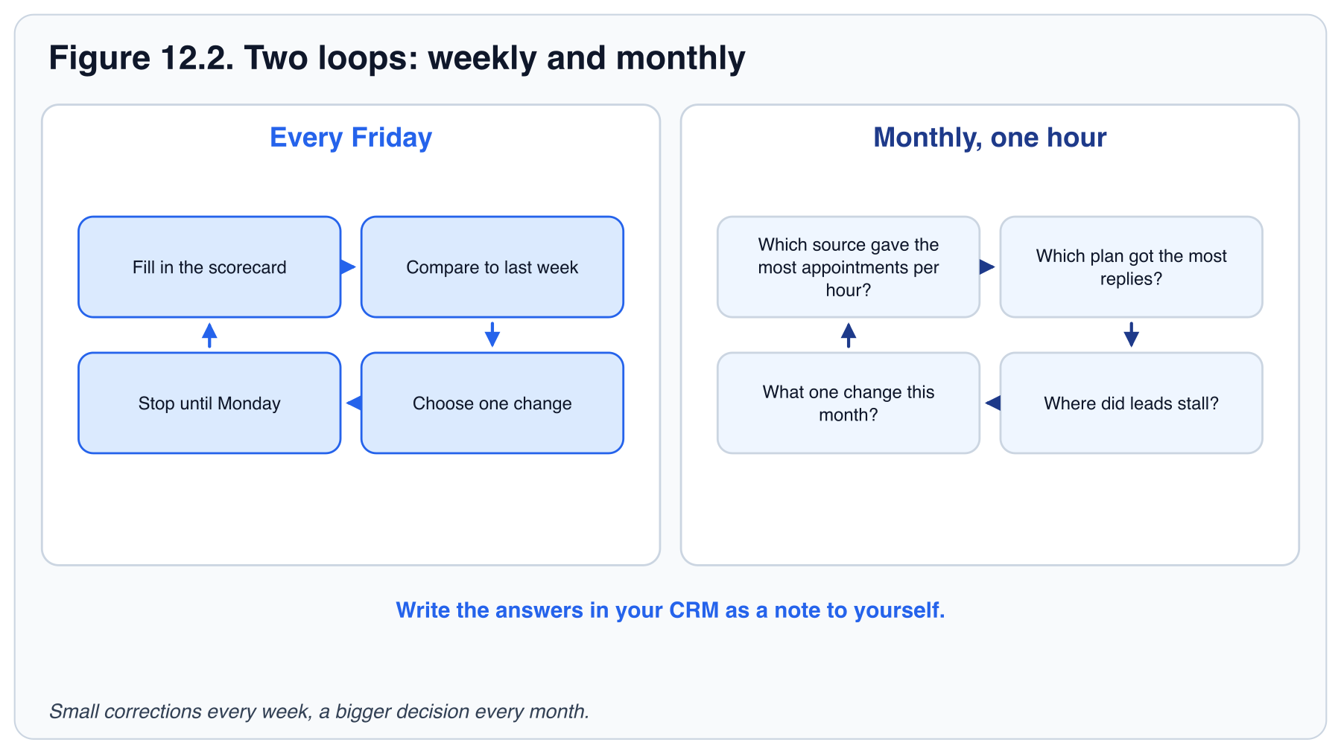

Assemble your 90-Day Business Plan
Every Try It in this book has produced one piece of your plan. Copy them onto one page:
- Your income goal and daily conversation number (Chapter 1).
- Your weekly conversation split by source (Chapter 2).
- Your content calendar (Chapter 3).
- Your CRM setup status and daily rhythm (Chapter 4).
- The three follow-up plans running (Chapter 5).
- Three scripts in your own words (Chapter 6).
- Your highest-scoring error and its fix (Chapter 7).
- Your weekly time blocks and scorecard numbers (Chapter 8).
- Your one-page consultation (Chapter 9).
- Your post-close plan (Chapter 10).
- Your compliance card: disclosure timing, consent rule, three "ask first" situations (Chapter 11).

Put each milestone on a date, and share the page with your broker or mentor.
TRY IT TODAY
- Set Day 1 on the roadmap above and write the three checkpoint dates (days 30, 60 and 90) on the figure. In the online handbook, the date field fills them in.
- Assemble your 90-Day Business Plan on one page from the list above. Put each milestone on a date and share it with your broker or mentor.
- Put the Friday scorecard review and the monthly review into your calendar for the next 90 days.
- Tell your broker, a mentor or team leader your milestone dates and ask them to check in.

KEY TAKEAWAYS
- Install, build rhythm, grow pipeline. Thirty days each.
- One weekly scorecard: Appendix A, the same rows as Table 8.2.
- One monthly review decides where your time goes next.

INTERACTIVE · TEST YOUR KNOWLEDGE
Three multiple-choice questions and a fill-in-the-blank, with the right answer and the reason shown on click.
Use this tool in the online handbook.

PART VII: EXECUTE

13. Resources and next steps
You began with a goal and a question: what do I do on a Tuesday morning? You now have a number to hit, a place to record it, a plan for every lead, words to say, a calendar to protect, and a way to stay in touch after the closing. That is a business, and it is yours.
This handbook is a starting point. The next ninety days are where it becomes real, and the ninety after that are where you replace the book's examples with your own numbers. Consistency with a simple system outperforms occasional brilliance. The pages that follow give you the week ahead, the people to lean on, and the two habits that matter more than everything else.
IN THIS CHAPTER YOU WILL LEARN TO
- Review your first 90 days against the scorecard and identify what worked.
- Set the next 90 days' targets from your own conversion ratios, not the book's examples.
- Choose the mentor, training and professional contacts you will use in your first year.

Do these this week
Finish any Try It you skipped, starting with Chapter 4's (your CRM setup) and Chapter 12's (the Friday and monthly reviews in your calendar). Then pick one chapter, do its exercise, and move to the next.

Where to get help
- Your office. Team leader, any coach your brokerage offers, and the agents who are two years ahead of you. Ask for a mentor.
- Brokerage training. The ongoing classes at your office cover scripts, your CRM and lead generation in depth.
- Your broker. For anything legal, contractual or unusual. Before, not after.
- Your lender partners. A good lender teaches you financing and sends you referrals. Meet three and pick one; Chapter 6 has the introduction script. Ask your broker what is and is not allowed before you agree to anything.
- This handbook's appendices. Appendix E has the interactive tools, and Appendix F has the essential links.

The two habits that matter most
If you remember nothing else from this handbook, remember these two. Speed-to-lead: answer every new lead to the standard in Chapter 4. Multi-touch follow-up: stay in touch for 90 days and then forever. These two habits separate agents who grow from agents who stay stuck. Everything else in the book exists to make them easy. The seven lines on the card below are the system; these two are the first things to check when results stall.

Plan the next 90 days
- Write a one-paragraph review of your first 90 days: what moved, what did not, what surprised you. Start from your Friday scorecards (Appendix A): which rows hit target most weeks, and which never did. Put it in the CRM as a note dated day 90. If you are still reading, write it for the first 30.
- Replace three of the book's example numbers with your own: conversations per appointment (Chapter 1), conversion by source (Chapter 2), touches before a reply (Chapter 5). Write the new ratio next to the old one.
- Choose one person to share the review with: your broker, a mentor or an accountability partner (Chapter 8). Put a date on it.
- Name the people from "Where to get help" you will actually use: one mentor, the next brokerage class you will attend, one lender, and one attorney or title contact. Put them in your CRM with a "Partner" tag and a date for the first conversation; Chapter 6 has the introduction script.
- Write one implementation intention: "On [day], at [time], I will [action]." Make it next Monday morning.

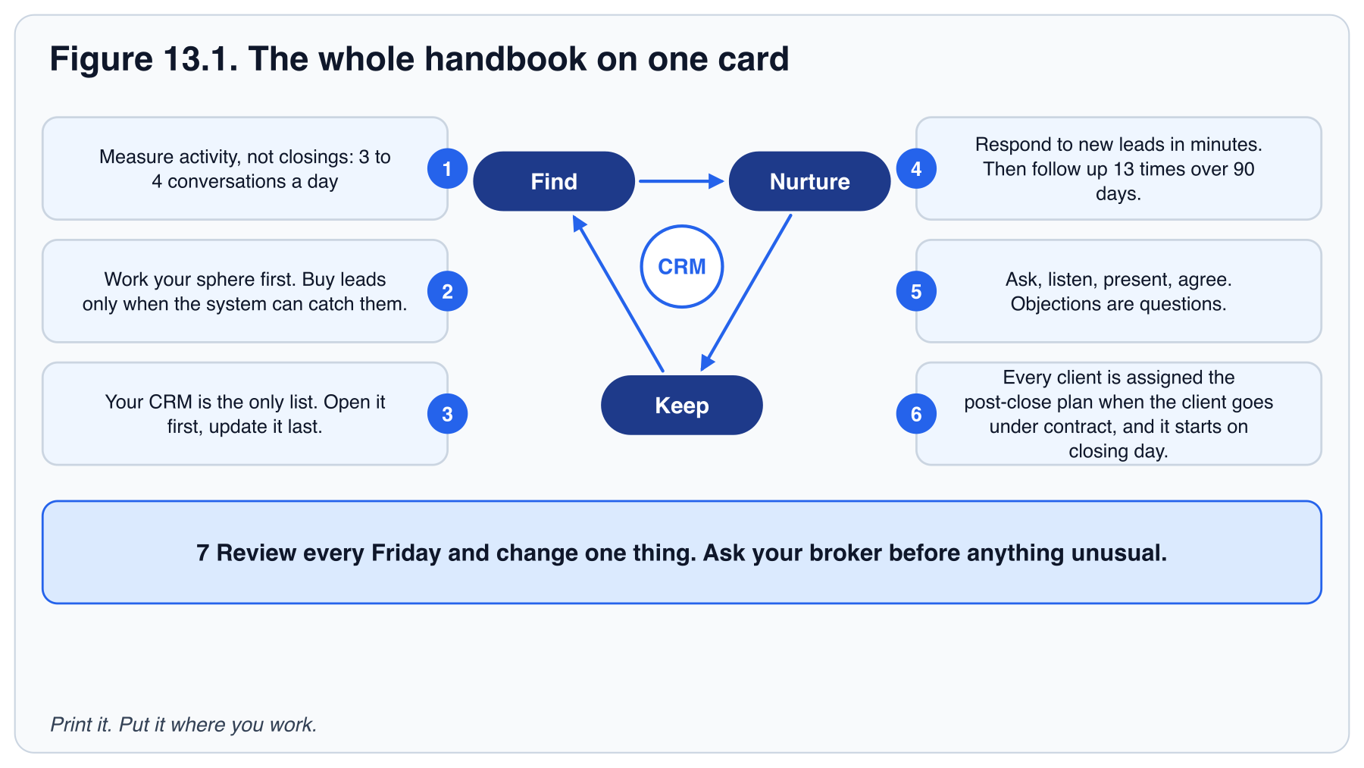
THE WHOLE HANDBOOK ON ONE CARD
- Measure activity, not closings. Three or four real conversations a day.
- Work your sphere first. Buy leads only when the system can catch them.
- Your CRM is the only list. Open it first, update it last.
- Respond to new leads in minutes. Then follow up 13 times over 90 days.
- Ask, listen, present, agree. Objections are questions.
- Every client is assigned the post-close plan when the client goes under contract, and it starts on closing day.
- Review every Friday and change one thing. Ask your broker before anything unusual.

INTERACTIVE · TEST YOUR KNOWLEDGE
Three multiple-choice questions and a fill-in-the-blank, with the right answer and the reason shown on click.
Use this tool in the online handbook.

Nobody will assign you a task list on Monday morning. Now you have written your own.

APPENDICES

Appendix A: Weekly activity scorecard
Fill it in every Friday. Targets match Table 8.2 and assume a full-time new agent in the first 90 days. Start at the low end of each range for the first 30 days, then raise them from your own ratios.
Table A.1. Weekly activity scorecard. Print or copy one per week.
ACTIVITY | WEEKLY TARGET | THIS WEEK | LAST WEEK
Outbound calls | 40 to 60
Conversations | 15 to 25
Follow-ups completed | 30 to 50
Appointments set | 1 to 2
Appointments held | 1+
Open houses or events | 1
Database updated (days out of 5) | 5
New contacts added | 15
Content posted | 2
Morning blocks held (out of 5) | 4+
Active opportunities | Growing
Pipeline value | Growing
Referrals received | Track

One thing I will do differently next week: ______________________________________________

INTERACTIVE · WEEKLY ACTIVITY SCORECARD
Enter weekly numbers and see each target turn green, amber or red.
Use this tool in the online handbook.

APPENDICES

Appendix B: Follow-up plan starter kit
Seven plans to build into your CRM. The first four take one afternoon; B.5 to B.7 wait until you have a farm, a not-yet buyer or a valuation lead to put on them. Write every message in your own voice before you turn the plan on.

B.1 New online lead (90 days)
Send automated texts or calls only to people whose consent you have recorded in the CRM, and stop at the first opt-out. Honor quiet hours. An inquiry is not, by itself, permission for this sequence. The day-0 text waits until you have that permission.
DAY | TOUCH | CHANNEL | CONTENT
0 | 1 | Text + email (automated) | Thanks for the inquiry about [property]. One easy question.
0 | 2 | Call (you) | Speed-to-lead script. Leave a short voicemail if no answer.
1 | 3 | Email | Three similar homes and an offer to set up a search.
3 | 4 | Text | "Did any of those catch your eye?"
7 | 5 | Call | Qualify: timeline, motivation, financing, representation.
10 | 6 | Email | Value piece: buyer guide or neighborhood report.
14 | 7 | Text | Market note with one number.
21 | 8 | Call | Check in; offer a consultation.
30 | 9 | Email | Monthly market update.
45 | 10 | Text | New listing or price change that fits their search.
60 | 11 | Call | "Where are things at for you?"
75 | 12 | Email | Value piece: case study of a recent client.
90 | 13 | Call | Final check-in, then move to the quarterly database plan.

B.2 New sphere contact: 8x8 (8 weeks)
WEEK | TOUCH | CONTENT
1 | Personal call or visit | Announce you are in real estate. Ask how they are. No pitch.
2 | Handwritten note | "Great to catch up." Business card enclosed.
3 | Email | Neighborhood market snapshot.
4 | Text | A local event or something personal to them.
5 | Mail | Home maintenance checklist for the season.
6 | Call | The referral ask from Chapter 6.
7 | Email | Introduction to a trusted vendor.
8 | Call or coffee | Check in; move to the quarterly plan.

B.3 Quarterly database plan (ongoing)
MONTH | TOUCH | CONTENT
1 | Call | Quarterly call with a reason: market, season, tax deadline.
2 | Email | Market update with three numbers.
3 | Mail or text | Something useful or personal; no ask.
Repeat every quarter. Add a home anniversary touch and a holiday card annually.

B.4 Post-close plan (first year)
Use Table 10.1 in Chapter 10. Six steps: closing day, one week, 30 days, quarterly (months 3, 6 and 9), home anniversary (month 12), and the annual appreciation event or gift. That is seven dated touches per client in the first year. After the first year, the contact stays on the quarterly plan in B.3. The Home Anniversary plan in Table 5.1 is not a separate sequence: the first anniversary is the month-12 step of Table 10.1, and every later one is the annual touch in B.3.

B.5 Monthly Neighborhood Nurture (ongoing)
For a geographic farm. Every household hears from you once a month; the cycle repeats through the year.
MONTH | TOUCH | CONTENT
1 | Mail | Neighborhood market snapshot: sales, days on market, one price trend.
2 | Email or social post | A local story: a business opening, school or park news, a seasonal event.
3 | Mail | Just-listed or just-sold card for a home in the farm (Chapter 3).
Repeat every quarter. Add an open-house invitation whenever you have a listing in the farm.

B.6 Buyer Long-Term Nurture (90 to 180 days)
For buyers who say "next year": start here when the qualifying call puts their timeline past 90 days, or when the day-90 check-in in B.1 finds it still is; use this instead of B.3 for them.
WEEK | TOUCH | CONTENT
1 | Call | Confirm the timeline and what would move it sooner. Set up a saved search at their pace.
2 | Email | Buyer guide: the year before you buy (credit, savings, a lender conversation).
4 | Text | One listing that fits: "No rush. This is what your range buys today."
6 | Email | Market update with three numbers.
8 | Call | Check in; offer the lender introduction (Chapter 6).
10 | Text | Something personal or local; no ask.
12 | Email | Value piece: a client who waited and bought well.
14 | Call | "Where are things at for you?" Re-set the timeline.
16 | Text | A home that sold near their target area, with what it went for.
18 | Email | Seasonal note: what the market usually does in the months ahead.
Repeat from week 2 while the timeline stays past 90 days. Once it is inside 90 days, move them to the B.1 cadence.

B.7 Seller Long-Term Nurture (6 to 12 months)
For home valuation leads and anyone who "might sell in a couple of years". Ask what prompted the request first, using the seller column of Table 5.2.
MONTH | TOUCH | CONTENT
0 | Call | Thank them for the valuation request and ask what prompted it.
1 | Email | The home value report: three comparable sales and what would raise the number.
2 | Mail | Just-sold card for a nearby home: showings, offers, days on market.
3 | Call | Quarterly call with a reason: a sale on their street, the season, a tax deadline.
4 | Email | Seller guide: what to fix, what to leave alone, when to list.
5 | Text | Something personal or local; no ask.
6 | Call | Updated home value and "where are things at for you?"
Repeat from month 1 until they name a date, then book the listing consultation (Chapter 9).

APPENDICES

Appendix C: CRM setup checklist
Finish every item in your first week. Ask your office technology trainer for help with anything that takes more than 30 minutes. The groups below follow the Chapter 4 setup, in the same order. Items that name a Keller Williams Command screen are labeled as examples; in another CRM, use its equivalent. One plan in the third group is built now, ahead of any contract. The post-close plan is built once, assigned on the day the client goes under contract, and activated on closing day; it runs seven dated touches in the first year, starting with the closing-day note. The last group carries the gate from Chapter 3. Before you pay for leads, pass the 9 p.m. test: a lead arriving at 9 p.m. tonight gets an immediate automated reply, a call by the next morning and a 90-day plan, all without you having to remember.
Table C.1. CRM setup checklist, print version. The online handbook breaks each group into individual items.
STEP | WHAT TO FINISH | DONE
1. Profile | Photo, bio, phone, email, license number, social links and brand colors (the Marketing Profile, in Keller Williams Command). | ☐
2. Contacts | Import from phone, email, social and spreadsheets. Deduplicate. Tag each contact by relationship and by source. | ☐
3. Follow-up plans | 8x8, quarterly call plan, new-lead plan and post-close plan built. The post-close plan is built now, ahead of any contract. | ☐
4. Lead routing | Teams only: rules set so inquiries reach the right person instantly. | ☐
5. Pipeline stages | Opportunities stages renamed to match how you work. | ☐
6. Mobile app | Installed, with notifications on for new leads and due tasks. | ☐
7. Before you pay for leads | The 9 p.m. test passed: immediate automated reply, a call by the next morning and a 90-day plan, all without you having to remember. | ☐

INTERACTIVE · CRM SETUP CHECKLISTS
Check off the CRM setup items and watch the progress meters.
Use this tool in the online handbook.

APPENDICES

Appendix D: Glossary
8x8
A follow-up plan of eight touches over eight weeks, used to establish a new relationship with a sphere contact.
Agency disclosure
The required explanation, usually on a state form, of whom the agent represents in a transaction and what that means for the client.
Agent Site
Your public website: profile, listings and home search, with reviews. The name is the Keller Williams Command example; other brokerages call it your agent website or profile page.
Client App
The consumer app, branded to you, that clients use to search for homes. The name is the Keller Williams Command example; other CRMs call it a client search app.
Conversation
In this handbook, a two-way exchange about real estate with someone who could buy, sell or refer. Voicemails and unanswered texts do not count.
Cost per appointment
Money and time spent on a lead source divided by the appointments it produced. The early measure: it exists before the source has closed anything.
Cost per closed deal
Money and time spent on a lead source divided by the closings it produced. The number that decides where your budget goes.
CRM
The agent platform for contacts, tasks, follow-up plans, Opportunities, marketing and transactions. Accessed on the web and through the mobile app.
Expired listing
A property whose listing agreement ended without a sale. Owners are often still motivated to sell.
Fair Housing
Federal, state and local laws that prohibit discrimination in housing on the basis of protected characteristics.
Farming
Concentrated, consistent marketing to one geographic neighborhood with the goal of becoming its recognized agent.
Follow-up plan
An automated sequence of touches in your CRM: texts, emails, and tasks that remind you to call.
FSBO
For sale by owner. A property the owner is attempting to sell without an agent.
IDX
Internet Data Exchange. The feed that lets your website display MLS listings and capture search leads.
Lagging indicator
A result that reports what already happened, such as closings or income.
Lead routing
Rules in your CRM that decide which team member receives a new lead.
Leading indicator
An activity you control today that predicts future results, such as conversations and appointments.
Marketing Profile
The branding settings in your CRM: photo, bio, contact details, license number and brand colors, reused on everything it sends. The name is the Keller Williams Command example.
Nurture
The scheduled, multi-touch follow-up that keeps a lead engaged until they are ready to act.
Office
A brokerage office: home of your managing broker, training and accountability. In the Keller Williams example it is the market center, with a team leader and a productivity coach.
Opportunities
The pipeline in your CRM where each potential transaction moves through stages from new to closed. Opportunities is the Keller Williams Command name; other CRMs call them deals.
Pipeline value
The sum of likely commission across active Opportunities. A weekly scorecard number.
Speed-to-lead
The time between a lead's inquiry and your first real response. Minutes win; hours lose.
Sphere of influence
Everyone who already knows you and would take your call. Your highest-converting lead source.
Touch
Any scheduled contact with a lead or client: call, text, email, note, visit or value piece.
Value piece
A touch that gives something useful (a report, a guide, an introduction) rather than asking for something.

APPENDICES

Appendix E: Interactive tools
These parts of the handbook respond to you. They work only in the online handbook, so this print edition lists them for reference. Each entry gives the tool’s name, where it sits in the book and what it does. Open the online handbook to use any of them.
Income goal calculator Calculator · Chapter 1
Turn an income goal into closings, conversations a week and a daily number, then stress-test it.
Lead source comparison Explorer + calculator · Chapter 2
Compare typical conversion ranges, then work out your own cost per appointment and cost per closed deal, with your time priced in.
Speed-to-lead explorer Explorer · Chapter 4
See how your response time moves you through the three conversion bands.
Response-time stopwatch Self-test · Chapter 4
Time a real test inquiry against the one-minute and five-minute standards.
Nurture timeline explorer Explorer · Chapter 5
Walk the 13-touch, 90-day plan: what to send, in which channel, and where most conversions happen.
Qualify and stage a lead Practice · Chapter 5
Spot which of the four qualifying questions are answered and decide active versus nurture.
Script practice Practice · Chapter 6 (and Chapter 9)
Hide a script, say it in your own words, then reveal it to compare. Copy any script.
Pitfall cycle explorer Explorer · Chapter 7
See which links of the pitfall loop each part of the one correction interrupts.
Six-errors self-score Self-test · Chapter 7
Rate yourself on each error and get pointed to the chapter that fixes the biggest one.
Weekly time-block planner Planner · Chapter 8
Build your morning blocks, check that lead generation lands before noon, export to your calendar.
Consultation lab Practice · Chapter 9
Rebalance a meeting so asking and listening take half, then spot the missed step in sample consultations.
Objection trainer Practice · Chapter 9
Answer common objections with the four-step pattern, then compare with the framework.
Post-close scheduler Planner · Chapter 10
Turn a closing date into every first-year touch with its date, and export them.
Fair Housing drill Practice · Chapter 11
Judge real phrases as problem or fine, with the reason for each.
90-day roadmap Planner + tracker · Chapter 12
Put dates on the three phases, tick milestones, and export the weekly and monthly reviews.
Pipeline value calculator Calculator · Chapter 12
Total your pipeline value and see who needs a Monday call.
Weekly activity scorecard Tracker · Appendix A
Enter weekly numbers and see each target turn green, amber or red.
CRM setup checklists Tracker · Appendix C
Check off the CRM setup items and watch the progress meters.
Checkpoint self-tests Self-test · End of Chapters 1 to 12
Answer each Checkpoint question first, then check the key points and rate yourself.
Test your knowledge Quiz · End of Chapters 1 to 13
Three multiple-choice questions and a fill-in-the-blank, with the right answer and the reason shown on click.

Also interactive
- Glossary terms. Terms such as CRM, IDX and 8x8 are underlined with dots the first time they appear in a chapter. Tap one for its definition; the full list is in Appendix D.
- Progress tracker. The sidebar shows sections read and checkpoint questions you are confident about. Open the menu on a phone to see it. Use Reset to mark sections unread.

APPENDICES

Appendix F: Essential links
Trusted sources to bookmark. Rules and forms vary by state, so confirm anything legal with your broker. The rows labeled California are specific to that state; if you work elsewhere, use ARELLO to find your own state's regulator, and your broker can name your state association.
Table F.1. Essential links, and what you will find at each one.
RESOURCE | WHAT YOU WILL FIND
California Association of REALTORS® (C.A.R.)  car.org | California. State association: standard forms, legal hotline, market data and member resources.
National Association of REALTORS® (NAR)  nar.realtor | National association: research, advocacy and professional resources.
NAR Code of Ethics  nar.realtor/about-nar/governing-documents/the-code-of-ethics | The ethical standards REALTOR® members agree to follow.
California Department of Real Estate (DRE)  dre.ca.gov | California. Licensing, exams, renewals and the rules your license depends on.
ARELLO  arello.org | Find the real estate regulator for any U.S. state or Canadian province.
HUD Fair Housing  hud.gov/helping-americans/fair-housing-act-overview | Federal Fair Housing Act guidance, protected classes and how complaints work.
Consumer Financial Protection Bureau  consumerfinance.gov | Plain-language guides to mortgages, closing costs and your clients' rights.
National Do Not Call Registry  donotcall.gov | Check and understand the rules before you cold call or text prospects.
IRS: Small Business and Self-Employed  irs.gov/businesses/small-businesses-self-employed | Estimated taxes, deductions and record keeping for independent contractors.
Finding, Nurturing, and Keeping Clients: a practical guide for new real estate agents. Conversion ranges are illustrative, not measured rates, and will vary by market. Nothing here is legal advice; consult your broker.

