

APO DevOps Forum Workshop

Lab Guide 9 – Internet of Things
CMX (Connected Mobile Experiences)

Table of Contents
Table of Contents 3
Overview 4
Welcome 4
Prerequisites 4
Instructions 5
9 – Location and Mobility Analytics using REST APIs 5
Task 900 – Common Tasks: CMX Sandbox and References 5
Task 901 – Run API calls directly from the Web Interface 7
Task 902 – Query API using Postman Chrome App 9
Task 903 – Query the CMX API using Python scripts 14
Practical Example Using the CMX Presense API 17
Task 904 – Write a Python Script to Emulate the Given Example 18
Task 904a – Write the output from your script to the Spark room using API 20

Overview

Welcome
Cisco Mobility Experience (CMX) provides a wealth of information about the clients and devices connected to Cisco wireless networks. All of this information can be accessed through the CMX API and can be utilized to automate and trigger actions based on a number of conditions including the location of an object or individual or conditions such as dwell time or repeat presence. The following lab will guide you through the basics of interacting with the CMX API through tools like Postman and python scripting.

Prerequisites
This Lab is based on a remotely operated infrastructure, attendees should bring:
- Ethernet enabled notebook
- Chrome Web Browser
- RestClient – Postman
- Python 2.x

Instructions

9 – Location and Mobility Analytics using REST APIs
Before we delve into querying and leveraging the CMX APIs for gathering data about wireless clients, it would be beneficial to see the CMX dashboard to get an idea of what information it contains. For this exercise, you will be using the DevNet MSE Sandbox located at https://msesandbox.cisco.com:8081.

Task 900 – Common Tasks: CMX Sandbox and References
For this exercise, open a web brower (preferably Google Chrome) to log into the sandbox. Chrome is recommended and will be used later as we access the API using Postman, a brower add-on.
Step-by-step Instructions

- Open Chrome and browse to https://msesandbox.cisco.com:8081 and login with username: learning and password: learning.

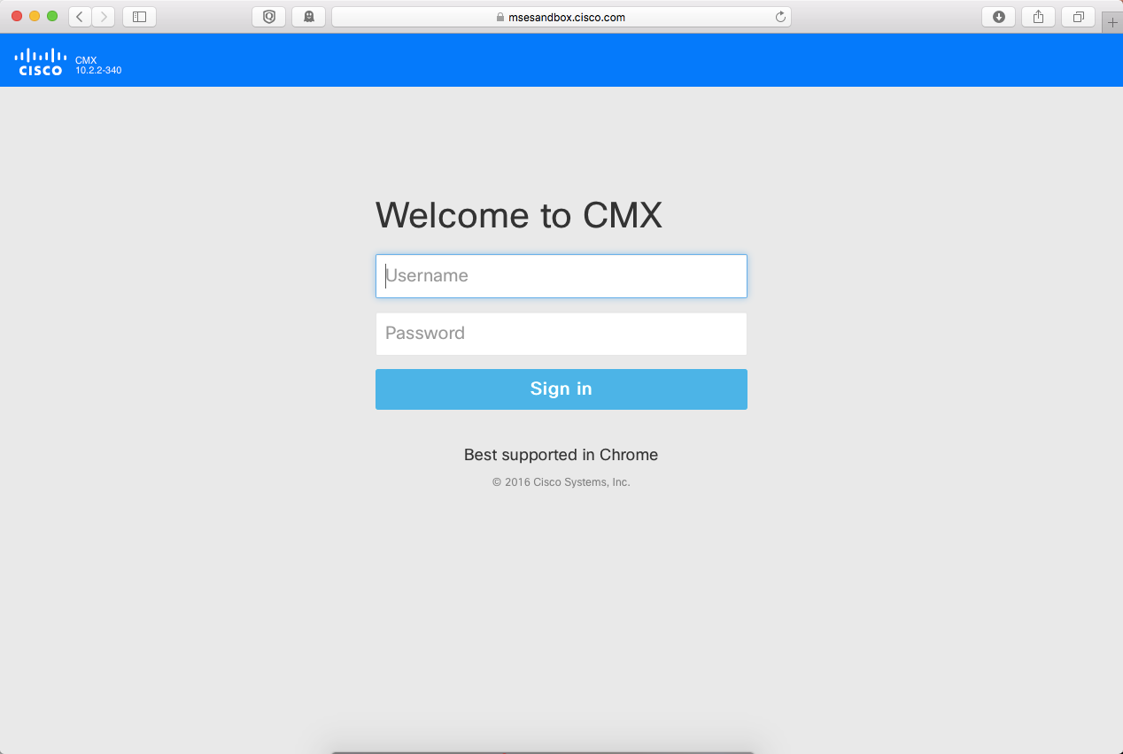
After authenticating, browse through the screens to get an idea of what information is available in the GUI as it will make more sense once we start querying the API for details about the connected clients.
- Open Detect & Locate and choose DevNet Campus DevNet Building DevNet Zone.
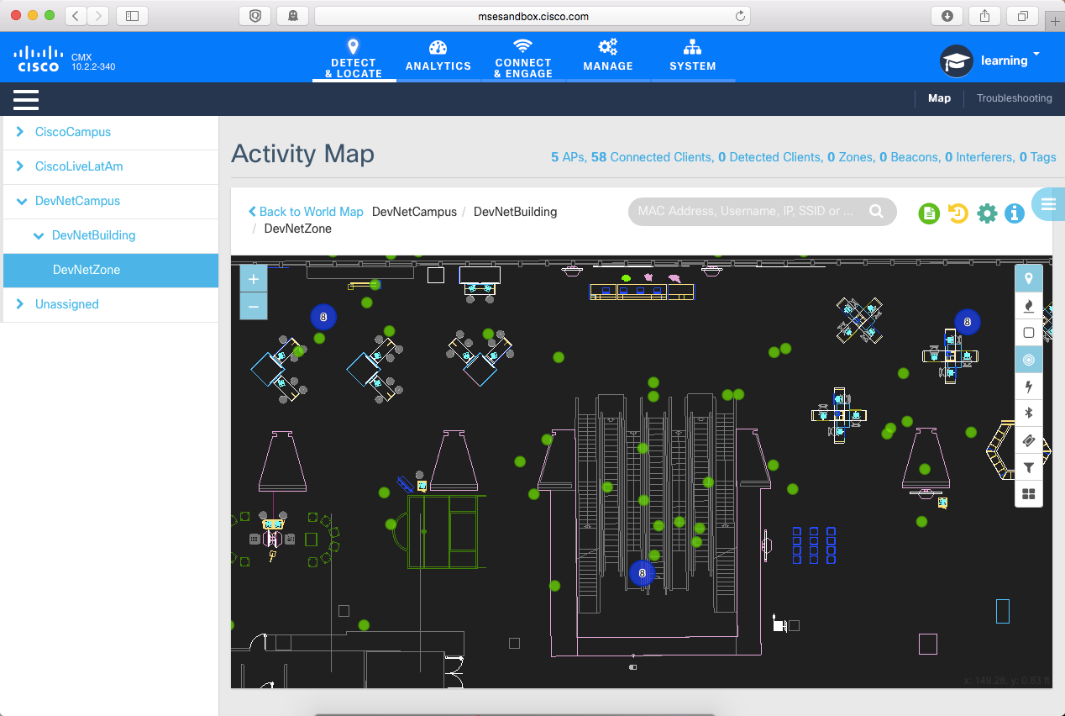

- Click on one of the mobile devices, indicated by the green dots to get an idea of how a device’s location is calculated (or approximated).
In this scenario, we are using AP triangulation to determine the location of the client. This is accurate to ~10 m, with Hyperlocation and AoA (Angle of Arrival) the level of accuracy could be closer to 1 m.
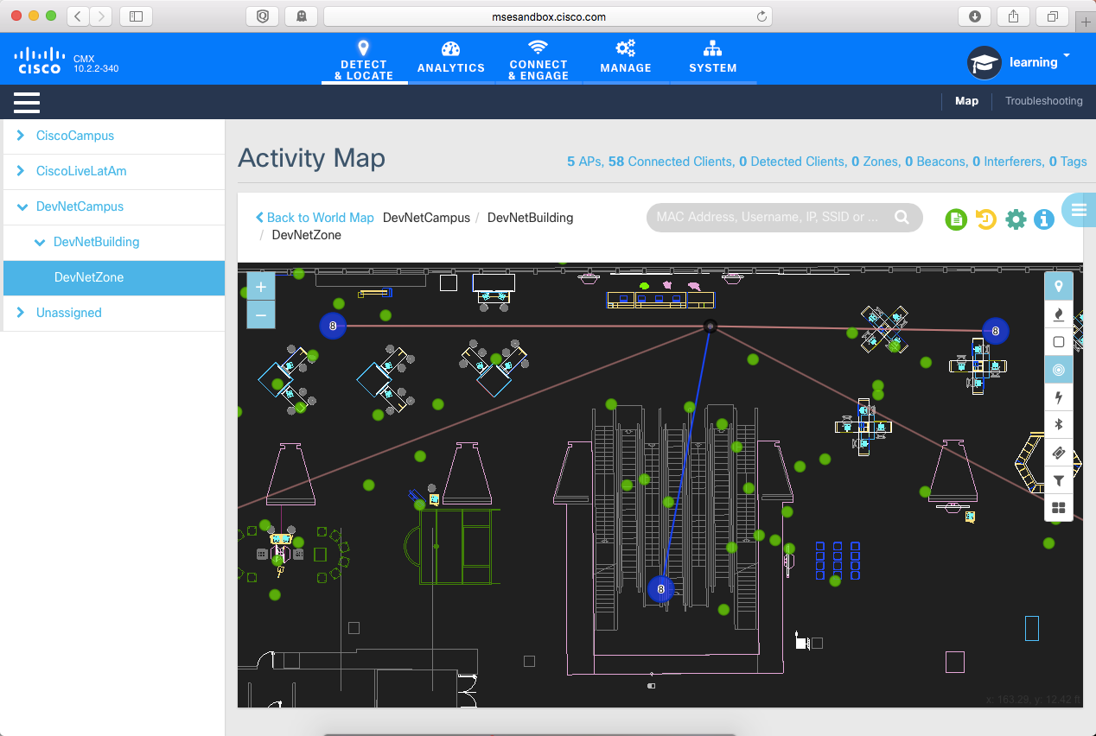
- Navigate to https://msesandbox.cisco.com:8081/apidocs to look through the API documentation and familiarize yourself with some of the Location API and Analytics API calls.

Task 901 – Run API calls directly from the Web Interface
CMX 10.X allows you to see the returned values for API calls directly in the web interface by supplying the correct credentials and querying the given API. It will create the appropriate call and return the results to the screen.
Step-by-step Instructions

- From the /apidocs virtual directory, click on the “View Details” button under the Location Analytics topic.
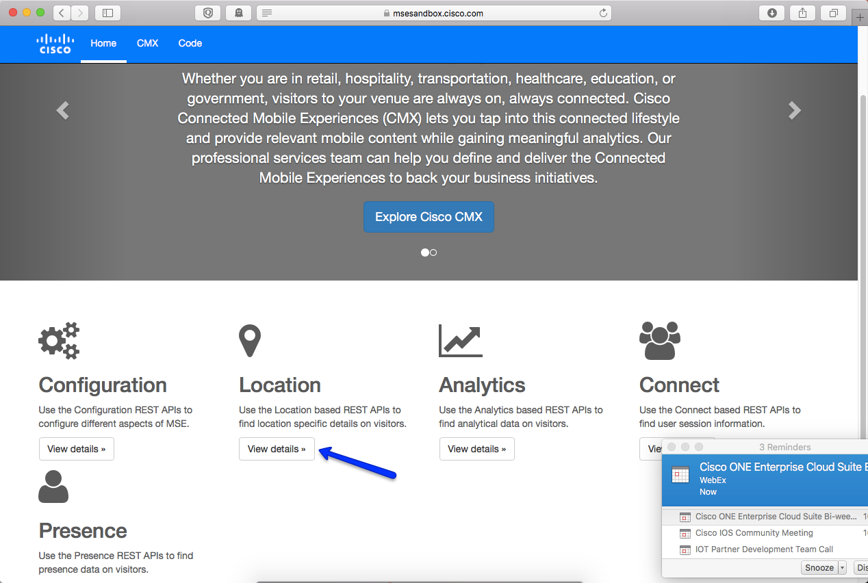

- Supply the username: learning and password: learning in the supplied fields of the web interface.
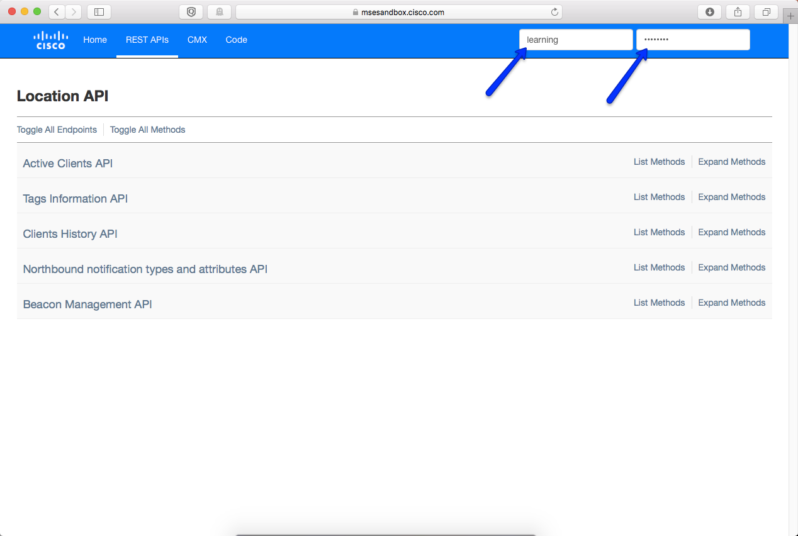

- Expand the Active Clients API and click on the “Try It!” button. This will query the MSE for all of the active clients via API call and return the results. You can also see the parameters that can be used to filter the results of the query. This will be important as we begin to track specific devices or want to limit the results of the output.

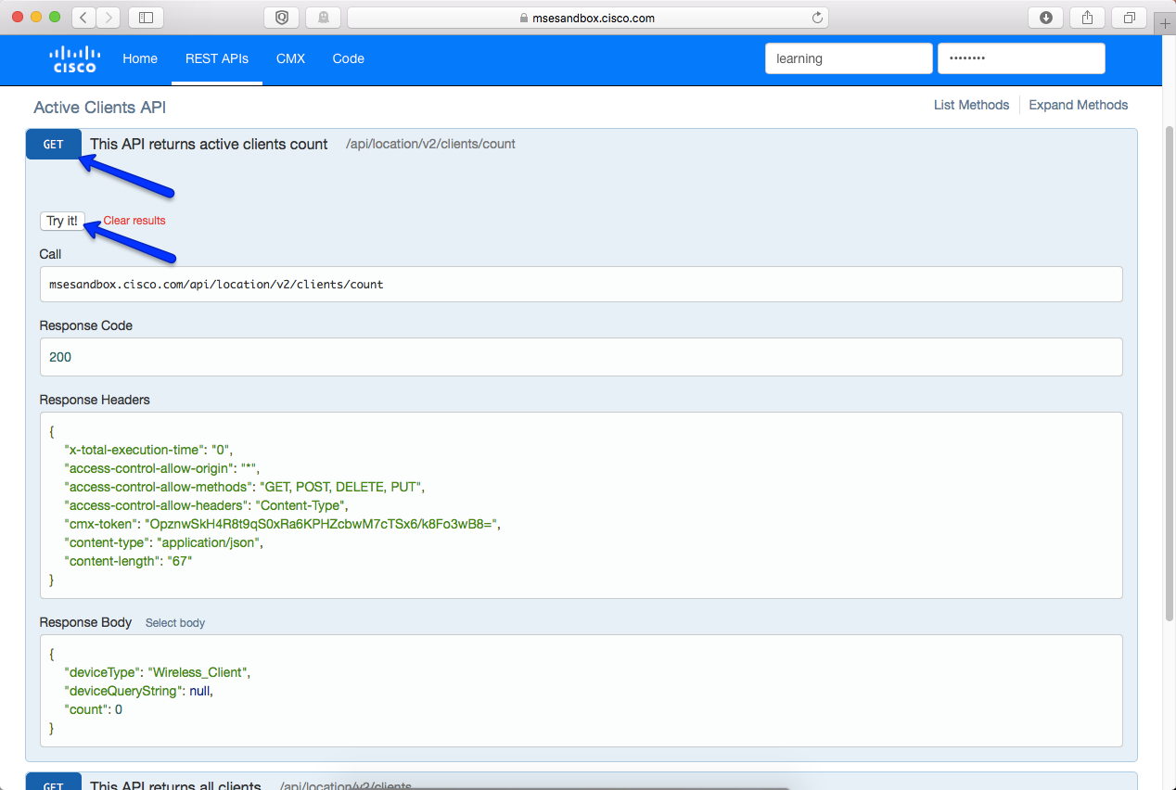

During testing, the v2 API calls were found to return incorrect values. If you test and the “active clients” count returned is zero, this is indicative of a filed bug. Apidocs does not let you run the v1 version of the API call, but you’ll see the correct response when testing with Postman later on in the lab.

Task 902 – Query API using Postman Chrome App
CMX 10.X allows you to see the returned values for API calls directly in the web interface by supplying the correct credentials and querying the given API. It will create the appropriate call and return the results to the screen.
Step-by-step Instructions
- Using Chrome, browse to https://chrome.google.com/webstore.
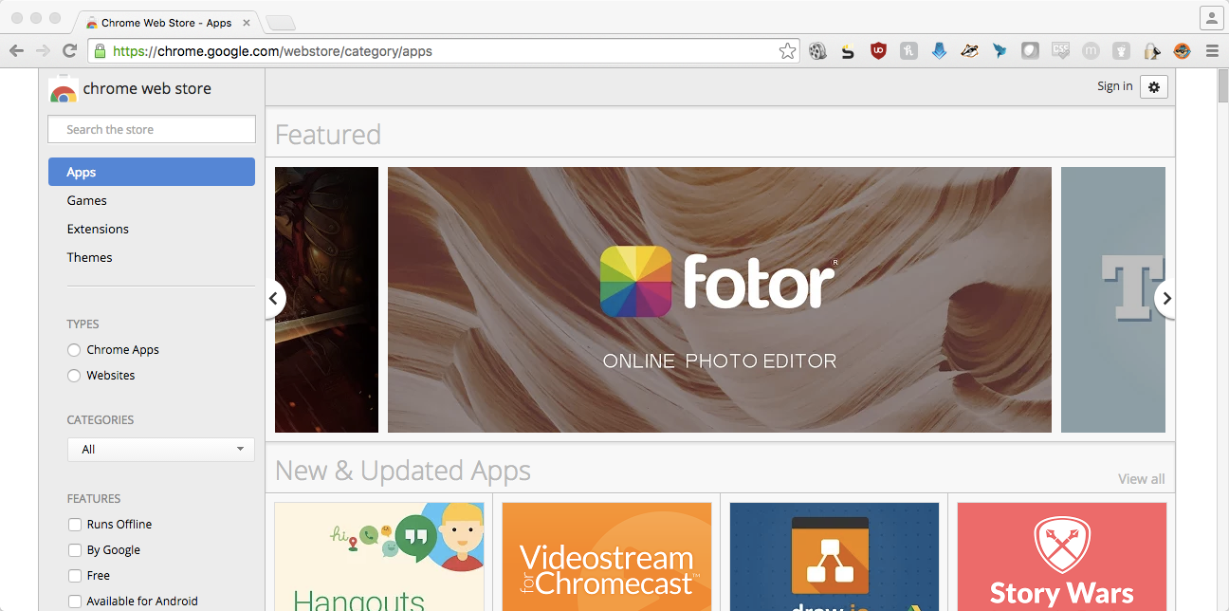
- Search for and download the Postman app.
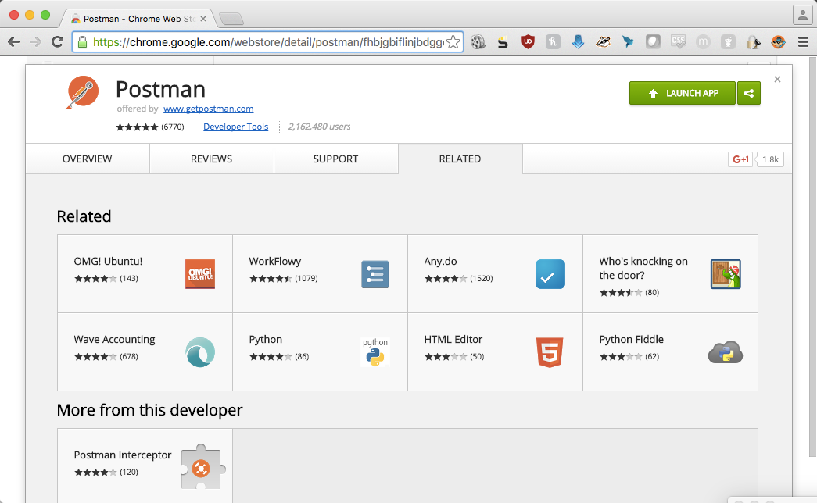
- Open Postman and configure the authentication credentials that will be used to query the API, use Basic authentication, username: learning, and password: learning.
If you look at the parameters for the crafted URL, you will see that Postman concatenates the username and password and encodes it using base64 into a string of characters.
- Use the following URL to query the total number of connected wireless clients known to CMX.

https://msesandbox.cisco.com:8081/api/location/v2/clients/count

You should see something similar to the output below that indicates how many clients are currently connected.

{
"deviceType": "Wireless_Client",
"deviceQueryString": null,
"count": 80
}

- Many applications will require that you filter the total number of connected clients by certain variables such as clients in a building or on a floor. Run the following query the API to determine the following values for the DevNetZone.
https://msesandbox.cisco.com:8081/api/config/v1/maps
  - Campus Name:
  - Building Name:
  - Floor Name:
  - Floor ID #:
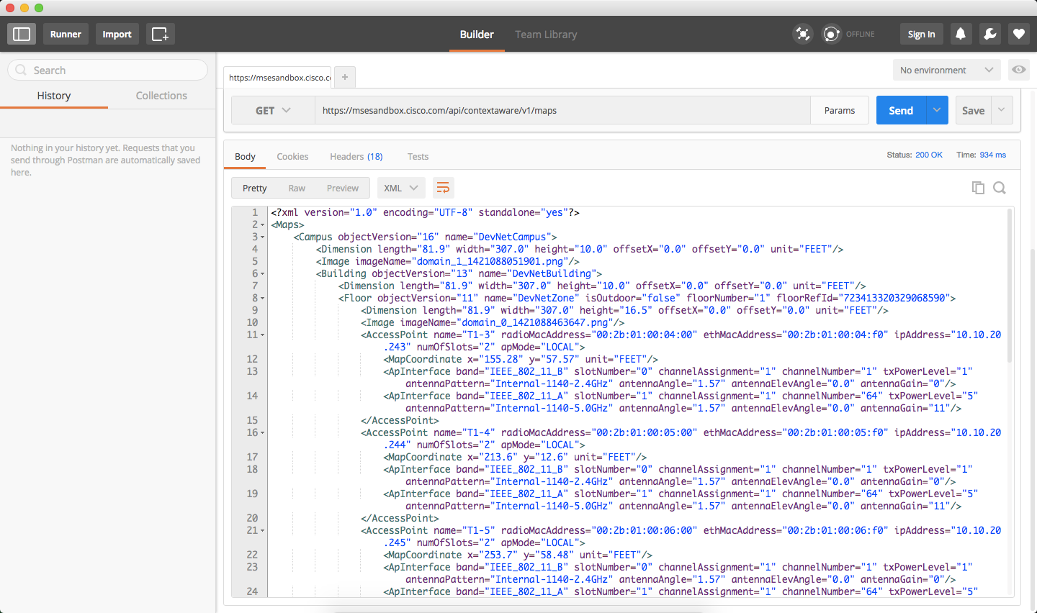
With the information about the various configured buildings and floors, you can get client information specific to the area you’d like to track. For instance, you can get a list of all of the MAC addresses that were seen in the DevNetZone floor in a given time range.
- Try the following API call to get all of the clients in DevNetZone yesterday.
https://msesandbox.cisco.com:8081/api/location/v1/history/uniqueclientsbyhierarchy?date=2016/07/10&floorid=723413320329068590

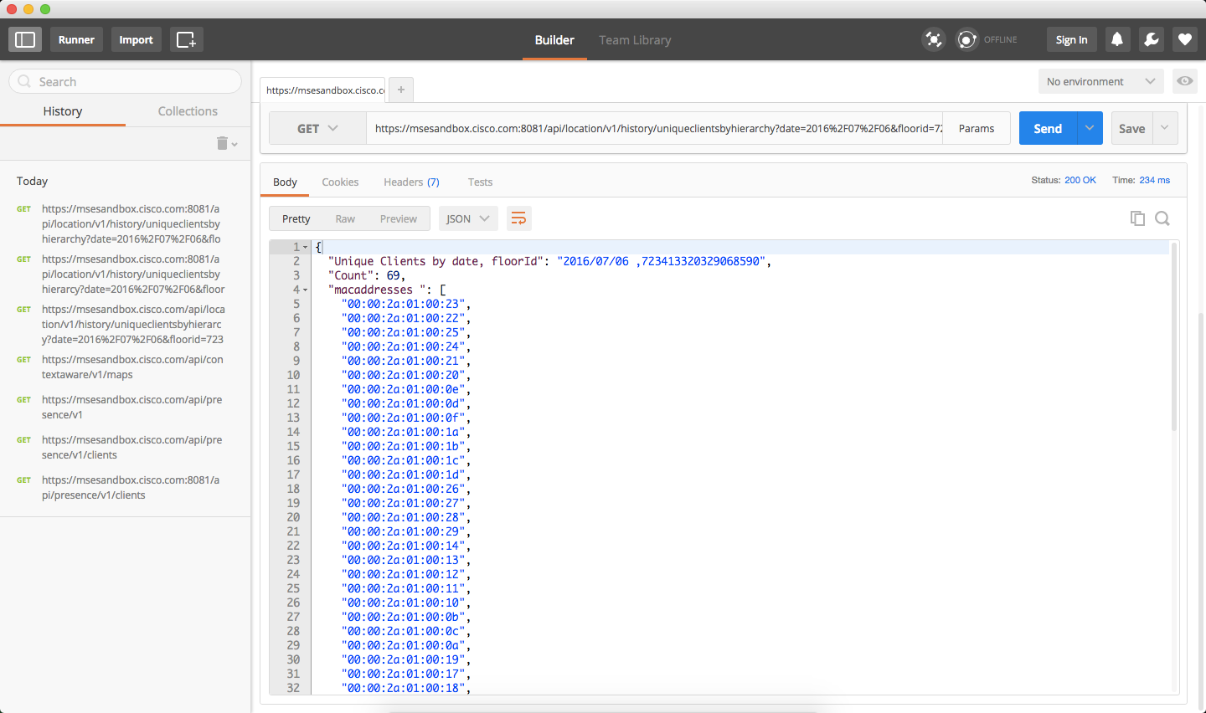
Pick one of the MAC addresses returned from the previous query to dig into the client specific details. For the examples below this guide will use 00:00:2a:01:00:02, though any of the client MAC addresses will work.
- Query the path of a specific client through the environment. Run the following query using Postman.

https://msesandbox.cisco.com:8081/api/location/v1/historylite/clients/00:00:2a:01:00:02
With API queries, you’ll notice that capitalization matters. When entering your MAC address, ensure the values are lower case and the Unicode equivalent of : (%3A) are uppercase. This is more common on MSE 8.X since CMX 10.X allows you to use a colon to separate your MAC address rather than Unicode.

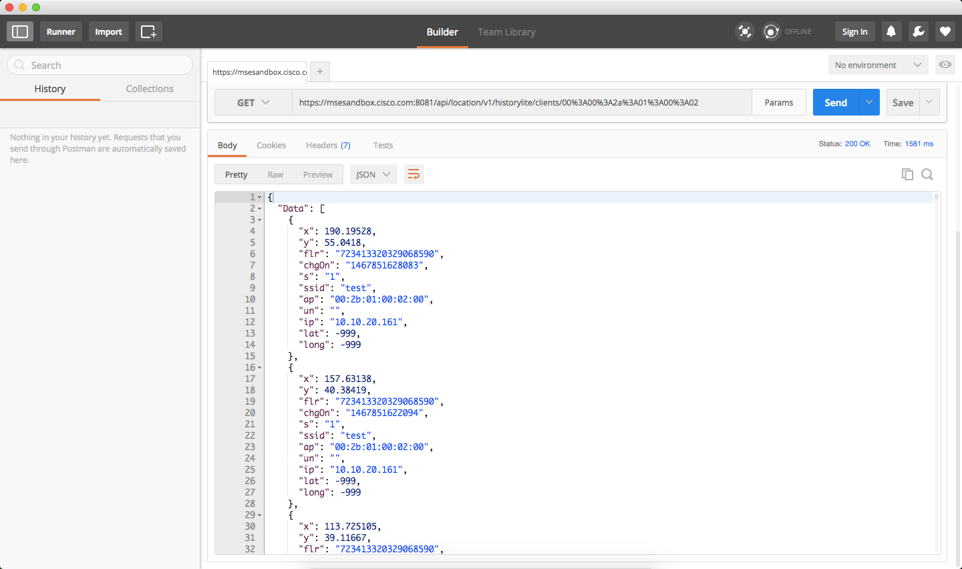
This returns many pieces of information including the (X,Y) coordinates of the client at a specific time, the floor and access point which the client is associated, the assigned IP address (and username if using 802.1x) over time.
Another piece of information that may be useful, as seen in a later example, is determining the number of clients in a specific area.
- Run the following query to determine the number of connected clients that are in the DevNetZone.
https://msesandbox.cisco.com:8081/api/location/v1/clients/count?mapHierarchy=DevNetCampus>DevNetBuildng>DevNetZone

or Tags:
https://msesandbox.cisco.com:8081/api/location/v1/tags/count?mapHierarchy=DevNetCampus>DevNetBuildng>DevNetZone
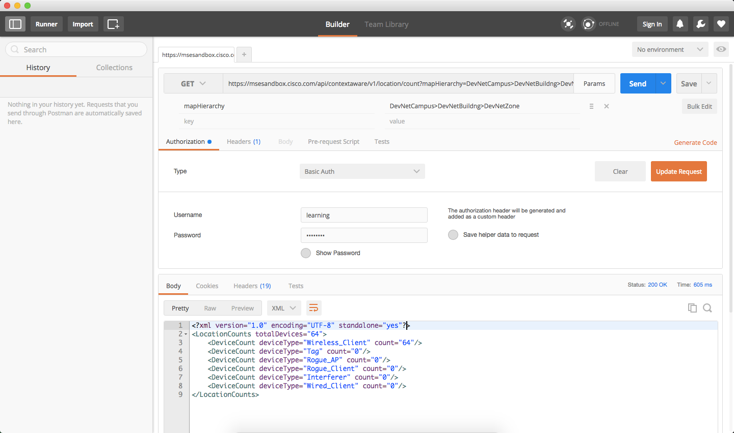
From the output you can see how many clients are currently connected in a given area based on your map hierarchy. A practical application of this will be discussed towards the end of the lab guide.
Congratulations – you have completed this task by using REST API to query CMX.

Task 903 – Query the CMX API using Python scripts
In addition to using developer tools like Postman to query the CMX APIs, it is possible to integrate these queries into custom scripts that will allow you to automate other functions or call other APIs based on the information collected by CMX. For this exercise, you will need to have Python installed on your client device.
- Browse to https://python.org and download the latest 2.7 release for your operating system.
Some operating systems, Linux, Mac OSX, etc. may have python preinstalled that can be leveraged for this exercise, however, you’ll want to make sure you’re running the latest version of the release, either 2.7 or 3.0.
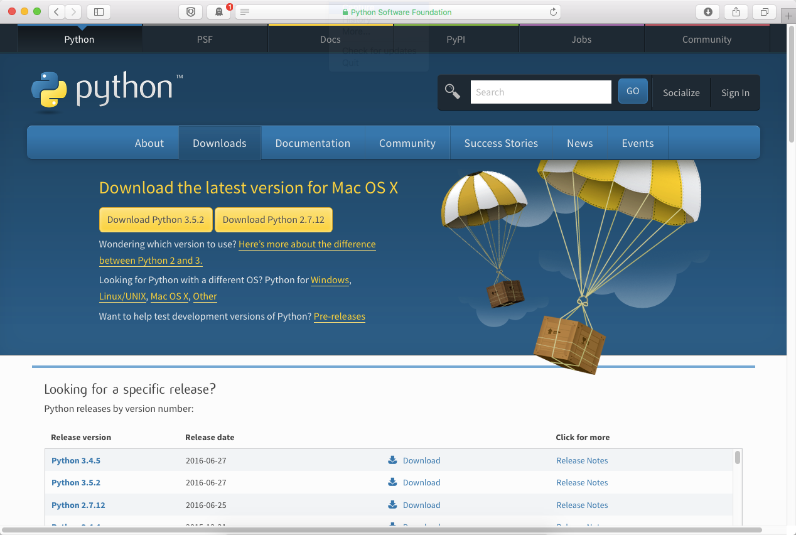
- Go to http://cs.co/DevOps2016 and pull down the sample python script that will be used to query the API.
- Install the required python modules to support CMX API calls. For this exercise, you will need both the requests and requests[secure] using pip.
Run the following commands to install the package manager and two packages.
$easy_install pip, $pip install requests, $pip install requests[secure].
You will see an output similar to the one below which indicates that the necessary packages and python modules have been installed successfully.

$ easy_install pip
Searching for pip
Best match: pip 8.1.1
Adding pip 8.1.1 to easy-install.pth file
Installing pip script to /Library/Frameworks/Python.framework/Versions/2.7/bin
Installing pip3.5 script to /Library/Frameworks/Python.framework/Versions/2.7/bin
Installing pip3 script to /Library/Frameworks/Python.framework/Versions/2.7/bin

Using /Library/Frameworks/Python.framework/Versions/2.7/lib/python2.7/site-packages
Processing dependencies for pip
Finished processing dependencies for pip

$ pip install requests
Collecting requests
Downloading requests-2.10.0-py2.py3-none-any.whl (506kB)
100% |████████████████████████████████| 512kB 881kB/s
Installing collected packages: requests
Successfully installed requests-2.10.0

$ pip install requests[security]
Requirement already satisfied (use --upgrade to upgrade): requests[security] in /Library/Frameworks/Python.framework/Versions/2.7/lib/python2.7/site-packages
Collecting pyOpenSSL>=0.13 (from requests[security])
Downloading pyOpenSSL-16.0.0-py2.py3-none-any.whl (45kB)
100% |████████████████████████████████| 51kB 1.1MB/s
Collecting ndg-httpsclient (from requests[security])
Downloading ndg_httpsclient-0.4.1.tar.gz
Collecting pyasn1 (from requests[security])
Downloading pyasn1-0.1.9-py2.py3-none-any.whl
Collecting cryptography>=1.3 (from pyOpenSSL>=0.13->requests[security])
Downloading cryptography-1.4-cp27-cp27m-macosx_10_10_intel.whl (2.4MB)
100% |████████████████████████████████| 2.4MB 408kB/s
Collecting six>=1.5.2 (from pyOpenSSL>=0.13->requests[security])
Downloading six-1.10.0-py2.py3-none-any.whl
Requirement already satisfied (use --upgrade to upgrade): setuptools>=11.3 in /Library/Frameworks/Python.framework/Versions/2.7/lib/python2.7/site-packages (from cryptography>=1.3->pyOpenSSL>=0.13->requests[security])
Collecting enum34 (from cryptography>=1.3->pyOpenSSL>=0.13->requests[security])
Downloading enum34-1.1.6-py2-none-any.whl
Collecting ipaddress (from cryptography>=1.3->pyOpenSSL>=0.13->requests[security])
Downloading ipaddress-1.0.16-py27-none-any.whl
Collecting idna>=2.0 (from cryptography>=1.3->pyOpenSSL>=0.13->requests[security])
Downloading idna-2.1-py2.py3-none-any.whl (54kB)
100% |████████████████████████████████| 61kB 4.9MB/s
Collecting cffi>=1.4.1 (from cryptography>=1.3->pyOpenSSL>=0.13->requests[security])
Downloading cffi-1.7.0-cp27-cp27m-macosx_10_10_intel.whl (212kB)
100% |████████████████████████████████| 215kB 1.8MB/s
Collecting pycparser (from cffi>=1.4.1->cryptography>=1.3->pyOpenSSL>=0.13->requests[security])
Downloading pycparser-2.14.tar.gz (223kB)
100% |████████████████████████████████| 225kB 1.9MB/s
Installing collected packages: enum34, ipaddress, pyasn1, six, idna, pycparser, cffi, cryptography, pyOpenSSL, ndg-httpsclient
Running setup.py install for pycparser ... done
Running setup.py install for ndg-httpsclient ... done
Successfully installed cffi-1.7.0 cryptography-1.4 enum34-1.1.6 idna-2.1 ipaddress-1.0.16 ndg-httpsclient-0.4.1 pyOpenSSL-16.0.0 pyasn1-0.1.9 pycparser-2.14 six-1.10.0

- Run the script using the command $python clientcount.py
An output similar to the following should be displayed:
$ python clientcount.py
{
“count”: 72,
“deviceQueryString”: null,
“deviceType”: “Wireless_Client”
}
Open the supplied code sample and look through the various parameters that are used to setup the API call and how the authentication occurs.
import requests
requests.packages.urllib3.disable_warnings()
from requests.auth import HTTPBasicAuth
import json
import base64

def main():
print("*********************************************************");
print("* Cisco CMX Command Line REST API Python Utility *");
print("* Please provide the input in the following format *");
print("* *");
print("* REST URL: https://[ip]/api/location/v1/clients/count *");
print("* Username: [username] *");
print("* Password: [password] *");
print("* *");
print("* *");
print("* Control C to exit *");
print("*********************************************************");

storedCredentials = False

try:

username = 'learning'
password = 'learning'
restURL = 'https://msesandbox.cisco.com:8081/api/location/v1/clients/count'
request = requests.get(
url = restURL,
auth = HTTPBasicAuth(username,password),
verify=False)

parsed = json.loads(request.content)
print json.dumps(parsed, indent=2)

except requests.exceptions.RequestException as e:
print(e)
With this framework, you can replace the restURL variable with any of those suppied by the API guide and combine the output these calls with other functionality to automate your environment based on the presence of clients, client counts in a particular area, dwelltime of a specific client or any other variable available via API.
Congratulations – you have completed this task by using python to query REST API on CMX.

Practical Example Using the CMX Presense API
It’s very possible that you’ve come to this event looking for ways to take your newly formed API sorcery and turn it into actionable, real-world, applications that you can implement with customers. The following section describes a proof of concept run by one of our customers in the higher education space, though it can be replicated really in any environment. You can walk through a sample of this scenario after the use case is described using the DevNet Sandbox as a reference environment.
Customer Scenario
A higher education customer was looking to reduce the operational expense of cooling several of their buildings by tuning their HVAC systems to only trigger on once an occupancy threshold was surpassed. They were regularly cooling vacent floors and buildings which required that they operate the HVAC system at all times, even when there wasn’t a need for it to be on.
They looked at alternative technologies like motion and occupancy sensors for these buildings, however retrofitting existing builds was cost preventative. They instead decided to look at leveraging CMX, a technology which was already deployed and working to gather traffic patterns of the buildings where they also needed help with HVAC utilization.
Technical Solution
A study was conducted where individuals would count the number of people who occupied an area and then they would coorelate that to a given device count returned from CMX. This device count (both associated and unassociated, or probing) was coorelated to the actual number of people on a given floor. The team wrote an algorithm that determined the number of people, based on the number of detected devices, and determined the optimum duty cycle for the HVAC that supported that given area.
The Result
The school was able to reduce costs by 9% over a 3-month window leveraging the CMX APIs and triggering the HVAC to run only when it was required. This resulted in a significant cost savings for the customer who is looking to replicate these results to other buildings.

Task 904 – Write a Python Script to Emulate the Given Example
Now it’s your turn to query the number of devices that are active in the DevNet Zone and have an action occur based on a passed threshold. Since the hotel did not agree to allow us to toggle their HVAC, we’ll have to make due with posting a message to the Spark room for this event using another API call.

- Edit the supplied python script and parse out the returned clients value (in JSON format) into a variable that we can use into our script.
Once the json.loads function is run on the data returned from the API call, the resulting data is in a standard python dictionary file which is able to be parsed for the specific values in which we are interested. The variable parsed stores this output which can then be accessed. (parsed = json.loads(request.content)).
- Consider the following addition to the script.

clientcount = parsed[“count”]

This will assign the number of clients to the variable clientcount. Then we can watch this variable over time and see if it exceeds a certain threshold by running our API call in a loop and recording this value.

Since this is just a quick proof of concept, the following code is pretty ‘hacky’ and would not be considered best practice for production environments. If you are a more adept at writing python and would like to put together something yourself, please do… and then make sure to share it so future events can leverage your greatness.
The following changes to the script are bolded and a comment is included to describe why it was added to the script.

import requests
requests.packages.urllib3.disable_warnings()
from requests.auth import HTTPBasicAuth
import json
import base64
import time #time python module for implementing sleep

def main():
print("*********************************************************");
print("* Cisco CMX Command Line REST API Python Utility *”);
print(“* Please provide the input in the following format *”);
print(“* *”);
print(“* REST URL: https://[ip]/api/location/v1/clients/count *”);
print(“* Username: [username] *”);
print(“* Password: [password] *”);
print(“* *”);
print(“* *”);
print(“* Control C to exit *”);
print(“*********************************************************”);

storedCredentials = False

while True: # While loop to run continuously until stopped with Ctrl-C
try:

username = ‘learning’
password = ‘learning’
restURL = ‘https://msesandbox.cisco.com:8081/api/location/v1/clients/count’
request = requests.get(
url = restURL,
auth = HTTPBasicAuth(username,password),
verify=False)

parsed = json.loads(request.content)
clientcount = parsed[“count”] #pull count from response and assign it to a variable
print clientcount #print the current count value to the screen
#print json.dumps(parsed, indent=2)

if clientcount > 90: #simple comparison to check if the value exceeds a threshold
print “Tell Spark it’s more than 90” #output to screen or post to Spark room

time.sleep(60) #wait 60 seconds between queries to avoid abuse of API

except requests.exceptions.RequestException as e:
print(e)

Task 904a – Write the output from your script to the Spark room using API
Since you’ve also learned how to write to the Spark API with the collaboration team, this would be a great opportunity to demonstrate this and put it into practice.
- Replace the print statement in the python script above with code that will post a message out to the Spark room once that same threshold is reached.
- Go to developer.ciscospark.com and get your personalized authentication token. Similar to the one below
NjNjYzIyMmUtZTE5OCOOMWExLWEzZjctOWZmOTY3NzRlYjk4OTA4MDU0ODEtMDIw

- Replace the print statement in the python script above with code that will post a message out to the Spark room once that same threshold is reached.
- Install the Cisco Spark modules for python

$pip install spark-python
~ $ pip install spark-python
Collecting spark-python
Downloading spark-python-0.0.6.tar.gz
Requirement already satisfied (use --upgrade to upgrade): requests in /Library/Frameworks/Python.framework/Versions/2.7/lib/python2.7/site-packages (from spark-python)
Installing collected packages: spark-python
Running setup.py install for spark-python ... done
Successfully installed spark-python-0.0.6

- Use the sample code from the Box site for create_room.py and send_message.py.
These will allow you to create a new room in Spark. The default room name is ‘DevOps Forum IoT’, but you can change it in the script.

- After the room is create, you can use the code from the send_message.py script to post a new message to the newly created Spark room.

- Integrate these new calls into your program by either creating new functions for create_room and send_message or call them from your main script with a message that you’d like to post to the Spark room.

This is the end of the CMX lab! Thanks for sticking with it!

