Source Code:
src - Win XP and others
src.wdk.vista - Windows Vista and 7

To build:
In the corresponding building environment, run “build –cZ”

To install on Vista 64 or Windows 7 64:

- Turn the test signing on the target machine
  - Bcdedit –set TESTSIGNING ON

- Install certificate
Clearly this is a solution of limited value, as the only copy of 64-bit Windows that is happy with your app/driver now is the one that you just did the work on. The signature on the driver only works there because makecert installed the root certificate for your driver signature in your local driver store. Thus, if you were to copy the signed version of chml to another computer, that computer wouldn't be able to validate the signature on the EXE, and you'd be back where you started. Try it -- copy the signed chml (or whatever you signed) to another system and examine its digital signature's status as we just did above, and you'll see something like this:
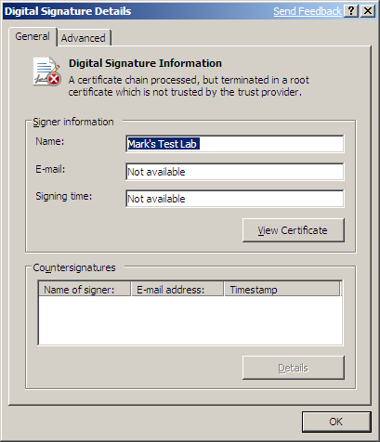
To be able to distribute something that you've signed, then, you must also distribute (and install) a cert with the app. To do that, copy the PFX file to the computer you just copied the application/driver to. Right-click the PFX file and choose "Install PFX." That starts a wizard as follows:
- Click next to skip opening page
- At the "File to Import" page, click Next
- Next, you'll see a "Password" page that wants the private key's password -- the password that you specified in the "-po" option of pvk2pfx. (Remember we've been using "leafwood." Don't bother checking anything else, and click Next
- This "Certificate Store" page is important, as it says where to install the cert, and you do not want Windows to choose a location, as it guesses wrong.
- Click the "Place all certificates in the following store" radio button and then the Browse button
- You'll get a dialog box showing you where the certs can go; check the box labeled "Show physical stores"
- Find "Trusted Root Certification Authorities" and click the plus sign next to it so that you can choose "Registry."
- Click OK to return to the wizard which should now look like the following figure.
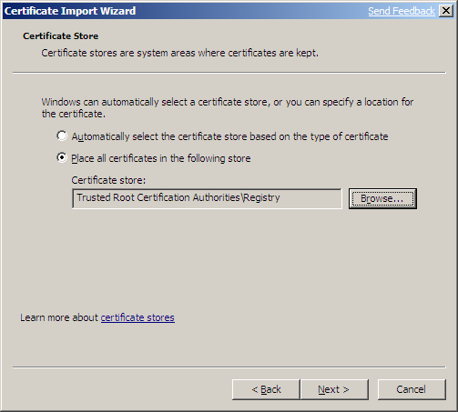
- Click Next and Finish. You'll get a confirmation message like this:
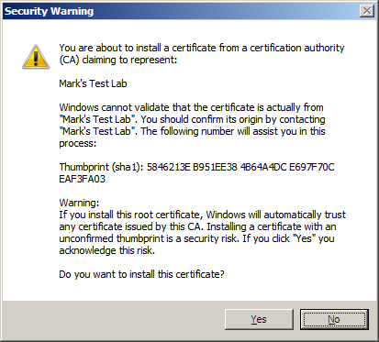
- Click Yes to dismiss it.
- Click OK to clear the "successful import" dialog box.
Check the "Digital Signature Details" on your signed app, and you'll see that it's fine now. Or... all that clicking irritates you (as it does me) and you're using a modern OS, here's a one-liner that does the same thing:
certutil -p leafwood -importpfx codesigner.pfx

