**Open Windows powershell :**

Configure Datapower image in docker using the the below command.

$docker pull ibmcom/datapower

|  |
| --- |
| Note :  If you run the above command, with Windows container enabled, it will not pull the Datapower image. Please see the screenshot.https://lh6.googleusercontent.com/U3kgAe_wOcxe5A89J2ZA3F0r1dCn12XEOp6rhOrg_AwV_TzOgPVeuDs8qtrZQtzF4A5AXiCO96f3Zc-dXM1NS63diQIBKimiGcCf7E3wM-tFCo_i84v3JHFMjz3N-0uRQWc8aFPo |

Switch it back to Linux container if you are enabled Windows container.

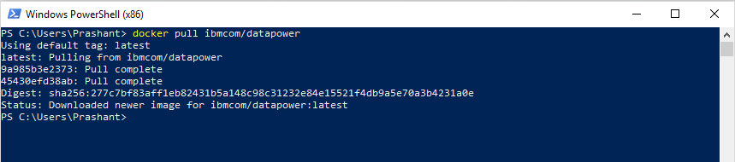

Now you can see Datapower image is imported. ( $docker images)

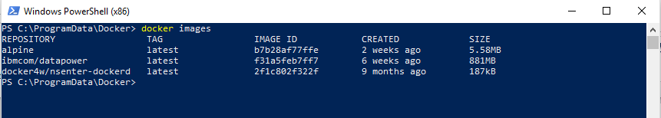

Change the working directory to C:\ProgramData\Docker, in console and run the following command.

docker run -it -v $PWD/config:/drouter/config -v $PWD/local:/drouter/local -e DATAPOWER_ACCEPT_LICENSE=true -e DATAPOWER_INTERACTIVE=true -p 9099:9099 --name DataPowerInWin ibmcom/datapower

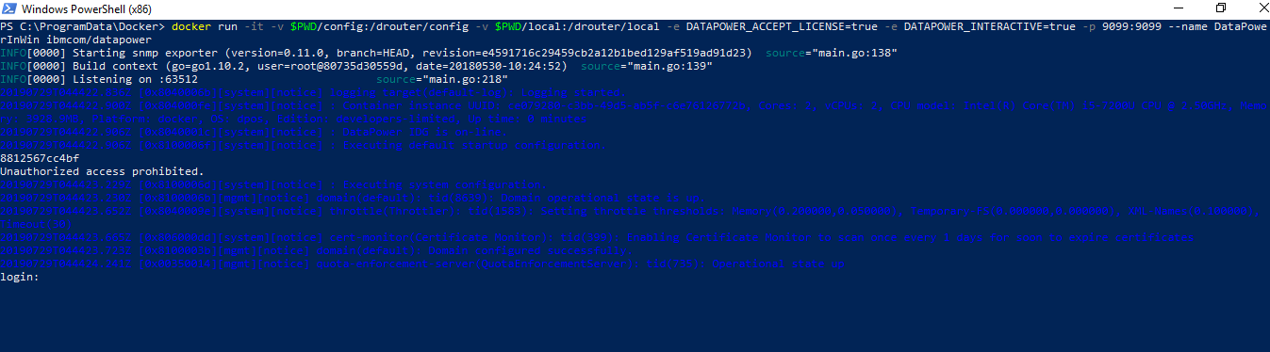

|  |
| --- |
| ( C:\ProgramData\Docker> docker run -it -v $PWD/config:/drouter/config -v $PWD/local:/drouter/local -e DATAPOWER_ACCEPT_LICENSE=true -e DATAPOWER_INTERACTIVE=true -p 9099:9099 --name DataPowerInWin ibmcom/datapower  )  PWD  = Present working Directory  $PWD = C:\ProgramData\Docker  $PWD/config  = C:\ProgramData\Docker\config  $PWD/local  = C:\ProgramData\Docker\local |