**How to run Datapower and Access the it in Web.**

Once you executed the Docker run command for ibmcom/datapower,

login is prompted.

Enter the below data for login and password

Login: admin

Password : admin

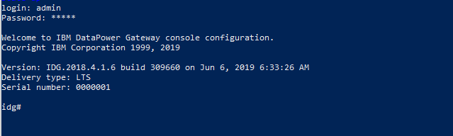

Now enter  “con”,

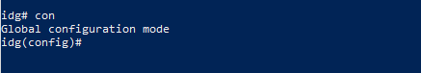

Now use the web-mgmt command to open the Datapower Control panel.

web-mgmt  command  manages the web management service.

 $web-mgmt  0 9099 9099

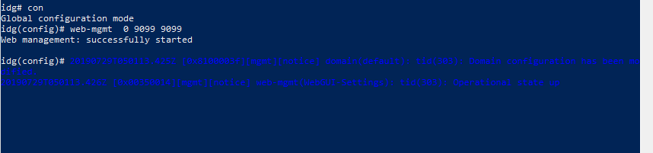

Open the browser and enter the below URL.

https://localhost:9099

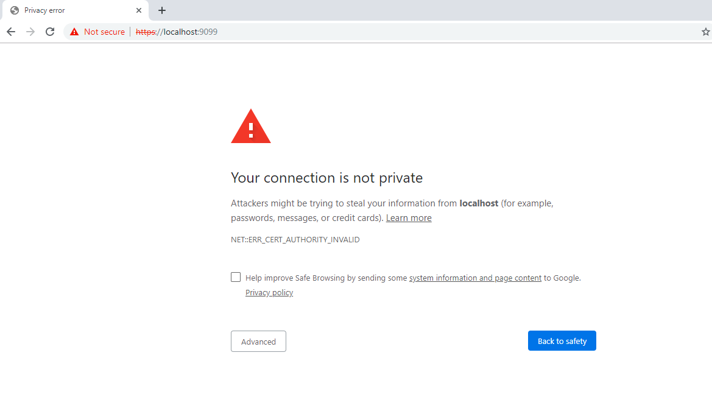

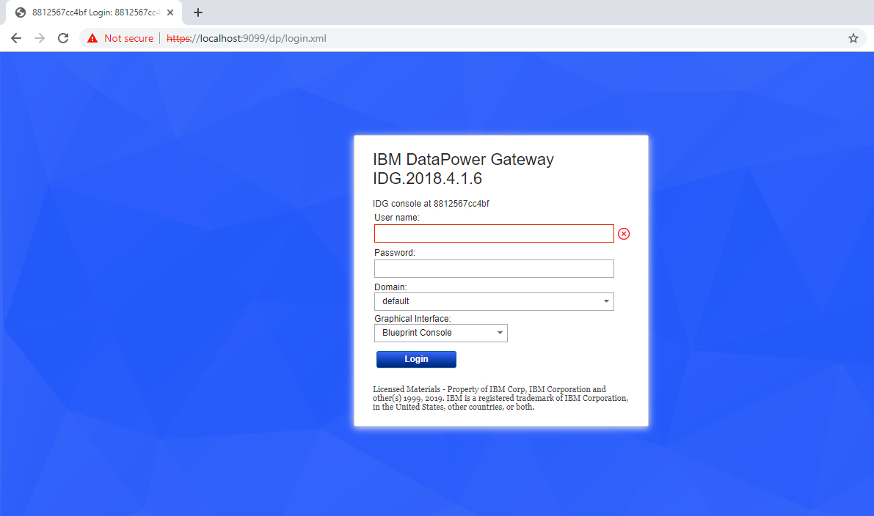

User name : admin

Password : admin

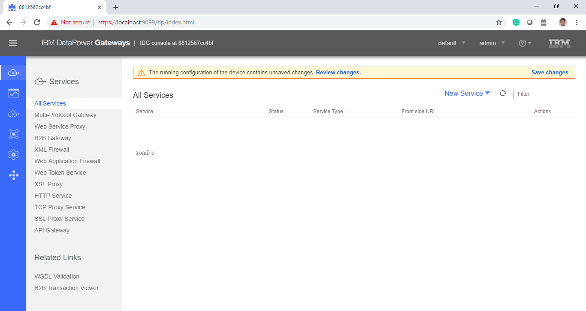

Select WebGUI to see in graphical interface.

