Download docker from here

<https://www.docker.com/products/docker-desktop>

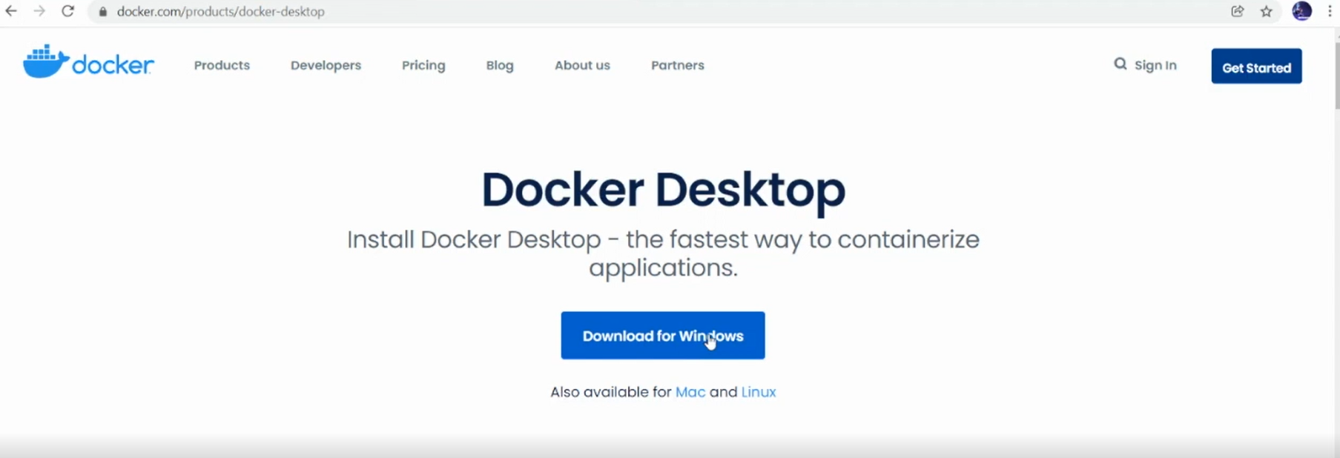

Play With Docker portal:

<https://labs.play-with-docker.com/>

