Docker Hub:

ACE:

<https://hub.docker.com/search?q=ACE&type=image>

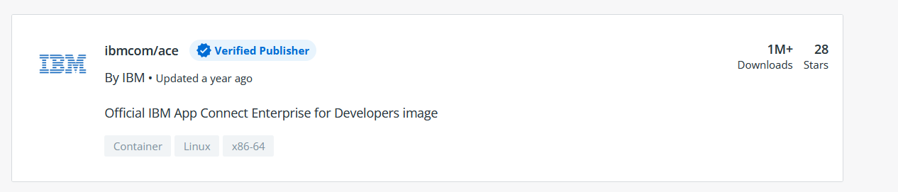

IIB:

<https://hub.docker.com/search?q=IIB&type=image>

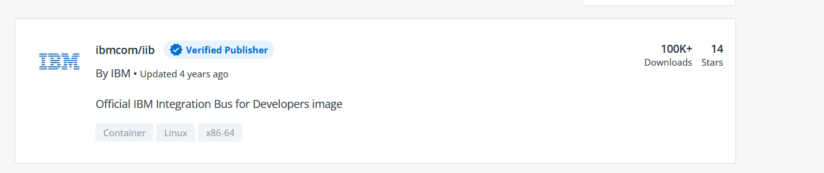

Commands:

--ACE using container docker -- docker ace

docker pull ibmcom/ace

docker run --name aceserver -p 7600:7600 -p 7800:7800 -p 7843:7843 --env LICENSE=accept --env ACE_SERVER_NAME=ACESERVER ibmcom/ace:latest

--IIB using container docker-- docker iib

docker pull ibmcom/iib

docker run --name Container1 -e LICENSE=accept -e NODENAME=NODE1 -e SERVERNAME=SERVER1 -P ibmcom/iib

port is available on playwith docker now, click on it. next to open port

--

To check container port:

docker port Container1

--on another docker session--

ssh otherNodeIP

docker exec -i Container1 /bin/bash

--to run a mqsi command or to check logs:

docker exec Container1 /bin/bash -c mqsilist

docker exec Container1 tail -f /var/log/syslog