Task 2 Progress Note
Synthetic Policymakers with Known Preferences
5 November 2026
Status. The reaction functions, rounding rule, train/test algorithm, nested-history algorithm, and true policy surfaces are in place. A provisional run on the current 96 scenarios passed the internal checks. Because the Task 1 scenario file has not yet been locked, the scenario IDs in the split and in the 20-decision histories remain provisional and will be regenerated under the same rules once that file is approved. No model calls have been made.
1. Where this stands against the work plan
Task 2 asks for five policymaker reaction functions, synthetic decision histories, a documented train/test split, and plots of the true policy surfaces. The functions and the surface plot are ready to carry forward. The code that builds the split and the histories is also ready, but any output tied to particular scenario IDs waits on approval of the scenario file.
Work-plan deliverable | Current status
Table of five reaction functions | Complete; independent of scenario IDs
True policy decision surfaces | Complete
Documented train/test split | Algorithm complete; current file is provisional
Synthetic decision histories | Algorithm complete; current file is provisional
Prompt pipeline and model calls | Not started; these are Tasks 3 and 4

2. How the reaction function is used
Each policymaker’s preferences are defined by a reaction function that we set in advance. We use that function only to compute the interest-rate decision for every scenario. The function, its coefficients, and any verbal description of the type stay on our side of the experiment. The model is not told the formula, the coefficients, or whether a type is inflation-sensitive or employment-sensitive. Types A–E are internal names only.
In the behavior-only condition, the model will see completed examples: the four macroeconomic gaps and the rate decision that follows from them. It has to infer the regularity from those examples. Held-out scenarios are then presented with the four numbers alone. After the model chooses, we score its choice against the decision generated by the same function and ask whether the recovered preference ordering matches Type A through Type E.
The files therefore separate what we use internally from what can later enter a prompt.
Material | Use
Reaction function and coefficients | Internal ground truth; excluded from prompts
Continuous latent rate | Internal calculation and later regression; excluded from prompts
Tightening, easing, and boundary tags | Internal coverage checks; excluded from prompts
Four gaps and the rounded decision | The only history fields shown to the model
Four gaps in a test scenario | Shown at evaluation, without the correct decision
Correct test-scenario decision | Used only after the model has answered

3. The five reaction functions
Rate changes are in basis points. The continuous rule is
latent rate = α + βπ × inflation gap − βu × unemployment gap + βexp × expectations gap + βy × output gap.
For every type, βπ + βu = 30, while the expectations and output coefficients stay fixed. Types differ only in the relative weight on inflation and unemployment. The preference ratio βπ/βu runs from 5 down to 0.2.
Type | α | βπ | βu | βexp | βy | βπ/βu
A | 0 | 25 | 5 | 8 | 2 | 5
B | 0 | 20 | 10 | 8 | 2 | 2
C | 0 | 15 | 15 | 8 | 2 | 1
D | 0 | 10 | 20 | 8 | 2 | 0.5
E | 0 | 5 | 25 | 8 | 2 | 0.2

4. The decision recorded in the history
The history stores the rounded decision. The continuous value is retained only in the internal files. The step is 5 basis points, on a grid from −100 to 100. A value that falls exactly halfway between two steps is rounded away from zero, so 67.5 is recorded as 70 and −42.5 as −45. On the current variable ranges, latent rates lie between about −52.5 and 67.5, so the grid limits do not bind.
A 25-basis-point step would hide part of the rule. It compresses Type A’s unemployment coefficient from 5 to about 3.8 and moves the out-of-sample preference ratio from 5 to about 8.6. A 0.5-point move in the expectations gap, or a 1.5-point move in the output gap, often fails to cross a 25-point threshold, so those slopes would barely appear in the examples. With a 5-point step, regressions on the rounded decisions recover preference ratios of 4.97, 1.99, 0.99, 0.50, and 0.20.
5. Split and nested histories
Scenarios are split inside each inflation-gap and unemployment-gap cell. After a seeded shuffle, the first half of the cell is reserved for histories and the second half for out-of-sample evaluation. The current file has six scenarios per cell, so the split is three and three. The generator searches seeds 0 through 999 and keeps the split whose training and test matrices are full rank, whose expectations and output gaps are balanced across the two sides, and which places clear tightening, clear easing, and near-boundary states on both sides.
All five policymakers see the same macroeconomic scenarios. Their decisions differ only because the coefficients differ, so the comparison across types is not mixed up with the choice of states. Twenty scenarios are drawn from the training half, with the first 2 nested in the first 5, the first 5 nested in the first 10, and the first 10 nested in the full 20. At most two histories come from the same inflation–unemployment cell. The first five must cover tightening, easing, and the boundary, and they must identify all five coefficients.
The region labels are an internal check and do not enter the reaction function. A state is tightening when the inflation gap is at least 1 and the unemployment gap is at most −0.5; easing when the inflation gap is at most 0 and the unemployment gap is at least 0.5; and a boundary state when it is neither of those and the absolute difference between the two gaps is at most 1.
6. Provisional run on the current scenario file
The run uses the current 96 scenarios from Task 1. The selected split seed is 21, with 48 training scenarios and 48 test scenarios. The checks passed: the two sides do not overlap, every history scenario comes from the training side, the histories are nested, the first 5, 10, and 20 histories have full rank, the continuous outcomes recover the five coefficient vectors exactly, and the rounded decisions preserve the ordering from Type A to Type E.
Type | True ratio | Recovered, all states | Recovered, test states | Latent range (bp)
A | 5 | 4.97 | 5.13 | −42.5 to 67.5
B | 2 | 1.99 | 1.96 | −45.0 to 65.0
C | 1 | 0.99 | 1.00 | −47.5 to 62.5
D | 0.5 | 0.50 | 0.50 | −50.0 to 60.0
E | 0.2 | 0.20 | 0.20 | −52.5 to 57.5
The first five provisional histories are, in order, tightening, easing, boundary, boundary, and easing. These scenario IDs are not the final history. Once the scenario file is locked, the same program regenerates the split and the histories.
7. True policy surfaces
The figure shows the continuous rule for each type, with the expectations gap and the output gap held at zero. The horizontal axis is the unemployment gap, the vertical axis is the inflation gap, and the black line is the contour on which the latent rate change is zero. From Type A to Type E the contour rotates from nearly horizontal to nearly vertical: the decision shifts from following inflation toward following unemployment.
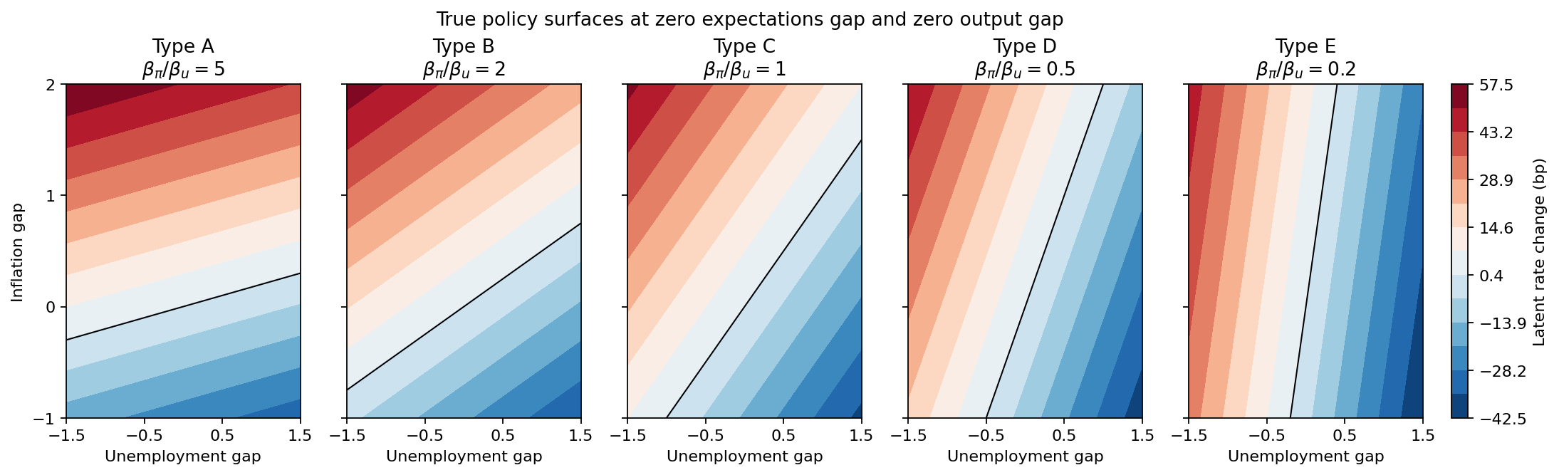
Figure 1. True policy surfaces at a zero expectations gap and a zero output gap.
8. What remains
After the Task 1 scenario file is approved, we will regenerate the split and the histories from the locked scenarios and remove the provisional label. Until then, the current scenario IDs will not be treated as the official history.
Task 3 is the point at which these histories enter the experimental conditions. In the behavior-only condition, the prompt will contain the four gaps and the rounded decision, and nothing from the reaction function. The label-only, aligned, conflict, and neutral-control conditions have not been written. The Task 4 pilot has not been run.
Two design choices are ready for review before the official histories are locked.
Coefficients. βπ + βu is held at 30 so that the types share a common overall scale and differ in composition. The expectations and output weights are common across types.
Five-basis-point step. The step keeps the expectations slope, the output slope, and Type A’s unemployment weight visible in the examples the model will see.
9. Files
All of the files below are in the task2 folder. Every table under provisional is marked as provisional.
File | Contents
synthetic_policy_generator.py | Builds the types, surfaces, split, and histories, then runs the checks
policymaker_types.csv | The five coefficient vectors
true_policy_surfaces.png | Figure 1
provisional/scenario_split.csv | Provisional train/test assignment
provisional/decision_histories.csv | Provisional nested histories and ground-truth decisions
provisional/test_targets.csv | Ground-truth decisions for the provisional test states
provisional/check_report.txt | Check results for this run

