VIN=26V

VOUT=1.7894V

VRT = 1.2411V (no wave)

VRES = 0.0004V (no wave)

VCC2=7.439V

VCC1=7.511V

Cont’d Waveforms

CH1 SW

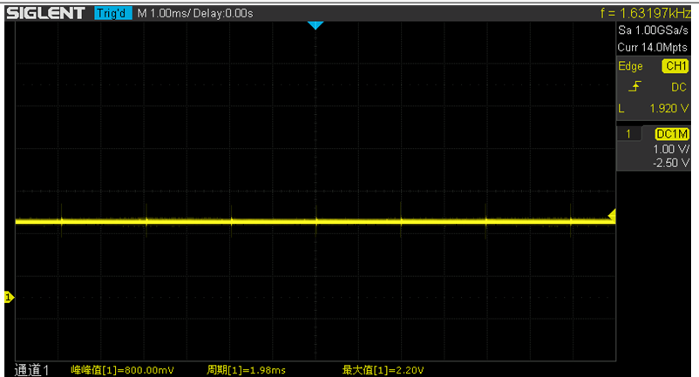

CH2 SW

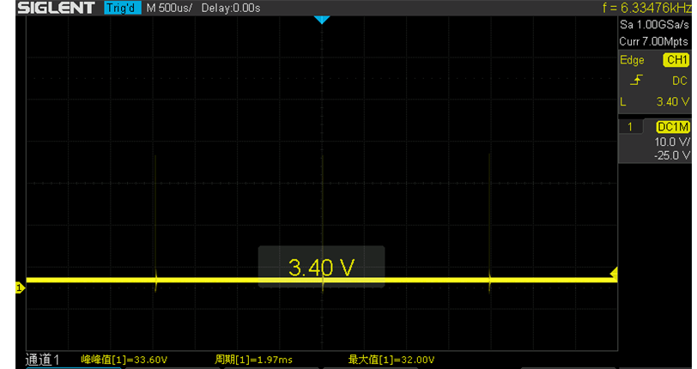

CH2+COMP1&2

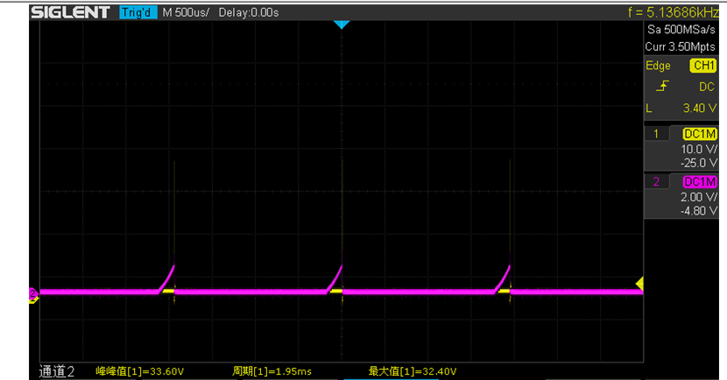

CH2 GATE H, GATE L

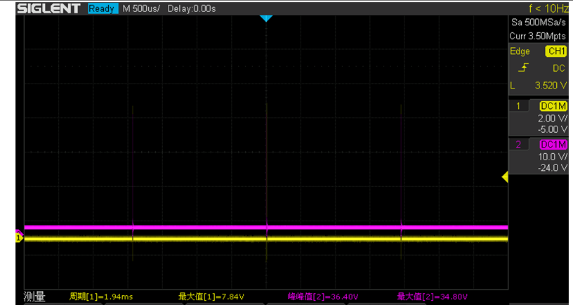

CH2 GATE H, GATE L

