CH1 SW @ NO LOAD

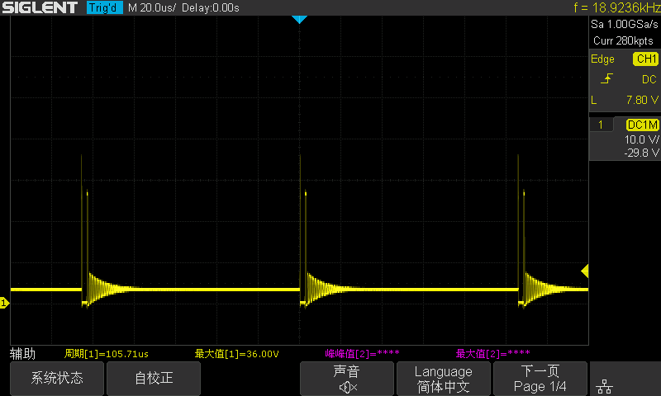

CH1 BOT GATE @ NO LOAD 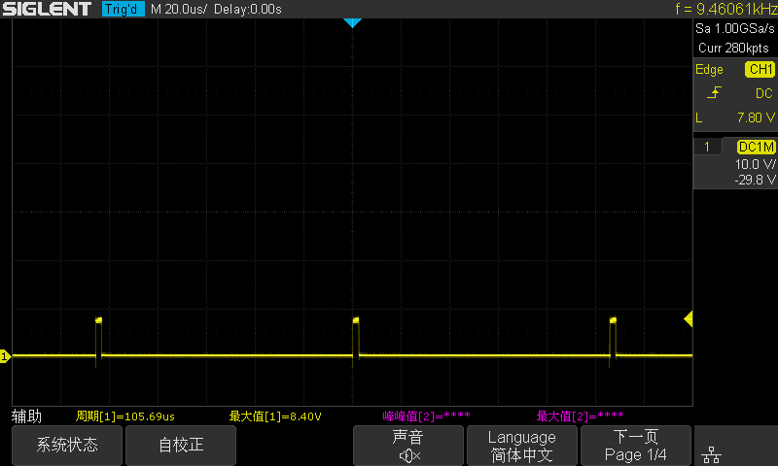

CH 1 TOP GATE @ NO LOAD

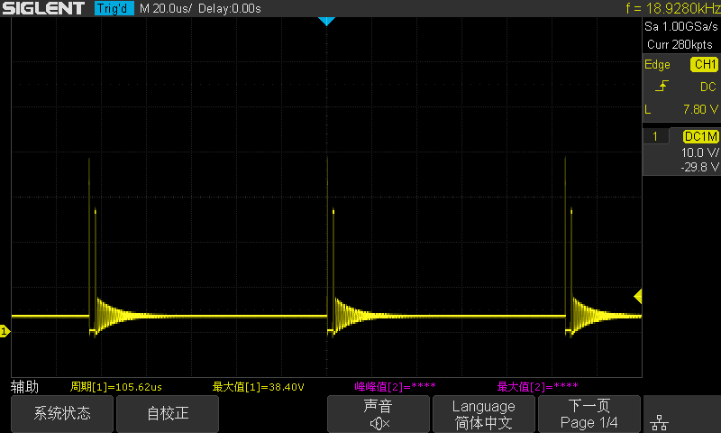

CH2 SW @ NO LOAD

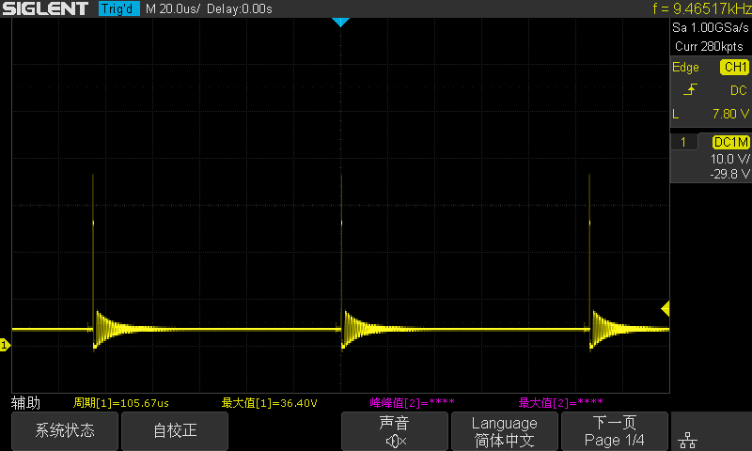

CH2 BOT GATE @ NO LOAD 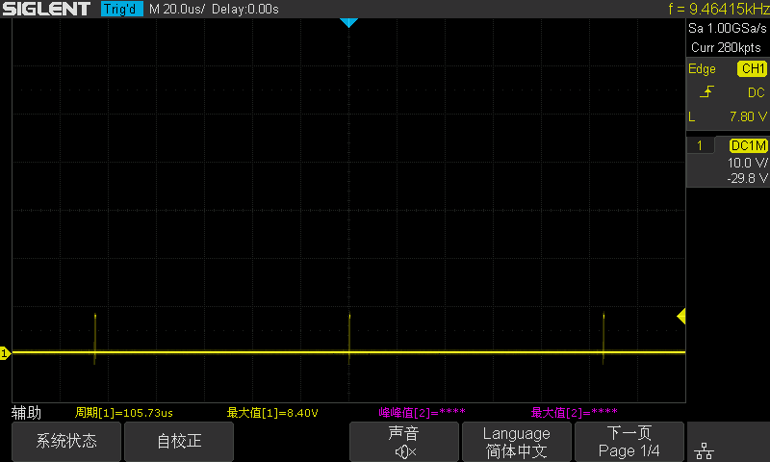

CH2 TOP GATE @ NO LOAD 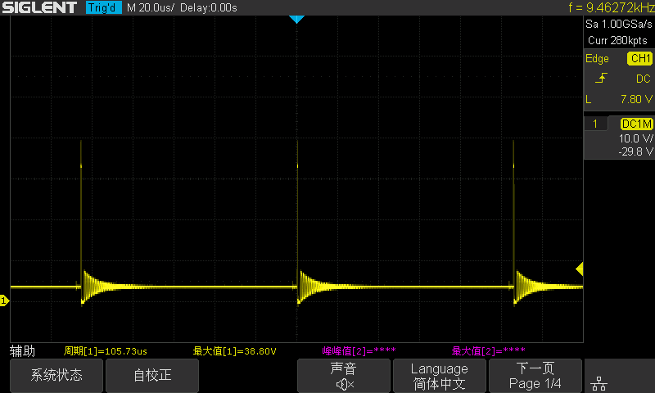

CH1 SW @ 1A CC

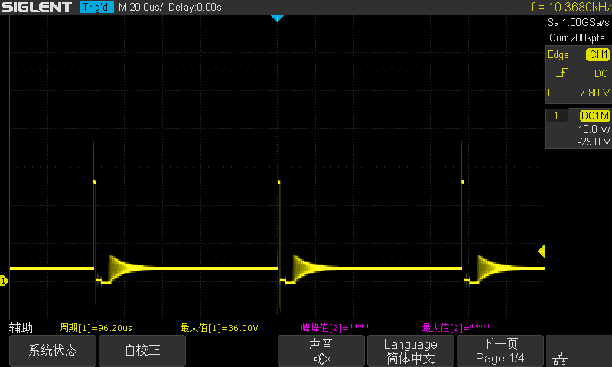

CH1 BOT GATE @ 1A CC

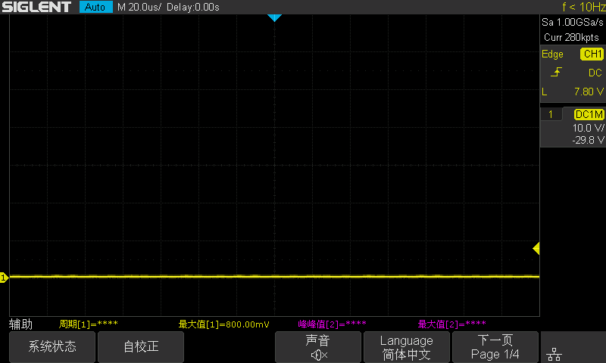

CH1 TOP GATE @ 1A CC

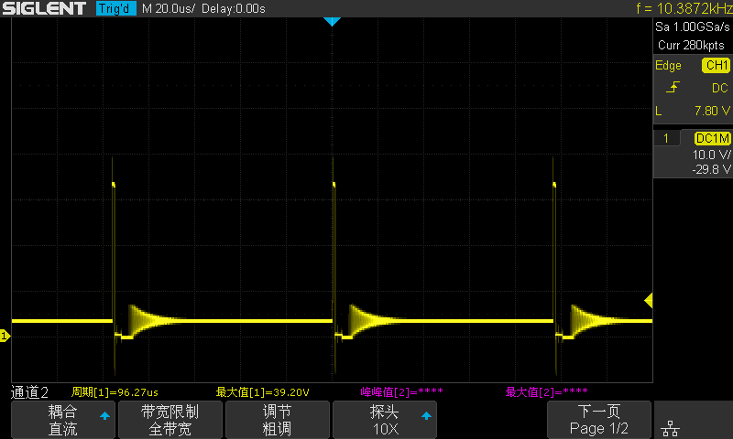

CH2 SW @ 1A CC

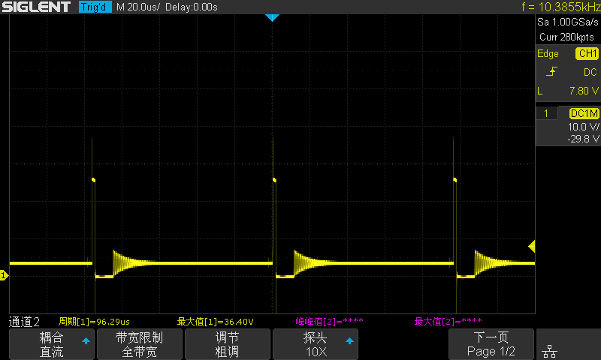

CH2 BOT GATE @ 1A CC

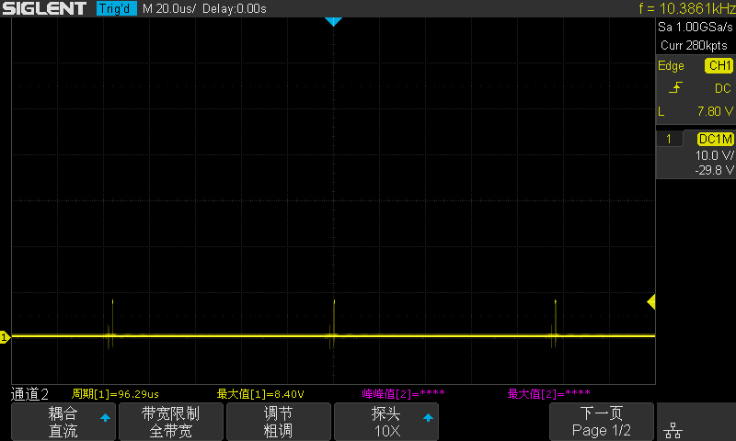

CH2 TOP GATE @ 1A CC

