The DiSH
A Digitally-Controlled Sample/Hold
Provided to the DIY community for non-commercial use by Brian Thornock, copyright 2020

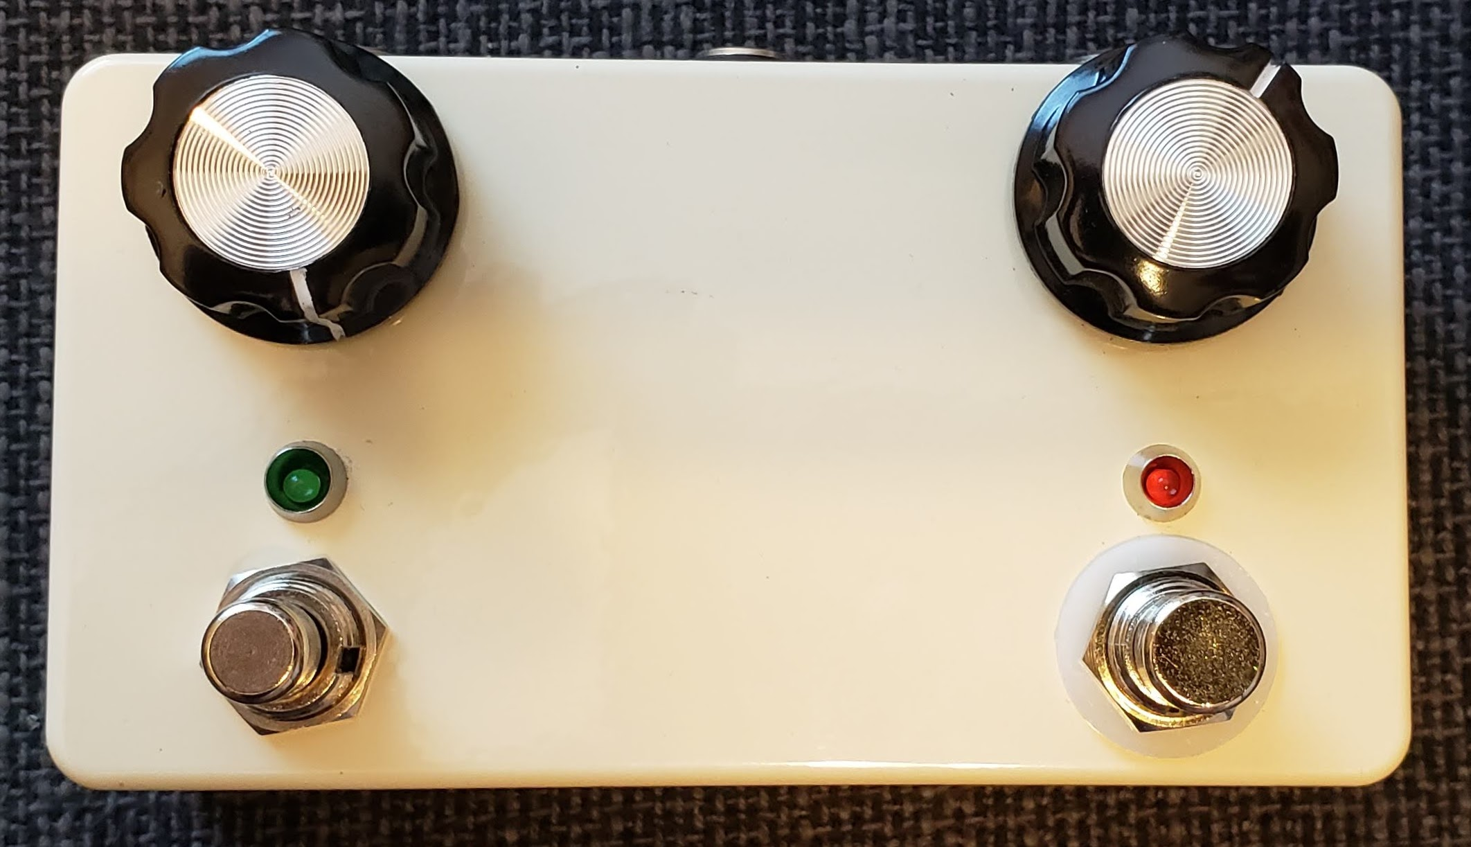
Overview

When it comes to sample/hold effects, there aren't many out there. Even less are DIY projects. For the most part, the Maestro FSH-1 is the only real DIY project, but many are left uncompleted due to some of the difficulties of that particular circuit, such as selecting a transistor for noise, ticking noises, and biasing. The DiSH was designed to retain the great sample/hold effect of the Maestro unit, while allowing for modern control and features. The DiSH is similar to the Subdecay Proteus, but I have never seen the innards of one and never played one, so any similarities are purely coincidental.

How it Works

The filter section of the DiSH is taken directly from the Maestro FSH-1, but the similarities end there. The random control voltage (CV) generation that is done by transistors in the FSH-1 has been replaced by the use of an ATTiny85 microcontroller. This allows for many fun features not present in the FSH-1, such as tap tempo, patterns, division control, etc. Additionally, the DiSH does not have the envelope controlled filter feature of the FSH-1. This was done primarily because I don't really like envelope controlled filters, but it also resulted in being able to get all of this in through hole fitting in a 125B enclosure.

The digital side of things looks pretty hairy if you open the code. Most of this is due to the nature of tap tempo and keeping track of current and past results. It requires lots of variables, interrupt timers, and lots of logic for checking things to make sure it stays stable and doesn't produce weird corner cases, many of which I found during development and of which the code is representative.

From a high level, the code is just keeping track of the tempo, flashing the LED in time, and every time the LED flashes, it generates a random number and converts that into a voltage between 0 and 5V with 1024 steps.

BOM

The BOM below is the list of parts I used for mine along with quantities. I got most of my stuff from Tayda, though the encoder was purchased from Mouser.

Part | Qty. | Notes
3k3 Resistor | 5 | 1/4W metal film
4k7 Resistor | 3 | 2 are bypass LED resistors, adjust to taste. The other is required
6k8 Resistor | 1 | 1/4W metal film
10k Resistor | 7 | 1/4W metal film
22k Resistor | 5 | 1/4W metal film
2M7 Resistor | 1 | 1/4W metal film
1nF Capacitor | 1 | Film box-type
10nF Capacitor | 2 | Film box-type
27nF Capacitor | 1 | Film box-type
47nF Capacitor | 1 | Film box-type
150nF Capacitor | 3 | Film box-type
220nF Capacitor | 1 | Film box-type
47uF Electrolytic Capacitor | 1 | 2.5mm spacing, 5mm diameter
220uF Electrolytic Capacitor | 2 | 2.5mm spacing, 6mm diameter
5k trimmer | 1 | Bourns 3362P-style
1MB Potentiometer | 1 | 9mm PCB mount
1N4001 or 1N5817 | 1 | Voltage polarity protection
12V Zener | 1
2N3906 | 1
78L05 | 1
ATTiny85-20PU | 1 | Digikey was cheapest
LM13700N | 1
TC1044SCPA | 1
Rotary encoder with switch | 1 | Mouser part #858-EN11-VSM1AF15
LED | 2 | Color your choice
125B Enclosure | 1
1/4” input jack | 2 | Lumberg or open frame style
DC power jack | 1 | Tayda #A-868 would be best
3PDT footswitch | 1
SPST momentary footswitch, NO | 1 | Tayda #A-2371

Schematic

The schematic below is broken into two parts: the power portion and the signal portion.

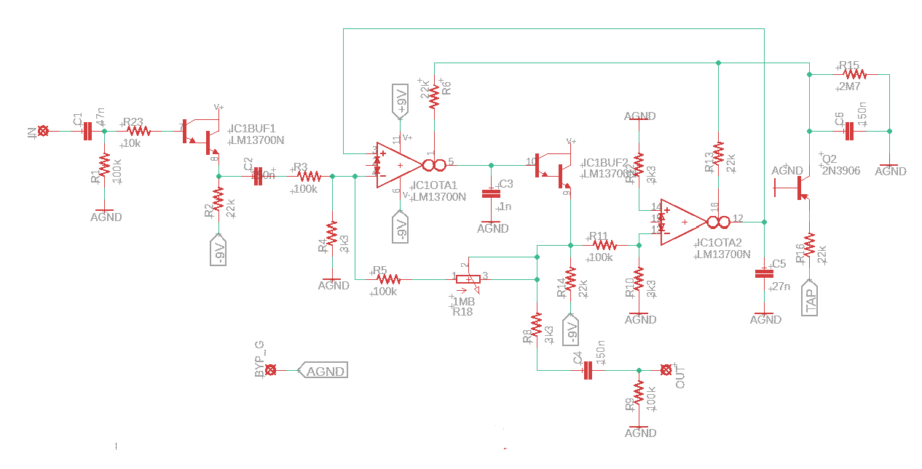

Signal Schematic
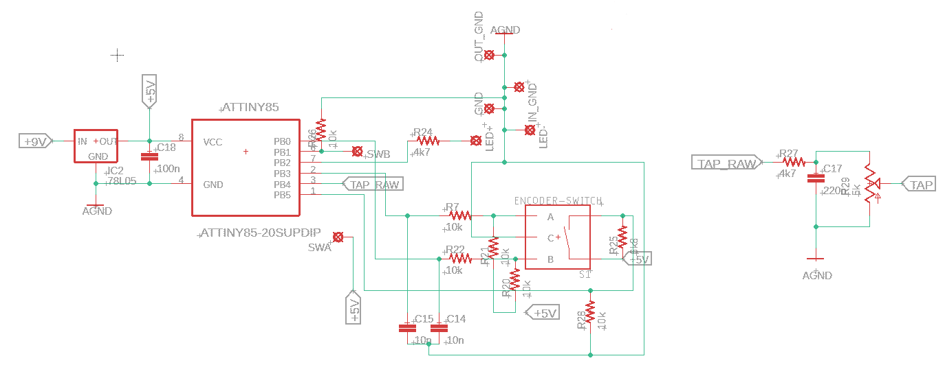

Digital Schematic

Power Schematic

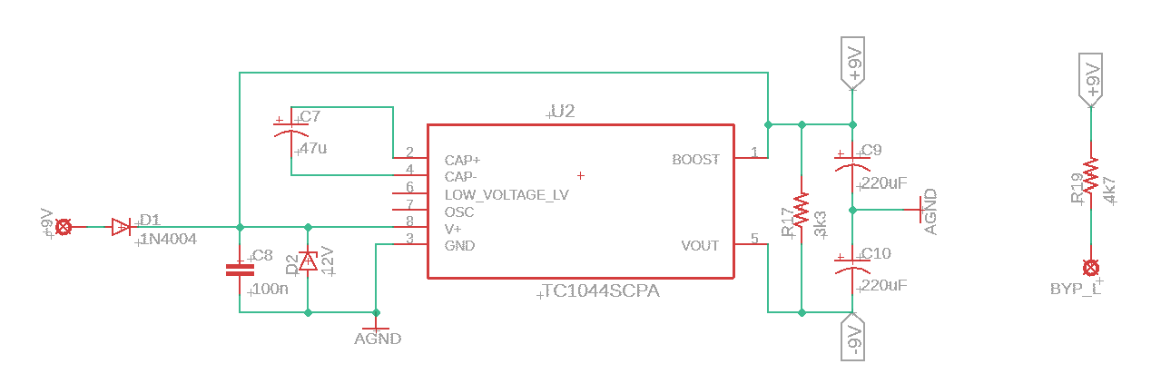
Programming the ATTiny85

Programming the ATTiny is most easily done using an Arduino nano or Arduino uno with a breadboard (or a dedicated fixture). There are many excellent resources for doing this online, including at https://scientificguitarist.wixsite.com/home/programming-attiny-mcu-s . Once the chip is correctly programmed and installed into the circuit, the LED for the speed indication should blink at about 2 Hz, the default speed.

Build Notes

Here are some things I noted from building the DiSH rev 2.0 PCB. Please read this section to make sure you don't go through excessive frustration.

Biasing the Control Voltage

The ATTiny outputs a random control voltage between 0 and 5V. The typical FSH-1 has control voltages that go up to about ½ volt. In order to set the range of voltages such that the output is usable and pleasing, the 5k bias trimmer is provided. This acts as a simple voltage divider to bring the maximum level down while preserving the 1024 voltage steps from the microcontroller.

Setting the bias is really easy. With the enclosure open, play the effect and set the sensitivity control to maximum. Adjust the bias trimmer so that the maximum filter frequency (the nasally portions) are still usable. This is a matter of personal taste. Adjusting the trimmer clockwise will increase the maximum nasally-ness, while going the other way will make the effect much more tame. Set it where you like, I like to have some nasally-ness to it, because the sensitivity control can back it off a fair amount. Once it's where you like it, close it up and rock it out!

Jacks

Note the open space on the PCB component side directly under the encoder and potentiometer. This space is all I could really give, and it makes the use of box jacks nearly impossible. To save the frustration, use an open frame jack, or, better yet, Lumberg style jacks. They can mount after the PCB is all installed without any trouble, just be careful with the orientation of the tip connector to make sure it doesn't short out.

DC Power Jack

I like using the smaller DC power jacks, but it turns out the leads are ever so slightly too long to be put on the same plane as the board. It's easy enough to just give some extra clearance, and as long as you don't have to pull the PCB after it's installed (like I did, multiple times....), you will be fine. I bent the leads out in my case and it worked fine, though a little finicky. Using an externally threaded DC power jack would eliminate this issue altogether.

Bypass Indication LED

I made an oopsie in the schematic that results in the bypass LED always being on. This is because the LED – connection goes to ground. It should instead to to the 3PDT switch in the usual way (I like the Madbean standard wiring diagram).

Enclosure Drilling

The pots, LED's, and buttons are designed to all go in a vertical line. The pots are spaced 2.95” apart, with the LED's 1.00” below them. Make sure you mount the top of the PCB very close to the enclosure side, as there is only about 1/8” wiggle room for the 3PDT switch to fit in. The SPST is an easier fit.

Changing Microcontroller Parameters

There are a few parameters that one might want to adjust in the microcontroller code. The first is the default tempo. Right now it is set to 180 BPM, which for a sample/hold effect is a little slow. You can bump this up in the parameters at the top of the code. It is called defaultSampleTime and is set in line 95 of SampleHold.ino. Make sure you change the parameters in lines 96 and 97 to the same value as well, so that you don't get crazy behavior. They are called sampleTime and prevSampleTime and are used to keep track of the current tempo and the one that is being tapped or dialed in.

The second parameter one might want to adjust is the pattern definition for the pattern setting. Right now the pattern is a half-quarter-quarter pattern. This can be adjusted to any pattern, really, but keeping it such that it adds up to an integer of a typical “measure” is ideal. This is changed in the pattern definition starting in line 268. The number of cases defines the number of “steps” and the patternMultiplier defines the duration (1 being the current tempo, 2 being twice as fast, and 4 being four times as fast). I haven't experimented much with this, but for the adventurous, you could really get your prog patterns on!

I also found the tap tempo to have a limit as to how fast this will go. This is really limited mostly by the button debouncing. Right now it is set to 100 ms debouncing time, which means the theoretical max is 10 Hz, but in practice it's slower than that. I set the debounce time while the circuit was on the breadboard, and therefore worst-case scenario for noise. It could probably be brought down some, I just haven't tried. The primary parameter here is debounceDelay in line 27.

In Closing

This project was a ton of fun. I think it is a great DIY project for getting into the benefits of microcontrollers and is a great blend of old school analog controlled by new-school digital. Feel free to monkey around with the code and see what else you can do there. I've used up all the pins on the ATTiny, but make it your own!

