FET-2B
A Tubes-to-JFET Adaptation of a Classic Bass Preamp
Provided to the DIY community for non-commercial use by Brian Thornock, copyright 2021

Overview

The year is 2008. Guitar pedal DIY is starting to hit some exciting times. Runoffgroove is shaking things up with their tube-to-jfet adaptations of classic amps and I am just starting to really get into doing DIY pedals. I had just built myself a bass to record bass parts to my songs, but running the bass directly into the interface just wasn't all that exciting. I started reading up on bass preamps and read tales of the legend of the Alembic F2B bass preamp. Not having the chops to build a full tube version (and being a super poor graduate student), I decided to do the tubes-to-JFET treatment of the F2B, and thus the FET-2B was born. This was my very first "design". I use quotes since it's a pretty straight up adaptation. However, it was quite nice sounding. The design remains a reasonably common choice with people looking for a bass preamp pedal, so I thought I would document it fully.

How it Works

The F2B is actually a very garden variety preamp in the Fender style. The values used for components are not necessarily chosen specifically to bass, but actually work quite well for a variety of sources. The circuit consists of an initial amplification stage followed by a standard Fender tone stack, into a volume control with treble bypass bright switch and a final amplification stage. Refer to the schematic to see just how simple this circuit really is. Like many of the classic amplifiers that we all know and love, there really isn't much to it.

BOM

The BOM below is the list of parts I used for mine along with quantities. While most parts are available from Tayda, the J201's used will either need to be through hole or SMD with adapter boards.

Part | Qty. | Notes
1k8 Resistor | 2
68k Resistor | 1
100k Resistor | 1
1M Resistor | 3
RLED | 1 | CLR for LED
100k Trimmer | 2
120pF Capacitor | 1
250pF Capacitor | 1
47nF Capacitor | 1
100nF Capacitor | 2
47uF Electrolytic Capacitor | 2
100uF Electrolytic Capacitor | 1
B10k Potentiometer | 1 | 16mm PCB Mount
B250k Potentiometer | 1 | 16mm PCB mount
A100k Potentiometer | 1 | 16mm PCB mount
1N5817 | 1 | Voltage polarity protection
J201 | 2
LED | 1
SPDT Toggle Switch | 1 | Bright Switch
Enclosure | 1
1/4” input jack | 2
DC power jack | 1
3PDT footswitch | 1

Component Values

R1 | 1M | BIAS1 | 100k trimmer
R2 | 68k | BIAS2 | 100k trimmer
R3 | 1M
R4 | 1k8 | Bass | B250k
R5 | 100k | Middle | B10k
R6 | 1k8 | Treble | B250k
R7 | 1M | Volume | A100k
R8 | RLED (CLR)
 |  | Bright | SPDT
C1 | 250pF
C2 | 47nF | Q1 | J201
C3 | 100nF | Q2 | J201
C4 | 120pF
C5 | 100nF | D1 | 1N5817
C6 | 47uF electrolytic | D2 | LED
C7 | 47uF electrolytic
C8 | 100uF electrolytic
Schematic

The schematic for this project is below. Note the simplicity of the design. It's quite a great beginner build.
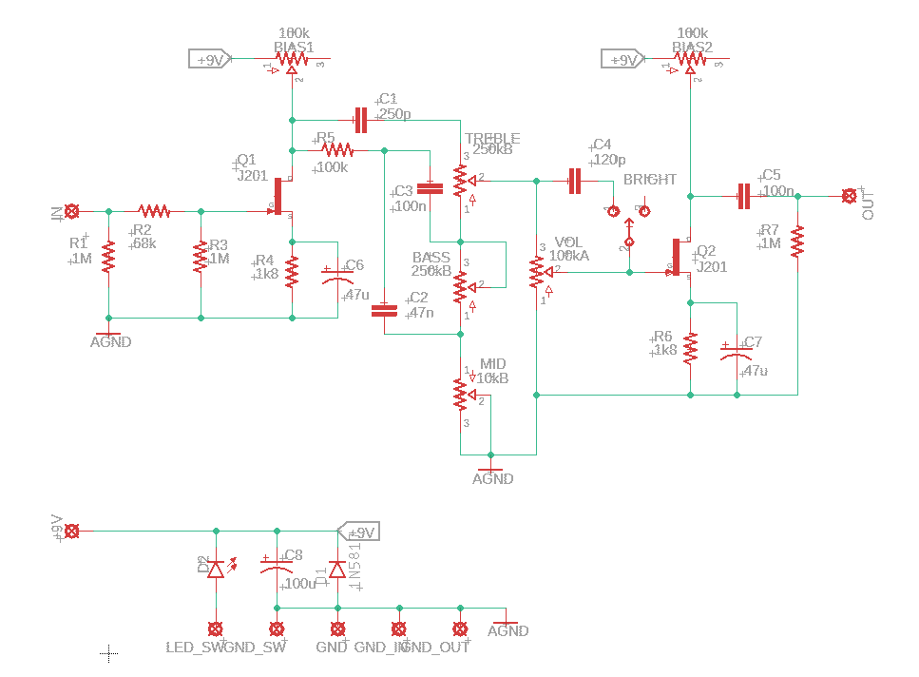

FET-2B Full Schematic
Build Notes

Here are some things I noted from building the Stalker that might be helpful to you. Please read this section to make sure you don't go through excessive frustration.

Enclosure Size/Drilling

The Wobble Box fits nicely into a 125B and should even be able to fit a 1590B. To fit the 1590B, depending on your pots and layout choices, you may need to mount the pots off the board

Jacks

The only possible considerations are if you are trying to mount in a 1590B. I'm not worried, I'm sure you'll be able to figure it out.

Biasing Trimmers

As is common to the tubes-to-JFET circuits, the trimmers are for biasing the drain of the JFET's to ½ supply voltage, which is nominally 4.5V. Just use a multimeter to measure voltage at the drain (without JFET in place) and turn the trimmer until you get there. You can make small adjustments by ear, but you'll find it sounds best within about 0.5V of ½ supply voltage.

Noise

There are two things about this design that have the potential to cause noise: the tone stack and the volume control. The tone stack is designed for a high voltage gain tube amplifier. Because we are dealing with much smaller voltages in a pedal, the resistive thermal noise in the tone stack may become noticeable. To avoid this, you can scale the resistors and pots down by a factor of 10 and scale the capacitors up by a factor of 10 to get the same frequency response with less noise. I simply left the design as I originally made it all those years ago, but there are no board changes necessary, just parts substitutions.

The volume control is placed before the final amplification stage, which means that as you turn the control down, the signal going into the final amplification stage contains a larger portion of noise. Moving the volume control after the final amplification stage should help reduce this. Perhaps I should do a Mark II of this circuit...Hmm...And surface mount, perhaps...

In Closing

This is a great beginner project for those looking for a bass preamp. The hardest part is likely dealing with the JFET's, either acquiring them or soldering the SMD part to an adapter board.

