Northwest Labs

System Project Proposal



Created By: Integrated Solutions

December 2016

Table of Contents

Executive Summary 7

Company Background and Problem Description 8

System Requirements and Scope of Solution 9

FURPS 9

Functionality 9

Usability 9

Reliability 9

Performance 9

Security 9

List of Use Cases 10

Sales Subsystem 10

Billing Subsystem 10

Order Tracking Subsystem 10

Customer Account Subsystem 11

Employee Account Subsystem 11

Payroll Subsystem 11

Inventory Subsystem 11

Catalog Subsystem 11

Scheduling Subsystem 11

Managerial Reporting Subsystem 12

Assay Reporting Subsystem 12

Scope of Solution 12

Included Subsystems 12

Not Included Subsystems 13

Cost Analysis 14

Development 14

Implementation 14

Total Initial Cost 14

Estimated Annual Maintenance 14

Feasibility and Risk Analysis 15

Suggested Security Controls 16

Development Process and Methodology 17

Modified Waterfall Method 17

Gather Requirements 17

Design 17

Implementation 17

Testing 17

Maintenance 17

Project Schedule 18

Recommended Deployment Resources 19

Application Servers 19

Database Servers 19

File Server 19

Recommendations for Alternatives 20

Summary 21

APPENDIX I

Menu Hierarchy II

HOME (P) III

ABOUT (P) III

CONTACT US (P) III

ORDERS (SR, M, C, LM) III

Billing (B, HLM) III

Order Tracking (LW, SR, M, C, B) III

[Customer] Account (SR, M, C*) IV

Employee Accounts (M, E) IV

Payroll (M, A, E) V

Inventory (LW) V

Catalog (MD, E, C, P) V

Lab Scheduling (LM, E, C) V

Managerial Reports (SR, A, M, C, MD) VI

Assay Reporting (LW, TD, C, TA) VI

LOG IN (P) VII

LOG OUT (P) VII

Details for Use Case List VIII

Create an Order Quote IX

Use Case Diagram – Create an Order Quote IX

Use Case Description - Create an Order Quote X

Activity Diagram – Create an Order Quote XI

System Sequence Diagram – Create an Order Quote XII

View – Create an Order Quote XIII

Create an Order XIV

Use Case Diagram – Create an Order XIV

Use Case Description – Create an Order XV

Activity Diagram – Create an Order XVI

System Sequence Diagram – Create an Order XVII

View – Create an Order XVIII

Update Hourly Charge Rate XIX

Use Case Diagram – Update Hourly Charge Rate XIX

Use Case Description – Update Hourly Charge Rate XX

Activity Diagram – Update Hourly Charge Rate XXI

System Sequence Diagram – Update Hourly Charge Rate XXII

View – Update Hourly Charge Rate XXIII

Update Assay Work Order Status XXIV

Use Case Diagram – Update Assay Work Order Status XXIV

Use Case Description – Update Assay Work Order Status XXV

Activity Diagram – Update Assay Work Order Status XXVI

System Sequence Diagram – Update Assay Work Order Status XXVII

View – Update Assay Work Order Status XXVIII

View Assay Work Order Status XXIX

Use Case Diagram - View Assay Work Order Status XXIX

Use Case Description - View Assay Work Order Status XXX

Activity Diagram - View Assay Work Order Status XXXI

System Sequence Diagram - View Assay Work Order Status XXXII

View - View Assay Work Order Status XXXIII

Send Compound Receipt Confirmation XXXIV

Use Case Diagram – Send Compound Receipt Confirmation XXXIV

Use Case Description – Send Compound Receipt Confirmation XXXV

Activity Diagram – Send Compound Receipt Confirmation XXXVI

System Sequence Diagram – Send Compound Receipt Confirmation XXXVII

View – Send Compound Receipt Confirmation XXXVIII

Update Work Order Details for Assay XXXIX

Use Case Diagram - Update Work Order Details for Assay XXXIX

Use Case Description - Update Work Order Details for Assay XL

Activity Diagram - Update Work Order Details for Assay XLI

System Sequence Diagram - Update Work Order Details For Assay XLII

View - Update Work Order Details For Assay XLIII

Create Further Test Recommendation XLIV

Use Case Diagram – Create Further Test Recommendation XLIV

Use Case Description – Create Further Test Recommendation XLV

Activity Diagram – Create Further Test Recommendation XLVI

System Sequence Diagram – Create Further Test Recommendation XLVII

View – Create Further Test Recommendation XLVIII

Approve Further Test Recommendation XLIX

Use Case Diagram – Approve Further Test Recommendation XLIX

Use Case Description – Approve Further Test Recommendation L

Activity Diagram – Approve Further Test Recommendation LI

System Sequence Diagram – Approve Further Test Recommendation LII

View - Approve Further Test Recommendation LIII

View Completed Reports LIV

Use Case Diagram – View Completed Reports LIV

Use Case Description – View Completed Reports LV

Activity Diagram – View Completed Reports LVI

System Sequence Diagram – View Completed Reports LVII

View – View Completed Reports LVIII

View Individual Assay Completion Time LIX

Use Case Diagram – View Individual Assay Completion Time LIX

Use Case Description – View Individual Assay Completion Time LX

Activity Diagram – View Individual Assay Completion Time LXI

System Sequence Diagram – View Individual Assay Completion Time LXII

View – View Individual Assay Completion Time LXIII

Create Profitability Report LXIV

Use Case Diagram – Create Profitability Report LXIV

Use Case Description – Create Profitability Report LXV

Activity Diagram – Create Profitability Report LXVI

System Sequence Diagram – Create Profitability Report LXVII

View – Create Profitability Report LXVIII

Create Ad-Hoc Report LXIX

Use Case Diagram – Create Ad-Hoc Report LXIX

Use Case Description – Create Ad-Hoc Report LXX

Activity Diagram – Create Ad-Hoc Report LXXI

System Sequence Diagram – Create Ad-Hoc Report LXXII

View – Create Ad-Hoc Report LXXIII

Create Assay Summary Report LXXIV

Use Case Diagram – Create Assay Summary Report LXXIV

Use Case Description – Create Assay Summary Report LXXV

Activity Diagram – Create Assay Summary Report LXXVI

System Sequence Diagram – Create Assay Summary Report LXXVII

View – Create Assay Summary Report LXXVIII

Compile All Report Data LXXIX

Use Case Diagram – Compile All Report Data LXXIX

Use Case Description – Compile All Report Data LXXX

Activity Diagram – Compile All Report Data LXXXI

System Sequence Diagram – Compile All Report Data LXXXII

View – Compile All Report Data LXXXIII

Database Information LXXXIV

Entity Relationship Diagram LXXXIV

LXXXVIII

Database Schema LXXXIX

Class Information XCVII

# Executive Summary

# Company Background and Problem Description

Northwest Labs is the industry leader for Chemical and Compound testing and in-depth assay analysis. Over their 17+ years of experience they have gained a reputation for their precise, well documented tests and accurate reports. As a result of this reputation, Northwest is growing rapidly, resulting in some problems with the current IT infrastructure.

The current system is a series of Microsoft Excel Spreadsheets and Microsoft Access Databases that were created by competent employees. These programs have served the company well in the past, but they are difficult to maintain. Employees that originally created these systems are constantly needing to adjust, tweak, and fix these programs, which brings them away from their work responsibilities.

Not only has Northwest started out-growing their current system, but customers and employees are requesting increased functionality and performance.

Customers are requesting that in addition to the exceptional service and quality that is provided by Northwest, they have access to the data and reports that have been created online. They would also like to see more frequent and meaningful communication with Northwest.

In addition to the problem of employees being taken away from responsibilities to provide support to the current system, other employees are requesting increased functionality. One major pain point is the lack of consistent and easy communication between the corporate offices in Seattle and the labs in Singapore. Employees would like to be able to see the real-time status of an order from its inception to billing and archived reports. The sales representatives would also like to be able to create quotes more efficiently than they currently do. Lastly, management would like to be able to create ad-hoc reports to discover problems and solutions, and to provide support for the current business model.

Integrated Solutions is proposing the development and implementation of a new system that will address the current problems with the information systems. We will also propose a few business processes and controls that will increase productivity and minimize risk. These changes will provide the functionality and performance that will give Northwest Labs the ability to continue growing and providing exceptional service to its clients.

# System Requirements and Scope of Solution

After reviewing the initial documents, we have identified some requirements that are identified in this section. Some of the requirements are shown according to the FURPS model. FURPS is an acronym which stands for Functionality, Usability, Reliability, and Performance. The “Use Case” section will show further system requirements and what the proposed system will be capable of.

## FURPS

### Functionality

The system must be able to increase the ability for sales reps in Seattle to provide accurate and timely quotes to customers.

The system must provide means for employees in Seattle and Singapore to see the real-time status of work orders.

The system must provide means for Northwest Labs to efficiently and effectively communicate work order status and other information with customers.

The system must be able to integrate with data outputs from the current systems that won't be affected by the change.

System shall allow for the current scheduling functionality and track the schedule.

### Usability

Employees must be able to learn the system in a timely manner as to not disrupt workflow or increase cost in excess.

The system must be consistent with other programs in usability (drop-down menus, log in/log out functionality, windows) as to be comfortable to employees and customers.

System shall have similar functionality of currently used spreadsheets to accommodate similar workflow.

### Reliability

The system must have no more than a 2% down time.

System shall have concurrent edit controls to assert data integrity for both offices and clients.

### Performance

The online system must have no more than a one-second delay with user interactions from the web portal.

The system must have very consistent data integrity.

Application shall be accessible to both locations and customers.

### Security

System shall have multiple access controls and require all employees to log in to perform tasks.

To protect integrity of assay results special authorization is required to access raw result on disk. Otherwise the system only has access to the raw files to compile at the request of the technical director and assistant.

To protect integrity of assay results, electronic transfer of compiled results shall require a hash check to verify the correct file is being sent as well as being sent over encryption.

## List of Use Cases

(Ordered by Subsystem)

This list of Use Cases shows the use case, or the reason someone would want to use the system and also the “Actor” or user who will be performing that use case. The use cases that are marked with two asterisks ** have corresponding Use Case Descriptions, Diagrams, and System Sequence Diagrams that are found in the appendix starting on page .

### Sales Subsystem



### Billing Subsystem



### Order Tracking Subsystem



### Customer Account Subsystem



### Employee Account Subsystem



### Payroll Subsystem



### Inventory Subsystem



### Catalog Subsystem



### Scheduling Subsystem



### Managerial Reporting Subsystem



### Assay Reporting Subsystem



## Scope of Solution

Of the subsystems discussed in the above use cases, Integrated Solutions has defined the following as being included within the scope of development for the new project:

### Included Subsystems

* Sales subsystem

* Billing subsystem

* Order tracking subsystem

* Customer Account subsystem

* Employee Account subsystem

* Catalog subsystem

* Managerial Reporting subsystem

* Assay reporting subsystem

The following are subsystems that are not included in the scope of the project in accordance with the findings of the study. However, they are included in this report because the new system must be able to interact with these systems. Inputs and outputs from the Non-Inclusive subsystems will be accounted for and each of these subsystems and will be given access to the database.

### Not Included Subsystems

* Payroll subsystem

* Inventory subsystem

* Scheduling subsystem

All other business processes and subsystems not listed above are not currently recognized to be within the scope of this project or relating to the known business processes. Upon acceptance of the project proposal and further requirement investigation, an updated scope definition will be prepared and approved before moving to the design phase of the project.

# Cost Analysis

Following is a spreadsheet showing an estimation of the cost of developing, implementing, and maintaining the proposed system. Some of the costs, especially those in the "Estimated Annual Maintenance" category, will be up to Northwest Lab's discretion.

Further discussion on pricing can be discussed and will possibly need to be adjusted as we gather further details of the project.

## Development

Programming estimation includes development of the database and the application.



## Implementation

Training Current Employee cost comes from an estimate of the average hourly wage of employees that will need to be trained. This will be adjusted as that information becomes available.



**Cloud Processing and Storage details can be found in the

“Recommended Deployment Resources section of this document on

Page .

## Total Initial Cost



We would highly recommend hiring a full time Database Administrator (salary) and a Help Desk Team (Hours reflect 10 team members full time) to support the new system. The pricing of this will be to your discretion and the market.

## Estimated Annual Maintenance



# Feasibility and Risk Analysis

The following project risk and feasibility analysis will inform Northwest Labs of the risks of undertaking this project, along with the associated potential impact, likelihood of occurrence, difficulty of timely anticipation, and overall threat of those risks.

The objective of this analysis is to identify and assess the potential risks to the project success and to take steps to eliminate or ameliorate these risks. The following risks have been provided to make all stakeholders aware of the potential for failure.



You will notice that many of the risks have a high potential impact on the project, such as: “Team member leaving”, “Loss of data on migration”, “Deliverable not meeting management expectation”, and “Poor performance”; these risks have a high potential impact, but they are not likely to happen. We wanted to make you aware of the risks but can assure you that Integrated Solutions handles these infrequent risks quickly and professionally when they do occur.

The other threat that needs to be highlighted is “Employees having difficulty adapting to the new system”. This threat can be mitigated by creating a culture in the company of excitement for the new system along with adequate training that highlights the benefits and need of the system.

# Suggested Security Controls

In addition to describing the proposed project, this report attempts to highlight known risks in the current business operations and offer suggestions to provide better reasonable assurance against fraud, damage, misuse and disaster in accordance with COSO Enterprise Risk Management Integrated Framework practices.

Integrated Solutions does not hold responsibility for the implementation of any suggested operation or application control until agreed upon by in terms of the project contract. Suggestions for general control implementation shall be the responsibility of Northwest Labs. Application control implementation shall be the responsibility of Integrated Solutions only upon agreement of the project. Conducting business in accordance with all accepted business controls is not the responsibility of Integrated Solutions

The following table shows activities that we have identified as having weaknesses, the associated threats that occur because of these weaknesses, and suggested controls.



# Development Process and Methodology

We at Integrated Solutions value the input of our clients and would strive to work with Northwest Labs in every step of the project. It is important that we have this communication so that all expectations are clear and fulfilled in order to achieve this, we will implement a "Modified Waterfall" methodology.

## Modified Waterfall Method

The modified waterfall method that we will be implementing is a method of system design that involves thorough planning and frequent verification and feedback from you the client. We will follow these steps to do this:

## Gather Requirements

We are currently in this step of the system development process. We have received some high level details and are coming back with an understanding of these requirements and our suggestion of how to implement a solution. You will provide us feedback and we will then revisit the requirements before moving on.

## Design

After the requirements are completely understood by both Integrated Solutions and Northwest Labs, we will move into the design phase. Here we will design the system and provide more detailed explanations and samples of what the end product will look like. After receiving feedback and revisiting the design, we will move on to the next step.

## Implementation

This is where we will build the system in entirety. After building the system we will get validation and verification that everything is correct and meets requirements before we move to the next step in the process.

## Testing

This portion of the process will include user testing (Northwest employees) as well as intensive testing on the reliability, performance, and security of the system.

## Maintenance

When testing has been completed, and is found to be satisfactory. We will deploy the system. After the system is deployed, it is agreed that Northwest Labs will maintain the system. We have suggested in the "Cost Analysis" portion of this document the implementation of a help desk team and a full time database analyst. Northwest Labs can approach Integrated Solutions for any further customization or modifications of the system as needed.

# Project Schedule

Based on the information currently on hand, Integrated Solutions believes that the proposed project will require six months of dedicated work to complete. This includes each of the steps mentioned in the methodology section of the document with the exception of maintenance which will be the responsibility of Northwest Labs.

The bulk of the time will be the building and testing phases. Due to the high availability and integrity needs of the application, these phases will include constant collaboration with Northwest Labs to assert that each subsystem developed meets the user and cultural expectation as they are completed. Time has been allocated for adjustment to original design and implementation and the final product will be familiar to Northwest Labs due to continued involvement.

Below is a Gantt chart showing the previously described schedule.

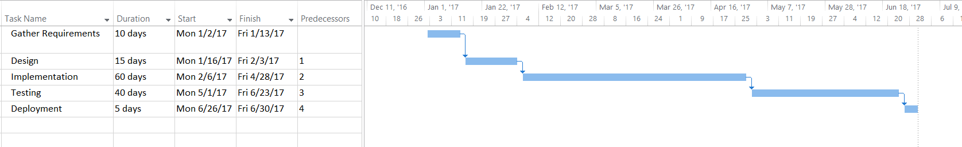

# Recommended Deployment Resources

Due to the rapid growth of Northwest Labs, current hardware, such as servers have been filled to capacity and will not be usable with the new system. We are recommending that Northwest Labs take its processing and data storage to the cloud instead of having servers on site. Cloud based solutions will be beneficial because it is cost effective, scalable, secure and redundant.

We have priced with and recommend Amazon Web Services as the Cloud provider for storage and processing. Amazon has a great track record and supports some of the largest companies in the world. The resources that we recommend are as follows:

## Application Servers

Two m3.2xLarge Windows 2012 Servers. These two servers will be our application servers. There will be one based in Amazon’s Northwest region and another based in the European region. This will accommodate users throughout the world, as well as the offices in Singapore and Seattle. The servers will have 15GB of RAM and 80GB of SSD storage, which should be more than enough for our application. The cost of the two m3.2xLarge servers is $18,200.64 yearly.

## Database Servers

Two db.m4.2xLarge SQL Servers. These two servers will be our database servers. They will also be based in the Northwest Region and the European region to accommodate all of the users throughout the world. These servers have 32 GB of RAM memory and dedicated bandwidth of 1,000 Mbps, which should be sufficient for our database needs. The cost of these two m4.2xLarge servers is $13,620.00 yearly.

## File Server

One 25 Terabyte Amazon Web Service S3 Storage instance. This will act as the file server to maintain all of the raw data and reports produced by Northwest Labs. This should be more than enough storage to handle the files that are created for the next few years, and all historical records and data. The cost for this is $9,000 yearly.

As Northwest labs continues to grow, these resources will easily grow with it. This data will also be held in secure locations, and Amazon is responsible for backing the system up and responding to any potential down-time. For these reasons we have recommended this cloud solution.

# Recommendations for Alternatives

# Summary

# APPENDIX

# Menu Hierarchy

The following portion of the document shows the menu structure for the website. We have included the users that will be able to view and access each of the menu items. The menu will be organized in the manner shown in the screenshot below. The content of the menu along with the aforementioned users who can access and view that menu is found on the following pages.



[Customer View]



[Manager View]

## HOME (P)

## ABOUT (P)

SR – Sales Representative

M – Manager

C – Customer

LM – Lab Manager

LW – Lab Worker

E – Employee

MD – Marketing Director

HLM – High Level Management

TD – Technical Director

TA - Technical Assistant

P - Public

Legend

## CONTACT US (P)

## Sales (SR, M, C, LM)

Order Quotes (SR, M, C)

Create Order Quote (SR, M)

Update Order Quote (SR, M)

View Order Quote (SR, M, C)

Orders (SR, M, LM, C)

Create an Order (SR, M, LM)

Save an Order (SR, M, LM)

Cancel Order (SR, M, LM)

Lookup Past Order (SR, M, LM, C)

Business Leads (SR, M)

Create Business Lead (SR, M)

Update Business Lead (SR, M)

Delete Business Lead (SR, M)

View Business Lead (SR, M)

Convert Business Lead to Customer Account (SR, M)

## Billing (B, HLM)

Bill Customer (B)

Apply Early Payment Discount (B)

Note

Italicized items will not necessarily be shown as menu items. They are in the menu hierarchy to assert that they can be found under the parent menu.

Approve Invoice (B)

Create Invoice (B)

Update Hourly Charge Rate (HLM)

## Order Tracking (LW, SR, M, C, B)

Update Compound Receipt Log (LW)

Update Assay Work Order Status (LW)

Read Assay Work Order Status (LW, SR, M, C)

Send Compound receipt Confirmation (LW)

Update Compound Weighing and Dispensing Log (LW)

Read Compound Weighing and Dispensing Log (LW)

Read Compound Receipt Log (LW, M)

Test Sample Spreadsheets (LW, B, SR, M, C)

Create Test Sample Spreadsheet (LW)

Update Test Sample Spreadsheet (LW, B)

Read Test Sample Spreadsheet (LW, B)

Further Test Recommendations (LW, SR, M, C, LM)

Create Further Test Recommendations (LW, LM)

Update Further Test Recommendations (LW, LM)

View Further Test Recommendations (LW, SR, M, C)

Approve Further Test Recommendations (SR, C)

## [Customer] Account (SR, M, C*)

Create Customer Account (SR, M)

Update [Customer] Account (SR, M, C*)

Words surrounded with [Brackets] will be seen differently in the menu by users that have an asterisk* next to their signifying letter.

Note

View [Customer] Account (SR, M, C*)

Archive Customer Account (SR, M)

View Completed Reports (SR, M, C)

## Employee Accounts (M, E)

[Staff Accounts] (M, E*)

Create Staff Account (M)

Update [Staff] Account (M, E*)

View [Staff] Account (M, E*)

Archive Staff Account (M)

View [Staff] Schedule (M, E*)

Update Staff Schedule (M)

Manager Accounts (M)

Create Manager Account (M)

Update Manager Account (M)

View Manager Account (M)

Archive Manager Account (M)

## Payroll (M, A, E)

View [Individual Employee] Timesheet (A, M, E*)

Update Individual Employee Timesheet (M)

View Total Employee Timesheet (M, A)

View [Individual] Payroll (M, A, E*)

Create Check (A)

Authorize Check Payment (M)

## Inventory (LW)

View Item Inventory (LW)

Add Item to Inventory (LW)

Delete Item from Inventory (LW)

Update Status of Item (LW)

## Catalog (MD, E, C, P)

Create New Assay Item (MD)

Update Assay Item (MD)

Delete Assay Item (MD)

View Catalog (MD, E, C, P)

## Lab Scheduling (LM, E, C)

Assay Scheduling (LM, E)

Create Weekly Assay Schedule (LM)

Print Weekly Assay Schedule (LM, E)

Update Weekly Assay Schedule (LM)

View Weekly Assay Schedule (LM, E)

[Individual Assay Schedules] (LM, E, C*)

Update Individual Completion Time (LM)

View Individual Assay Completion Time (LM, E, C)

## Managerial Reports (SR, A, M, C, MD)

Customer Reports (A, SR, M, A, C)

Create Customer Reports (A)

Update Customer Reports (A)

View Customer Reports (SR, M, A, C)

Archive Customer Reports (A)

Performance Reports (M)

Create Performance Reports (M)

Update Performance Reports (M)

View Performance Reports (M)

Archive Performance Reports (M)

Profitability Reports (M, MD)

Create Profitability Reports (M)

Update Profitability Reports (M)

View Profitability Reports (M, MD)

Archive Profitability Reports (M)

Monthly Sales Rep Reports (M, MD)

Create Sales Representative Reports (M)

Update Sales Representative Reports (M)

View Sales Representative Reports (M, MD)

Archive Sales Representative Reports (M)

Ad-Hoc Reports (SR, M)

Create Ad-Hoc Reports (M)

Update Ad-Hoc Reports (M)

View Ad-Hoc Reports (M, MD)

## Assay Reporting (LW, TD, C, TA)

Assay Data (TD, C, LW)

Upload Raw Assay Data (LW)

View Raw Assay Data (TD)

Create Assay Data Report (TD)

Update Assay Data Report (TD)

View Assay Data Report (TD, C)

Assay Summary (TD, TA)

Create Assay Summary Report (TD)

Update Assay Summary Report (TD)

View Assay Summary Report (TD, TA, C)

Archive Summary Report (TD, TA)

Send Completed Assay Report (TD, TA)

Prepare Assay Report Media (TD, TA)

## LOG IN (P)

## LOG OUT (P)

# Details for Use Case List

This section will include details for use cases, referenced earlier in the document. Specifically: Use Case Diagrams, Use Case Descriptions, Activity Diagrams, System Sequence Diagrams and Views.

## Create an Order Quote

### Use Case Diagram – Create an Order Quote

### Use Case Description - Create an Order Quote

|  |  |  |
| --- | --- | --- |
| **Use Case Name** | Create a quote for an order | |
| **Scenario** | Sales Representative creates a new quote for an order | |
| **Triggering Event** | Customer requests a quote for an order. | |
| **Brief Description** | Customer requests a quote for an order. Sales Representative creates a quote based on the order. The quote is created by the system based on the base price for the assay plus the average price for similar compounds. If the compound has never been used before, then the price will be given based on the maximum labor cost plus the base price for the assay plus a margin for materials. | |
| **Actors** | Sales Representative | |
| **Related Use Cases** | Created an order | |
| **Stakeholders** | Management, Sales, Customer, Lab | |
| **Preconditions** | None | |
| **Postconditions** | Sales Rep can proceed with creation of order at customers request | |
| **Flow of Events** | **Actor** | **System** |
| 1. Sales Representative starts a new order quote 2. Sales Representative enters assay types and quantity 3. Sales Representative finishes the order quote 4. Sales Representative enters contact info | * 1. prompt user to select assay type   2. calculates the average price of items   3. prompt the user to finish the order quote   4. Prompt user for customer contact info   5. System emails quote to customer   6. System saves quote and contact info to business lead |
| **Exception Conditions** | 3.1 User does not want to give contact info. In this case don’t save the quote | |

### Activity Diagram – Create an Order Quote

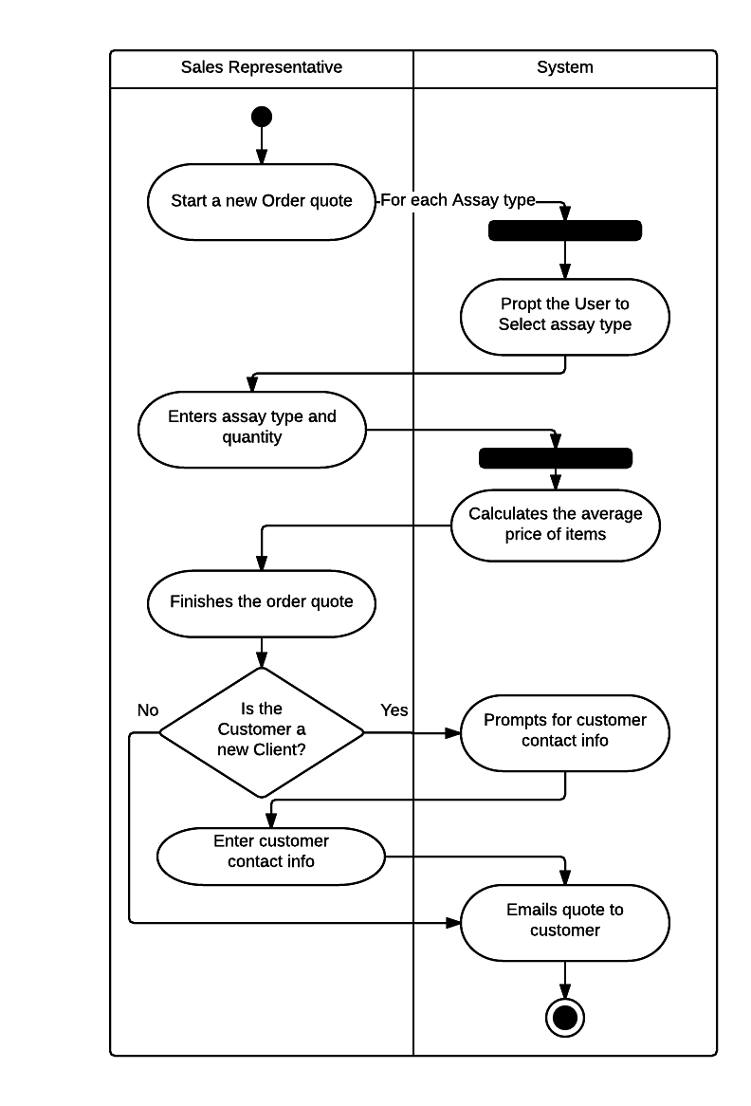

### System Sequence Diagram – Create an Order Quote

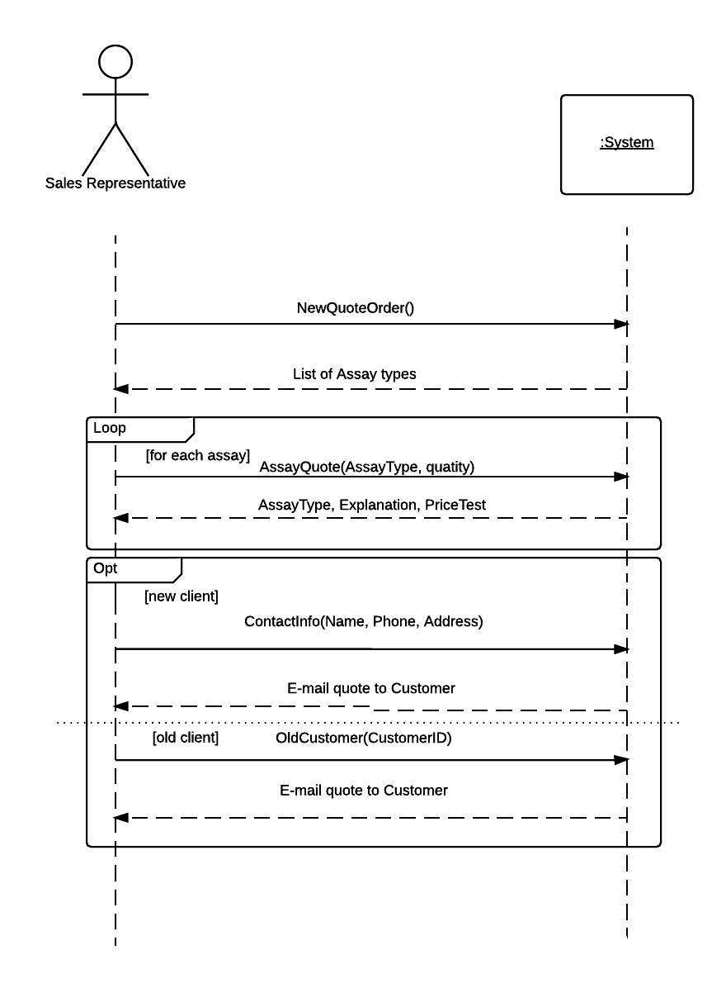

### View – Create an Order Quote

## Create an Order

### Use Case Diagram – Create an Order

### Use Case Description – Create an Order

|  |  |  |
| --- | --- | --- |
| **Use Case Name** | Create an order | |
| **Scenario** | Sales Representative creates a new order | |
| **Triggering Event** | Customer contacts Sales Representative with order information to create an order | |
| **Brief Description** | Sales Representative creates a new order for a customer. | |
| **Actors** | Sales Representative | |
| **Related Use Cases** | Create an order quote | |
| **Stakeholders** | Management, Sales, Customer, Lab | |
| **Preconditions** | Customer needs to have an account | |
| **Postconditions** | Lab workers are able to schedule assay for completion. | |
| **Flow of Events** | **Actor** | **System** |
| 1. Sales Representative selects customer from customers list  2. Sales Representative starts a new order  3. Sales Representative enters assay types and quantity  4. Sales Representative finishes the order | 1.1 Display customer information  2.1 Prompt user to select assay type  3.1 Display quoted price for assay  4.1 System authorizes order and sends to be scheduled  4.2 System saves order with Work Order ID number and displays work order ID number  4.3 System sends email confirmation to customer with WO ID number |
| **Exception Conditions** | 2.1 Customer wants to cancel order and Sales Representative cancels the order | |

### Activity Diagram – Create an Order

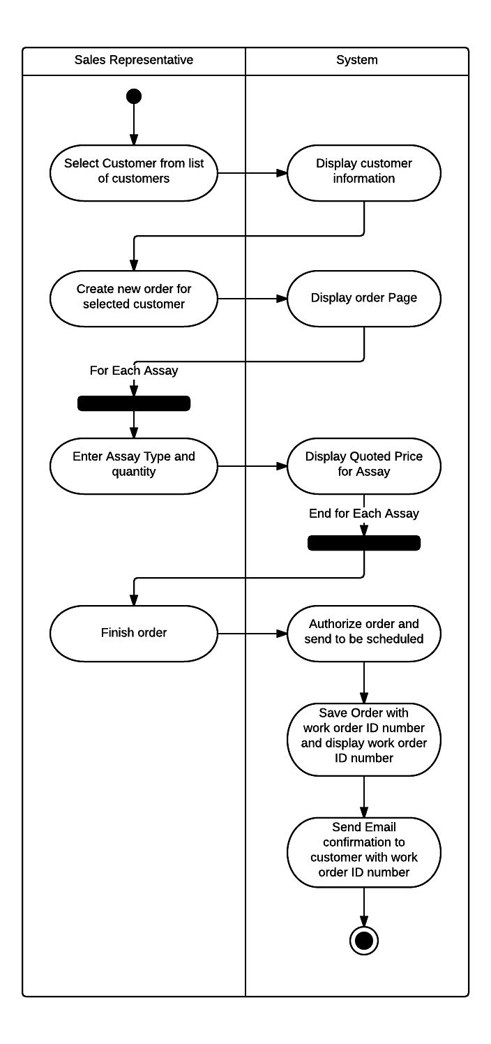

### System Sequence Diagram – Create an Order

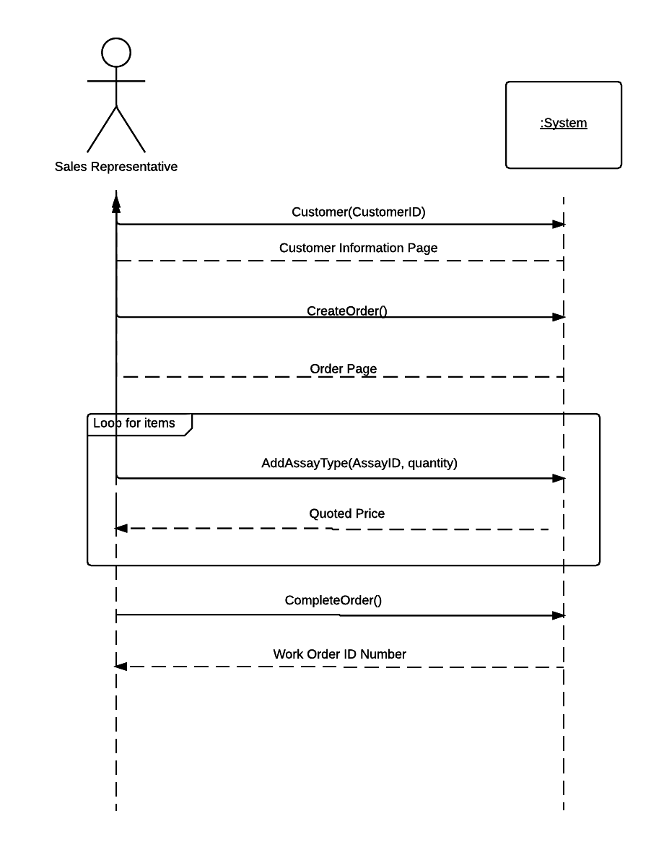

### View – Create an Order

## Update Hourly Charge Rate

### Use Case Diagram – Update Hourly Charge Rate

### Use Case Description – Update Hourly Charge Rate

|  |  |  |
| --- | --- | --- |
| **Use Case Name** | Update Hourly Charge Rate | |
| **Scenario** | Management wants to update the Hourly Charge Rate for Assay | |
| **Triggering Event** | Executive Decisions | |
| **Brief Description** | Management can change the hourly charge rate that is applied to all Assays | |
| **Actors** | High Level Management | |
| **Related Use Cases** | None | |
| **Stakeholders** | Management, Customer | |
| **Preconditions** | Management has a reason to change the hourly charge | |
| **Postconditions** | Hourly Charge is updated and applied to future orders | |
| **Flow of Events** | **Actor** | **System** |
| 1. Management selects hourly charge rate from billing dropdown menu  2. Management submits hourly charge r  3. Confirm Hourly charge rate change | 1.1 System displays hourly charge rate  2.1 System prompts user to confirm change  3.1 System saves Hourly Charge Rate |
| **Exception Conditions** | 2.1 Management does not choose to confirm, and hourly charge rate is not changed. | |

### Activity Diagram – Update Hourly Charge Rate

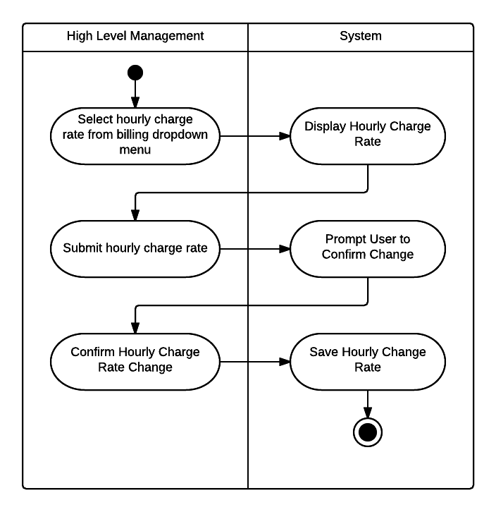

### System Sequence Diagram – Update Hourly Charge Rate

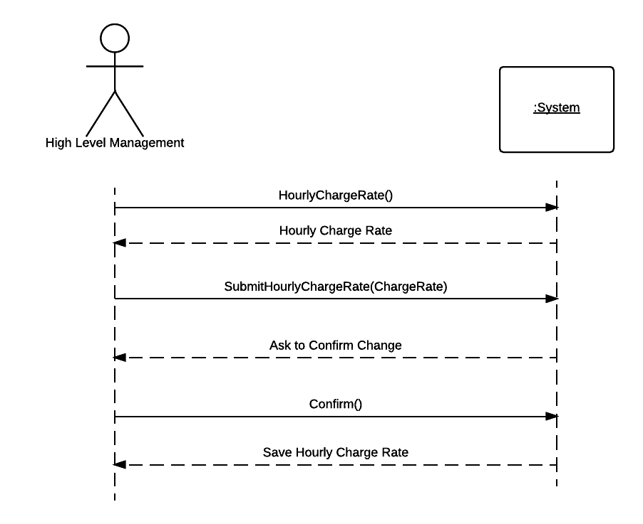

### View – Update Hourly Charge Rate

## Update Assay Work Order Status

### Use Case Diagram – Update Assay Work Order Status

### Use Case Description – Update Assay Work Order Status

|  |  |  |
| --- | --- | --- |
| **Use Case Name** | Update Assay Work Order Status | |
| **Scenario** | Lab workers update Assay Work Order status to see the progress of the assay | |
| **Triggering Event** | Steps in the Assay are finished | |
| **Brief Description** | When a Lab worker gets the compound for a new assay he will change the status. Then when it is scheduled and pending tests it will be changed, then when the tests are completed it will be changed again. There will be other steps as well per the progress of the Assay | |
| **Actors** | Lab Worker | |
| **Related Use Cases** | View Assay Work Order Status | |
| **Stakeholders** | Lab Worker, Lab Manager, Management | |
| **Preconditions** | The next step in the work order has been completed | |
| **Postconditions** | The Assay work order status is accurately up to date, and can be seen by the customer, sales, and office managers | |
| **Flow of Events** | **Actor** | **System** |
| 1. Lab Worker selects what work order to view  2. Lab worker updates progress of work order status and clicks save | 1.1 System displays all assays associated with work order  2.1 System saves info and refreshes screen with updated progress of work order status |
| **Exception Conditions** | 2.1 Lab worker does not save. Work order status is not updated. | |

### Activity Diagram – Update Assay Work Order Status

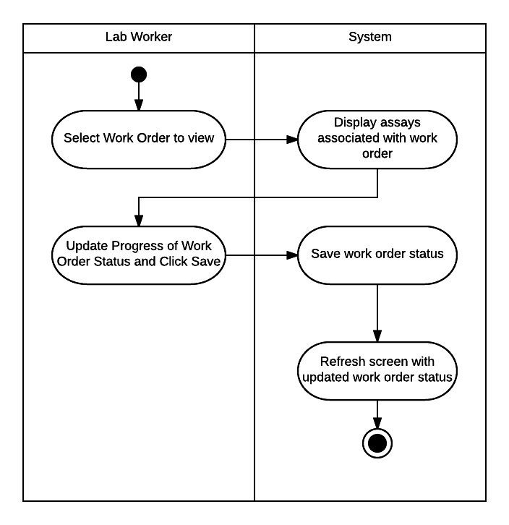

### System Sequence Diagram – Update Assay Work Order Status

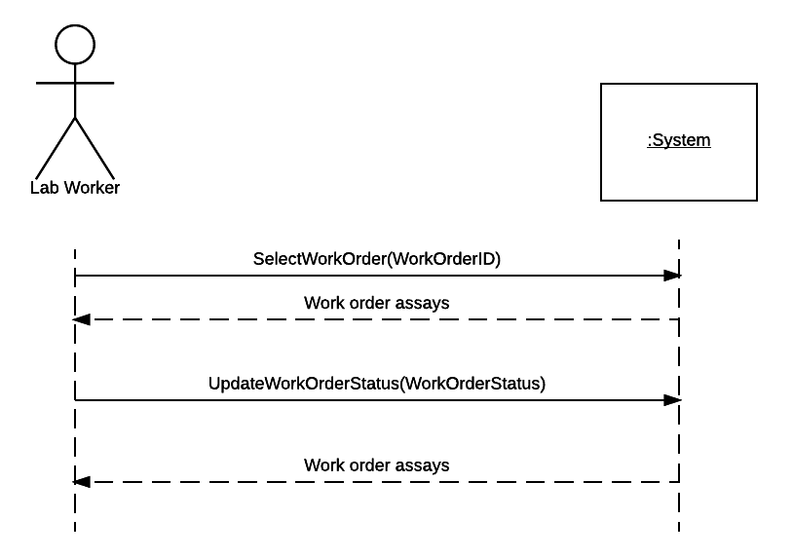

### View – Update Assay Work Order Status

## View Assay Work Order Status

### Use Case Diagram - View Assay Work Order Status

### Use Case Description - View Assay Work Order Status

|  |  |  |
| --- | --- | --- |
| **Use Case Name** | View Assay Work Order Status | |
| **Scenario** | Customer wants to check on the status of the Assay that they sent to Singapore | |
| **Triggering Event** | None | |
| **Brief Description** | When lab workers in Singapore change the status of the work order, the customer should be able to see the updated status from their customer portal | |
| **Actors** | Customer | |
| **Related Use Cases** | Update Assay Work Order Status | |
| **Stakeholders** | Lab Worker, Lab Manager, Management, Customer | |
| **Preconditions** | Work order status has to be set | |
| **Postconditions** | The customer is updated on the status of the work order. | |
| **Flow of Events** | **Actor** | **System** |
| 1. Customer selects order to view in their orders | 2.1 System displays all assays in the work order, and updated progress report. |
| **Exception Conditions** | None | |

### Activity Diagram - View Assay Work Order Status

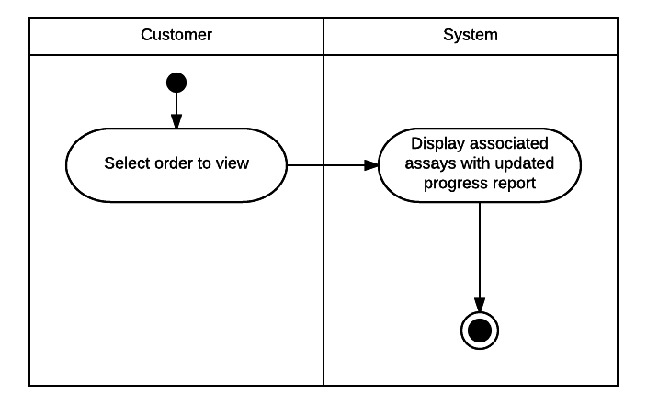

### System Sequence Diagram - View Assay Work Order Status

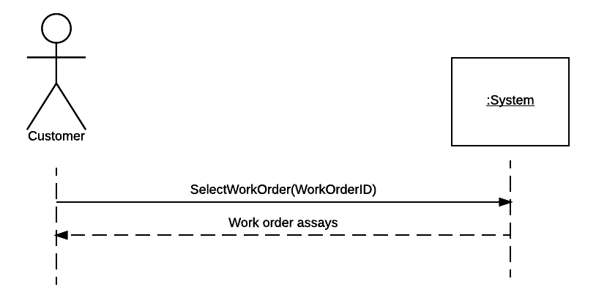

### View - View Assay Work Order Status

## Send Compound Receipt Confirmation

### Use Case Diagram – Send Compound Receipt Confirmation

### Use Case Description – Send Compound Receipt Confirmation

|  |  |  |
| --- | --- | --- |
| **Use Case Name** | Send Compound Receipt Confirmation | |
| **Scenario** | Lab workers have received the Compound from the customer order, and need to send a confirmation email to the customer | |
| **Triggering Event** | Lab worker receives compound in Singapore | |
| **Brief Description** | The customer wants to know when their compound is received by the Lab in Singapore. When the compound is received a lab worker marks the compound as received in the Order and the system sends an email confirmation to the Customer | |
| **Actors** | Lab Worker | |
| **Related Use Cases** | None | |
| **Stakeholders** | Lab Worker, Lab Manager, Management, Customer | |
| **Preconditions** | Lab worker receives compound | |
| **Postconditions** | Customer receives email confirmation from the Singapore lab | |
| **Flow of Events** | **Actor** | **System** |
| 1. Lab worker selects associated work order for the customer  2. Lab worker clicks button to mark receipt of compound  3. Lab worker accepts confirmation | 1.1 System displays screen for work order including option to mark receipt of compound  2.1 System asks for confirmation  3.1 System saves receipt of compound time and date  3.2 System sends receipt of compound to email address on file for associated customer. |
| **Exception Conditions** | 2.1 Lab worker does not choose to confirm, compound receipt is not saved and email is not sent. | |

### Activity Diagram – Send Compound Receipt Confirmation

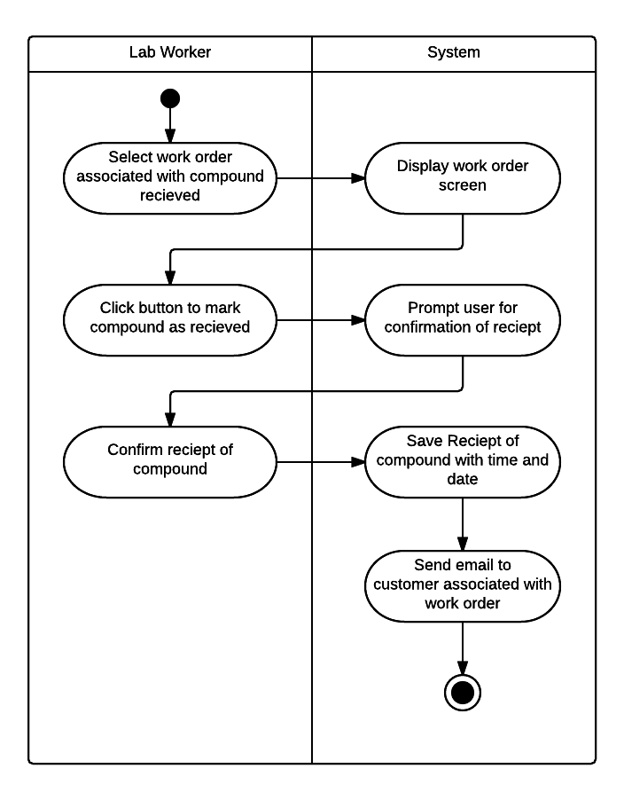

### System Sequence Diagram – Send Compound Receipt Confirmation

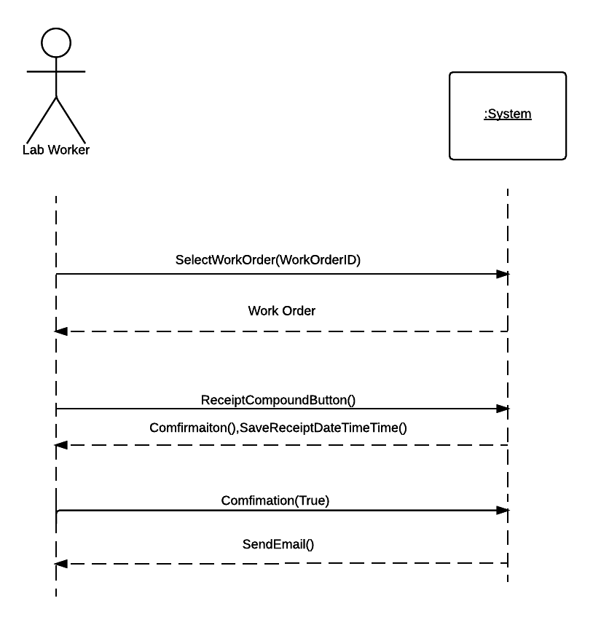

### View – Send Compound Receipt Confirmation

## Update Work Order Details for Assay

### Use Case Diagram - Update Work Order Details for Assay

### Use Case Description - Update Work Order Details for Assay

|  |  |  |
| --- | --- | --- |
| **Use Case Name** | Update Work Order Details for Assay | |
| **Scenario** | Lab workers update the work order details for the different assays | |
| **Triggering Event** | Assay is completed | |
| **Brief Description** | The work order details include the materials used for each assay and compound and their prices, the hours worked multiplied by the hourly charge rate set by management, and the base price for the assay. The billing department will use this information to create invoices | |
| **Actors** | Lab Worker | |
| **Related Use Cases** | View Work Order Details | |
| **Stakeholders** | Lab Worker, Lab Manager, Management, Billing | |
| **Preconditions** | One assay in a work order has been completed and needs to have the work order details | |
| **Postconditions** | The Assay work order details for that assay are completed and can be seen by lab workers, lab managers, and the billing department | |
| **Flow of Events** | **Actor** | **System** |
| 1. Lab Worker selects work order to view  2. Lab worker selects “Details” for Assay  3. Lab worker enters details for materials used and hours worked.  4. Lab worker clicks to save | 1.1 System shows all associated assays for work order  2.1 System displays work order details for selected assay.  3.1. System calculates price for hours worked using hourly charge rate, and gets price for materials used.  4.1 System saves and displays work order details with updated materials, hours, and their prices along with base price, and total. |
| **Exception Conditions** | 2.1 Lab worker does save work order details. System does not save or update work order details. | |

### Activity Diagram - Update Work Order Details for Assay

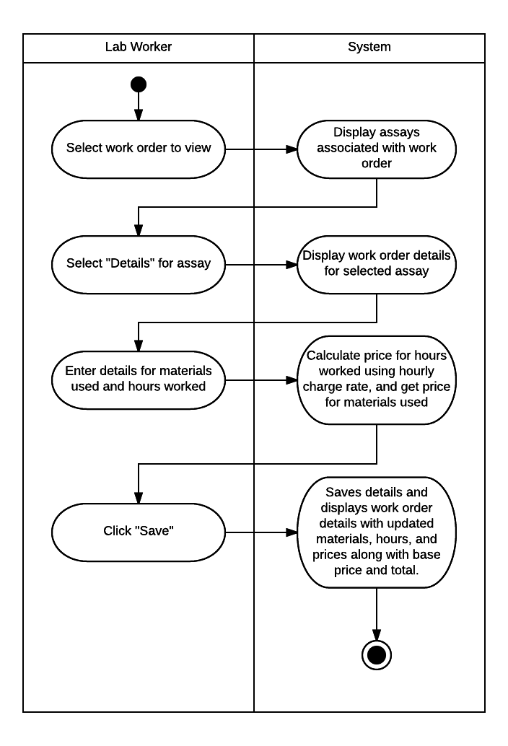

### System Sequence Diagram - Update Work Order Details For Assay

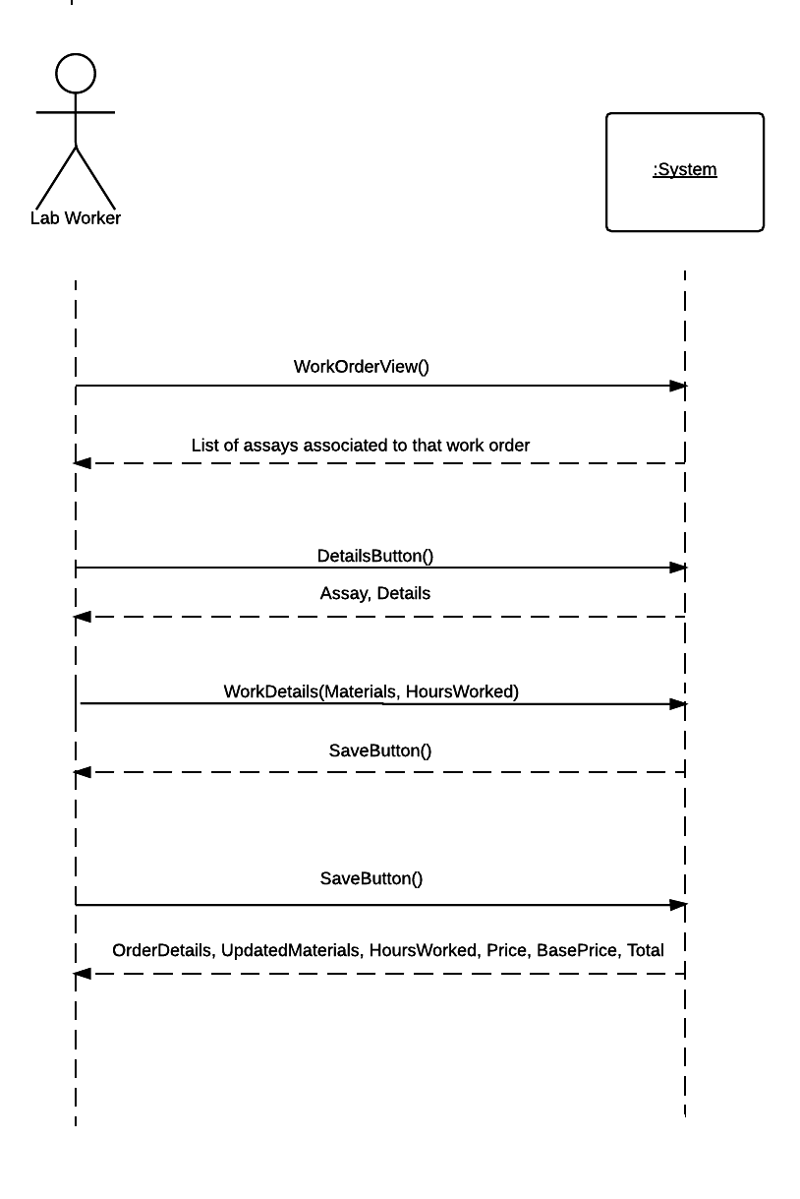

### View - Update Work Order Details For Assay

## Create Further Test Recommendation

### Use Case Diagram – Create Further Test Recommendation

### Use Case Description – Create Further Test Recommendation

|  |  |  |
| --- | --- | --- |
| **Use Case Name** | Create Further Test Recommendation | |
| **Scenario** | Lab workers are recommending further testing to the customer on a selected compound | |
| **Triggering Event** | Assays for a work order are finished and new tests are recommended | |
| **Brief Description** | When Assays are finished lab workers can give recommendations to the customer to perform further tests. The customer can then choose to approve those new tests. | |
| **Actors** | Lab Worker | |
| **Related Use Cases** | View Further test recommendation, Approve further test recommendation | |
| **Stakeholders** | Lab Worker, Lab Manager, Management, Customer | |
| **Preconditions** | Work Order is completed, and further tests are recommended | |
| **Postconditions** | Customer receives an email and can see on the order further recommended tests. They can choose to approve or decline the further tests. | |
| **Flow of Events** | **Actor** | **System** |
| 1. Lab Worker selects correct work order from list of current work orders  2. Lab worker selects assay  3. Lab worker selects option to suggest further test  4. Lab worker selects assay types and enters explanation  5. Lab worker confirms | 1.1 System displays work order and related assays  2.1 System displays assay information and option to suggest further tests  3.1 System displays assay types  3.2 System displays text box for explanation.  4.1 System calculates and displays price and asks for confirmation  5.1 System saves further recommendations  5.2 System sends email to customer asking for approval |
| **Exception Conditions** | 4.1 Lab worker decides not to confirm. The further recommendations will not be saved, and no email will be sent to customer | |

### Activity Diagram – Create Further Test Recommendation

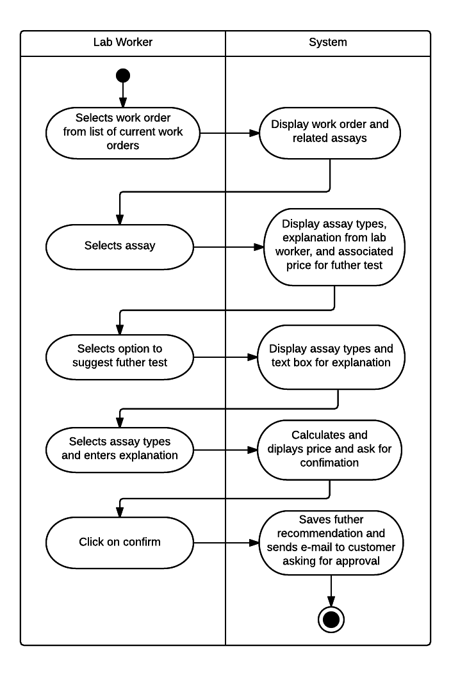

### System Sequence Diagram – Create Further Test Recommendation

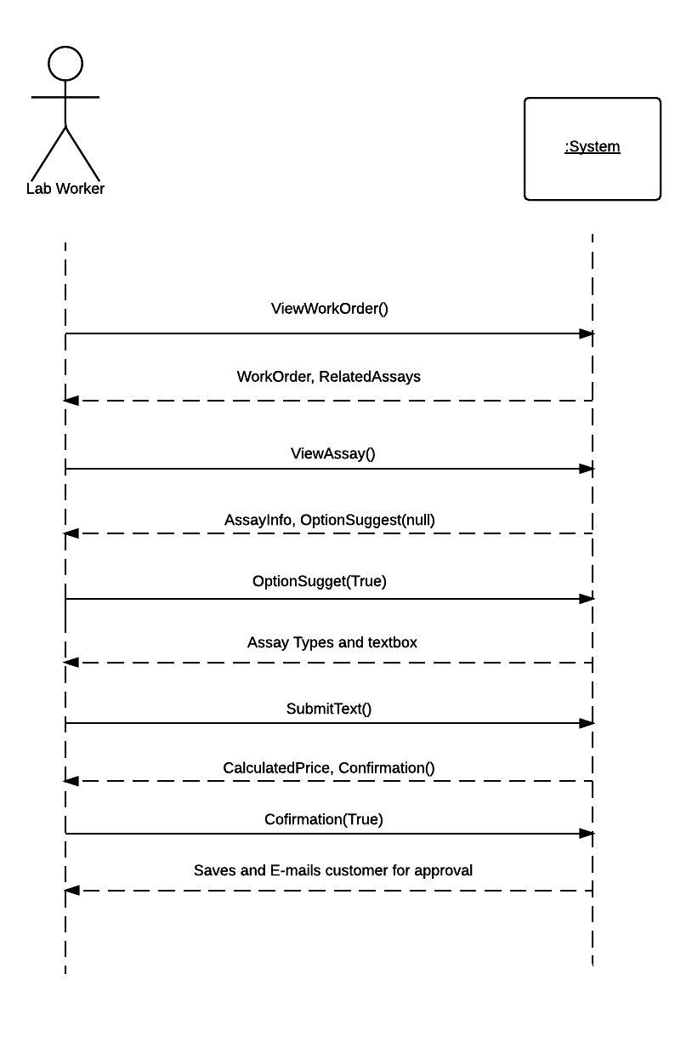

### View – Create Further Test Recommendation

## Approve Further Test Recommendation

### Use Case Diagram – Approve Further Test Recommendation

### Use Case Description – Approve Further Test Recommendation

|  |  |  |
| --- | --- | --- |
| **Use Case Name** | Approve further test recommendation | |
| **Scenario** | Lab worker has recommended further tests for the assay, and the customer can decide if they want to accept or decline those recommendations | |
| **Triggering Event** | Lab worker has recommended further tests for the assay | |
| **Brief Description** | If further tests need to be run on a compound, a lab worker will enter in a recommendation for further tests. The customer can then see those recommendations and approve or decline those tests. This description shows how the customer can accept and approve the test recommendation | |
| **Actors** | Customer | |
| **Related Use Cases** | Create Further Test Recommendation, View further test recommendation | |
| **Stakeholders** | Customer, Lab Worker, Lab Manager, Management | |
| **Preconditions** | Lab worker has submitted a further test recommendation, and customer can see that recommendation | |
| **Postconditions** | Recommendations are added to the work order and bill is updated with price of new tests | |
| **Flow of Events** | **Actor** | **System** |
| 1. Customer selects work order from list of current work orders.  2. Customer selects link for further test recommendations  3. Customer confirms further test recommendation | 1.1 System shows each assay and its progress  1.2 If lab worker has sent a further test recommendation system shows link for the recommendation  2.1 System displays assay types, explanation from lab worker, and associated price for further tests.  2.2 System displays confirm or decline further test recommendation  3.1 System sends confirmation email to customer  3.2 System adds new assays to work order and to preliminary schedule |
| **Exception Conditions** | 3.2 Customer declines further test recommendation. System does not add new assays to work order or to preliminary schedule. | |

### Activity Diagram – Approve Further Test Recommendation

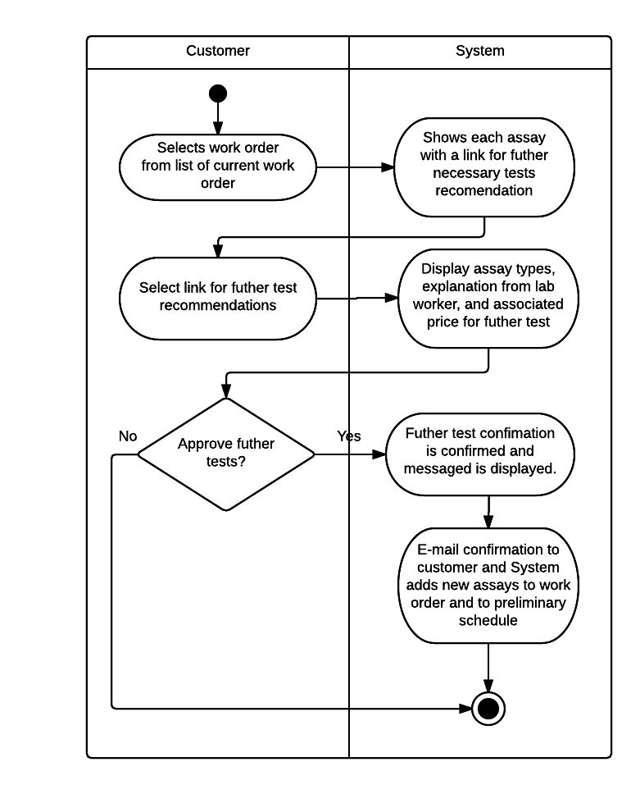

### System Sequence Diagram – Approve Further Test Recommendation

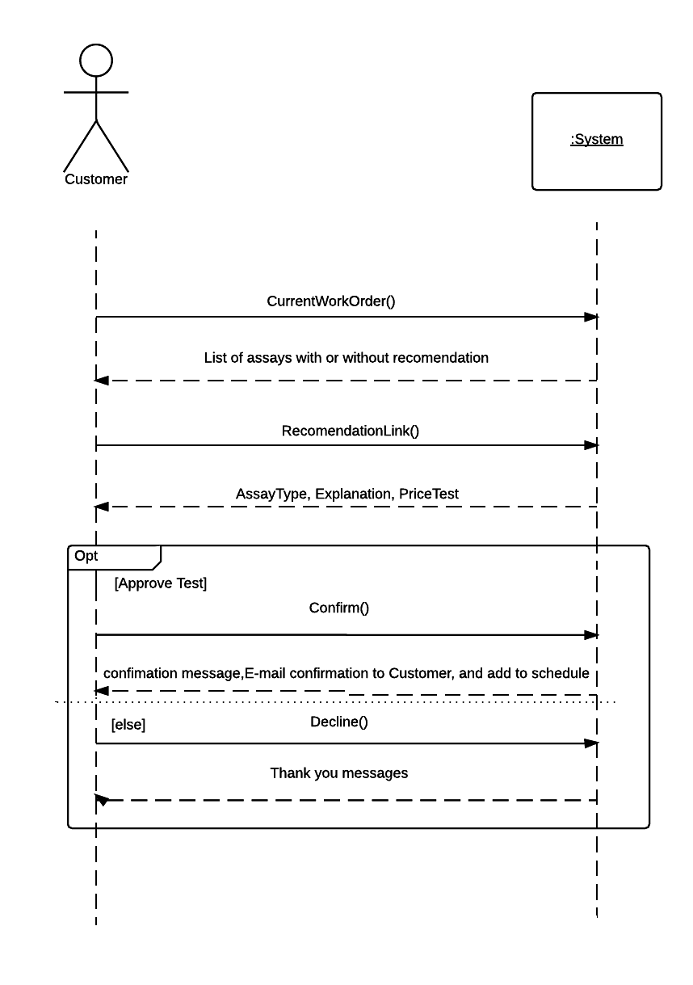

### View - Approve Further Test Recommendation

## View Completed Reports

### Use Case Diagram – View Completed Reports

### Use Case Description – View Completed Reports

|  |  |  |
| --- | --- | --- |
| **Use Case Name** | View Completed Customer Reports | |
| **Scenario** | Customer view his own Report | |
| **Triggering Event** | Customer requests from the System his own completed report | |
| **Brief Description** | Customer is able to access his own completed report of the system with his previous orders. He can do this by using his Customer account name and password. | |
| **Actors** | Customer | |
| **Related Use Cases** | View Individual Assay Completion Time | |
| **Stakeholders** | Customer, Manager, Sales Representative | |
| **Preconditions** | Customer must be logged on to be able to access the system | |
| **Post conditions** | Customer may be able to access the whole account information | |
| **Flow of Events** | **Actor** | **System** |
| 1. Customer clicks on button called view complete report 2. Customer is able to see his Report. | * 1. System provides the complete report view to user |
| **Exception Conditions** | 1.1 Customer may enter wrong Account Name and Password. | |

### Activity Diagram – View Completed Reports

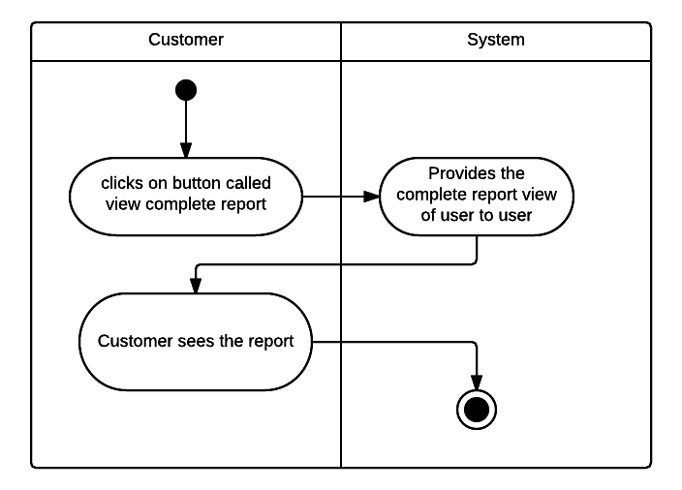

### System Sequence Diagram – View Completed Reports

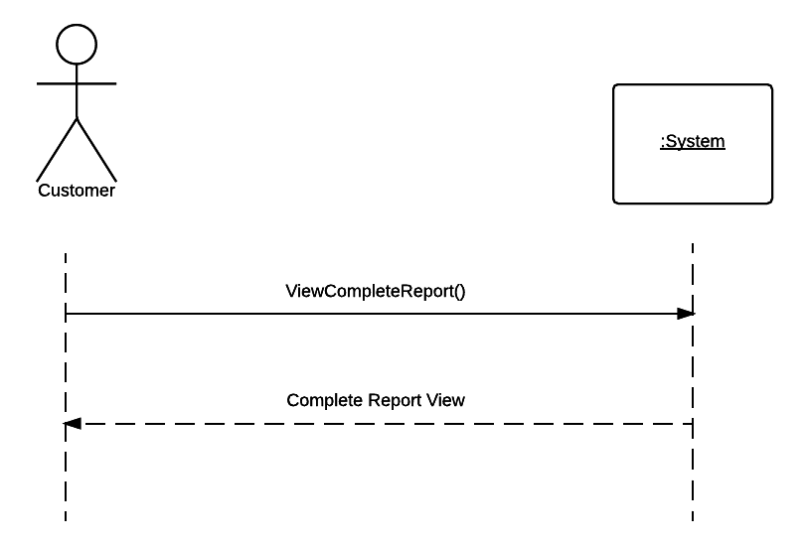

### View – View Completed Reports

## View Individual Assay Completion Time

### Use Case Diagram – View Individual Assay Completion Time

### Use Case Description – View Individual Assay Completion Time

|  |  |  |
| --- | --- | --- |
| **Use Case Name** | View Individual Assay Completion Time | |
| **Scenario** | Customer views own Individual Assay Completion Time | |
| **Triggering Event** | Customer desires to view from the System own Individual Assay Completion Time | |
| **Brief Description** | Customer is able to access Individual Assay Completion Time of the system. He can do this by using his Customer account name and password, and by accessing his order details schedule | |
| **Actors** | Customer | |
| **Related Use Cases** | View Completed Reports | |
| **Stakeholders** | Customer, Manager, Sales Representative | |
| **Preconditions** | Customer must be logged on to. Also, the Customer must have an Assay that was by the company. | |
| **Post conditions** | The Individual Assay Completion Time should be closed | |
| **Flow of Events** | **Actor** | **System** |
| 1. Customer chooses work order from current work order list. 2. Customer is able to see each Individual Assay Completion Time. | * 1. System displays all associated Assays and Completion Time for the Client. |
| **Exception Conditions** | 1.1 Customer may enter wrong Account Name and Password. | |

### Activity Diagram – View Individual Assay Completion Time

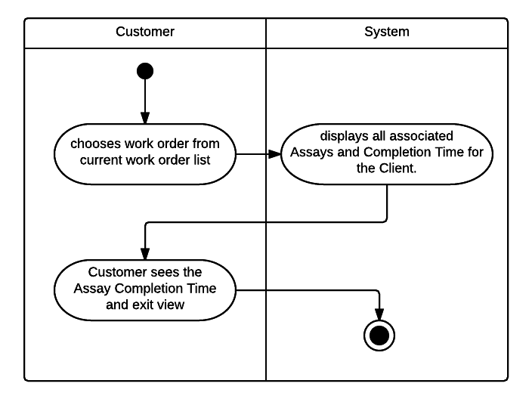

### System Sequence Diagram – View Individual Assay Completion Time

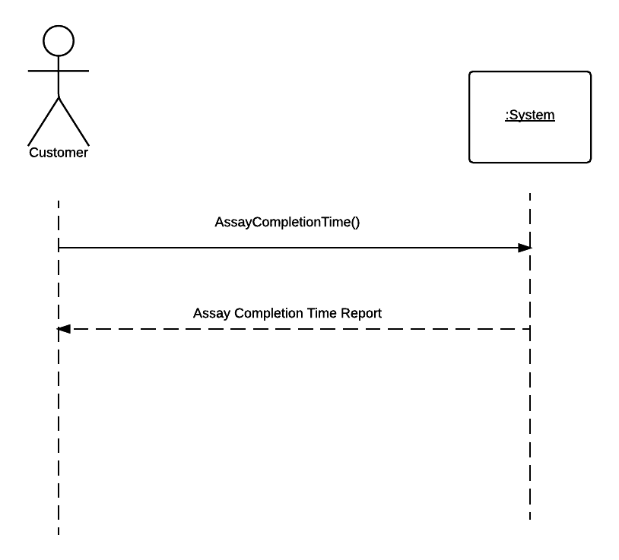

### View – View Individual Assay Completion Time

## Create Profitability Report

### Use Case Diagram – Create Profitability Report

### Use Case Description – Create Profitability Report

|  |  |  |
| --- | --- | --- |
| **Use Case Name** | Create Profitability Report | |
| **Scenario** | Manager wants to create a Profitability Report | |
| **Triggering Event** | Manager wants to create a Profitability Report | |
| **Brief Description** | Manager is able to create a profitability report by sales agent, customer, and type of Assay with few clicks | |
| **Actors** | Manager | |
| **Related Use Cases** | Create Ad-Hoc Report | |
| **Stakeholders** | Manager, Sales Representative, Marketing directors | |
| **Preconditions** | Manager must be logged on in the system | |
| **Post conditions** | Reports are sent to Management and the marketing directors | |
| **Flow of Events** | **Actor** | **System** |
| 1. Managers clicks on Profitability reports by choosing Profitability reports on a drop box. 2. Manager set different criteria for Profitability reports 3. Manager verify and clicks approve to submit Profitability report to Marketing directors | * 1. System Return page with drop boxes with different criteria.   2. System process the information and verify financial Report and sends to the view   3. System submits Profitability report to Marketing director’s and Manager’s e-mail. |
| **Exception Conditions** | 1.1 Customer may want to cancel profitability report. | |

### Activity Diagram – Create Profitability Report

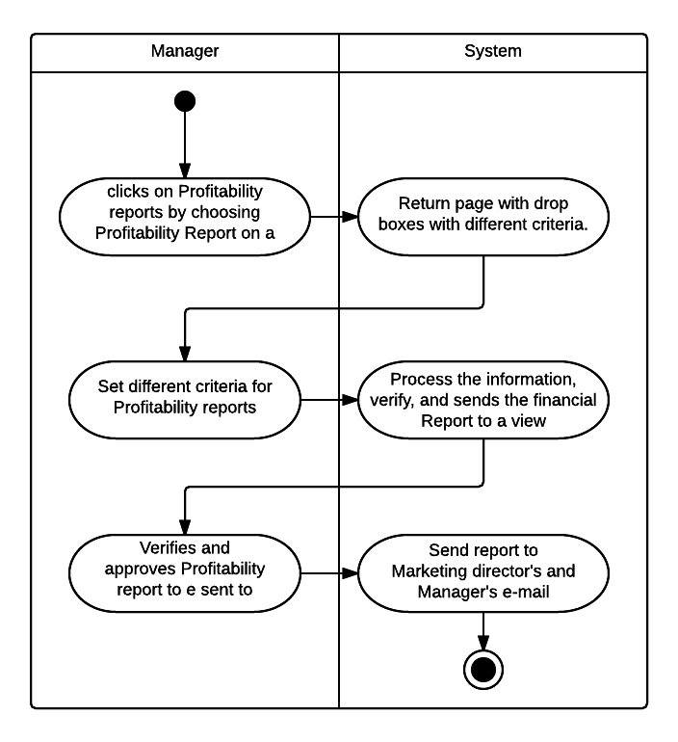

### System Sequence Diagram – Create Profitability Report

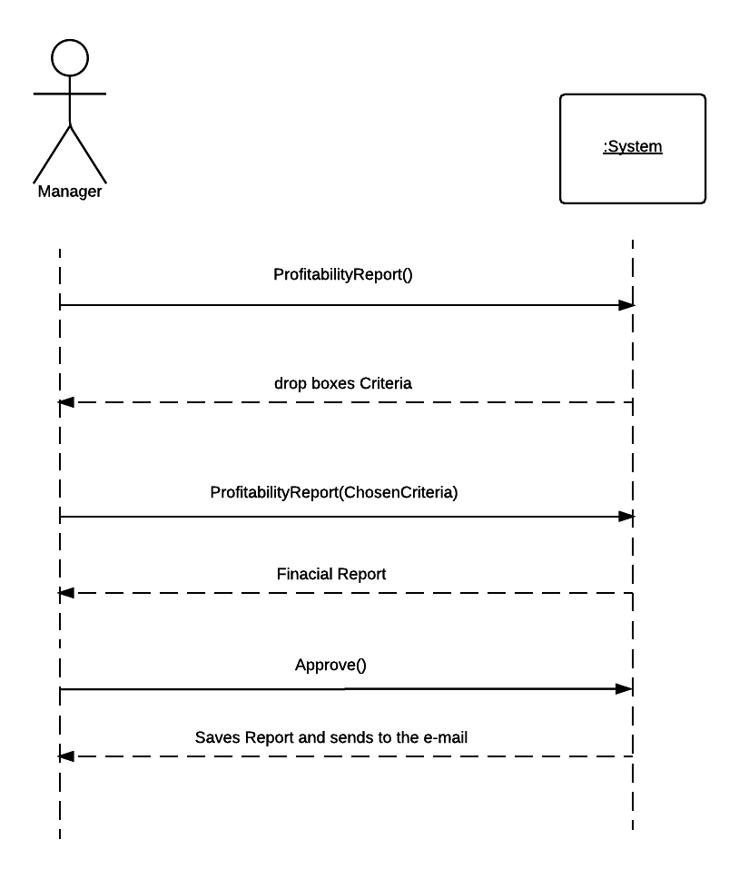

### View – Create Profitability Report

## Create Ad-Hoc Report

### Use Case Diagram – Create Ad-Hoc Report

### Use Case Description – Create Ad-Hoc Report

|  |  |  |
| --- | --- | --- |
| **Use Case Name** | Create Ad-Hoc Report | |
| **Scenario** | Sales Representative creates Ad-Hoc Report | |
| **Triggering Event** | Sales Representative wants to create Ad-Hoc Report | |
| **Brief Description** | Sales Representative is able to create Ad-Hoc Report by using his own chosen criteria | |
| **Actors** | Sales Representative | |
| **Related Use Cases** | Create Profitability Report | |
| **Stakeholders** | Manager, Sales Representative, Marketing directors | |
| **Preconditions** | Sales Representative must be logged on in the system | |
| **Post conditions** | Ad-Hoc Document Report must have being created. | |
| **Flow of Events** | **Actor** | **System** |
| 1. Sales Representative clicks on Ad-Hoc Report by choosing Ad-Hoc Report on a drop box. 2. Sales Representative set different criteria for Ad-Hoc Report 3. Sales Representative verify and Save Ad-Hoc Report | * 1. System Return page with drop boxes with different criteria.   2. System process the information and verify Ad-Hoc Report.   3. System saves Ad-Hoc Report. |
| **Exception Conditions** | 1.1 Customer may want to cancel Ad-Hoc Report. | |

### Activity Diagram – Create Ad-Hoc Report

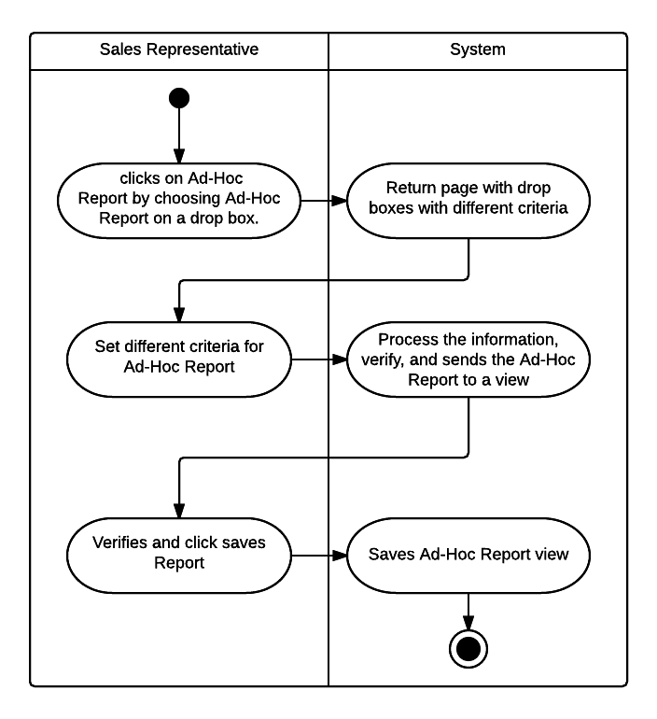

### System Sequence Diagram – Create Ad-Hoc Report

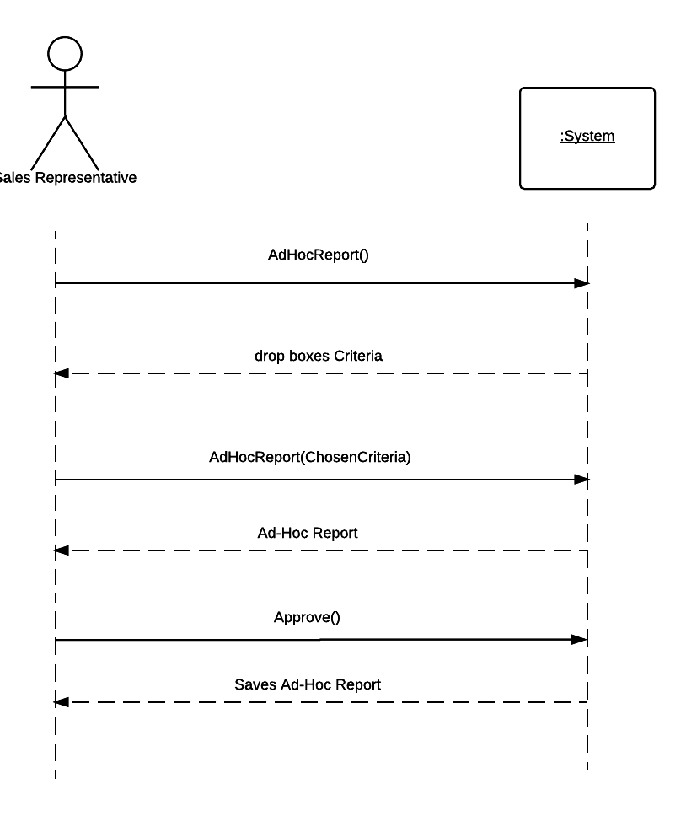

### View – Create Ad-Hoc Report

## Create Assay Summary Report

### Use Case Diagram – Create Assay Summary Report

### Use Case Description – Create Assay Summary Report

|  |  |  |
| --- | --- | --- |
| **Use Case Name** | Create Assay summary Report | |
| **Scenario** | Technical Director creates an Assay Summary Report | |
| **Triggering Event** | Technical Director wants to create an Assay Summary Report | |
| **Brief Description** | Technical Director may choose to create an Assay Summary Report. | |
| **Actors** | Technical Director | |
| **Related Use Cases** | Create Profitability Report | |
| **Stakeholders** | Manager, Technical Director, Lab Worker | |
| **Preconditions** | Technical Director must be logged on in the system | |
| **Post conditions** | New Assay summary Report is saved on the system | |
| **Flow of Events** | **Actor** | **System** |
| 1. Technical Director clicks on Assay Summary Report by choosing Assay Summary Report on a drop box. 2. Technical Director set different criteria for Assay Summary Reports 3. Technical Director verify summary data Report and clicks save | * 1. System Return page with drop boxes with different criteria.   2. System process the information and verify Assay Summary Report.   3. System store and index Assay Summary Report |
| **Exception Conditions** | 1.1 Technical Director cancels Assay Summary Report | |

### Activity Diagram – Create Assay Summary Report

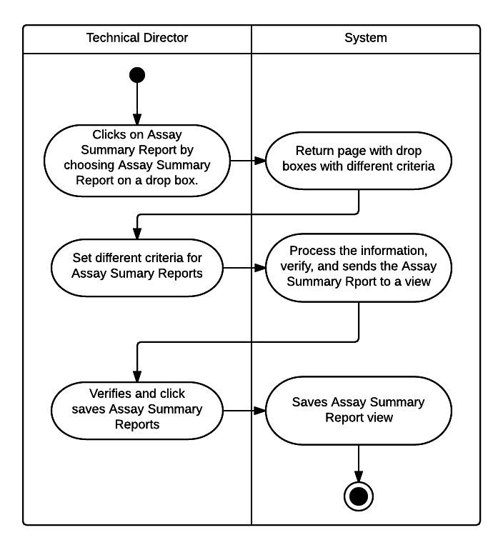

### System Sequence Diagram – Create Assay Summary Report

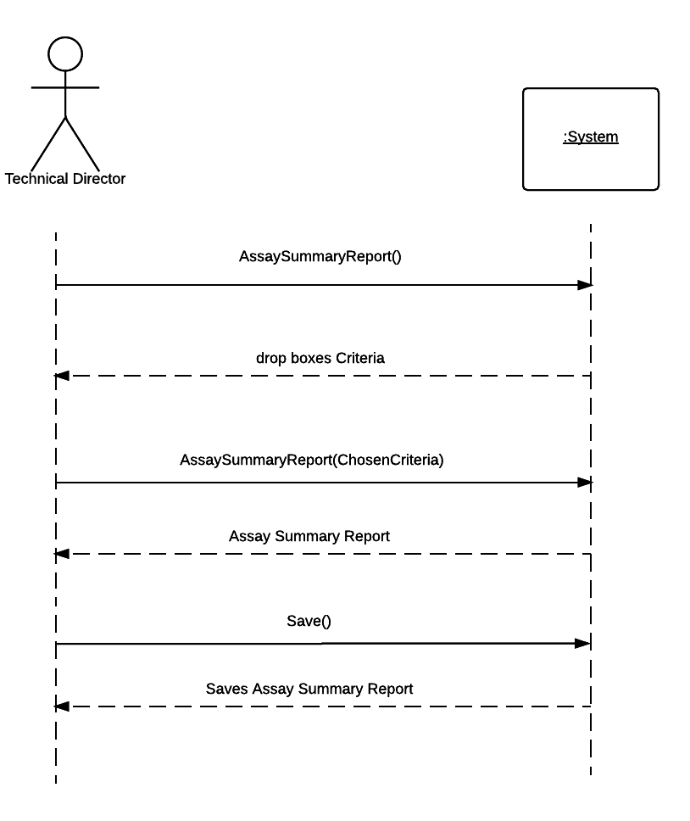

### View – Create Assay Summary Report

## Compile All Report Data

### Use Case Diagram – Compile All Report Data

### Use Case Description – Compile All Report Data

|  |  |  |
| --- | --- | --- |
| **Use Case Name** | Compile All Report Data | |
| **Scenario** | Technical Director Assistant creates a Compile All Report Data | |
| **Triggering Event** | Technical Director Assistant wants to create a Compile All Report Data | |
| **Brief Description** | Technical Director Assistant may choose to create Compile All Report Data. | |
| **Actors** | Technical Director Assistant | |
| **Related Use Cases** | Create Profitability Report | |
| **Stakeholders** | Manager, Technical Director, Technical Director Assistant | |
| **Preconditions** | Technical Director Assistant must be logged on in the system | |
| **Post conditions** | All Report Data is zipped together as a Compiled Report Data | |
| **Flow of Events** | **Actor** | **System** |
| 1. Technical Director Assistant clicks on Compile Report Data by choosing Compile Report Data on a drop box. 2. Sales Representative set different criteria for Compile Report Data 3. Sales Representative verify Compile Report Data and clicks save | * 1. System Return page with drop boxes with different criteria.   2. System process the information and verify Compile Report Data.   3. System compiles, zips, and saves all Report Data together |
| **Exception Conditions** | 1.1 Technical Director Assistant Compile Report Data | |

### Activity Diagram – Compile All Report Data

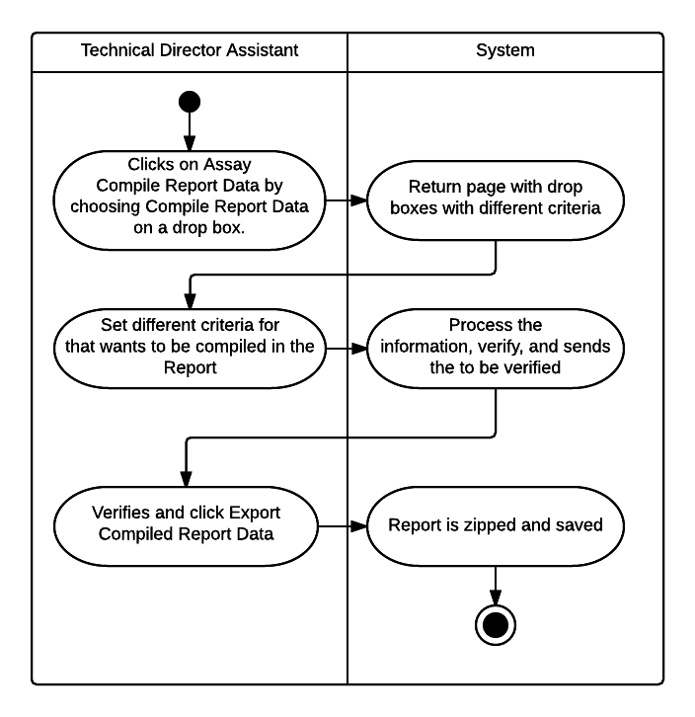

### System Sequence Diagram – Compile All Report Data

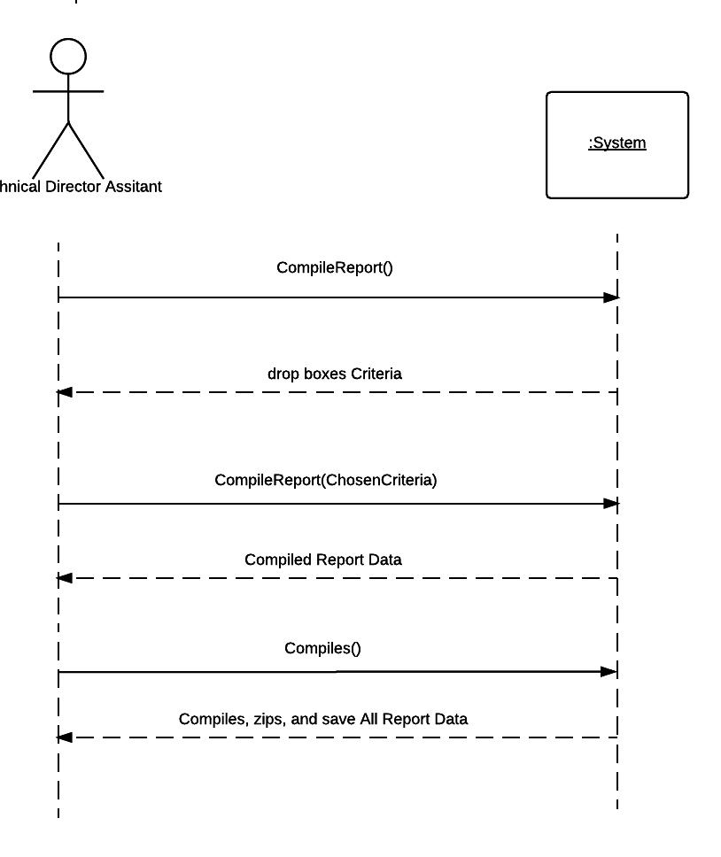

### View – Compile All Report Data

# Database Information

The database for the new system will be very important to the success of the communication between the two locations, as well as creating the customer portal. In this section, we will provide the Entity Relationship Diagram for the database, as well as a SQL schema to create the database and all of the tables therein.

## Entity Relationship Diagram

This Entity Relationship Diagram displays the tables that will be found in the database, the fields and their datatypes, the primary and foreign keys, and the relationship between tables. Below is an overview of the diagram, and the complete diagram will be shown in detail on the following pages.

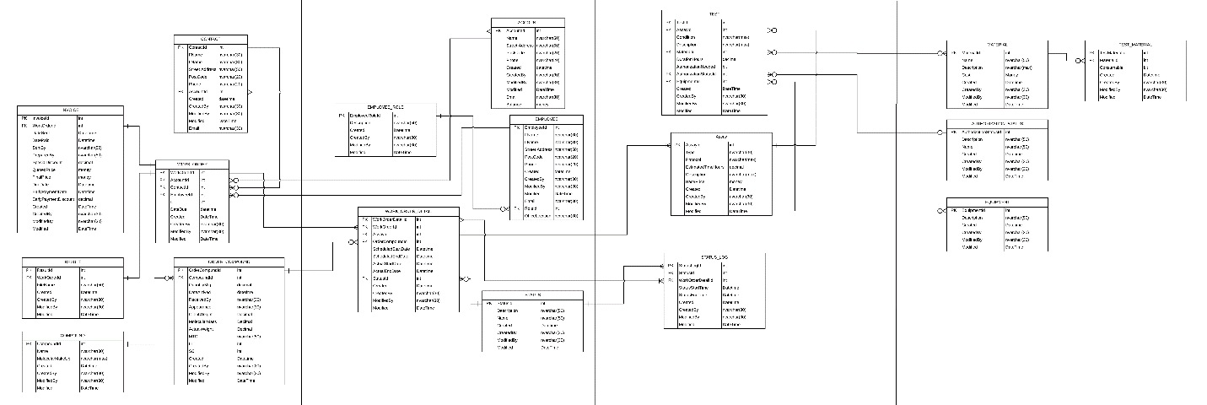

Page 4

Page 3

Page 2

Page 1

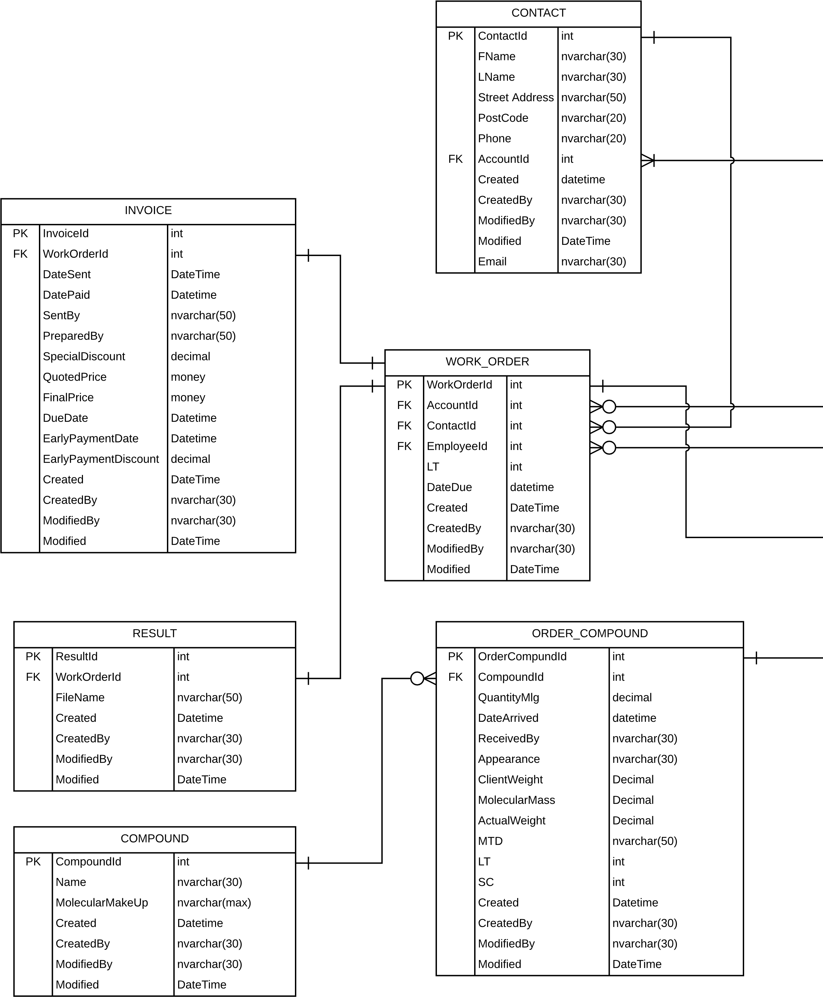

Page 1

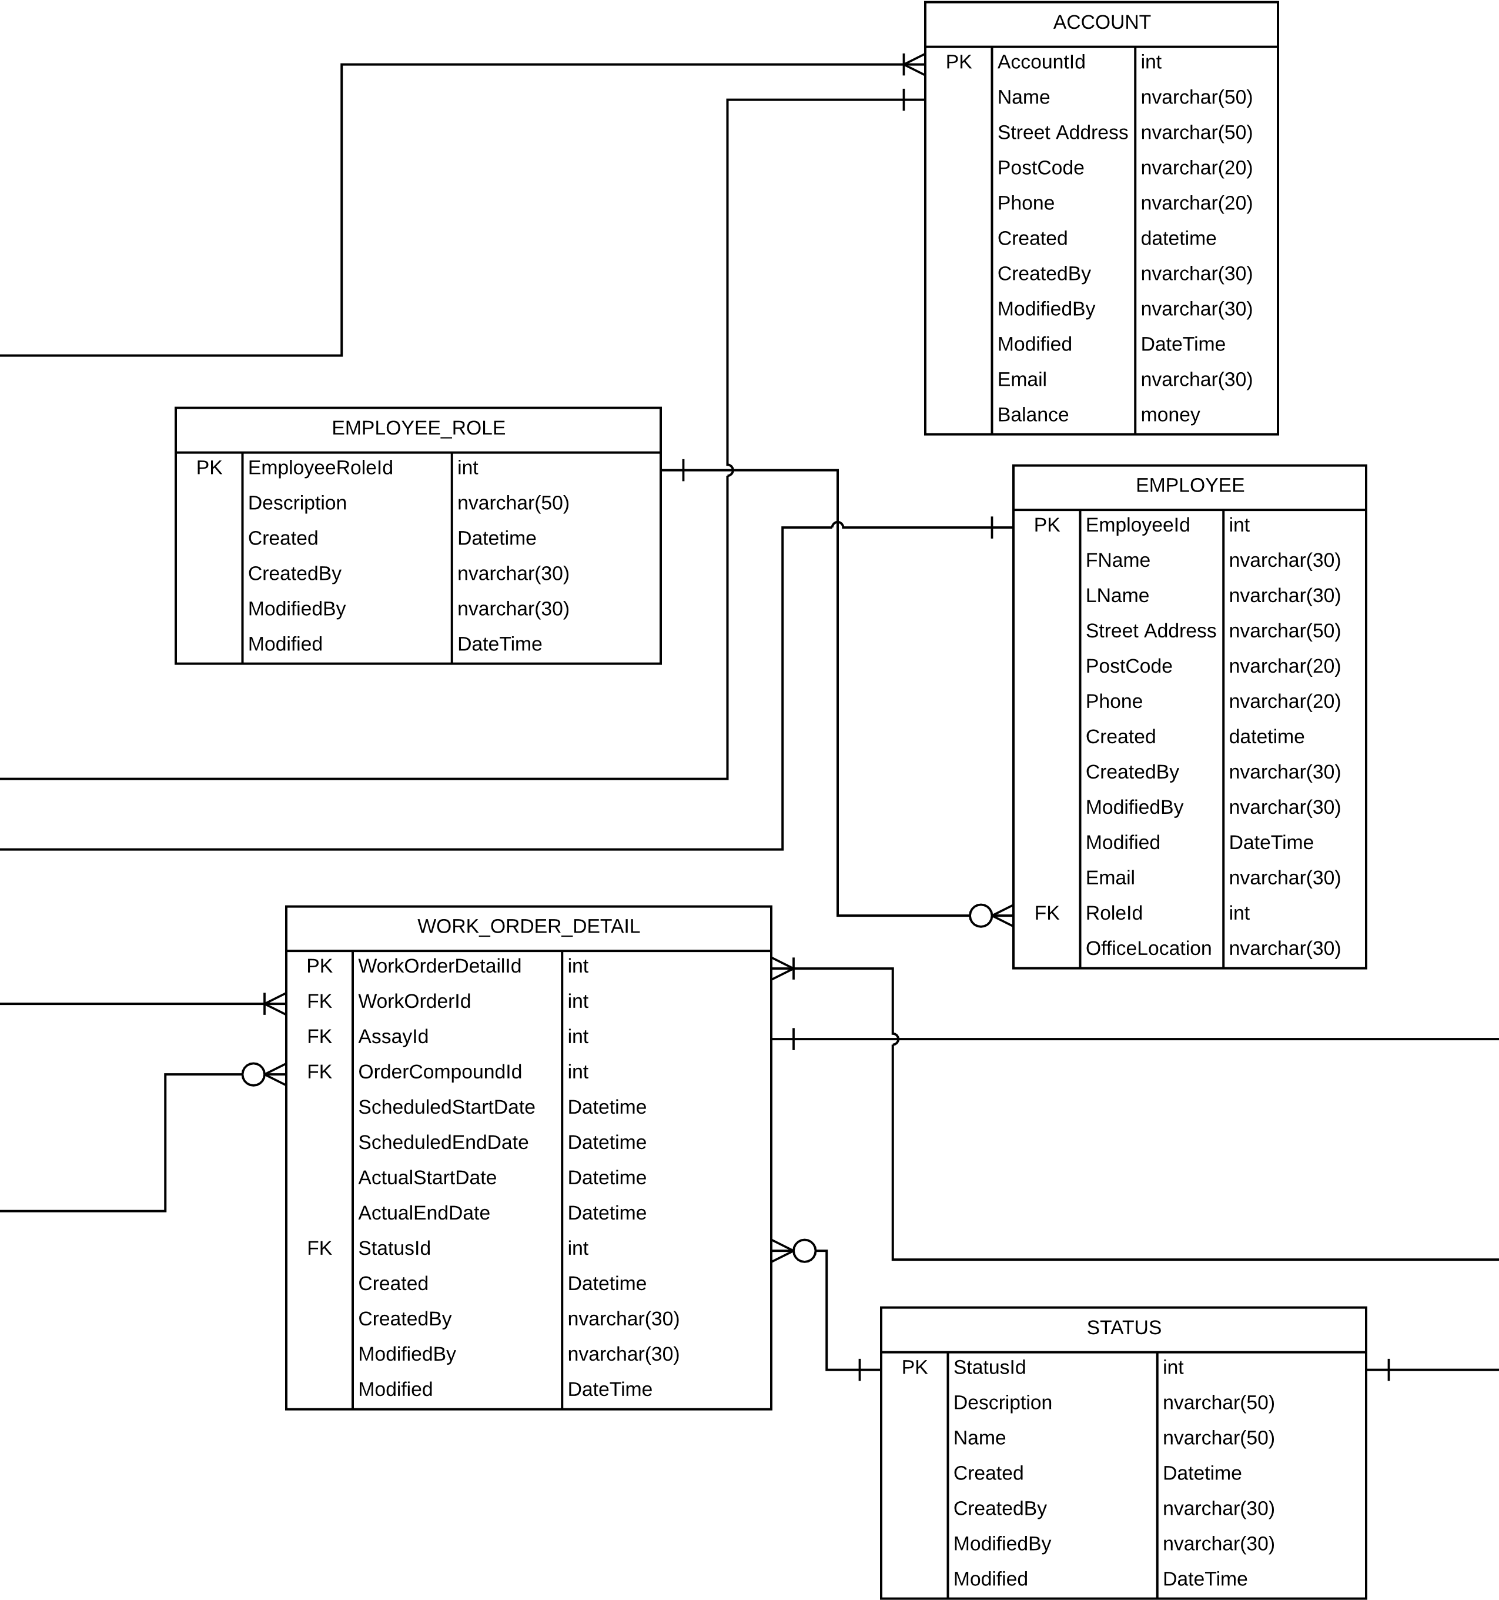

Page 2

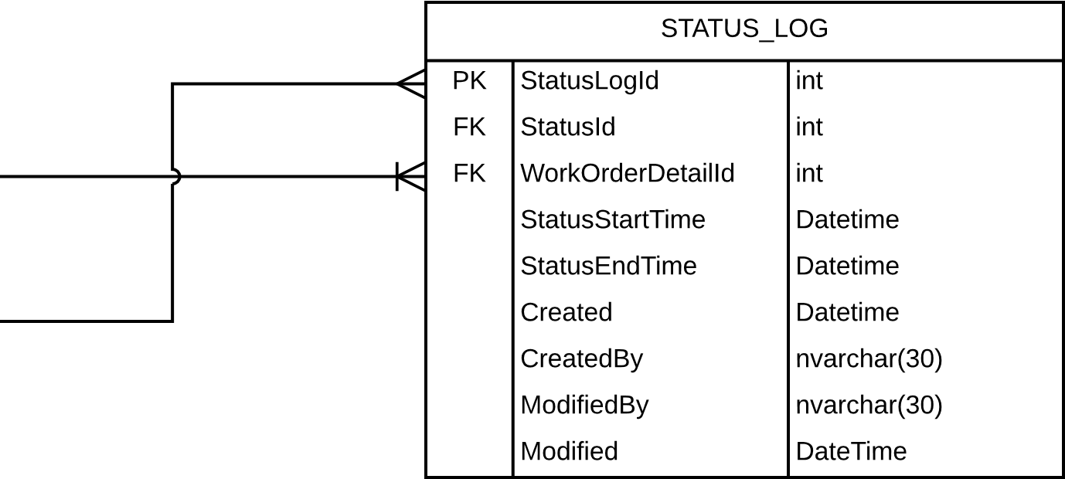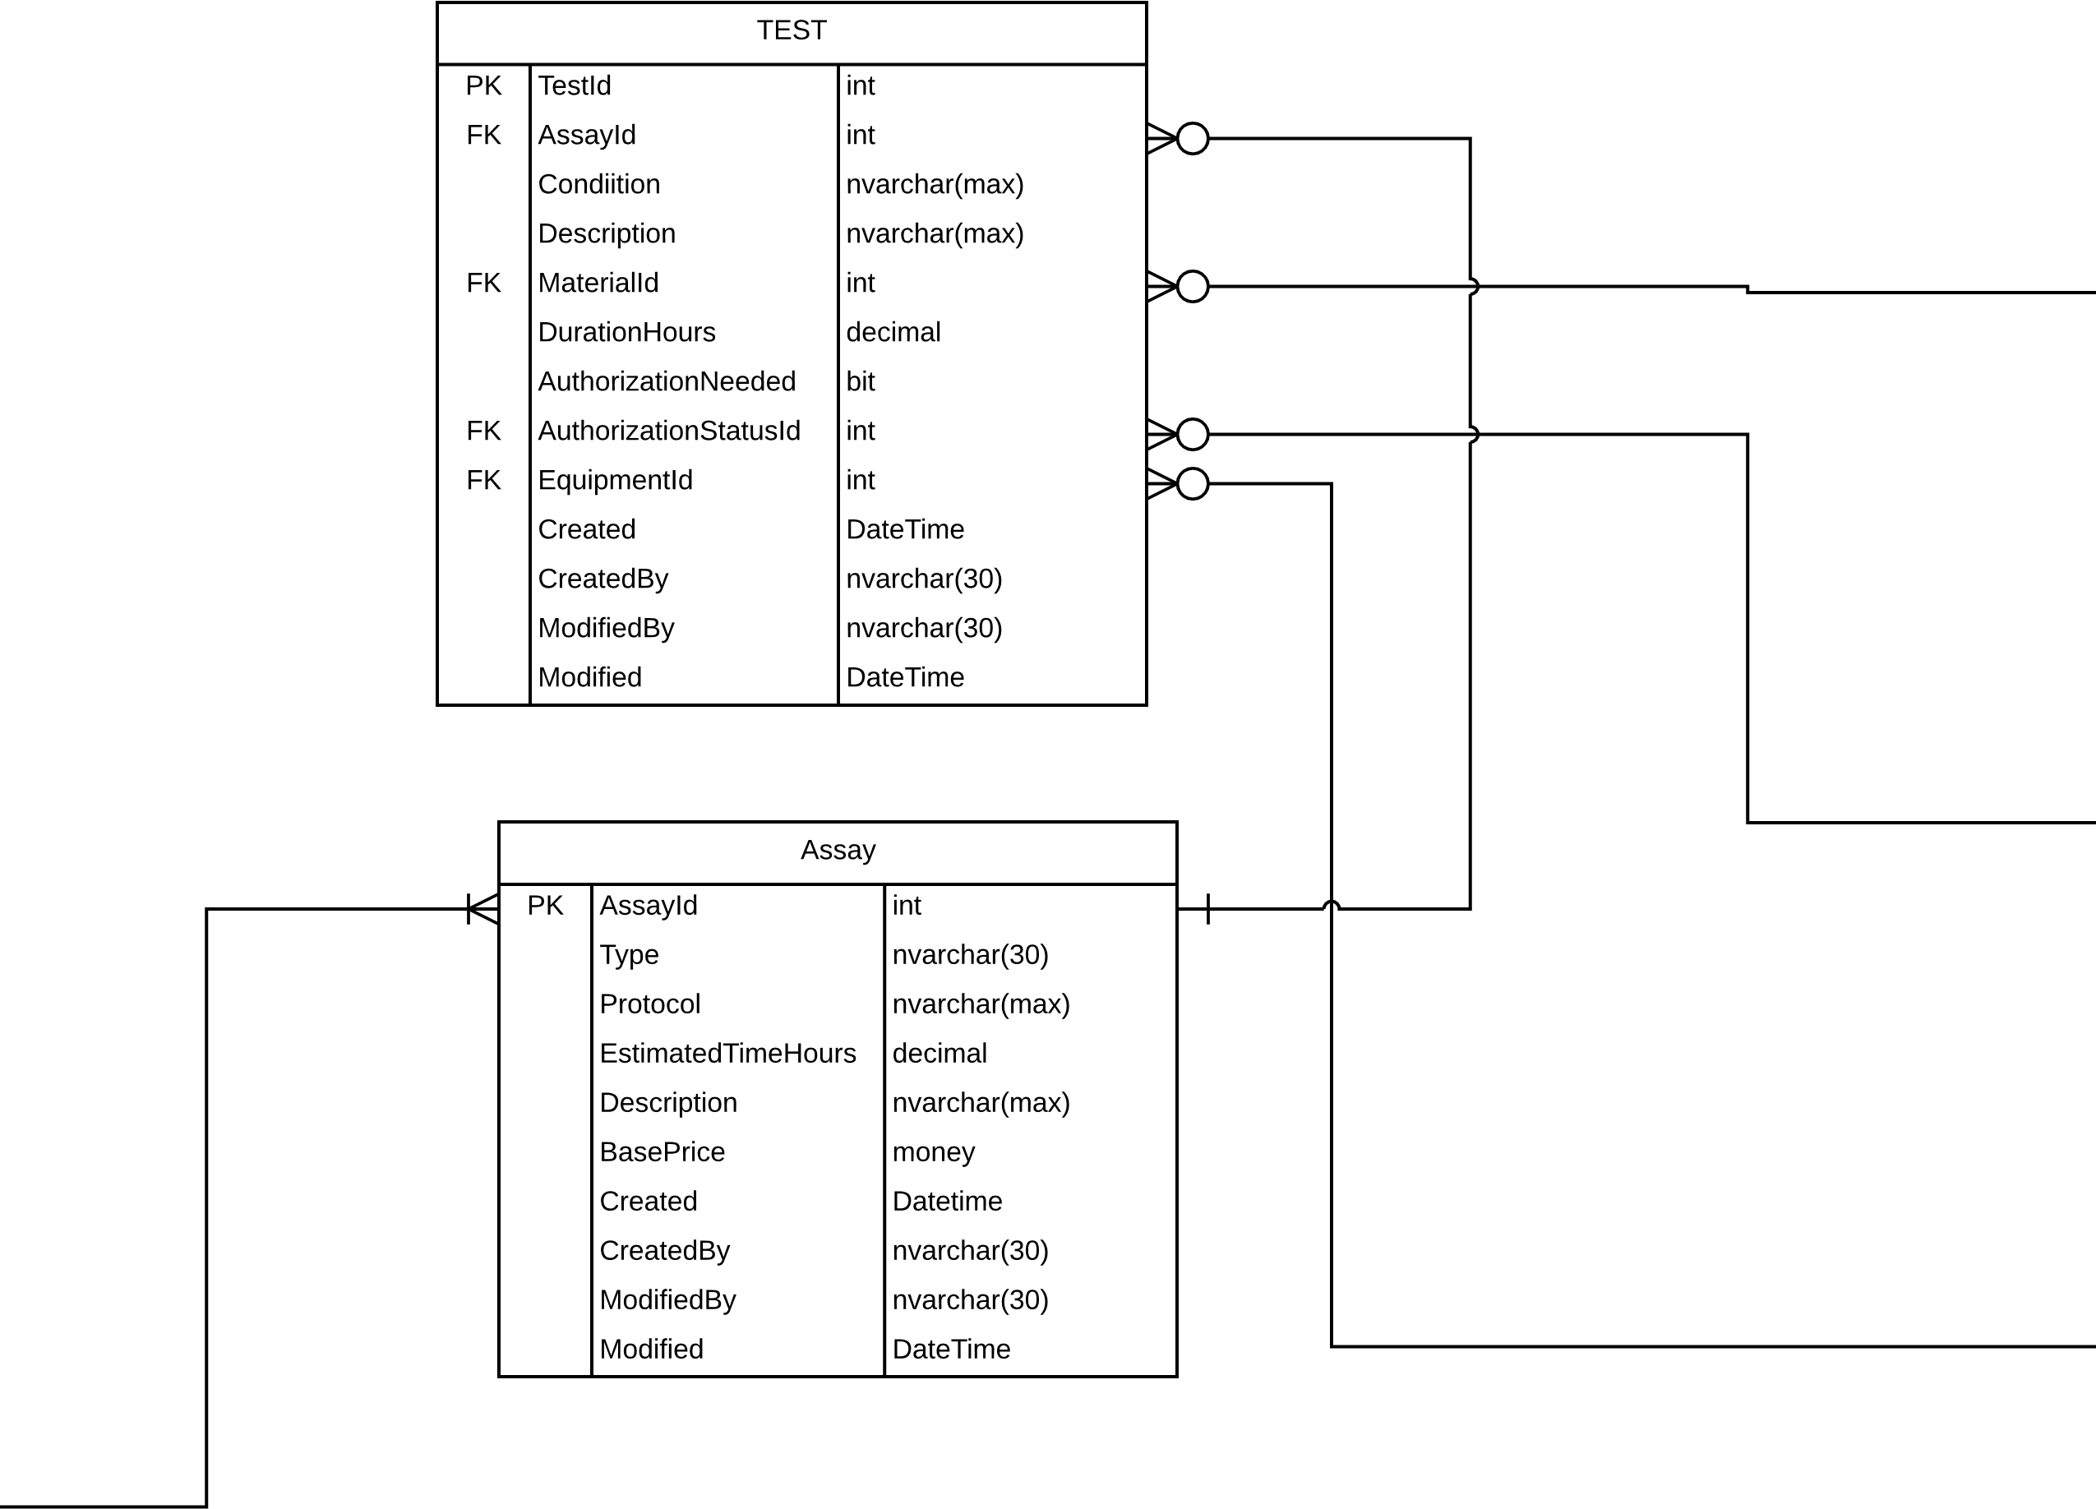

Page 3

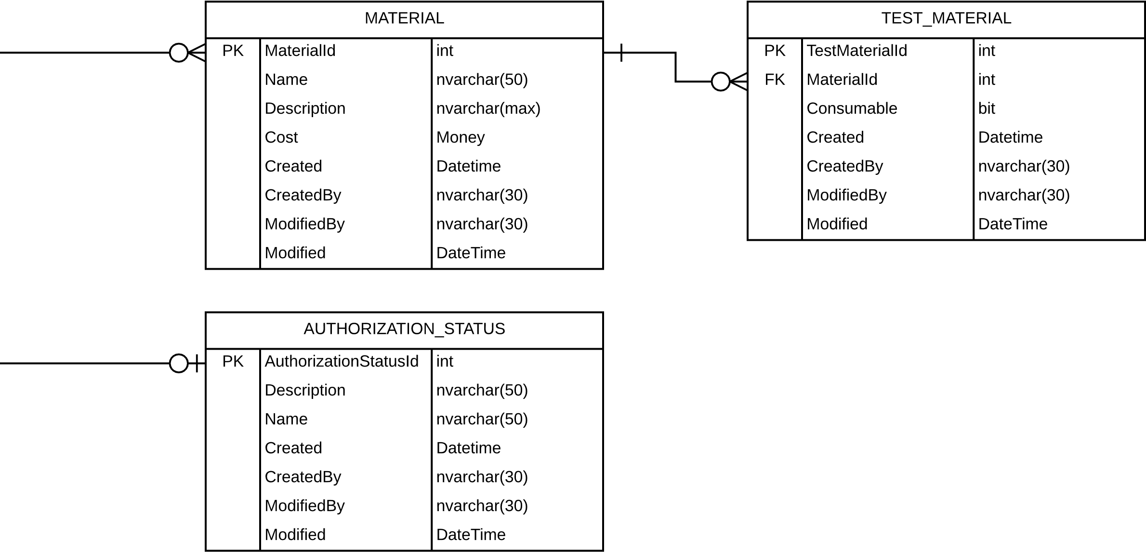

Page 4

## 

## Database Schema

The following SQL (Standard Query Language) statement is a DDL Statement (Data Definition Language). When run in Microsoft Sql Server, it will create a database with all of the tables, fields, and relationships shown in the ERD above.

/*****************************************************************

File: NorthwestLabIntex.sql

Description: Used for creating the objects and loading data

into the NORTHWEST_LAB schema for MSSQL

Created: 11/29/2016 IS

Modified: 11/29/2016 IS

Version: 1.0

******************************************************************/

CREATE DATABASE NORTHWEST_LAB;

GO

USE NORTHWEST_LAB;

GO

--drop existing tables

DROP TABLE INVOICE;

DROP TABLE WORK_ORDER;

DROP TABLE CONTACT;

DROP TABLE ORDER_COMPOUND;

DROP TABLE RESULT;

DROP TABLE COMPOUND;

DROP TABLE EMPLOYEE_ROLE;

DROP TABLE WORK_ORDER_DETAIL;

DROP TABLE STATUS;

DROP TABLE EMPLOYEE;

DROP TABLE ACCOUNT;

DROP TABLE TEST;

DROP TABLE ASSAY;

DROP TABLE STATUS_LOG;

DROP TABLE MATERIAL;

DROP TABLE TEST_MATERIAL;

DROP TABLE AUTHORIZATION_STATUS;

DROP TABLE EQUIPMENT;

--create tables

CREATE TABLE [INVOICE] (

[InvoiceId] int,

[WorkOrderId] int,

[DateSent] DateTime,

[DatePaid] Datetime,

[SentBy] nvarchar(50),

[PreparedBy] nvarchar(50),

[SpecialDiscount] decimal,

[QuotedPrice] money,

[FinalPrice] money,

[DueDate] Datetime,

[EarlyPaymentDate] Datetime,

[EarlyPaymentDiscount] decimal,

[Created] DateTime,

[CreatedBy] nvarchar(30),

[ModifiedBy] nvarchar(30),

[Modified] DateTime,

PRIMARY KEY ([InvoiceId])

);

CREATE INDEX [FK] ON [INVOICE] ([WorkOrderId]);

CREATE INDEX [ ] ON [INVOICE] ([PreparedBy], [CreatedBy], [ModifiedBy], [Modified]);

CREATE TABLE [WORK_ORDER] (

[WorkOrderId] int,

[AccountId] int,

[ContactId] int,

[EmployeeId] int,

[LT] int,

[DateDue] datetime,

[Created] DateTime,

[CreatedBy] nvarchar(30),

[ModifiedBy] nvarchar(30),

[Modified] DateTime,

PRIMARY KEY ([WorkOrderId])

);

CREATE INDEX [FK] ON [WORK_ORDER] ([AccountId], [ContactId], [EmployeeId]);

CREATE INDEX [ ] ON [WORK_ORDER] ([LT], [DateDue], [CreatedBy], [ModifiedBy], [Modified]);

CREATE TABLE [AUTHORIZATION_STATUS] (

[AuthorizationStatusId] int,

[Description] nvarchar(50),

[Name] nvarchar(50),

[Created] Datetime,

[CreatedBy] nvarchar(30),

[ModifiedBy] nvarchar(30),

[Modified] DateTime,

PRIMARY KEY ([AuthorizationStatusId])

);

CREATE INDEX [ ] ON [AUTHORIZATION_STATUS] ([CreatedBy], [ModifiedBy], [Modified]);

CREATE TABLE [EMPLOYEE_ROLE] (

[EmployeeRoleId] int,

[Description] nvarchar(50),

[Created] Datetime,

[CreatedBy] nvarchar(30),

[ModifiedBy] nvarchar(30),

[Modified] DateTime,

PRIMARY KEY ([EmployeeRoleId])

);

CREATE INDEX [ ] ON [EMPLOYEE_ROLE] ([CreatedBy], [ModifiedBy], [Modified]);

CREATE TABLE [CONTACT] (

[ContactId] int,

[FName] nvarchar(30),

[LName] nvarchar(30),

[Street Address] nvarchar(50),

[PostCode] nvarchar(20),

[Phone] nvarchar(20),

[AccountId] int,

[Created] datetime,

[CreatedBy] nvarchar(30),

[ModifiedBy] nvarchar(30),

[Modified] DateTime,

[Email] nvarchar(30),

PRIMARY KEY ([ContactId])

);

CREATE INDEX [ ] ON [CONTACT] ([FName], [LName], [Street Address], [PostCode], [Phone], [Created], [CreatedBy], [ModifiedBy], [Modified], [Email]);

CREATE INDEX [FK] ON [CONTACT] ([AccountId]);

CREATE TABLE [EMPLOYEE] (

[EmployeeId] int,

[FName] nvarchar(30),

[LName] nvarchar(30),

[Street Address] nvarchar(50),

[PostCode] nvarchar(20),

[Phone] nvarchar(20),

[Created] datetime,

[CreatedBy] nvarchar(30),

[ModifiedBy] nvarchar(30),

[Modified] DateTime,

[Email] nvarchar(30),

[RoleId] int,

[OfficeLocation] nvarchar(30),

PRIMARY KEY ([EmployeeId])

);

CREATE INDEX [ ] ON [EMPLOYEE] ([FName], [LName], [Street Address], [PostCode], [Phone], [Created], [CreatedBy], [ModifiedBy], [Modified], [Email], [OfficeLocation]);

CREATE INDEX [FK] ON [EMPLOYEE] ([RoleId]);

CREATE TABLE [RESULT] (

[ResultId] int,

[WorkOrderId] int,

[FileName] nvarchar(50),

[Created] Datetime,

[CreatedBy] nvarchar(30),

[ModifiedBy] nvarchar(30),

[Modified] DateTime,

PRIMARY KEY ([ResultId])

);

CREATE INDEX [FK] ON [RESULT] ([WorkOrderId]);

CREATE INDEX [ ] ON [RESULT] ([CreatedBy], [ModifiedBy], [Modified]);

CREATE TABLE [COMPOUND] (

[CompoundId] int,

[Name] nvarchar(30),

[MolecularMakeUp] nvarchar(max),

[Created] Datetime,

[CreatedBy] nvarchar(30),

[ModifiedBy] nvarchar(30),

[Modified] DateTime,

PRIMARY KEY ([CompoundId])

);

CREATE INDEX [ ] ON [COMPOUND] ([CreatedBy], [ModifiedBy], [Modified]);

CREATE TABLE [STATUS] (

[StatusId] int,

[Description] nvarchar(50),

[Name] nvarchar(50),

[Created] Datetime,

[CreatedBy] nvarchar(30),

[ModifiedBy] nvarchar(30),

[Modified] DateTime,

PRIMARY KEY ([StatusId])

);

CREATE INDEX [ ] ON [STATUS] ([CreatedBy], [ModifiedBy], [Modified]);

CREATE TABLE [STATUS_LOG] (

[StatusLogId] int,

[StatusId] int,

[WorkOrderDetailId] int,

[StatusStartTime] Datetime,

[StatusEndTime] Datetime,

[Created] Datetime,

[CreatedBy] nvarchar(30),

[ModifiedBy] nvarchar(30),

[Modified] DateTime,

PRIMARY KEY ([StatusLogId])

);

CREATE INDEX [FK] ON [STATUS_LOG] ([StatusId], [WorkOrderDetailId]);

CREATE INDEX [ ] ON [STATUS_LOG] ([CreatedBy], [ModifiedBy], [Modified]);

CREATE TABLE [ACCOUNT] (

[AccountId] int,

[Name] nvarchar(50),

[Street Address] nvarchar(50),

[PostCode] nvarchar(20),

[Phone] nvarchar(20),

[Created] datetime,

[CreatedBy] nvarchar(30),

[ModifiedBy] nvarchar(30),

[Modified] DateTime,

[Email] nvarchar(30),

[Balance] money,

PRIMARY KEY ([AccountId])

);

CREATE INDEX [ ] ON [ACCOUNT] ([Street Address], [PostCode], [Phone], [Created], [CreatedBy], [ModifiedBy], [Modified], [Email]);

CREATE TABLE [ORDER_COMPOUND] (

[OrderCompundId] int,

[CompoundId] int,

[QuantityMlg] decimal,

[DateArrived] datetime,

[ReceivedBy] nvarchar(30),

[Appearance] nvarchar(30),

[ClientWeight] Decimal,

[MolecularMass] Decimal,

[ActualWeight] Decimal,

[MTD] nvarchar(50),

[LT] int,

[SC] int,

[Created] Datetime,

[CreatedBy] nvarchar(30),

[ModifiedBy] nvarchar(30),

[Modified] DateTime,

PRIMARY KEY ([OrderCompundId])

);

CREATE INDEX [FK] ON [ORDER_COMPOUND] ([CompoundId]);

CREATE INDEX [ ] ON [ORDER_COMPOUND] ([DateArrived], [ReceivedBy], [ClientWeight], [CreatedBy], [ModifiedBy], [Modified]);

CREATE TABLE [EQUIPMENT] (

[EquipmentId] int,

[Description] nvarchar(50),

[Created] Datetime,

[CreatedBy] nvarchar(30),

[ModifiedBy] nvarchar(30),

[Modified] DateTime,

PRIMARY KEY ([EquipmentId])

);

CREATE INDEX [ ] ON [EQUIPMENT] ([CreatedBy], [ModifiedBy], [Modified]);

CREATE TABLE [MATERIAL] (

[MaterialId] int,

[Name] nvarchar(50),

[Description] nvarchar(max),

[Cost] Money,

[Created] Datetime,

[CreatedBy] nvarchar(30),

[ModifiedBy] nvarchar(30),

[Modified] DateTime,

PRIMARY KEY ([MaterialId])

);

CREATE INDEX [ ] ON [MATERIAL] ([CreatedBy], [ModifiedBy], [Modified]);

CREATE TABLE [WORK_ORDER_DETAIL] (

[WorkOrderDetailId] int,

[WorkOrderId] int,

[AssayId] int,

[OrderCompoundId] int,

[ScheduledStartDate] Datetime,

[ScheduledEndDate] Datetime,

[ActualStartDate] Datetime,

[ActualEndDate] Datetime,

[StatusId] int,

[Created] Datetime,

[CreatedBy] nvarchar(30),

[ModifiedBy] nvarchar(30),

[Modified] DateTime,

PRIMARY KEY ([WorkOrderDetailId])

);

CREATE INDEX [FK] ON [WORK_ORDER_DETAIL] ([WorkOrderId], [AssayId], [OrderCompoundId], [StatusId]);

CREATE INDEX [ ] ON [WORK_ORDER_DETAIL] ([ScheduledStartDate], [ActualStartDate], [CreatedBy], [ModifiedBy], [Modified]);

CREATE TABLE [ASSAY] (

[AssayId] int,

[Type] nvarchar(30),

[Protocol] nvarchar(max),

[EstimatedTimeHours] decimal,

[Description] nvarchar(max),

[BasePrice] money,

[Created] Datetime,

[CreatedBy] nvarchar(30),

[ModifiedBy] nvarchar(30),

[Modified] DateTime,

PRIMARY KEY ([AssayId])

);

CREATE TABLE [TEST] (

[TestId] int,

[AssayId] int,

[Condiition] nvarchar(max),

[Description] nvarchar(max),

[MaterialId] int,

[DurationHours] decimal,

[AuthorizationNeeded] bit,

[AuthorizationStatusId] int,

[EquipmentId] int,

[Created] DateTime,

[CreatedBy] nvarchar(30),

[ModifiedBy] nvarchar(30),

[Modified] DateTime,

PRIMARY KEY ([TestId])

);

CREATE INDEX [FK] ON [TEST] ([AssayId], [MaterialId], [AuthorizationStatusId], [EquipmentId]);

CREATE INDEX [ ] ON [TEST] ([DurationHours], [CreatedBy], [ModifiedBy], [Modified]);

CREATE TABLE [TEST_MATERIAL] (

[TestMaterialId] int,

[MaterialId] int,

[Consumable] bit,

[Created] Datetime,

[CreatedBy] nvarchar(30),

[ModifiedBy] nvarchar(30),

[Modified] DateTime,

PRIMARY KEY ([TestMaterialId])

);

CREATE INDEX [FK] ON [TEST_MATERIAL] ([MaterialId]);

CREATE INDEX [ ] ON [TEST_MATERIAL] ([CreatedBy], [ModifiedBy], [Modified]);

# Class Information