**meetup command**

!meetup <name of meetup> <time here> <channel name here>

Join this meetup here!

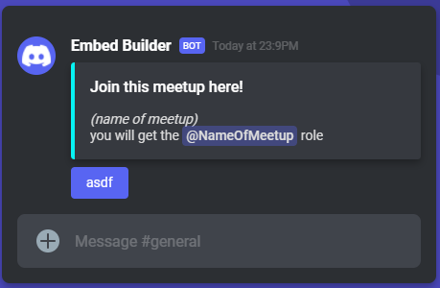

**Requirements:**

* creates a role and sends a message into the channel prompting people to react to it
* those who react to the message with the targeted react (something default like :eyes: or something)
  + make it a mentionable role??
* after time frame, deletes the role.

**Who has command**

!whohas <role here>

shows an embed with all the users with this role, paginated.

<https://www.npmjs.com/package/discord.js-pagination>

https://stackoverflow.com/questions/48897574/how-do-i-list-all-members-with-a-role-in-discord-js

should probably give a headstart on this.