Flowers Unlimited Part II: Biochemistry

Introduction:

The Biological Phenomenon Under Study
In this lab, you will explore the biological mechanisms behind the expression of flower color in a hypothetical plant. These flowers can be white, red, orange, yellow, green, blue, purple, or black.

Scenario:
You are the chief biologist for Flowers Unlimited, a breeder of fine flowers. Your company sells seeds that customers plant in their gardens. Since most of your customers expect that the flowers will grow each year from seeds produced the previous year, you try to produce true-breeding plants whenever you can.

You’ve found a new species of flower with an attractive shape. You’ve collected four plants from the wild: two green, one red, and one white. Your customers would really like to have purple flowers from this plant. You set out to create a true-breeding purple flower.

In Part I, you found the alleles involved in color production. You went on to describe the colors produced by different allele combinations. You now need to expand your understanding to how these colors are produced and how they interact at a Biochemical level.

Tasks:
- Determine the differences in amino acid sequence between the proteins produced by the alleles you found in Part I.
- Determine how the amino acid sequence of a pigment protein determines its color.
- Explain, in terms of the proteins present, the interactions between the alleles you found in part I.
  - Why is the color phenotype of some pigment proteins dominant while others are recessive?
  - How do the pigment proteins combine to produce the overall color of the plant?
- Construct a purple protein to demonstrate your understanding of this process.

Using the tool:

When you start MGE, the program will load the four starting flower types into the Greenhouse; this takes a little while. You will see this:
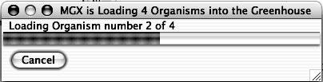

When the program is ready, you can switch to the tool for this section by clicking the “Biochemistry” tab near the top of the window. You will see something like this:
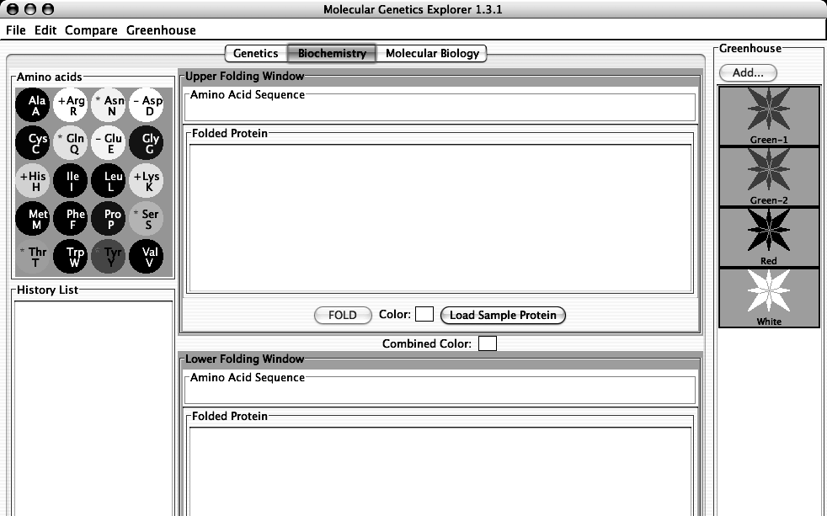
This is a reference for the names and properties of the amino acids.
The single-letter code is shown below the three-letter code.
White circles are hydrophilic; gray are intermediate; and black are hydrophobic.
A red (-) indicates a negatively-charged side chain
A blue (+) indicates a positively-charged side chain
A green (*) indicates a side chain that can make a hydrogen bond.
This part of the program uses the one-letter code for the 20 amino acids:

Amino Acid | 3-letter code | 1-letter code | Mnemonic
Alanine | Ala | A | Alanine
Arginine | Arg | R | aRginine
Asparagine | Asn | N | asparagiNe
Aspartic acid | Asp | D | asparDic acid
Cystine | Cys | C | Cystine
Glutamine | Gln | Q | Q-tamine
Glutamic Acid | Glu | E | glu-tE-amic acid
Glycine | Gly | G | Glycine
Histidine | His | H | Histidine
Isoleucine | Ile | I | Isoleucine
Leucine | Leu | L | Leucine
Lysine | Lys | K | lysinK
Methionine | Met | M | Methionine
Phenylalanine | Phe | F | Fenylalanine
Proline | Pro | P | Proline
Serine | Ser | S | Serine
Threonine | Thr | T | Threonine
Tryptophan | Trp | W | tWptophan
Tyrosine | Tyr | Y | tYrosine
Valine | Val | V | Valine

Click in the Amino Acid Sequence Box at the top of the Upper Folding Window. Type a short sequence of letters and you will see a short amino acid sequence appear in the window. This tool converts the single-letter code to the three-letter code automatically.

Click the “FOLD” button and a two-dimensional version of your amino acid sequence will appear in the Folded Protein window.

There are several important things to not about this folding process:

This is a highly-simplified model of protein folding. It is not intended to predict the correct structures of any proteins; it is designed to illustrate the major principles involved in that process. The important features of proteins that this software retains are as follows:
- Amino acids have side-chains of varying hydrophobicity, charge, and hydrogen bonding capacity.
- The amino acids are connected in an un-branched chain that can bend.
- Hydrophobic amino acids will tend to avoid the water that surrounds the protein; hydrophilic amino acids will bind to the water.
- Amino acids that can form hydrogen bonds will tend to form hydrogen bonds if they can.
- Positively-charged amino acids will tend to form ionic bonds with negatively-charged amino acids if they can.
- Like-charged amino acids will repel each other if they can.
- Ionic interactions are stronger than hydrogen bonds, which are stronger than hydrophobic interactions.

Even though this software provides some important insights into protein folding, you should always keep in mind that this is an approximation. The most important "gotcha's" to be aware of are:
- This program folds proteins in 2-dimensions only.
- This program treats all amino acids as equal-sized circles.
- This program models an environment where disulfide bonds do not form.
- This program folds the protein based on the interactions between the side chains only.
- This program does not model secondary or quaternary structure.
- This program assumes that all side chains with hydrogen bonding capability can bond with each other.
These simplifications are necessary for two reasons. The first is technical: it turns out to be extremely difficult to predict the full 3-d folded structure of a protein given only its amino acid sequence. As of the writing of this lab manual, it takes a super-computer several days to predict the fully-folded shape of even a small protein like lysozyme. Even then, the predictions don’t always match known structures. Given the computers we have in the Bio 111 labs, it might take years….

The second reason is educational. Proteins are complex 3-dimensional molecules; thus, it can be hard to find your way around when inside one. Likewise, it would be very difficult to visually compare two protein molecules to observe the effects of changes to their amino acid sequence. It would be easy to miss the forest (the forces that control protein structure) for the trees (the tiny details of the structures).

For these reasons, we will use this simplification. It retains the properties of amino acids that are important for this lab while being simple and fast.
There are three kinds of experiments you can perform with this tool. The following sections use examples to show you how to do each; you will need to devise your own experiments to carry out the tasks above.

I) Examine the Pigment Proteins Present in an Organism from the Greenhouse. This simulates extracting the pigment protein(s) produced by the two alleles of the pigment protein gene that an organism possesses, displaying their two-dimensional structures, and displaying their colors.

1) Double-click on the Green-2 organism in the Greenhouse. You should see this:

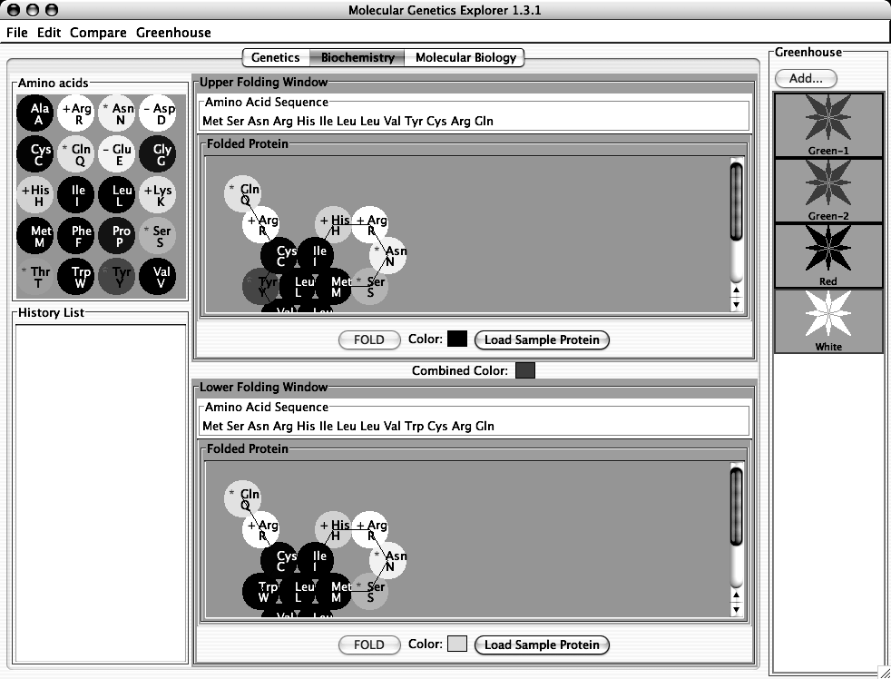

The Green organism contains two alleles of the pigment protein gene. Each of these alleles produces a different protein. One of these proteins is shown in the Upper Folding Window; it is a blue-colored protein as shown by the blue square next to the “Color:” label. The other protein is shown in the Lower Folding Window; this is yellow-colored protein. The combined color of the two proteins is green as shown by the Combined Color in between the two Folding Windows.

II) Compare the amino acid sequences of two pigment proteins. This aligns the two amino acid sequences so that the highest number of matching amino acids is obtained and then finds the remaining differences.

1) Double-click on the Green organism in the Greenhouse. You should see that the
Upper Folding Window shows a blue protein and the Lower Folding Window
shows a yellow protein.

2) You can compare the amino acid sequence of these two proteins by clicking on the
“Compare” menu and choosing “Upper vs. Lower”. A window will appear
showing the differences between the two sequences. This is shown below:

This shows that the only difference is that, in the upper (blue) protein, amino acid 10 is
tyrosine, while in the lower (yellow) protein, amino acid 10 is tryptophan.

III) Edit a Protein Sequence or Create a New Protein Sequence and Determine its Two-Dimensional Structure and Color. You can edit the sequence in either of the Amino Acid Sequence boxes and click the “Fold” button to predict the two-dimensional structure and color of the protein. The tool will also give the color that results from the combination of the colors in the Upper and Lower windows.

For example, click anywhere in the “Tyr” corresponding to amino acid 10 in the Upper Amino Acid Sequence box. Click the “delete” key and that amino acid will disappear. Type an “L” (the one letter code for leucine) and the amino acid sequence should be:

Met Ser Asn Arg His Ile Leu Leu Val Val Cys Arg Gln

Click the “FOLD” button in the Upper Folding Window. You will see that the color of the new protein is white as shown by the “Color:” in the Upper Folding Window. You should also notice that:
- the “Combined Color” at the center of the window is now yellow.
- there is now an entry in the History List with your new protein. The background of History List entry is white to show the color of this protein.

You can also click the “Load Sample Protein” button. This will load a sample amino acid sequence that folds to a white-colored protein with a shape that is similar to many colored proteins.

If you double-click an entry in the History List, you will you get a pop-up menu with a list of useful options:

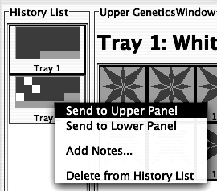

- Send to Upper Panel: Sends this Tray to the Upper Panel so you can cross those organisms.
- Send to Lower Panel: Sends this Tray to the Lower Panel so you can cross those organisms.
- Add Notes...: Allows you to add notes to the Tray in the History List. These notes will appear if you leave the cursor over the Tray for a few seconds.
- Delete from History List: deletes the Tray from the History List; this is cannot be undone.

IMPORTANT NOTE:
This software is under development. Please treat it gently and be patient. Please report any bugs to your TA. You should save your Greenhouse regularly, especially if you save a large number of organisms.
Specific Tasks for this section
- What are the differences in the amino acid sequences of the proteins produced by the alleles you define in Part I? Hint: use the Compare menu to find the difference(s) between the amino acid sequences.
- What features of the amino acid sequence make a protein pigmented?
- What features of the amino acid sequence make a protein a particular color?
- How do the colors combine to produce an overall color? How does this explain the genotype-phenotype rules you found in part (I)?
- Which proteins are found in each of the four starting organisms?
- Using this knowledge, construct a purple protein.

Put your data in the tables below:

(a) allele color amino acid sequence (highlight differences)

(b) What features of a protein make it colored?

(c) What features of the amino acid sequence make a protein a particular color?

(d) How do the colors combine to produce an overall color? How does this explain the genotype-phenotype rules you found in part (I)?

(e) Which proteins are found in each of the four starting organisms?

Green-1

Green-2

Red

White

(f) Show your TA that you have made a purple protein. For full credit, you need to explain to your TA why it is purple.

