Flowers Unlimited Part III:
Molecular Biology

Introduction:

The Biological Phenomenon Under Study
In this lab, you will explore the biological mechanisms behind the expression of flower color in a hypothetical plant. These flowers can be white, red, orange, yellow, green, blue, purple, or black.

Scenario:
You are the chief biologist for Flowers Unlimited, a breeder of fine flowers. Your company sells seeds that customers plant in their gardens. Since most of your customers expect that the flowers will grow each year from seeds produced the previous year, you try to produce true-breeding plants whenever you can.

You’ve found a new species of flower with an attractive shape. You’ve collected four plants from the wild: two green, one red, and one white. Your customers would really like to have purple flowers from this plant. You set out to create a true-breeding purple flower.

In Part I, you found the alleles involved in color production. You went on to describe the colors produced by different allele combinations. In Part II, you found the biochemical mechanism behind the colors. You also made a purple protein. However, it is not possible to simply add a purple protein to a plant and have it produce purple offspring. You will need to do a little genetic engineering to get the pure-breeding purple plant. That is what you will do in this part.

Tasks:
- Determine the differences in DNA sequence of the alleles you defined in Part I.
- Determine how the DNA sequence of a pigment protein gene determines the color of the protein produced.
- Explain, in terms of the genes present, the interactions between the alleles you found in part I.
  - Why is the color phenotype of some pigment proteins dominant while others are recessive?
  - How do the pigment proteins combine to produce the overall color of the plant?
- Construct a purple protein to demonstrate your understanding of this process.

Using the tool:

When you start MGE, the program will load the four starting flower types into the Greenhouse; this takes a little while. You will see this:
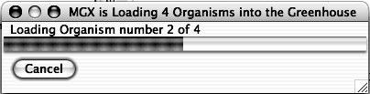

You can switch to this tool by clicking the “Molecular Biology” tab near the top of the window.

You will see something like this:
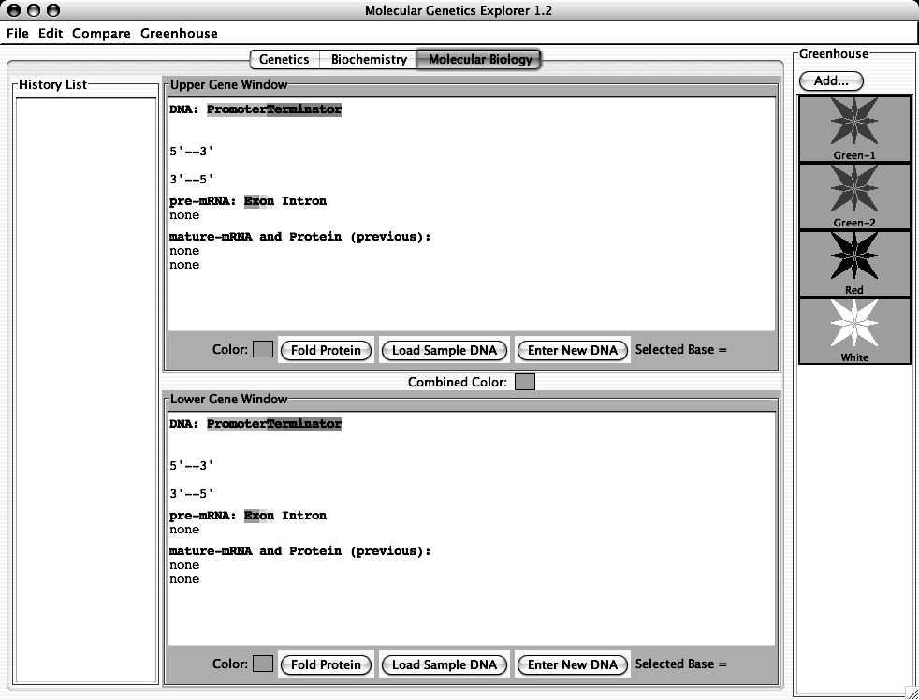

You use this part of the program like you used the Biochemistry section in Part II.
This part of the program simulates the expression of eukaryotic genes as follows:

Eukaryotic genes, like those found in our simulated organisms, have promoters and terminators for controlling transcription as well as start and stop codons for controlling translation. Although the promoter and terminator sequences are different in different organisms, the genetic code, including the start and stop codons is identical in all organisms. The promoter and terminator sequences used in the hypothetical organism simulated by the tool are shown below:
a promoter: a terminator:
5’-TATAA-3’ 5’-GGGGG-3’
||||| |||||
3’-ATATT-5’ 3’-CCCCC-5’
*Transcription begins with the *Transcription ends with the
first base-pair to the right of first base-pair to the left of
this sequence and proceeds to the this sequence.
right.

therefore, a gene would look like this:
5’-TATAAXXXXXXXXXXXXXXXXXXXXXXXXXXXXXGGGGG-3’
|||||||||||||||||||||||||||||||||||||||
3’-ATATTXXXXXXXXXXXXXXXXXXXXXXXXXXXXXCCCCC-5’
*the region shown as X’s would be transcribed into pre-mRNA.

In addition, eukaryotic genes have a few features that prokaryotic genes do not have. These are:
- transcription produces an mRNA called a pre-mRNA which is not yet ready for translation.
- this pre-mRNA is then processed in several steps:
  - The introns are removed and the exons are joined; this is called mRNA “splicing”. This is controlled by splice signal sequences. In real organisms, these sequences are not well known. In general, introns start with 5’-GU-3’ and end with 5’-AG-3’. In the hypothetical organism, introns start with 5’-GUGCG-3’ and end with 5’-CAAAG-3’.
  - a modified G nucleotide is added to the 5’ end of the mRNA; this is called the “cap”. This is not shown.
  - many A’s are added to the 3’ end of the mRNA; this is called the tail. In real organisms, as many as 400 A’s can be added at a specific signal sequence; the tool adds 13 A’s as a tail to the 3’ end of any mRNA. Note that these A’s do not correspond to T’s in the DNA.

In previous labs, you did the work by hand; this was necessary in order to make the processes clear to you. Now that you understand how these processes work, the tool will do all the tedious work of:
- finding the promoter and terminator
- reading the DNA sequence to produce the pre-mRNA
- finding the splice sites
- splicing and tailing the mRNA
- finding the start codon
- translating the mRNA
The tool will then allow you to make specific mutations in a gene sequence and it will then calculate and display their effects on the mRNA and protein. You do not have to deal with all the details listed above; the software will take care of it all. Researchers use tools like this to analyze the genes they are studying.

There are three kinds of experiments you can perform with this tool. The following sections use examples to show you how to do each; you will need to devise your own experiments to carry out the tasks above.

I) Examine the Pigment Protein Genes Present in an Organism from the Greenhouse. This simulates sequencing the DNA from the two pigment proteins genes that an organism possesses, expressing them, and displaying their colors.

1) Double-click on the Green-2 organism in the Greenhouse. You should see this:

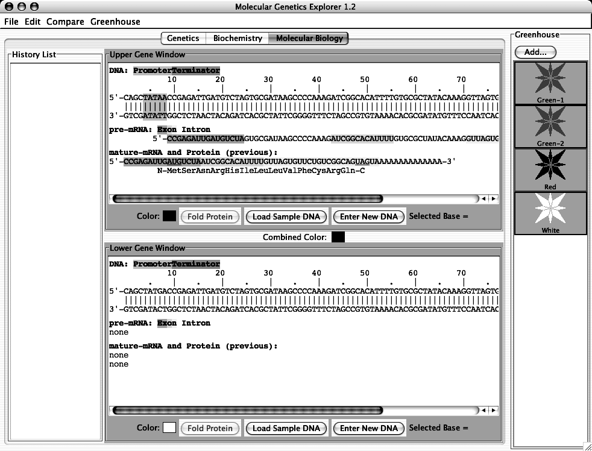

The Green-2 organism contains two alleles of the pigment protein gene. Each of these alleles has a distinct DNA sequence. One of these sequences is shown in the Upper Gene Window; it is a green-colored protein as shown by the red square next to the “Color:” label. The other protein is shown in the Lower Gene Window; this is also a green-colored protein. The combined color of the two proteins is red as shown by the Combined Color in between the two Gene Windows.

IMPORTANT NOTE:
This software is under development. Please treat it gently and be patient. Please report any bugs to your TA. You should save your Greenhouse regularly, especially if you save a large number of organisms.

The Gene Windows also show the key features of the genes:
- Clicking on a base in the upper DNA strand highlights the corresponding bases in the mRNA and the corresponding amino acid in the protein (as appropriate).
- In the DNA sequence:
  - Promoters are shown in green
  - Terminators are shown in red
- In the pre-mRNA sequence:
  - Exons are shown in color
  - Introns are not colored
- In the mature mRNA sequence:
  - Exons are colored as in the pre-mRNA
  - Start and stop codons are underlined

II) Compare the DNA sequences of two pigment protein genes. You can compare the DNA sequence of the two genes by clicking on the “Compare” menu and choosing “Upper vs. Lower”. A window will appear showing the differences between the two sequences.

III) Edit a DNA Sequence or Create a New DNA Sequence and Determine the Resulting Protein’s Amino Acid Sequence and Color. You can edit the sequence in either of the Gene Windows and click the “Fold” button to predict the color of the protein. The tool will also give the color that results from the combination of the colors in the Upper and Lower windows.

You can edit the DNA in several ways:
- To delete the selected base, use the “delete” key.
- To replace the selected base with another base, type a lower-case letter (a, g, c, or t).
- To insert bases to the left of the selected base, type an upper-case letter (A, G, C, or T).
- You can enter an entirely new (or copied) DNA sequence by clicking the “Enter New DNA Sequence” button.

For example:

1) Double-click the Red organism in the Greenhouse.

2) In the Upper Gene Window, click on the top DNA strand near base 20. The base you
have clicked on will be highlighted in blue. In addition:
- the corresponding bases in the mRNAs and the corresponding amino acid in the protein will be selected.
- at the bottom of the Upper Gene Window, you will see “Selected Base = 20” or some similar number corresponding to the base you selected.
If you have not selected base 20, use the arrow keys to select it.

3) Type “C”. This will change base 20 from G to C, thus removing the start codon for
the gene. You will immediately see that the protein sequence shown under the
mRNA sequence, now reads “none” indicating that no protein will be made from
this gene. Furthermore, the border of the Upper Gene Window will turn pink to
indicate that the new protein has not been folded.

4) Click the “Fold Protein” button in the Upper Gene Window to fold the resulting
protein. You will see the following:
- the border of the Upper Gene Window will turn back to gray
- the color chip in the Upper Gene Window will show white (the color of the new protein)
- a blank entry with a white background will be generated in the History List to show the new protein. You can bring it back to one of the Gene Windows by selecting it in the History List and clicking the “>Upper” or “>Lower” button as appropriate.

You can save this new organism to the Greenhouse by clicking the “Add…” button above the Greenhouse. You will be prompted to give this organism a name. You might want to switch over to the Genetics tool and self-cross this organism to see what happens.

You can also click the “Load Sample DNA” button. This will load a sample amino acid sequence that folds to a white-colored protein with a shape that is similar to many colored proteins.

If you double-click an entry in the History List, you will you get a pop-up menu with a list of useful options:

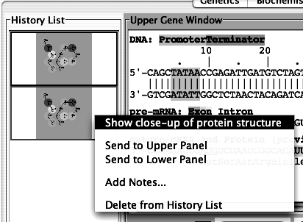

- Show close-up of protein structure: this will pop up a window that shows a larger picture of the protein’s 2-dimensional structure than is shown in the History List.
- Send to Upper Panel: Sends this Tray to the Upper Panel so you can cross those organisms.
- Send to Lower Panel: Sends this Tray to the Lower Panel so you can cross those organisms.
- Add Notes...: Allows you to add notes to the Tray in the History List. These notes will appear if you leave the cursor over the Tray for a few seconds.
- Delete from History List: deletes the Tray from the History List; this is cannot be undone.

Specific Tasks for this section
- What are the differences in the DNA sequences of the alleles you defined in Part I.
- Do all the white alleles have the same DNA sequence? Hint: use the Compare menu to compare the sequences.
- Which DNA sequences are found in each of the four starting organisms?
- Using this knowledge, construct a pure-breeding purple organism.
- Advanced tasks: How does the DNA sequence of the different alleles explain the effects of mutations you found in part I?
You should put your data in the tables below:

(a) and (b)

allele color change(s) in amino acid sequence change(s) in DNA sequence

Are all the white alleles the same?

(c) Green-1

Green-2

Red

White

(d) Show your TA that you have made a pure-breeding purple organism. For full credit, you need to explain to your TA why it is purple and pure-breeding.

Lab Report
- This report is due in class today; you can write it using Microsoft Word on the lab macs and then print it on the lab printer.
- This is a group project for a group grade.
- Although you worked together as a class, your report must be in your own words.

Your lab report must consist of answers to the following questions:
- Explain the how each part of this lab addressed the differences between an gene and an allele of that gene.
  - How would a geneticist use the data you’ve collected to explain the difference between a gene and an allele of that gene?
  - How would a biochemist use the data you’ve collected to explain the difference between a gene and an allele of that gene?
  - How would a molecular biologist use the data you’ve collected to explain the difference between a gene and an allele of that gene?
- How did you make your pure-breeding purple organism?
  - What DNA sequences did you change to make it purple?
  - How did you know that it was going to be purple?
  - How did you construct the organism so that it would be pure-breeding?
  - How did you test that it was in fact pure-breeding?

The Genetic Code in mRNA
 | U | C | A | G
U | UUU phe  UUC phe  UUA leu  UUG leu | UCU ser  UCC ser  UCA ser  UCG ser | UAU tyr  UAC tyr  UAA STOP  UAG STOP | UGU cys  UGC cys  UGA STOP  UGG trp | UC  A  G
C | CUU leu  CUC leu  CUA leu  CUG leu | CCU pro  CCC pro  CCA pro  CCG pro | CAU his  CAC his  CAA gln  CAG gln | CGU arg  CGC arg  CGA arg  CGG arg | UC  A  G
A | AUU ile  AUC ile  AUA ile  AUG met | ACU thr  ACC thr  ACA thr  ACG thr | AAU asn  AAC asn  AAA lys  AAG lys | AGU ser  AGC ser  AGA arg  AGG arg | U  C  A  G
G | GUU val  GUC val  GUA val  GUG val | GCU ala  GCC ala  GCA ala  GCG ala | GAU asp  GAC asp  GAA glu  GAG glu | GGU gly  GGC gly  GGA gly  GGG gly | U  C  A  G

