Flowers Unlimited Part I: Genetics

Objectives:
- To reinforce your understanding of Genetics, Biochemistry, and Molecular Biology
- To show the connections between these three disciplines
- To show how these three approaches can be combined to give a complete picture of a biological phenomenon
- To figure out a complete explanation of a biological phenomenon

Introduction:

The Biological Phenomenon Under Study
In this lab, you will explore the biological mechanisms behind the expression of flower color in a hypothetical plant. These flowers can be white, red, orange, yellow, green, blue, purple, or black.

Scenario:
You are the chief biologist for Flowers Unlimited, a breeder of fine flowers. Your company sells seeds that customers plant in their gardens. Since most of your customers expect that the flowers will grow each year from seeds produced the previous year, you try to produce true-breeding plants whenever you can.

You’ve found a new species of flower with an attractive shape. You’ve collected four plants from the wild: two green, one red, and one white. Your customers would really like to have purple flowers from this plant. You set out to create a true-breeding purple flower.

Unifying Three Parts of Modern Biology
The three major parts of this course are:
- Genetics = explaining biological phenomena in terms of genes. How is flower color inherited?
- Biochemistry = explaining biological phenomena in terms of proteins and other molecules. How does protein sequence determine protein structure and color?
- Molecular Biology = explaining the connection between genes (DNA) and protein. How does the DNA sequence of the color gene lead to a particular color?
The connections between these three fields of biology are shown below in a diagram credited to David Botstein (each of the arrows corresponds to “can be explained in terms of”, the words in this font are the different disciplines of biology):

genes

individual
life functions Molecular
Genetics
Biochemistry
of living things Biology

proteins
Understanding any biological phenomenon requires information from all three of these disciplines. Throughout this course, you will re-visit this lab to create an increasingly complete picture of the phenomenon under study. Each time, you will add to the model of color production in these flowers.

Tools Available in MGE
For each of the three disciplines, there is a different tool in MGE that will allow you to explore the same set of creatures using a different set of techniques:
- Genetics. The flowers in this simulation are diploids. As with most flowers, they are all hermaphrodites (both male and female). With this tool, you can perform the following experiments:
  - Cross any two organisms. A new window will appear with the offspring of this cross.
  - Self-cross any organism. In this case, the single selected organism is both mother and father to the resulting offspring.
  - Mutate any organism. A new window will appear with a set of flowers that are mutant versions of the selected organism.
- Biochemistry. The color in these flowers results from the form(s) of pigment proteins present in an individual plant. With this tool, you can perform the following experiments:
  - Examine the pigment proteins present in a plant. The tool shows you the amino acid sequence and two-dimensional structure of the pigment proteins present in a given plant.
  - Design your own proteins. You can edit an existing protein sequence or type in an entirely new sequence. The program will then predict the two-dimensional structure of the resulting protein as well as its color. It will also predict the color resulting from the combination of any two proteins.
- Molecular Biology. The pigment proteins in these plants are produced by pigment protein genes. With this tool, you can perform the following experiments:
  - Examine the pigment protein genes present in a plant. The tool shows the DNA, pre-mRNA, mature mRNA, and protein sequences present in a given plant. You can explore the introns, exons, etc. of these genes.
  - Design your own genes. You can edit an existing DNA sequence or type in an entirely new sequence. The program will then predict the mRNA, protein sequence, two-dimensional structure of the resulting protein as well as its color. It will also predict the color resulting from the combination of any two proteins.
  - Design your own plants. You can save edited DNA sequences as new organisms for further study.

When you start MGE, the program will load the four starting flower types into the Greenhouse; this takes a little while. You will see this:
The Greenhouse contains the starting set of organisms.
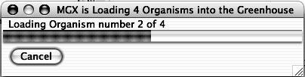

When the program is ready, you will see a screen like this:
These are the Menus; they apply to all the tools.
These Buttons select the tool you will be using.

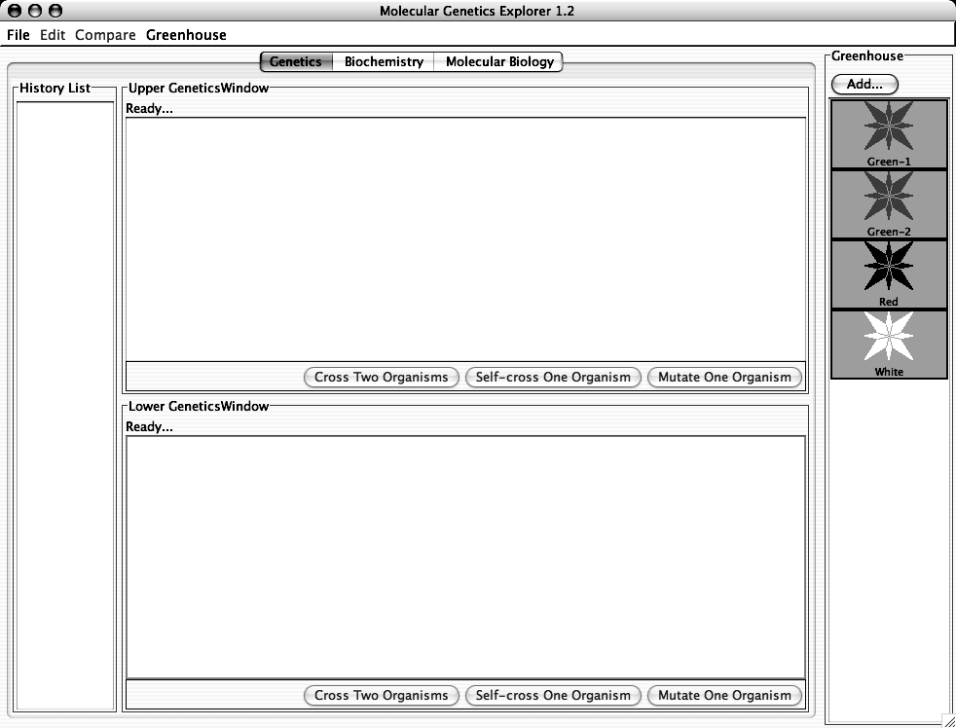
The History List stores the results of each of your experiments. These results can be sent to the upper or lower panes (see later).
Upper Work Panel.
Results of crosses, etc. will appear here.
Lower Work Panel.
Results of crosses, etc. will appear here.

Each organism is shown as a flower:
The color of the picture shows the color of the flower. These flowers can be white, red, orange, yellow, green, blue, purple, or black. When any organism is selected, the black border turns green to show that it has been selected.

The next sections of this manual will show you the various tools and the tasks that you will need to carry out.

Part I: Genetics

Tasks:
- Determine how color is inherited in these flowers. NOTE: the color is controlled by one gene only.
  - Determine the colors of the alleles present in the original set of organisms.
  - Which alleles are dominant?
  - Which alleles are recessive?
  - How do the alleles combine to produce the overall color of the plant?
- Construct a purple organism to demonstrate your understanding of this process.

Using the tool:
You can switch to this tool by clicking the “Genetics” tab near the top of the window.

There are three kinds of experiments you can perform with this tool. The following sections use examples to show you how to do each; you will need to devise your own experiments to carry out the tasks above.

I) Cross Two Organisms. Suppose that you wanted to cross Red and White:

1) Click on Green-1 and then on White in the Greenhouse. The rectangular borders of
both should turn green to show that they have been selected. The “Cross Two
Organisms” buttons in the Upper and Lower Work Panels should be activated.

2) Click the “Cross Two Organisms” button in the Upper Work Panel. You should see
something like this:
These are the offspring of the cross. You can select any of these for crossing, etc.

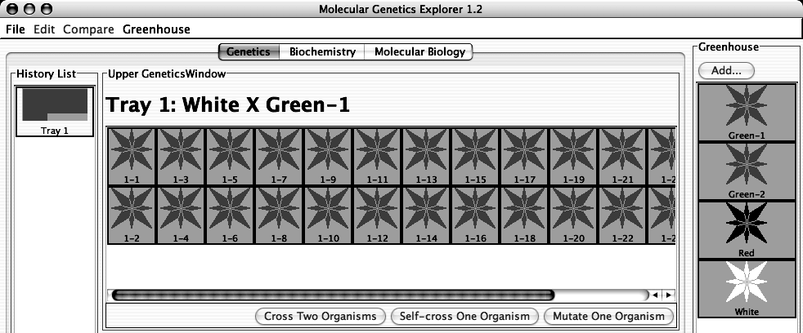

This represents the Tray of plants containing the offspring you just produced. The colored squares represent the different colors of the offspring produced.

If you double-click on the Tray in the History List, you get a pop-up menu with a list of useful options:

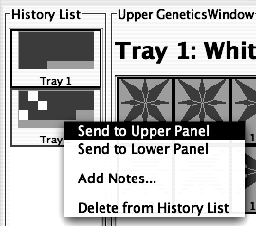

- Send to Upper Panel: Sends this Tray to the Upper Panel so you can cross those organisms.
- Send to Lower Panel: Sends this Tray to the Lower Panel so you can cross those organisms.
- Add Notes...: Allows you to add notes to the Tray in the History List. These notes will appear if you leave the cursor over the Tray for a few seconds.
- Delete from History List: deletes the Tray from the History List; this is cannot be undone.
II) Self-cross a single Organism. Suppose that you wanted to self-cross one of the offspring in Tray 1:

1) Select any one organism from Tray 1 in the Upper Work Panel. You can de-select an
organism by clicking on it. When you have only one organism selected, the
“Cross Two Organisms” buttons will be grayed out and the “Self-Cross One Organism” and “Mutate One Organism” buttons will be activated.

2) Click the “Self-Cross One Organism” button in the Lower Work Panel. You should
see something like this (since offspring are generated by random choice of
parental alleles, you will likely see slightly different numbers of red and white
offspring):

You should see something like this:
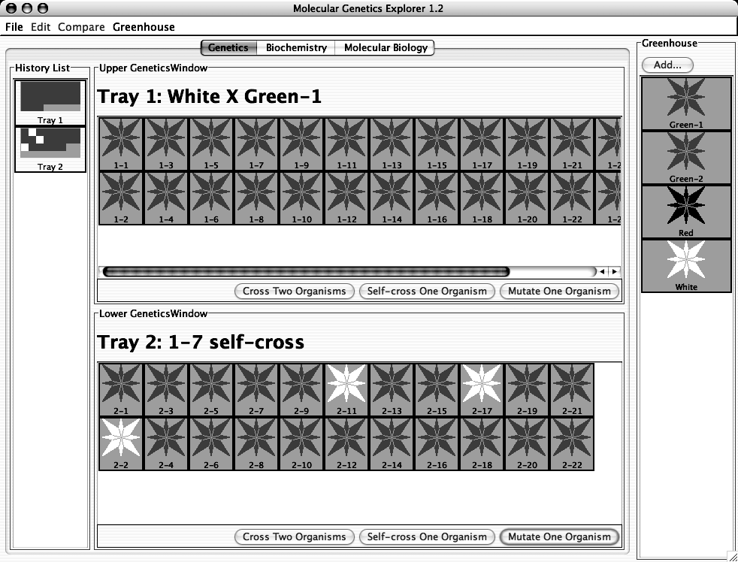
The offspring of this self-cross are in the Lower Work Panel. Note the addition of Tray 2 to the History List.

III) Mutate any one organism. This simulates treating the cells of one organism with a strong dose of a mutagen and then growing each of those mutant cells into a separate plant. The flowers of the resulting mutant plants are displayed in a new Tray. This process can take a few minutes. Suppose that you wanted to mutate one of the white organisms in Tray 2:

1) Select a white organism from Tray 2. When you have only one organism selected, the
“Cross Two Organisms” buttons will be grayed out and the “Self-Cross One Organism” and “Mutate One Organism” buttons will be activated.

2) Click the “Mutate One Organism” button in the Upper Work Panel. A pop-up will
appear telling you that the program is busy making mutants. You can cancel this
process if you like.

You will then see a new Tray with the mutants and a new entry in the History List.

At this point, there are several other things you can do:

A) If you find an interesting organism, you can save it to the Greenhouse:

1) Click the “Add…” button at the top of the Greenhouse.

2) You will be prompted to give the organism a name. Give it a descriptive name and
click “OK”. You will see your new organism appear in the Greenhouse. You
can now access it using the other tools in this program.

3) At this point, the organism is saved in the program, but not on the disk. To save the
contents of the Greenhouse to disk, click on the Greenhouse Menu and select “Save Greenhouse”.

B) You can cross or mutate any of the organisms visible in the Greenhouse, Upper Work
Panel, or Lower Work Panel.

C) You can bring any Tray from the History List to a Work Panel by double-clicking the Tray and selecting the appropriate item in the pop-up menu.

D) You can add notes to any Tray in the History List by double-clicking the Tray and choosing the “Add Notes...” item from the resulting pop-up menu. These notes will appear if you leave the cursor over the Tray for a few seconds.

Specific Tasks to do with this tool:
- How many different alleles are there? Which colors do they produce? It will be useful to use multiple-allele notation like this: C^{R} = red; C^{G} = green, etc.
- Which are dominant and which are recessive?
- How do the colors combine to produce an overall color? For this, it may help to make a genotype-phenotype table and then try to abstract rules from that. You should be sure that you have tried all the possible combinations of the alleles you found in part (a).
- Using the symbols you have developed, give the genotypes of the four starting organisms.
- Using this knowledge, construct a purple flower.
- Can you construct a pure-breeding purple flower with the starting set of organisms?
- Advanced Tasks: What can you learn from mutations?
  - Is it easier to mutate from color to white or vice versa?
  - What new color(s) can you find by mutation?

Put your data in the tables below:

(a) and (b) allele color

(c) Genotype Phenotype

What rules can you find to explain the data above?

(d) Green-1:

Green-2:

Red:

White:

(e) Have your TA check off that you have constructed a purple flower. For full credit, you must be able to explain to your TA why the flower is purple.

(f) Can you construct a pure-breeding purple flower using only the four starting strains? Why or why not?

You will continue this project in the second part of the lab in a few weeks.

