
Auto Controller 2 Manual
by brianuuuSonic

Pokemon Legends: Z-A: Donut Maker
Make donuts and reset until one or multiple of the same donut with specified flavor power is found.
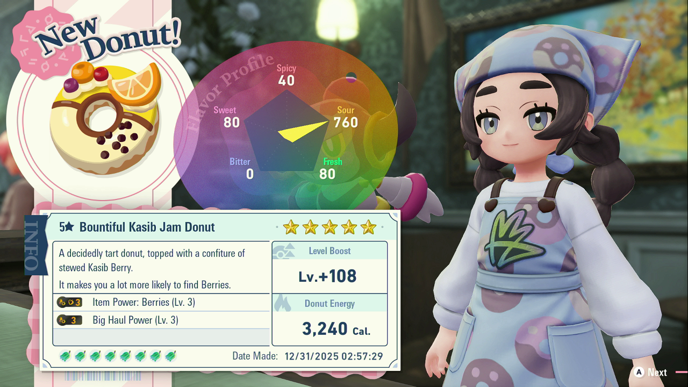

Requirements
- Serial Port: Yes
- Camera Device: Yes
- Audio Input: No

Program Settings
- Target Amount:
How many of the same donut to make
- Hyper Berry Order:
Sequence of how many Up/Down presses to select berries, separated by commas.
Positive number = Down press, Negative number = Up press, Zero = same berry
Example: 2,-1,0,0 (Four berries, down twice, up once, then same berry twice more)
Note: this always uses the Hyper Berry menu
- Flavor Power Selection:
Drag & Drop desired flavor power from Available Powers into each slot, target donut will match at least one of the flavor powers in each slot. You can have all 3 levels in the same slot, then the result donut will pick any level of that power

Setup Instructions
- Switch 2 user must disable all HDR settings and put current account to leftmost slot
- Make sure Language settings in Global Settings is set to the correct language
- Set Text Speed to Fast
- Check your berry combination is possible with the desired flavor powers: https://www.pokeos.com/plza/donuts
- Talk to Ansha, press Minus twice to go to Hyper Berry menu. From the current cursor’s position, count how many up and down presses to select each berry.
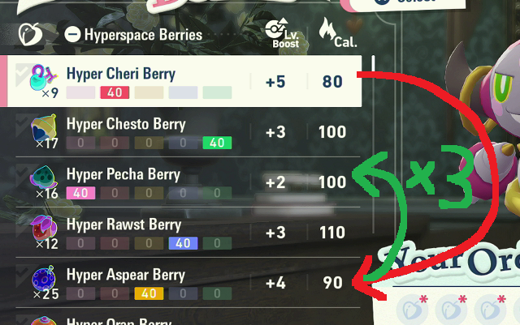
Say you want to have 1x Hyper Aspear Berry then 3x Hyper Pecha Berry, that will be 4 down presses, then 2 up presses, then same berry twice more, which gives 4,-2,0,0
- You MUST make sure you have enough berries to make donuts, especially if you are making multiple of the same donut
- (Recommanded) Reset time of day on a bench to prevent time of day change during the program
- You can start the program from anywhere within Lumiose City

Expected Results
The program starts by flying to Vert Pokemon Center and putting down a backup save, then fly to Hotel Z and make donut. If donut power matches, it either completes or continues by flying to Vert Pokemon Center to put a backup save again; if donut powers don’t match, it restarts to load back up save which would start from Vert Pokemon Center again.

