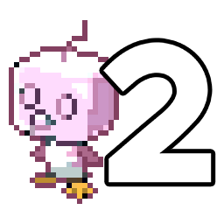
Auto Controller 2 Manual
by brianuuuSonic

Pokemon Fire Red/Leaf Green: Nugget Farmer
Farm nuggets from Team Rocket grunt on Nugget Bridge until you have 999 nuggets. If the grunt is defeated, this cannot be used anymore.
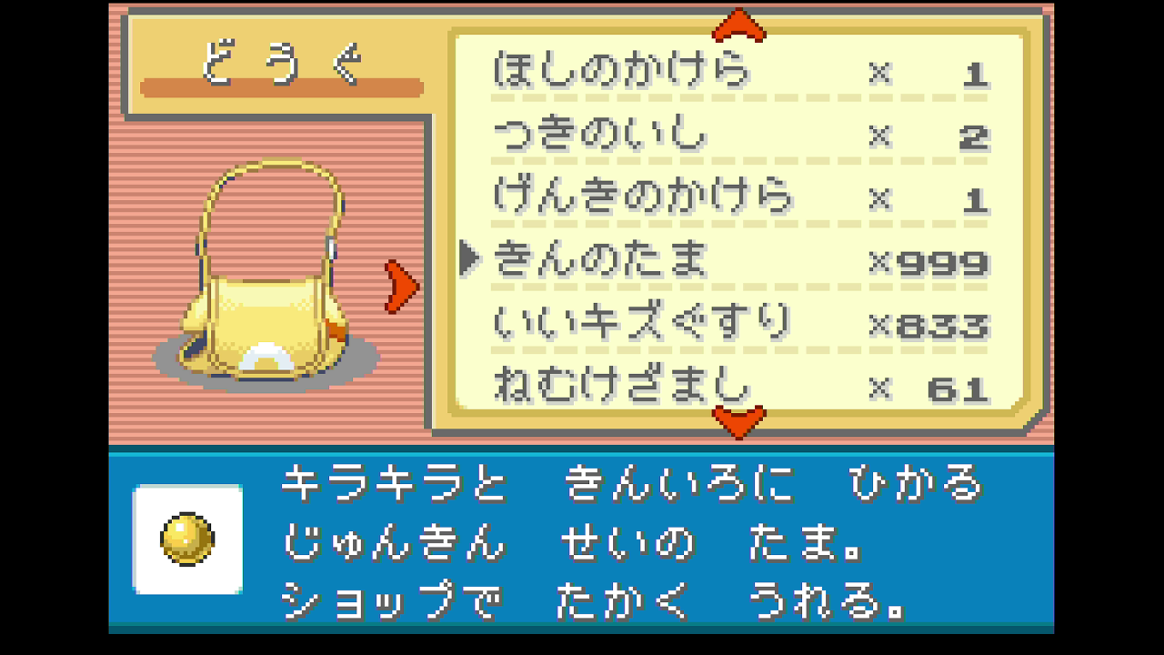

Requirements
- Serial Port: Yes
- Camera Device: Yes
- Audio Input: No

Program Settings
- Loop Count:
How many nuggets to get, should be less than how many nuggets to get to 999

Setup Instructions
- Switch 2 user must disable all HDR settings
- Set Text Speed to Fast, turn off Battle Scene
- Only have 1 Pokemon with very low level and defensive stats on the team (Note that you cannot get any Lv.2 Pokemon after reaching Cerulean City)
- Stand in front of Nurse Joy in Cerulean City Pokemon Center

Expected Results
The program starts by navigating to the Team Rocket Grunt, receives the nugget and spam A until you lose the battle, returns to PC and repeat.

