
Auto Controller 2 Manual
by brianuuuSonic

Pokemon Fire Red/Leaf Green: RNG Manipulation
A helper program that presses A at precise times to do RNG manipulation, this can be used for all RNG methods, like static encounters, sweet scent, game corner prizes etc. This program essentially replaces Eon Timer since the settings is mostly the same.
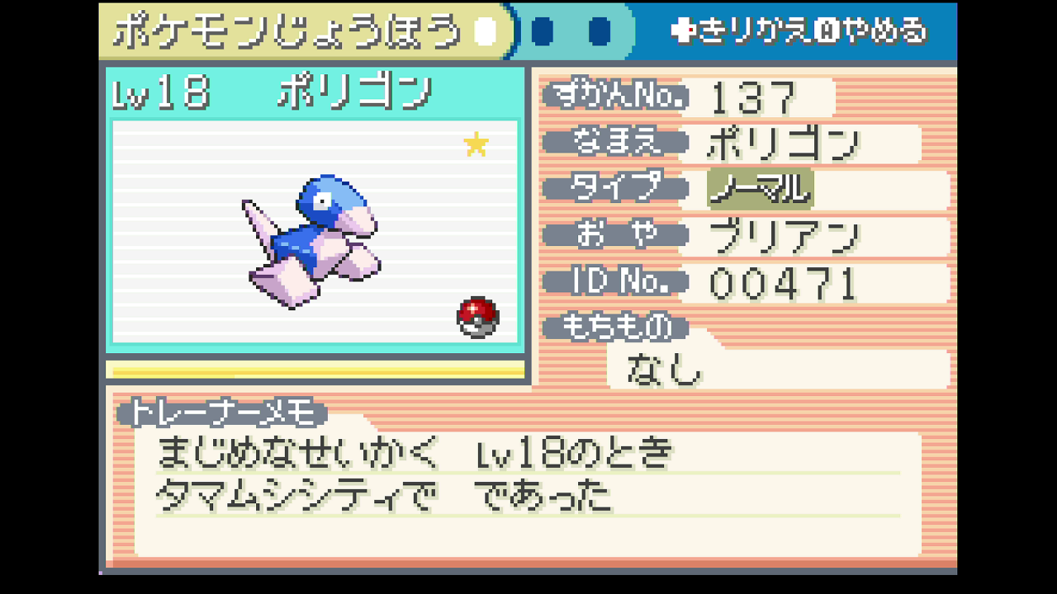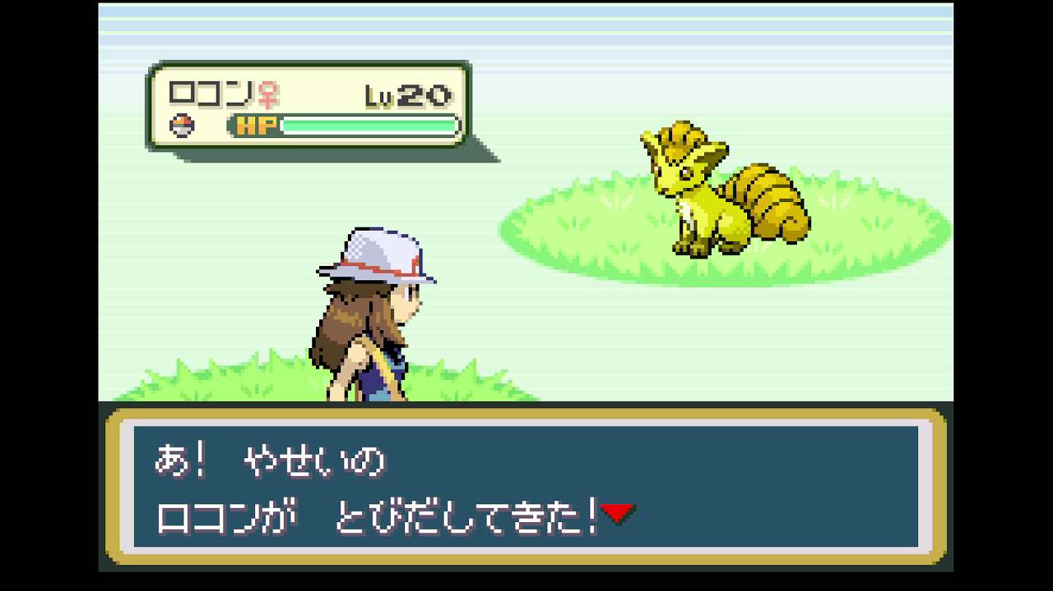

Requirements
- Serial Port: Yes
- Camera Device: Yes
- Audio Input: No

Program Settings
- Seed Time:
Target seed to hit, how many ms to wait from Home screen until pressing A at the title screen
- Seed Calibrate:
Adjustment if your actual hit seed is too early/late from the target seed
- Continue Screen Frames:
How many frames to wait at continue screen before pressing A, at this screen each frame advances by 1
- Continue Calibrate:
Adjustment if you actual hit frame is too early/late from the target frame
- Overworld Frames:
How many frames to wait in the overworld before pressing A, here each frame advances by 2, you rarely have to touch this value unless encounter animation is very long like Snorlax or Deoxys etc.
- Move Up instead of Press A:
Replaces final A press with Up move, for Ho-Oh only
- Command after Flashback:
Command used after flashback, use this for going through gift Pokemon dialogues or navigating to Sweet Scent button etc., the time to complete this command must fit between flashback and final A press. Use Command Recorder program to record this
- Command after Pokemon:
Command used after the final A press, you can use this to catch Pokemon with Master Ball or navigate to Pokemon summary screen. Use Command Recorder program to record this

Obtaining SID without Glitches
- To obtain your SID (Secret ID) without glitches, you must have a full odds shiny. Luckily there are multiple programs to do this: Gift Reset, Overworld Shiny, Prize Corner Reset, Starter Reset, Static Reset
- Once you have a shiny Pokemon, you need to calculate its IV with https://marriland.com/tools/iv-calculator/
- You may have to level it up a few times to get the exact IVs, you MUST NOT EV train the Pokemon by defeating other Pokemon, use Rare Candies or put it into Day Care and use Underground Path Cycle in Custom Command program to gain EXP
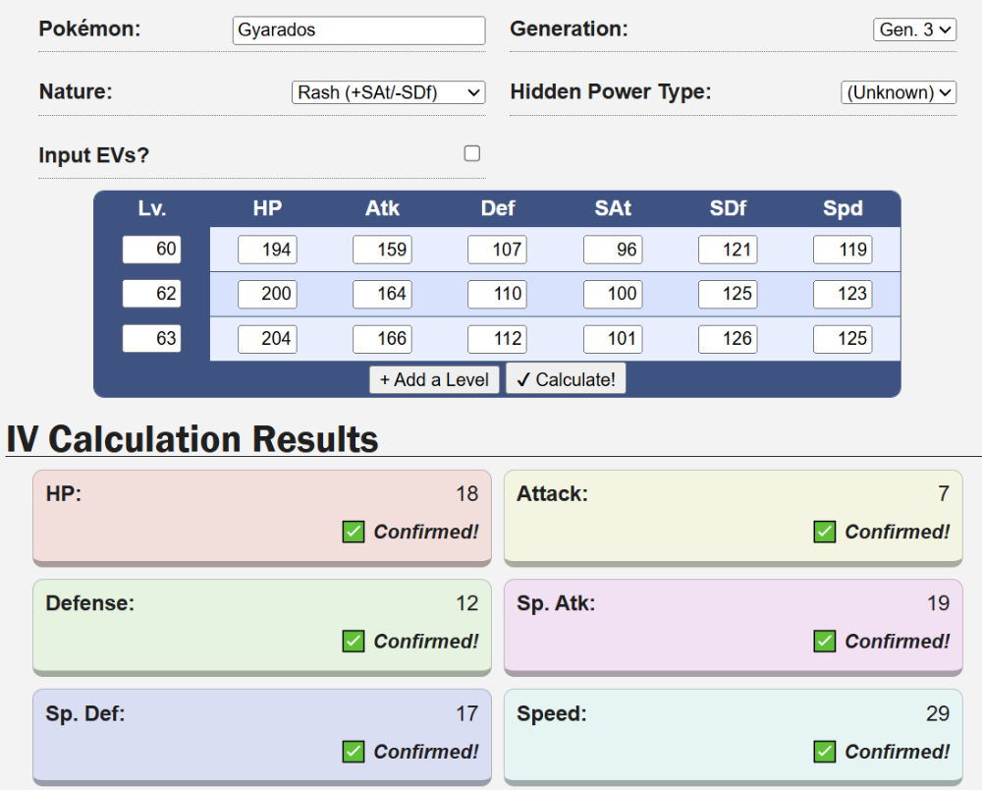
- Once you have the exact IVs, you need PokeFinder: https://github.com/Admiral-Fish/PokeFinder/releases
Open IVs to PID in Gen 3 Tools, enter IVs, nature of your shiny Pokemon and TID, this should give you your SID. (Method 1 is common for static Pokemon, Method 2 is command for wild Pokemon)
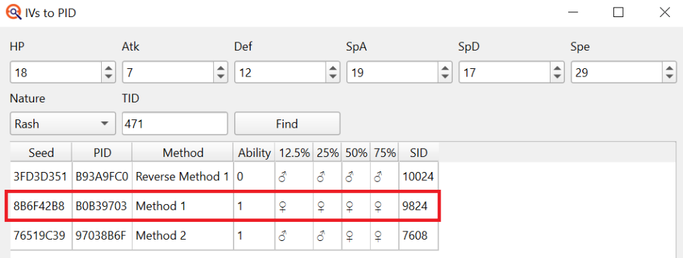

Tutorials
From brianuuuSonic (me):
Eevee: https://www.youtube.com/watch?v=7cS4DqFoaX8
Snorlax: https://www.youtube.com/watch?v=09tJUsu-E0g

From im a blisy:
Starters: https://www.youtube.com/watch?v=DfO2Zb9i3Bs
Lengendary: https://www.youtube.com/watch?v=Gtxa6CyTOGM

