
Auto Controller 2 Manual
by brianuuuSonic

Pokemon Legends: Z-A: Respawn Reset
Pokemon respawns after certain amount of time, this takes advantage of it a restart game just before it spawns to reroll for shiny.
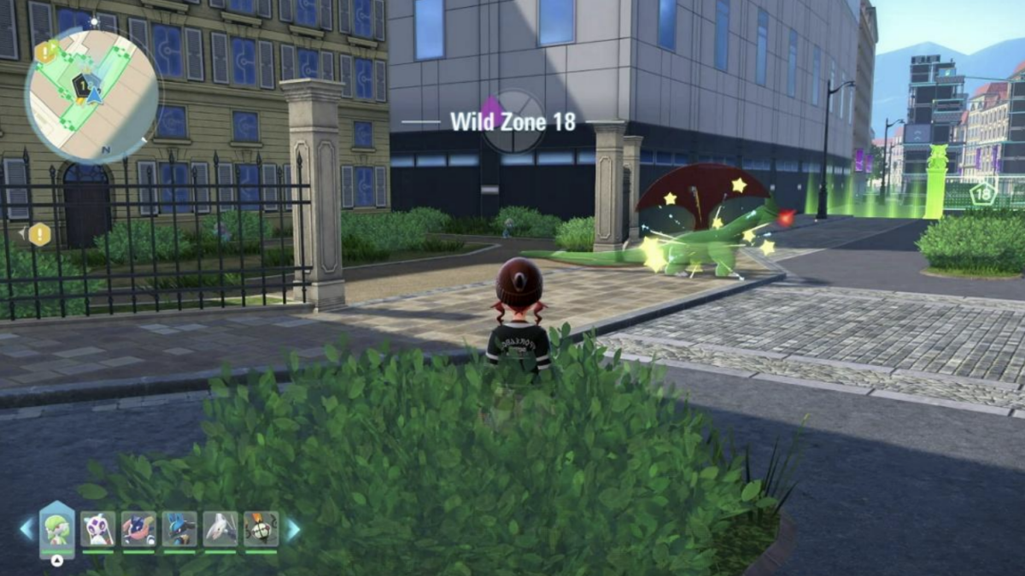

Requirements
- Serial Port: Yes
- Camera Device: Yes
- Audio Input: Yes

Program Settings
- Wait Time:
Time to allow sound detection after entering game, if you are using this for multiple spawns at the same time you might want to increase the time to make sure all Pokemon are spawned

Setup Instructions
- Kill the Pokemon you want to hunt for shiny
- Stand next to where the Pokemon will respawn, your avatar MUST be facing the direction where there Pokemon respawn within the camera, this ensures the shiny sound plays, press L to reset camera orientation
- Each Pokemon’s respawn time can be different, normal Pokemon respawn after 3 mins whilst Alpha respawn after 5 mins, set a timer after Pokemon dies and save the game before the timer runs out
- You have to make sure after restarting the game, the Pokemon spawns within 5 seconds, if not wait a little then save again, adjust where your character is facing if necessary
- (Optional) When it spawns fast enough, verify if the Pokemon is different after a few resets, by checking its gender/level (if it is allowed to change)

Expected Results
The program starts immediately by restarting the game, upon enter game, it waits for X seconds to detect shiny sound, repeat after timeout.

