
Auto Controller 2 Manual
by brianuuuSonic

Pokemon Fire Red/Leaf Green: Prize Corner Reset
Soft reset Prize Corner Pokemon until a shiny is found
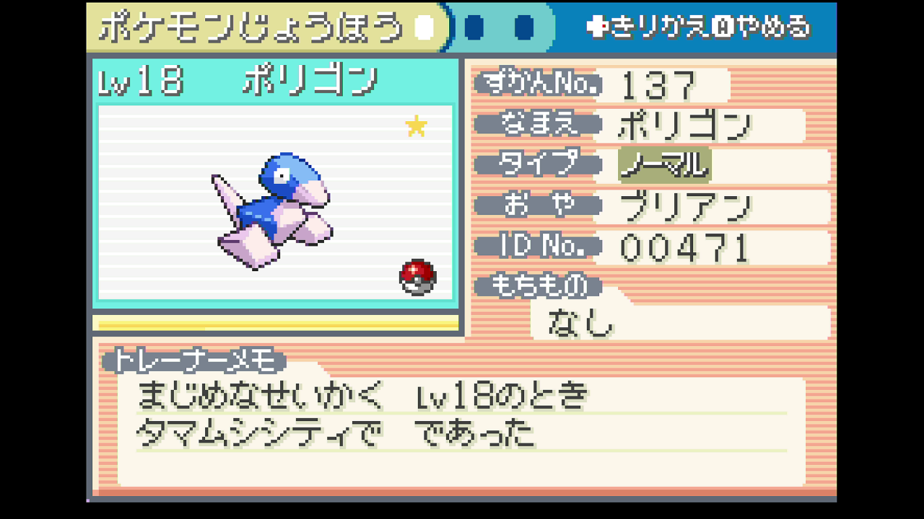

Requirements
- Serial Port: Yes
- Camera Device: Yes
- Audio Input: No

Program Settings
- Prize Slot:
Which slot of Pokemon to obtain

- Prize Count:
How many of the same prize to get, you must have enough coins and empty party spaces

- Seed Frame:
Wait this many frames (not accurate) before pressing A at the title screen. This setting is changed by the program while running
- Advance Frame:
Wait this many frames (not accurate) before finishing dialogue after picking starter. This setting is changed by the program while running

Setup Instructions
- Switch 2 user must disable all HDR settings, Console Screen’s HDR Output and HDR Output below
- Set Text Speed to Fast
- Make sure you have enough coins to purchase desired number of prize Pokemon
- Make sure you have enough empty party room for the prize Pokemon
- Save in front of the Pokemon prize NPC (middle)

Expected Results
The programs starts by soft resetting with ABXY, delay by Seed Frame at title screen, delay by Advance Frame and collect X prize Pokemon. Then it checks last X Pokemon’s summary for the yellow shiny star, if not shiny the program increments Seed Frame or Advance Frame to check a different RNG permutation. Note that when a shiny is found, the program might have scrolled to a different Pokemon.

