
Auto Controller 2 Manual
by brianuuuSonic

Mega Man Star Force Legacy Collection:
Auto Battler (MMSF3)
Automatically grinds battle in MMSF3. For collecting Noise abilities, Noise Frags, Zenny etc.
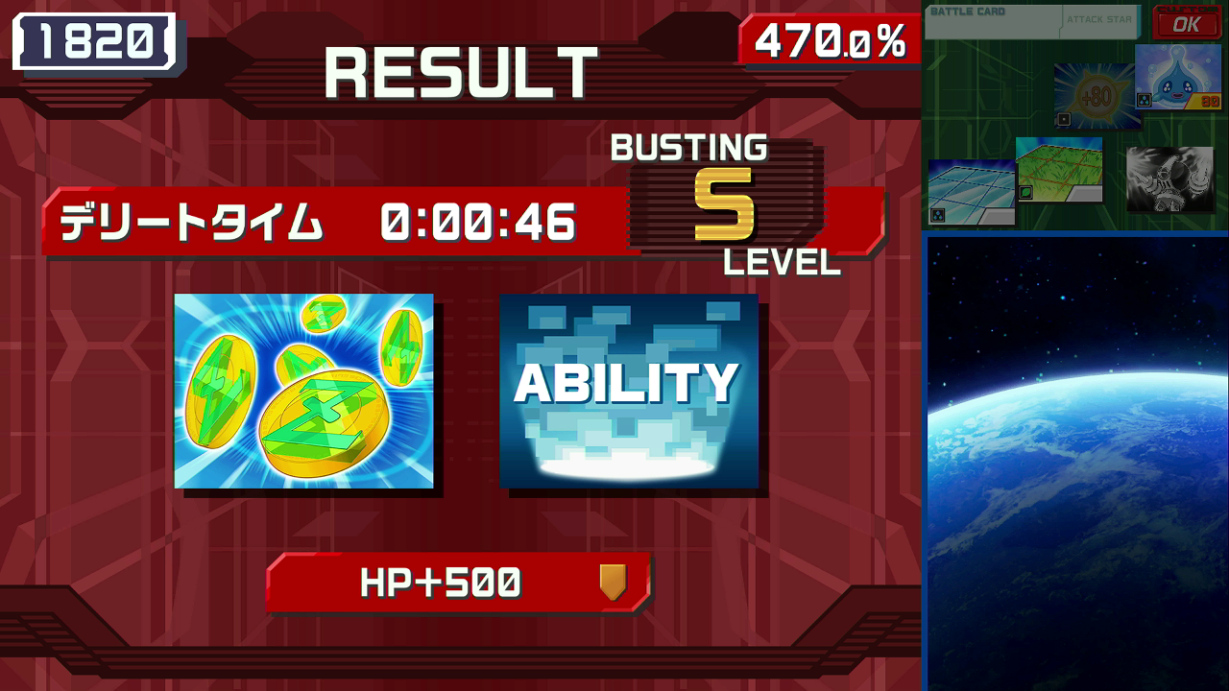

Requirements
- Serial Port: Yes
- Camera Device: Yes
- Audio Input: No

Program Settings
- Battle Count:
How many battles to do, set 0 for infinity

Setup Instructions
- Switch 2 user must disable all HDR settings, Console Screen’s HDR Output and HDR Output below
- Set Screen Layout to the following (the default setting):
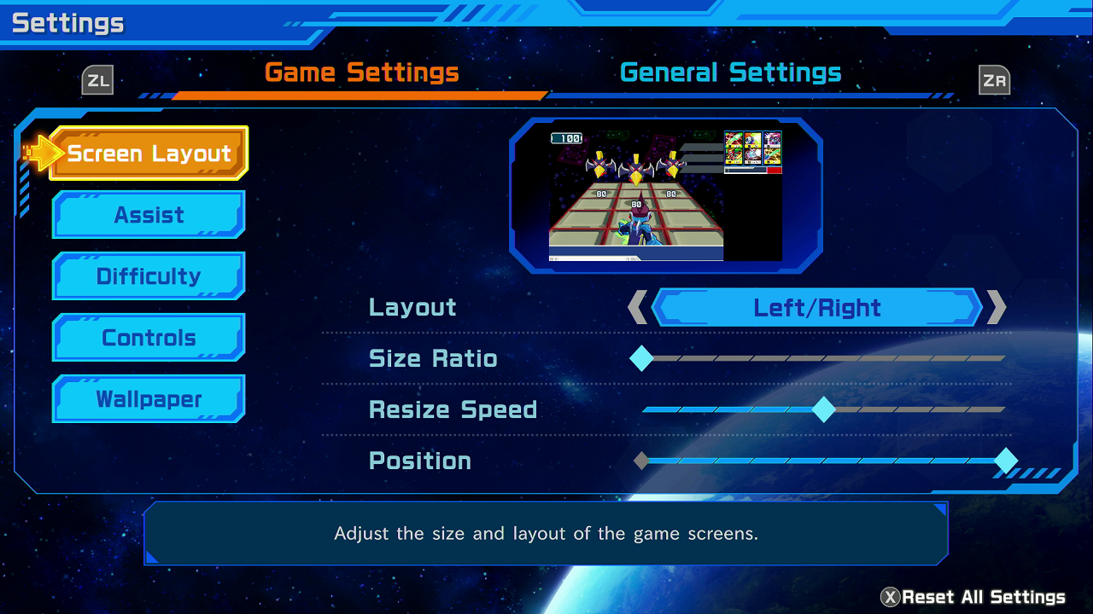
- Set Assist settings to the following:
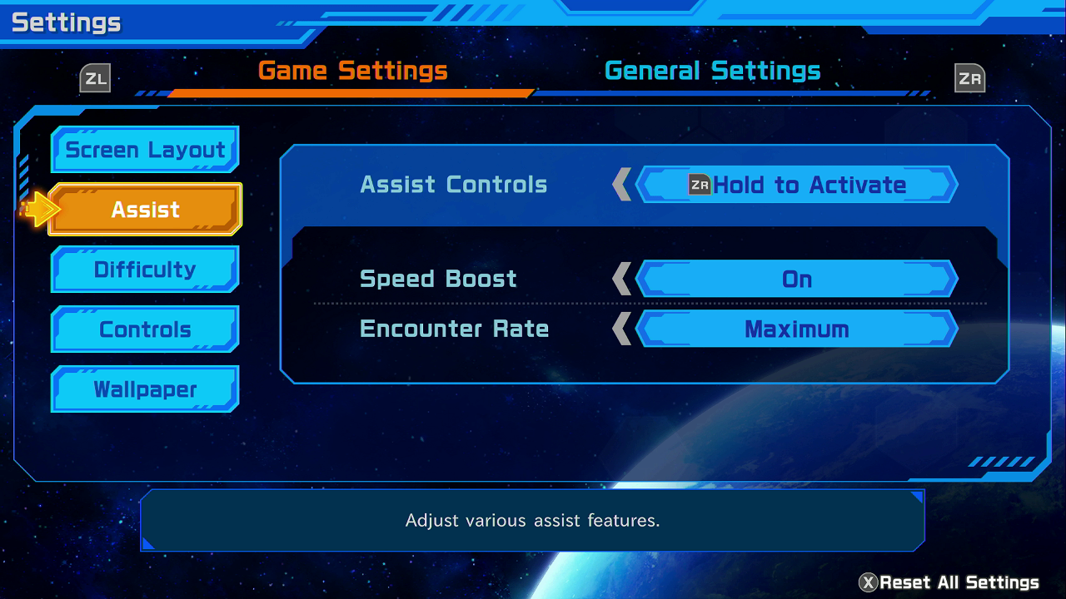
- Have Radar Missile as a default card in your folder, make sure the folder is equipped
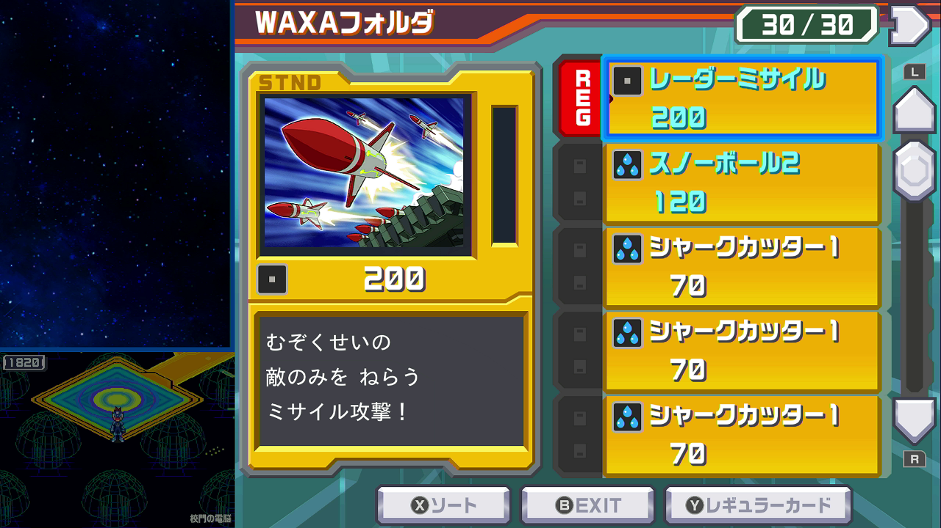
- Go to School Gate CC, stand at the bottom corner and start the program
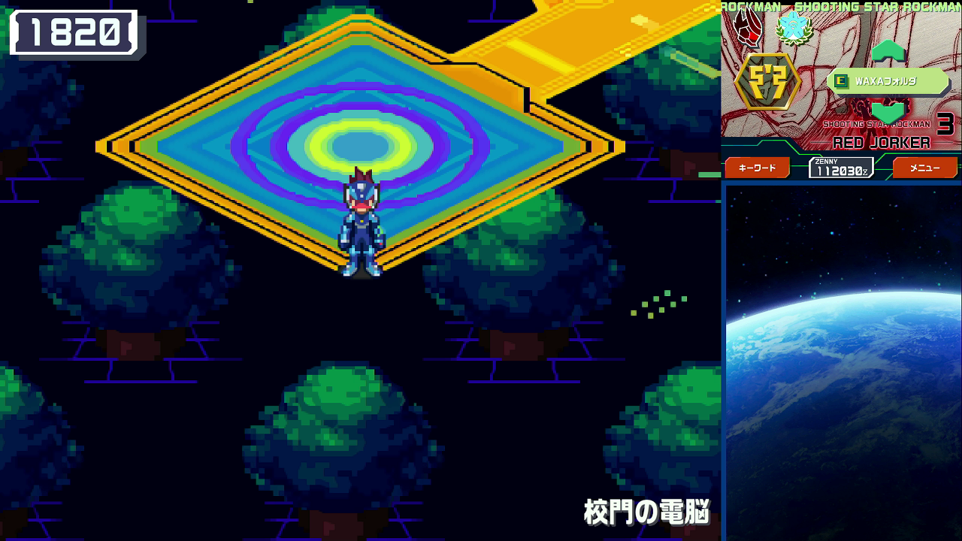

Expected Results
The program will start battle and use default card (Radar Missile) to kill all viruses, this works even if the card is covered. If the battle triggers Noise Change it will be cancelled.

