
Auto Controller 2 Manual
by brianuuuSonic

Pokemon Fire Red/Leaf Green: Starter Reset
Soft reset starter Pokemon until a shiny is found
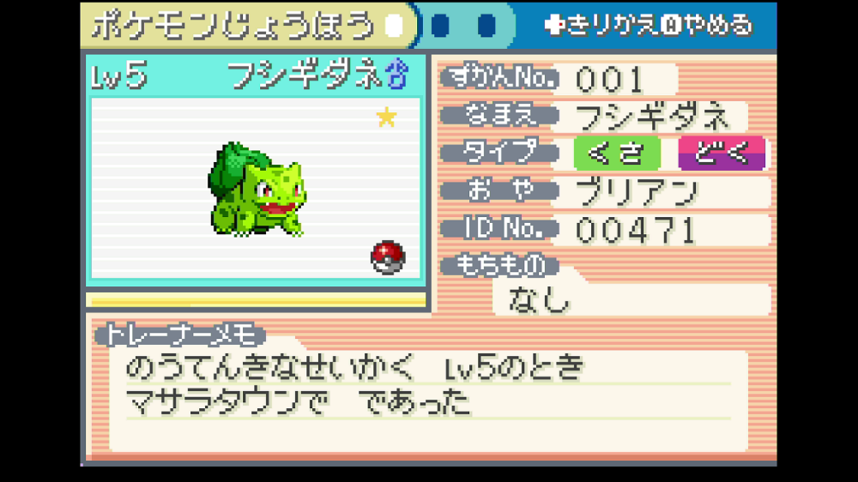

Requirements
- Serial Port: Yes
- Camera Device: Yes
- Audio Input: No

Program Settings
- Seed Frame:
Wait this many frames (not accurate) before pressing A at the title screen. This setting is changed by the program while running
- Advance Frame:
Wait this many frames (not accurate) before finishing dialogue after picking starter. This setting is changed by the program while running

- Confirm Delay:
Delay in ms between pressing yes and generating starter Pokemon before adding Advance Frame, you shouldn't have to change this

Setup Instructions
- Switch 2 user must disable all HDR settings
- Set Text Speed to Fast
- Save in front of the starter you want to pick

Expected Results
The programs starts by soft resetting with ABXY, delay by Seed Frame at title screen, pick the starter and delay by Advance Frame before finishing all dialogues. Then it checks starter’s summary for the yellow shiny star, if not shiny the program increments Seed Frame or Advance Frame to check a different RNG permutation.

Tips: The program saves the settings for Seed/Advance Frame so you can pick up from the permutation it stopped last time.

Tips 2: After a certain amount of permutations (~5000), it will start slowing each reset by over 1 second, you can delete your save file and start a new game, this will generate a new trainer ID for RNG. Play until before picking the starter, reset program to default settings and start again.

